FILED BY ALLEGIANT TRAVEL COMPANY

PURSUANT TO RULE 425 UNDER THE SECURITIES ACT OF 1933

AND DEEMED FILED PURSUANT TO RULE 14a-12

UNDER THE SECURITIES EXCHANGE ACT OF 1934

SUBJECT COMPANY: SUN COUNTRY AIRLINES HOLDINGS, INC.

COMMISSION FILE NO. 001-40217

The following communication regarding the acquisition of Sun Country Airlines Holdings, Inc. (“Sun Country”) by Allegiant Travel Company (“Allegiant”) was sent from Greg Anderson, CEO of Allegiant, to employees of Sun Country on January 26, 2026:



2

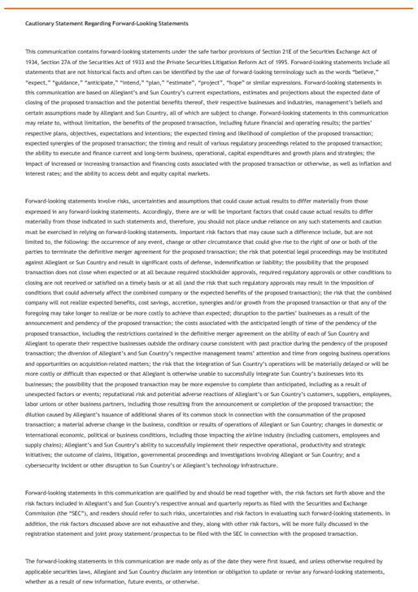

3

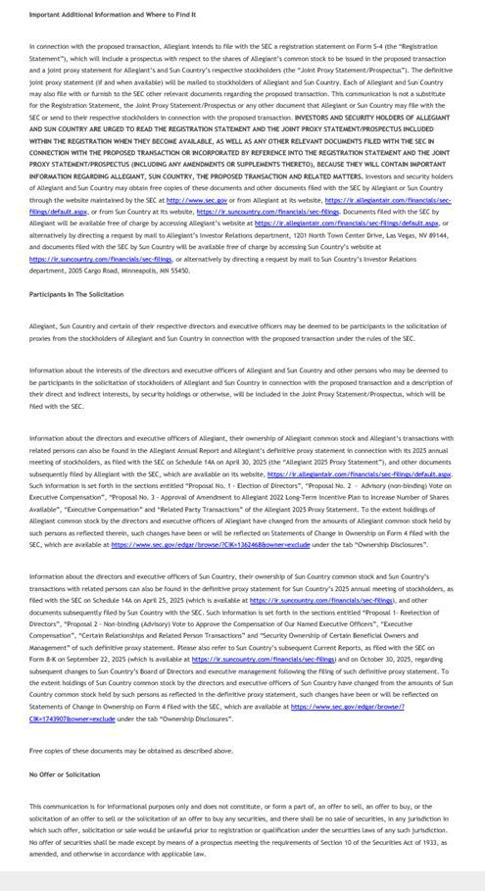

4

