FILED BY ALLEGIANT TRAVEL COMPANY

PURSUANT TO RULE 425 UNDER THE SECURITIES ACT OF 1933

AND DEEMED FILED PURSUANT TO RULE 14a-12

UNDER THE SECURITIES EXCHANGE ACT OF 1934

SUBJECT COMPANY: SUN COUNTRY AIRLINES HOLDINGS, INC.

COMMISSION FILE NO. 001-40217

The following is a transcript of a portion of a town hall meeting held for employees of Allegiant Travel Company (“Allegiant”) on February 20, 2026, and an accompanying presentation, regarding the pending acquisition by Allegiant of Sun Country Airlines Holdings, Inc. A video of the town hall meeting and accompanying presentation was made available beginning on February 23, 2026:

Town Hall Transcription

February 20, 2026

Laura Overton (Vice President, General Counsel & Legal Affairs)

Hello everyone and welcome to your fourth quarter 2025 Town Hall. We are so excited for you to join us here today as we are going to provide an update on the recently announced Sun Country acquisition and also to provide an update on the progress we've made so far with that integration. We will also provide an update on the 2025 profit sharing and the 2026 goals ahead of that. Finishing up today will be your pre submitted questions and we thank you all for all of the questions that you did submit. We got a lot of them and we love to see that. We are joined today in the room by a mix of your senior leaders starting with Greg Anderson, our CEO; BJ Neal, our President and CFO; Tyler Hollingsworth, our COO; Drew Wells, our Chief Commercial Officer; Michael Broderick, our Chief Integration Officer; Rebecca Henry, our CHRO; and they are all here in the room to answer your questions today. So with that, I'm going to hand it over to Greg to kick us off.

Greg Anderson (CEO)

Laura, thank you and thank you everyone for joining us today on this Friday afternoon. We thought it'd be helpful to start with just how proud we are of Team Allegiant and everything you've done and all the execution we saw throughout 2025. It really helped us to reinforce our foundation to be a more resilient and even better airline. So I thought I'd hit on just kind of the three key pillars here. And financially because of your great work, we were able to meaningfully improve our balance sheet and we're also near the top of the industry in terms of margins, which was a challenging year for our industry as well. So really proud of all the great work there commercially. Drew and his team did a lot to continue to strengthen our foundation. This includes work where they partnered with our IT shop to kind of further modernize our technology stack with new tools that can help make our airline even better. More tools to come. We also broaden our product offerings through initiatives such as Allegiant Extra. So hats off to the team for the great work commercially and then operationally. You ran the best operations in our company's history and you did this also while restoring peak utilization in introducing our new Max aircraft and so really proud of everything you've done and we're off to a strong start in 2026 as we continue to step up our game. Some of us in the room just had the opportunity to tour our brand new state-of-the-art training center here in Las Vegas, 75,000 square feet. Really excited about it. But just last but not least, on this page, even external party parties are taking notice of all of your great work, and that includes the prestigious Wall Street Journal ranking as the second best airline in the US. Now this ranking's primarily based on objective operational stats or metrics.

So hats off again to the team for everything you've done and I believe this is the highest ranking ever for a value airline.

So with that, why don't we go to the next page and because all that great work you have done has really helped strengthen our foundation and help set us up nicely for this acquisition of Sun Country. And before we dive into the integration process, I thought it was important to note that we do understand that an integration like this naturally brings uncertainty and that the best thing we can do to reduce as much of that uncertainty as possible is through clear planning and clear communication. And so Michael Broderick, who's sitting here to my left, he'll be leading these efforts for Allegiant. So if we go to the next page. Michael Broderick, he'll be leading the efforts for Allegiant. Eric Levenhagen will be leading these efforts for Sun Country. They are off to a strong start.

I'm not going to spend a lot of time on the detail on this page. Michael's going to come in and provide more there, but at a high level, I just wanted to say that our integration plan is really about two things. First, it's about being ready on day one after the deal closes. We expect deal close around back half of this year. Second is building a thoughtful road map for the entire integration, which is a multi-year journey. But importantly, as Michael and Eric and the collective team are working through this, we're not rushing into changes. We're putting the structure in place now so that when the time comes, we move in a way that's safe, that's coordinated and that's respectful of both airlines. So I like to say that the overall goal is straightforward and that's to create a stronger, more resilient either airline, one that unlocks more growth, more opportunity and more long-term stability than either one of us could achieve on our own. And that's the reason we're doing this whole thing.

So if we go to the next page, we thought it'd be helpful just to start off and say that this integration journey is led by three core principles. First and foremost, do no harm. Both airlines are performing at a very high level and we are not going to disrupt what's working. Integration will be phased thoughtfully and only when safe to do so. And second, our decision making will be objective and it will be data-driven. We need to protect the strengths of each airline and what makes us both successful. And finally we are going to be disciplined. Discipline creates consistency and it's very important that throughout this process and at all times we say what we do and we do what we say. And so a commitment of ours is to keep you informed, to make decisions thoughtfully and that lead to the strengthening of the combined airline.

I think with that, I have the pleasure to turn it over to Michael Broderick, our Senior Vice President and Chief Integration Officer. Michael.

Michael Broderick (Senior Vice President, Chief Integration Officer)

Thank you, Greg, and it's my pleasure to be able to spend some time and explain in more detail about the Integration Management Office and also what this integration will look like over the next couple of years. I'll first start off and talk about five key areas of focus and how the Integration Office will think about how we spend our time and our efforts. The first one I want to focus on and highlight is our efforts are already underway towards day one or deal close. And really what this means is when the transaction is legally approved, we want to ensure that this happens smoothly, and so we've already had our teams kick off towards day one readiness. The second area of focus for us is to ensure that we're following all the legal and regulatory compliance guidelines. The third is to ensure minimal disruptions to our customers. You've just heard Greg mention that and I just want to again highlight how important that is for us. Both Allegiant and Sun Country have earned great reputations; that Wall Street Journal report that Greg just cited that that that's a meaningful achievement for all of our frontline team members and what we want to ensure throughout this process is that we don't lose any of that goodwill that we've earned by running a great operation. Fourth is to foster a world class culture. As many know, Sun Country has achieved something quite remarkable out of the MSP area. They have a great scheduled service business, they have a cargo business and they run a great charter operations as well. And behind those great results is an impressive culture and what the efforts of the Integration Office will be is focusing on how do we build on the strengths of not only Allegiant’s culture, but the strengths of Sun Country's culture. Greg's frequently mentioned before our desire to be the leading airline in the leisure space and we'll be able to do that by combining both of the strong and great things that both team members have done across each of each of the organizations. Finally, I want to just focus on the information and the role of communication that the IMO will have. We know this process will have a lot of questions and uncertainty that will come to mind, and we want to ensure that we're providing you with the information that you need to know. We'll be providing you information on what's happening, why it's happening and what to look forward to coming next.

I want to spend a minute and talk about how we organize our efforts throughout the integration. And first, what I think it's important to say upfront is that the integration will not be run by a select few number of individuals making all the decisions for the airline. But rather, it will be about empowering existing leaders from both organizations. We'll break down topics or work scope that will need to happen throughout the integration and we'll leverage the experience of our team members from both sides as they work on the plans and the recommendations to move forward. At times, some of those decisions will need to follow up through Greg and BJ, but we think most of the decisions and recommendations will stay at our existing leadership levels as they're working towards the integration. The role of the Integration Management Office in this process is to ensure that there's cohesion between all of the respective work streams’ plans to ensure that there's good knowledge of the interdependencies and that we have a plan that allows us to work efficiently together.

I want to now transition to the next slide and introduce the Integration Management office from both Allegiant and Sun Country. And on the Allegiant side, I can tell you it's an incredibly experienced and talented organization and I'm really pleased to be able to work with this group of individuals. We have something like 100 years of combined airline experience ranging from areas like fleet, supply chain, technology, operations, communication, program management and many others. And I just wanted to quickly read out the names of the Allegiant team members to highlight them. First off, we have Andrew Ramonette, Tyler Maatallah, Kyle Rothell (who will also be splitting his duties in the IMO with supporting Greg as his Chief of Staff),

TJ Masters, Nina Valeriano and Nesbert Hidalgo are the core members of the Integration Management Office. On the Sun Country side, it's an equally impressive team. They have something like 60 years of combined experience, including in areas that I touched on the Allegiant side, but also on people leadership, customer communication, technology, legal and many others. We had the opportunity to have the Sun Country team members out here to launch the Integration Management Office and we've been working closely with them ever since. And it's a great team and a privilege for all of the Allegiant team to be able to work with the Sun Country team members.

As the integration effort will span multiple years, I want to take a few minutes and explain that process and how we think about it in its distinct phases. The first phase that we're in is called the integration setup and blueprint phase. And as this name implies, this is where we're organizing our efforts. We're standing up the Integration Office. We're designing the guiding principles that will inform how we make decisions as we move throughout this journey. Phase one will conclude at the end of this month and then we'll move into phase two, the design, detail planning and day one readiness phase. And again, as this name implies, this is where we start to work together towards the plan of not only day one readiness, but also how we'll sequence the integration steps that will happen once the deal closes. Phase three begins when the transaction is approved and closed, and this is when you'll start to see the integration happening. We'll start to see the integration of our teams, the integrations of our tools and systems, and eventually the integration of our operation. And one thing that I want to be very clear on as we move throughout the integration is that there are two very important guarding principles that we will not violate. The first is we will never move at a pace that will jeopardize safety and the second, again, around this principle of minimal disruption, we want to ensure that not only are we not disrupting our customers throughout this process, but that we're not providing disruption for our team members as they have to go out and serve those customers on the front line every single day. Then as we move on to phase four, this is when we finally integrated and we're truly one airline. We'll have one set of tools, one team and truly running as one operation. And one of the most important things about this combined airline is the is the strength that we'll have of combining both together. And this strength allows us to give a higher customer value proposition than what either airline could have done independently. And also with this increased strength, we'll be able to offer our team members more growth opportunities, again at a greater pace than what we could have done independently. Now I just want to wrap up my remarks and talk about a couple of other important milestones that will occur throughout the integration post-close. The first is the milestone around single operating certificate or SOC as you may also hear it. This is where we truly operate as one airline and this is an important and detailed effort that we're beginning our planning efforts. We'll be identifying subject matter experts across the operational groups from both Allegiant and Sun Country to begin those efforts and ensure that we get to a single operating certificate after close. And the second one is when we combine into one single brand. We have tremendous respect for the Sun Country brand and all that it means for those in the MSP area. We ultimately felt as we move forward as a combined entity, it would be more efficient to communicate the value proposition and the strengths of both airlines under one single brand, and we've elected that brand to be Allegiant. And in the foreseeable future, however, we'll continue to operate as distinct brands. But as we get closer to that point in time, you'll get more information about what that will look like in that process. Now I want to turn the some time over to BJ Neal, who will give us more information about what changes to expect in the near term and what will change or what will stay the same in the near term. Thanks.

Robert “BJ” Neal (President, CFO)

Thanks Michael. Good afternoon to all of our team members. Thank you for taking the time to be here and to listen in today. So by now we've spoken at length about, you know, the rationale for the transaction and Michael's given you a detailed overview of how we will execute on integrating the two companies. So I just want to take a moment to talk about what will remain the same immediately post closing, and then, how do we expect that to evolve over time. So as both Greg and Michael have mentioned now, business continuity is paramount during the integration. Michael mentioned closing means that the transaction is final from a legal and financial perspective. Essentially, Sun Country Airlines will become fully owned by Allegiant Travel Company. Now, there will be a period of time after that closing where we would expect day-to-day roles for most team members to be exactly the same as they are today. Both Sun Country and Allegiant are running great businesses. They're profitable and they're delivering operational excellence. We have no interest in disrupting that. Now, perhaps one of the most important parts of that is customer service. Both airlines are known for their customer commitment and a level of service which clearly stands well above other low-fare or value carriers. It is among our highest priorities to ensure that this continues and in fact there are many ways where we have good opportunity to learn from each other to determine best practices for the combined organization with the customer in mind. Next is pay and benefits. We don't expect any changes immediately for team members at either Sun Country or Allegiant on day one. Now over time, these programs will eventually merge into one, but I'd expect that to take some time and I'd expect that to be a net positive given the larger size of the combined team. And then finally, as we've said previously, we will initially continue to operate under two separate brands. OK. So how does that evolve? Well, ultimately we plan to become one organization and that means we'll come together under one organization structure or management structure. And I realize organizational changes, they can be difficult. They're not always right for every single team member. But in this case, I'd encourage you to look at the opportunities that this combination can create. This particular acquisition is about growth. We're two of the industry's most profitable carriers and we don't have to cost cut our way to financial success here. And that's not always the case with M&A. We get to join forces to play to each other's strengths as we look to growing the business, and I believe that will present team member opportunities that perhaps neither carrier would have had on a stand-alone basis. One of those changes of course is location. So we've been clear that we expect the combined headquarters to be based in Las Vegas. We'll be thoughtful and understanding and flexible as we begin bringing our HQ team members together here in Las Vegas going forward.

Now that said, I'd be remiss not to mention our combined commitment to Minneapolis–Saint Paul. We expect to have a large presence at MSP, certainly from an operational perspective, and we're still exploring other areas that would make sense. In any case, this will be our largest base of operations and our largest customer origination market. As we come together, we'll adapt in many of the ways we work. We'll give ourselves time to learn from Sun Country in areas where we can improve at Allegiant, and we'll ask them to consider Allegiant's strengths as well. And then finally, as Michael mentioned, there will come a point in time where we will unify under one single Allegiant brand. It'll become important to present ourselves to our customers, to our future team members and to various business partners as one combined company. We'll do this at the right time, after we have a single operating certificate. Before I hand this back to Greg, I just want to reiterate our commitment to fairness and to transparency throughout the integration process. I think there's a tremendous opportunity for our team members as we combine these two successful carriers to be the clear leader in leisure travel. Greg.

Greg Anderson

BJ, thank you. Before we take specific questions to the integration, let me just provide some closing comments on the integration piece and I think it's worth restating that we do recognize that there's uncertainty that comes with a transition like this. It's very real and we don't take it lightly. Our goal is to remove uncertainty as we can and work towards as seamless an integration as possible. And hopefully with what Michael and BJ have walked through, you can see how we're approaching this integration, which is thoughtfully, transparently and with respect. But I do have a few simple, what I think are simple, asks for you, our team members. And that's first, just keep doing what you're doing. Run a safe, reliable operation and continue to support one another. That consistency is the foundation for what we're building on here. And second, please support your IMO lead where appropriate. Your voice matters and it's going to help shape our combined airline. And third, please don't hesitate to provide feedback, whether that's through your manager or through the dedicated e-mail on this page, which is acquisitionquestions@allegiantair.com. We want to hear from you. And let me, before we go to specific questions here, just say we are committed to doing the right thing. And we look forward to building something truly great together. And with that, Laura, can we open it up to questions just specific to the integration for now?

Laura Overton

Absolutely. We have received many questions related to the integration as you can imagine, which your leadership is going to do their best to answer today. With that in mind, it is important to note that we are still very early in the process and there are certain regulatory and legal constraints around certain topics. The first question, Greg, is for you. How does the integration impact our pending joint venture with Viva Aerobus?

Greg Anderson

That's a good question. The integration doesn't necessarily change our interest in working with Viva. However, what I'd say our priority is the Sun Country transaction here. Viva also recently announced a deal with Volaris, which will be their focus. I also want to mention too that the Sun Country acquisition, it's going to accelerate international opportunities for us at Allegiant in our communities. That includes Mexico, which we're really excited about. But over time, let us reassess what the right path forward is with Viva.

Laura Overton

Okay, great. The next question is for BJ. If the Sun Country integration closes in the second half of 2026, how will this impact our profit sharing program?

BJ Neal

Yeah, thanks, Laura. Well, we're going to talk about profit sharing in a bit more detail here in a moment, but essentially, we don't expect it to. For the first half of 2026, we're continuing under the current program in any event (and I'll talk in a minute about some potential changes to the second half). But given that we don't expect to be under a single operating certificate during this year, I would largely expect the current profit sharing program to be unaffected.

Laura Overton

Okay, back to Greg. What does the integration with Sun Country mean for our fleet?

Greg Anderson

It's a really important question. It strengthens our fleet strategy. When the team and BJ and I in particular, but the rest of the team, as we were designing the deal structure, we were very intentional to protect the balance sheet and to maintain a conservative capital structure. But I also think it's worth noting that fleet ownership is one of our biggest differentiators as we serve the leisure customer and the combined company will have roughly 200 aircraft to begin with and the vast majority of which will be owned aircraft, not leased. So this is going to support us in keeping our fixed costs low, and it's going to enhance our ability to flex capacity in any environment. But importantly, Sun Country brings free cash flow and they bring solid earnings. So this is a powerful combination with Allegiant and with our well-timed Max order and our abilities to trade aircraft opportunistically. So together I would answer this question to say I expect the combined company to have not only lower aircraft ownership costs, but even more opportunities around fleet.

Laura Overton

Great. BJ, are we keeping all of their 737s or will we only utilize the newer aircraft?

BJ Neal

It's a little too early to say. We'll review their fleet in in more detail, including down to the maintenance status, as part of the integration process. So we don't have immediate plans to retire any Sun Country aircraft unless that was something already intended by Sun Country’s management team. We have started to do some work on the 2027 fleet plan of a pro forma combined organization just based on public information, so we're starting to put some ideas and thoughts together around that, but we'll have more to share and have some decisions made shortly after the transaction's approved.

Laura Overton

Great. Greg, given recent airline mergers, is there potential for Alaska to divest its A330 cargo operation and could that present an opportunity in addition to Sun Country's 737 cargo fleet?

Greg Anderson

That's a that's a good question. I probably better not speculate on hypotheticals or I'll get in trouble with Laura, so I won't speculate on what Alaska may or may not do. But with that said, I want to reinforce that both cargo and charter segments will be a very important part of the combined company and we do think that given our base network strategy (22 bases coupled with MSP) that we'll have more resources spread throughout the United States and we think that can help us unlock more efficiencies through both the charter and the cargo programs. And we're interested in unlocking any opportunities to expand these programs that makes sense for the combined company.

Laura Overton

Okay, another one for you, Greg. Will Allegiant consider offering complimentary soda to stay competitive in the Minneapolis–Saint Paul market and meet the expectations of Sun Country's current customers?

Greg Anderson

Yeah, I think we're always considering ways to provide more choice to our customers and improving the customer experience. You know, I should note though that it's important that we balance these decisions with accessibility and low fares for our customers. To me, the punch line here is that, yeah, you'll see us continue to evolve our product in a way that gives our customers more choice, but at the same time, we're going to maintain that value proposition of convenience and affordability.

Laura Overton

Okay. Turning to Michael, how will unions be addressed as part of the integration?

Michael Broderick

Yes, seniority lists are integrated through a union-led process that's governed by federal rules. The unions will work to reach an agreement on the seniority list integration, and if they're not able to on their own, they'll often go into an arbitration process. But management is not involved in any of this process.

Laura Overton

Thank you. Greg, back to you. Are there going to be more career opportunities as we integrate with Sun Country and after the transition?

Greg Anderson

Yeah, joining forces with Sun Country means it'll be a larger combined company and more size and scale, you know, that naturally creates more roles, more development, more long-term career opportunities. So I want to take a minute though with this question to say a major advantage I think in this transaction is that there's zero overlap in bases. So that helps remove a lot of that frontline friction that you've seen in other airline mergers. But overall, Laura, really the theme here is this integration (and BJ hit on this really well) is that it's about building on strengths, it's about unlocking opportunities and growth that neither airline could achieve on its own.

With more fleet flexibility, with a broader network, diversified revenue streams, we expect that the combined company will provide more career opportunities and more long term stability.

Laura Overton

Great, thanks. Back to Michael. If the Sun Country acquisition is approved, can you share how it may impact multiple areas of the business including, things like interline access, the co-branded card, fleet and route strategy, cargo operations, OCC location, seniority integration and the approach to overlapping stations?

Michael Broderick

Yeah, this is a really good question and I'm sure there are many others out there. We're still too early in the integration phase to have made any of these decisions as we launch our integration planning effort, what I previously described as phase two, this is where we'll have our teams begin to start looking into these areas.

And at that point, we'll have better line of sight into when we'll have answers on these specific topics.

Laura Overton

Thank you. That does wrap up our updates related to the integration.

***


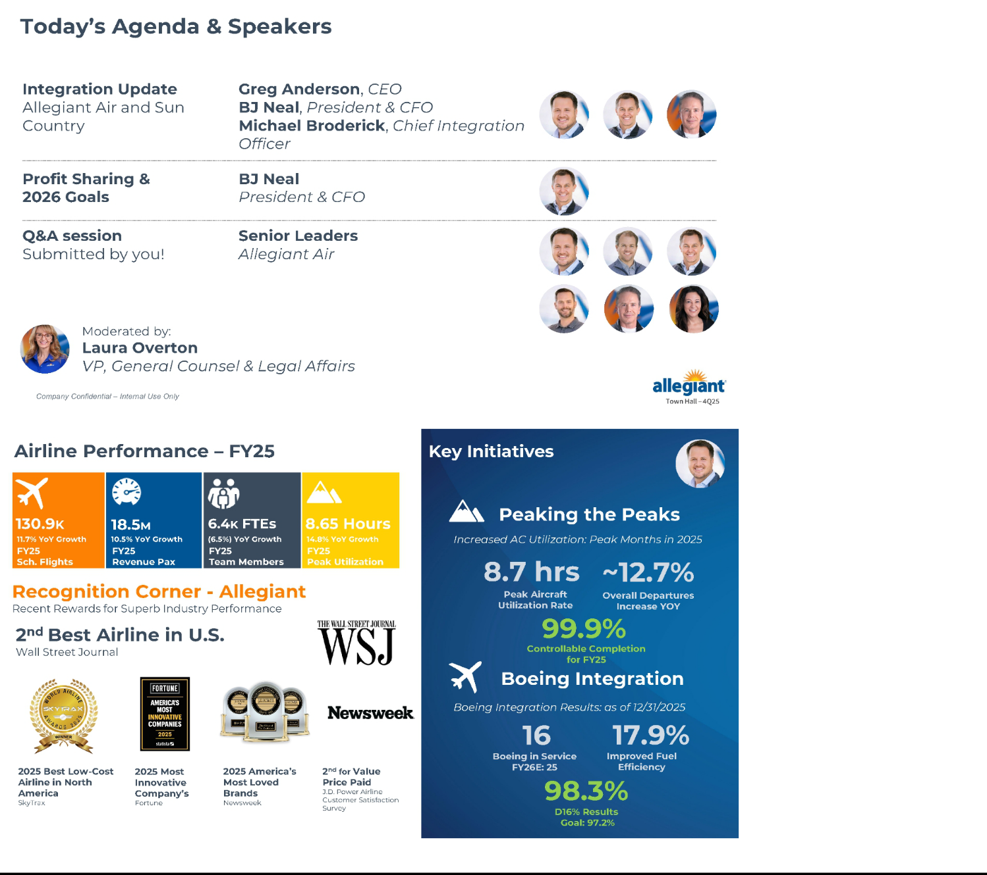

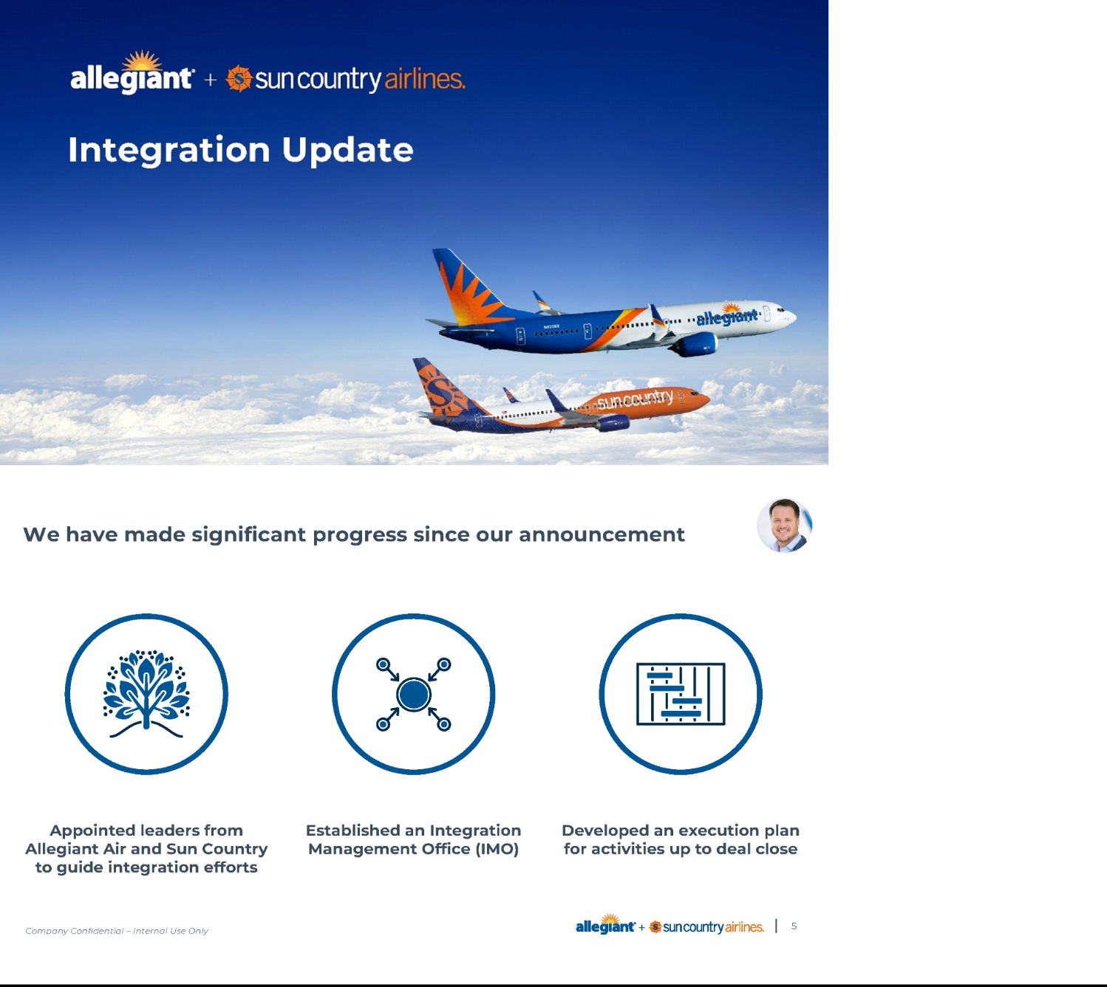

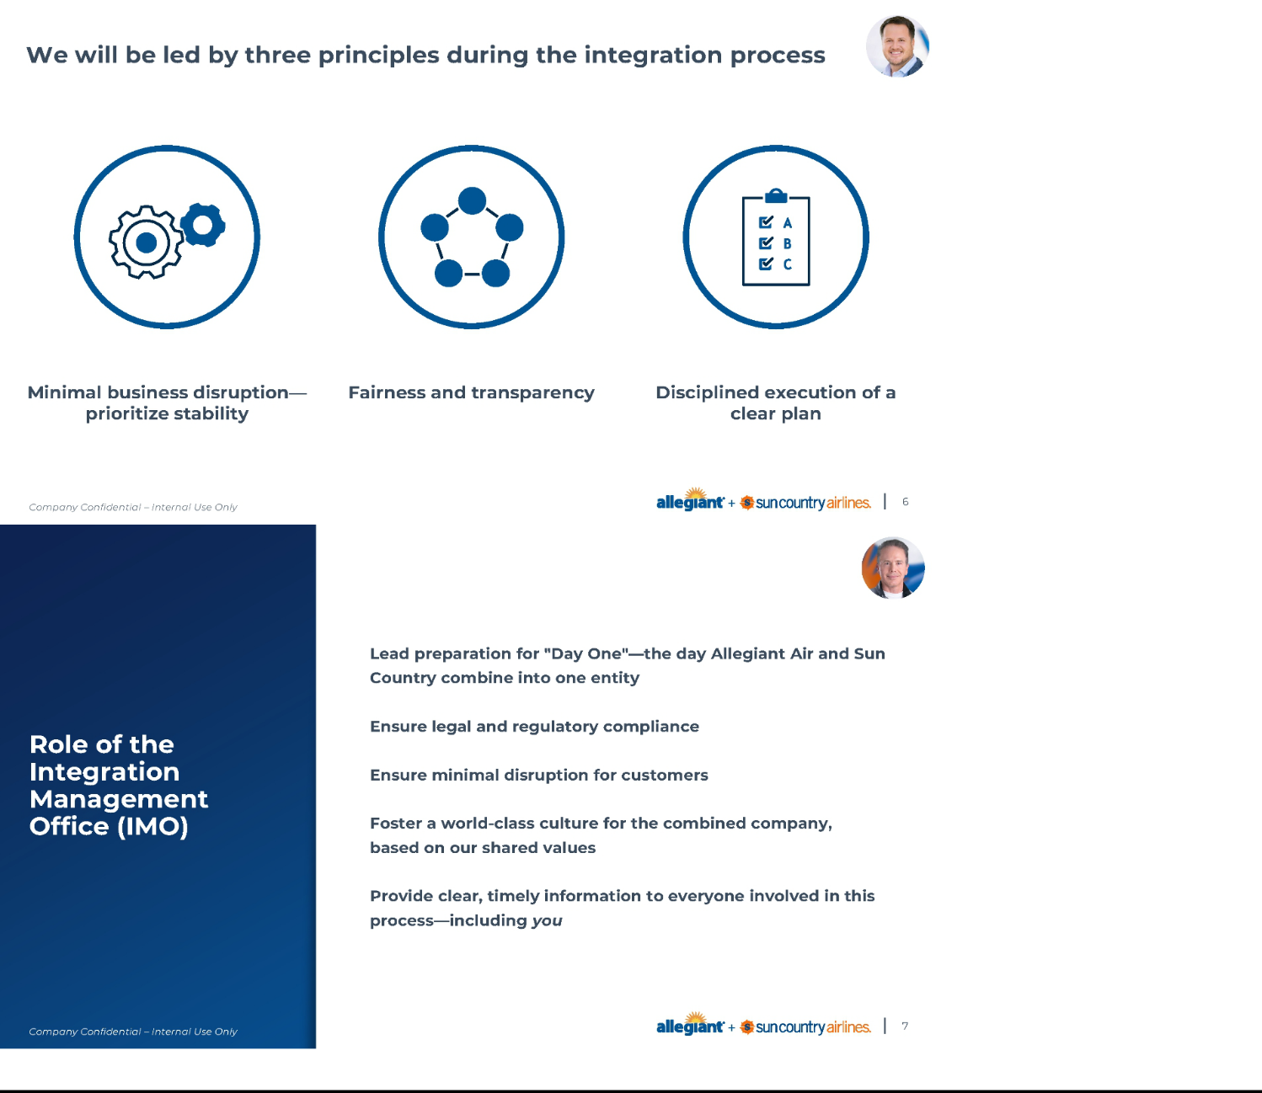

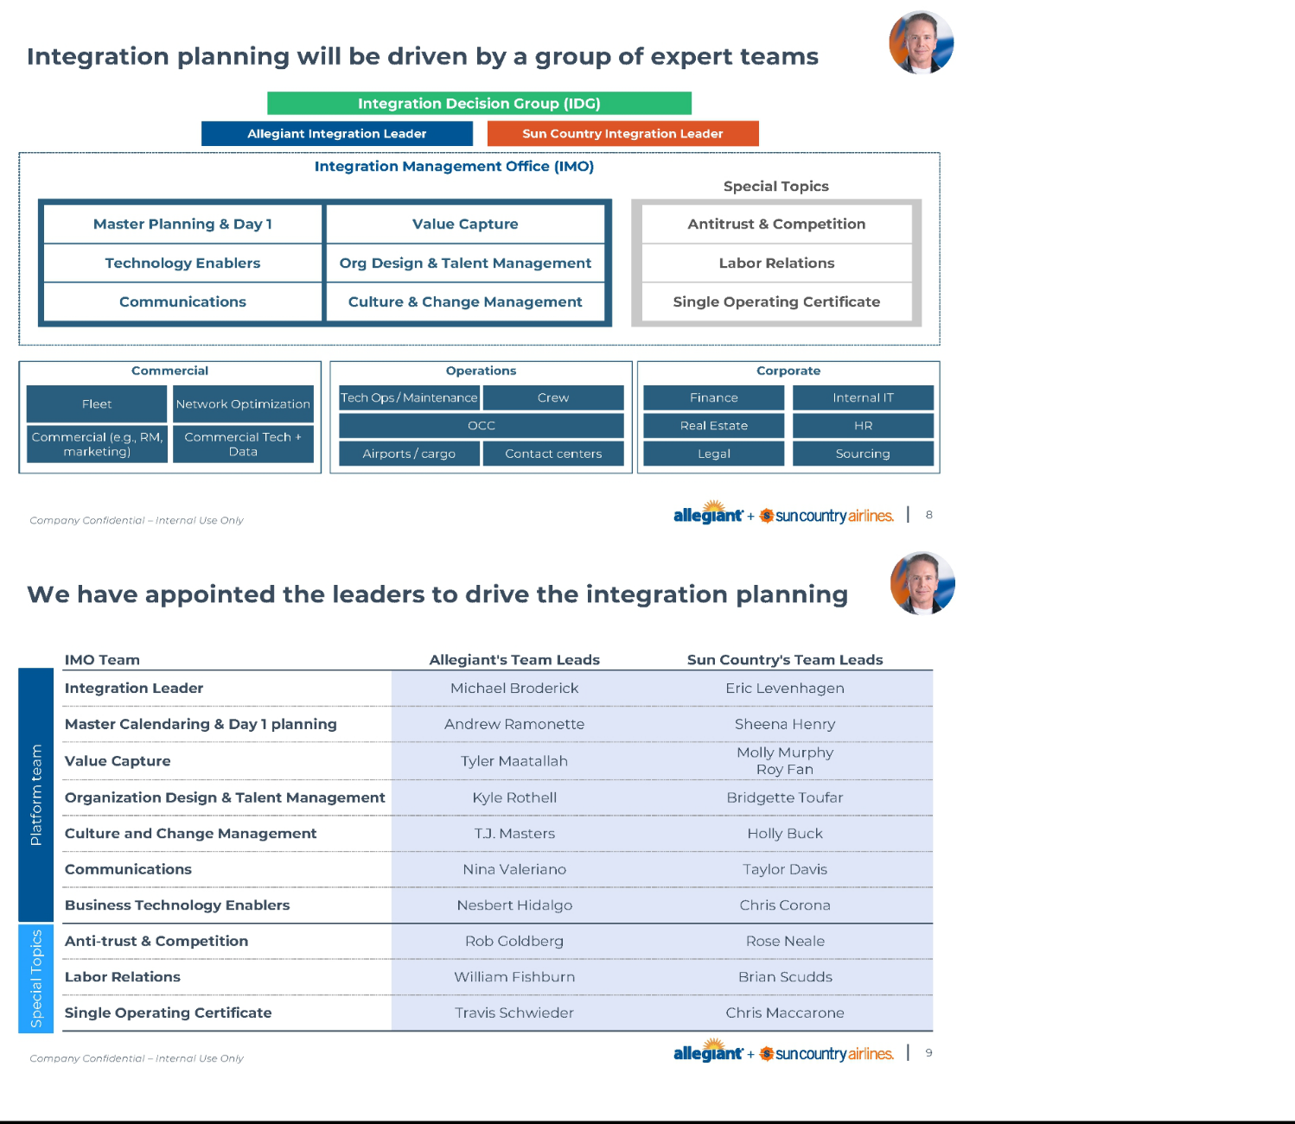

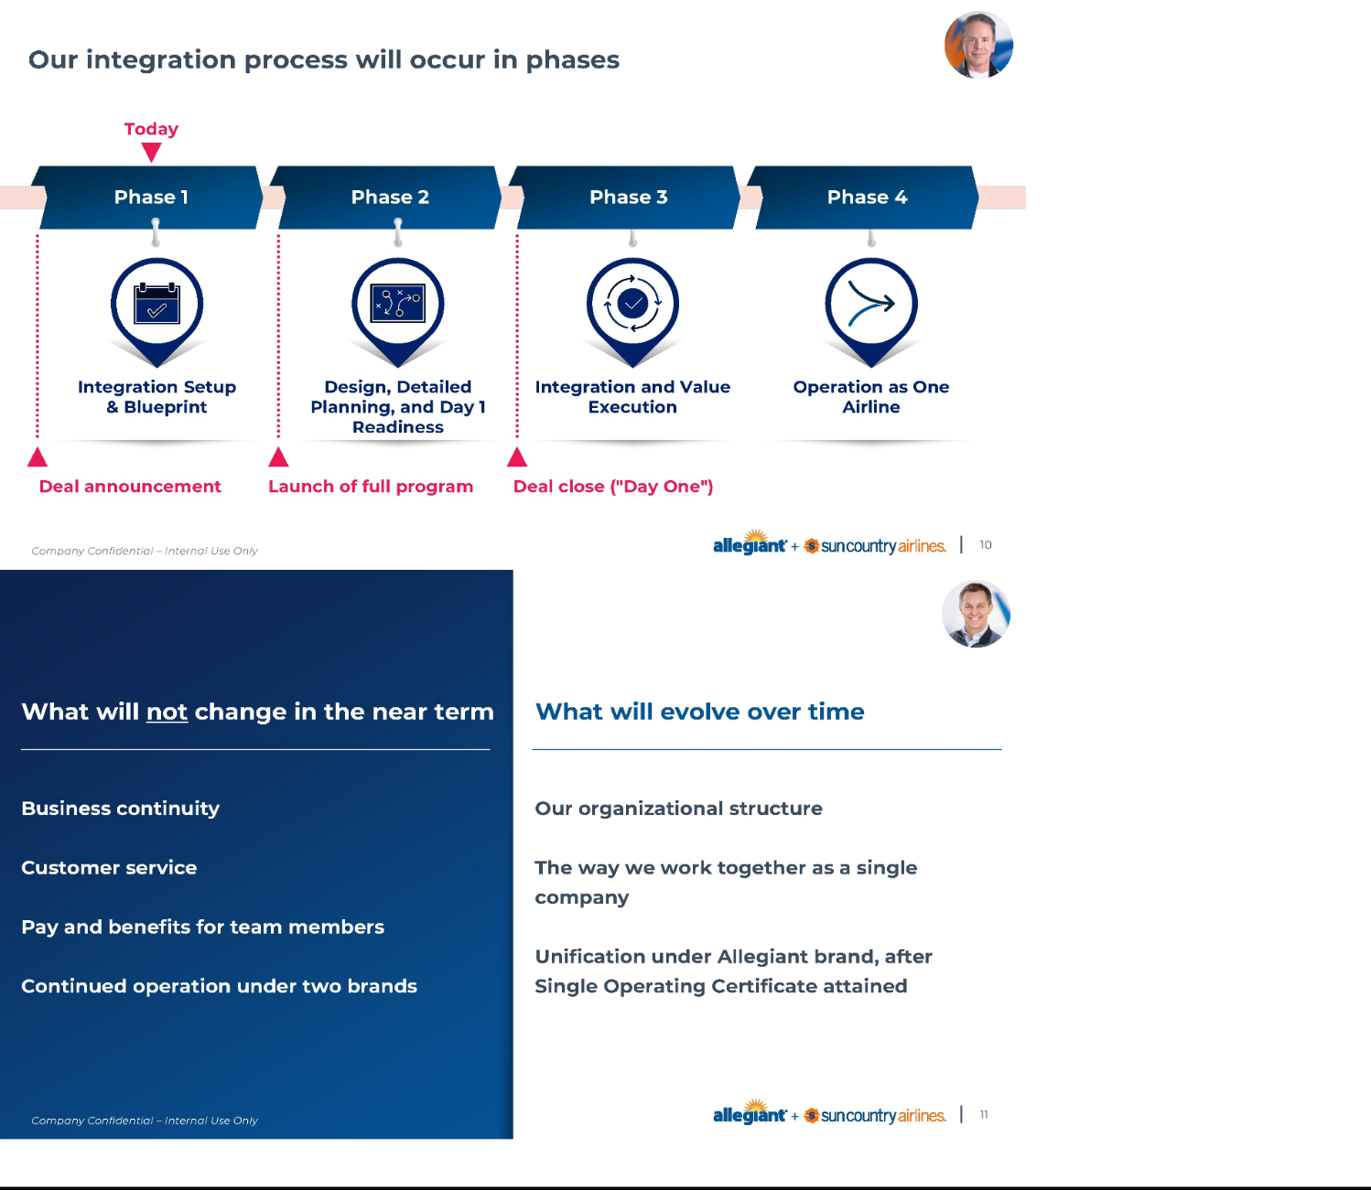

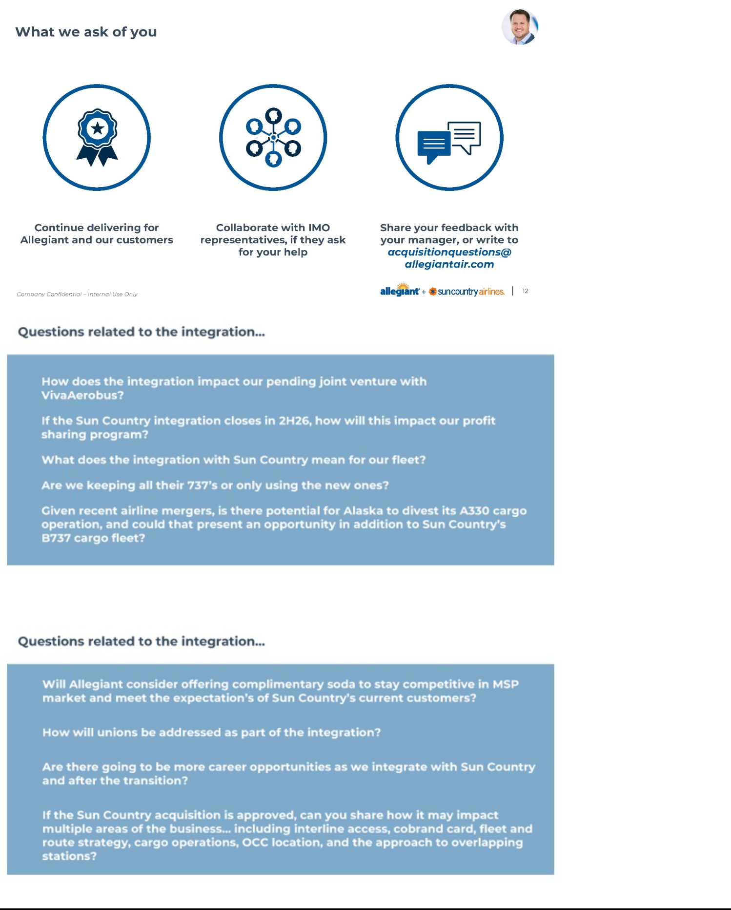

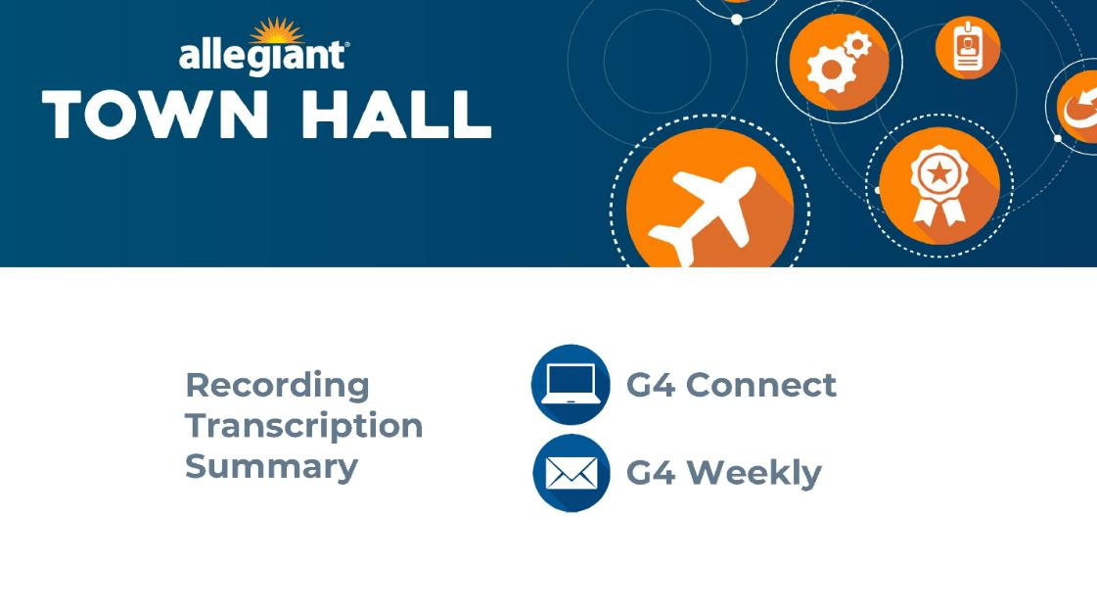

Cautionary Statement Regarding Forward-Looking Statements

This communication contains forward-looking statements under the safe harbor provisions of Section 21E of the Securities Exchange Act of 1934, Section 27A of the Securities Act of 1933 and the Private Securities Litigation Reform Act of 1995. Forward-looking statements include all statements that are not historical facts and often can be identified by the use of forward-looking terminology such as the words “believe,” “expect,” “guidance,” “anticipate,” “intend,” “plan,” “estimate”, “project”, “hope” or similar expressions. Forward-looking statements in this communication are based on Allegiant’s and Sun Country’s current expectations, estimates and projections about the expected date of closing of the proposed transaction and the potential benefits thereof, their respective businesses and industries, management’s beliefs and certain assumptions made by Allegiant and Sun Country, all of which are subject to change. Forward-looking statements in this communication may relate to, without limitation, the benefits of the proposed transaction, including future financial and operating results; the parties’ respective plans, objectives, expectations and intentions; the expected timing and likelihood of completion of the proposed transaction; expected synergies of the proposed transaction; the timing and result of various regulatory proceedings related to the proposed transaction; the ability to execute and finance current and long-term business, operational, capital expenditures and growth plans and strategies; the impact of increased or increasing transaction and financing costs associated with the proposed transaction or otherwise, as well as inflation and interest rates; and the ability to access debt and equity capital markets.

Forward-looking statements involve risks, uncertainties and assumptions that could cause actual results to differ materially from those expressed in any forward-looking statements. Accordingly, there are or will be important factors that could cause actual results to differ materially from those indicated in such statements and, therefore, you should not place undue reliance on any such statements and caution must be exercised in relying on forward-looking statements. Important risk factors that may cause such a difference include, but are not limited to, the following: the occurrence of any event, change or other circumstance that could give rise to the right of one or both of the parties to terminate the definitive merger agreement for the proposed transaction; the risk that potential legal proceedings may be instituted against Allegiant or Sun Country and result in significant costs of defense, indemnification or liability; the possibility that the proposed transaction does not close when expected or at all because required stockholder approvals, required regulatory approvals or other conditions to closing are not received or satisfied on a timely basis or at all (and the risk that such regulatory approvals may result in the imposition of conditions that could adversely affect the combined company or the expected benefits of the proposed transaction); the risk that the combined company will not realize expected benefits, cost savings, accretion, synergies and/or growth from the proposed transaction or that any of the foregoing may take longer to realize or be more costly to achieve than expected; disruption to the parties’ businesses as a result of the announcement and pendency of the proposed transaction; the costs associated with the anticipated length of time of the pendency of the proposed transaction, including the restrictions contained in the definitive merger agreement on the ability of each of Sun Country and Allegiant to operate their respective businesses outside the ordinary course consistent with past practice during the pendency of the proposed transaction; the diversion of Allegiant’s and Sun Country’s respective management teams’ attention and time from ongoing business operations and opportunities on acquisition-related matters; the risk that the integration of Sun Country’s operations will be materially delayed or will be more costly or difficult than expected or that Allegiant is otherwise unable to successfully integrate Sun Country’s businesses into its businesses; the possibility that the proposed transaction may be more expensive to complete than anticipated, including as a result of unexpected factors or events; reputational risk and potential adverse reactions of Allegiant’s or Sun Country’s customers, suppliers, employees, labor unions or other business partners, including those resulting from the announcement or completion of the proposed transaction; the dilution caused by Allegiant’s issuance of additional shares of its common stock in connection with the consummation of the proposed transaction; a material adverse change in the business, condition or results of operations of Allegiant or Sun Country; changes in domestic or international economic, political or business conditions, including those impacting the airline industry (including customers, employees and supply chains); Allegiant’s and Sun Country’s ability to successfully implement their respective operational, productivity and strategic initiatives; the outcome of claims, litigation, governmental proceedings and investigations involving Allegiant or Sun Country; and a cybersecurity incident or other disruption to Sun Country’s or Allegiant’s technology infrastructure.

Forward-looking statements in this communication are qualified by and should be read together with, the risk factors set forth above and the risk factors included in Allegiant’s and Sun Country’s respective annual and quarterly reports as filed with the Securities and Exchange Commission (the “SEC”), and readers should refer to such risks, uncertainties and risk factors in evaluating such forward-looking statements. In addition, the risk factors discussed above are not exhaustive and they, along with other risk factors, will be more fully discussed in the registration statement and joint proxy statement/prospectus to be filed with the SEC in connection with the proposed transaction.

The forward-looking statements in this communication are made only as of the date they were first issued, and unless otherwise required by applicable securities laws, Allegiant and Sun Country disclaim any intention or obligation to update or revise any forward-looking statements, whether as a result of new information, future events, or otherwise.

Important Additional Information and Where to Find It

In connection with the proposed transaction, Allegiant intends to file with the SEC a registration statement on Form S-4 (the “Registration Statement”), which will include a prospectus with respect to the shares of Allegiant’s common stock to be issued in the proposed transaction and a joint proxy statement for Allegiant’s and Sun Country’s respective stockholders (the “Joint Proxy Statement/Prospectus”). The definitive joint proxy statement (if and when available) will be mailed to stockholders of Allegiant and Sun Country. Each of Allegiant and Sun Country may also file with or furnish to the SEC other relevant documents regarding the proposed transaction. This communication is not a substitute for the Registration Statement, the Joint Proxy Statement/Prospectus or any other document that Allegiant or Sun Country may file with the SEC or send to their respective stockholders in connection with the proposed transaction. INVESTORS AND SECURITY HOLDERS OF ALLEGIANT AND SUN COUNTRY ARE URGED TO READ THE

REGISTRATION STATEMENT AND THE JOINT PROXY STATEMENT/PROSPECTUS INCLUDED WITHIN THE REGISTRATION WHEN THEY BECOME AVAILABLE, AS WELL AS ANY OTHER RELEVANT DOCUMENTS FILED WITH THE SEC IN CONNECTION WITH THE PROPOSED TRANSACTION OR INCORPORATED BY REFERENCE INTO THE REGISTRATION STATEMENT AND THE JOINT PROXY STATEMENT/PROSPECTUS (INCLUDING ANY AMENDMENTS OR SUPPLEMENTS THERETO), BECAUSE THEY WILL CONTAIN IMPORTANT INFORMATION REGARDING ALLEGIANT, SUN COUNTRY, THE PROPOSED TRANSACTION AND RELATED MATTERS. Investors and security holders of Allegiant and Sun Country may obtain free copies of these documents and other documents filed with the SEC by Allegiant or Sun Country through the website maintained by the SEC at http://www.sec.gov or from Allegiant at its website, https://ir.allegiantair.com/financials/sec-filings/default.aspx, or from Sun Country at its website, https://ir.suncountry.com/financials/sec-filings. Documents filed with the SEC by Allegiant will be available free of charge by accessing Allegiant’s website at https://ir.allegiantair.com/financials/sec-filings/default.aspx, or alternatively by directing a request by mail to Allegiant’s Investor Relations department, 1201 North Town Center Drive, Las Vegas, NV 89144, and documents filed with the SEC by Sun Country will be available free of charge by accessing Sun Country’s website at https://ir.suncountry.com/financials/sec-filings, or alternatively by directing a request by mail to Sun Country’s Investor Relations department, 2005 Cargo Road, Minneapolis, MN 55450.

Participants In The Solicitation

Allegiant, Sun Country and certain of their respective directors and executive officers may be deemed to be participants in the solicitation of proxies from the stockholders of Allegiant and Sun Country in connection with the proposed transaction under the rules of the SEC.

Information about the interests of the directors and executive officers of Allegiant and Sun Country and other persons who may be deemed to be participants in the solicitation of stockholders of Allegiant and Sun Country in connection with the proposed transaction and a description of their direct and indirect interests, by security holdings or otherwise, will be included in the Joint Proxy Statement/Prospectus, which will be filed with the SEC.

Information about the directors and executive officers of Allegiant, their ownership of Allegiant common stock and Allegiant’s transactions with related persons can also be found in the Allegiant Annual Report and Allegiant’s definitive proxy statement in connection with its 2025 annual meeting of stockholders, as filed with the SEC on Schedule 14A on April 30, 2025 (the “Allegiant 2025 Proxy Statement”), and other documents subsequently filed by Allegiant with the SEC, which are available on its website, https://ir.allegiantair.com/financials/sec-filings/default.aspx. Such information is set forth in the sections entitled “Proposal No. 1 – Election of Directors”, “Proposal No. 2 – Advisory (non-binding) Vote on Executive Compensation”, “Proposal No. 3 – Approval of Amendment to Allegiant 2022 Long-Term Incentive Plan to Increase Number of Shares Available”, “Executive Compensation” and “Related Party Transactions” of the Allegiant 2025 Proxy Statement. To the extent holdings of Allegiant common stock by the directors and executive officers of Allegiant have changed from the amounts of Allegiant common stock held by such persons as reflected therein, such changes have been or will be reflected on Statements of Change in Ownership on Form 4 filed with the SEC, which are available at https://www.sec.gov/edgar/browse/? CIK=1362468&owner=exclude under the tab “Ownership Disclosures”.

Information about the directors and executive officers of Sun Country, their ownership of Sun Country common stock and Sun Country’s transactions with related persons can also be found in the definitive proxy statement for Sun Country’s 2025 annual meeting of stockholders, as filed with the SEC on Schedule 14A on April 25, 2025 (which is available at https://ir.suncountry.com/financials/sec-filings), and other documents subsequently filed by Sun Country with the SEC. Such information is set forth in the sections entitled “Proposal 1– Reelection of Directors”, “Proposal 2 – Non-binding (Advisory) Vote to Approve the Compensation of Our Named Executive Officers”, “Executive Compensation”, “Certain Relationships and Related Person Transactions” and “Security Ownership of Certain Beneficial Owners and Management” of such definitive proxy statement. Please also refer to Sun Country’s subsequent Current Reports, as filed with the SEC on Form 8-K on September 22, 2025 (which is available at https://ir.suncountry.com/financials/sec-filings) and on October 30, 2025, regarding subsequent changes to Sun Country’s Board of Directors and executive management following the filing of such definitive proxy statement. To the extent holdings of Sun Country common stock by the directors and executive officers of Sun Country have changed from the amounts of Sun Country common stock held by such persons as reflected in the definitive proxy statement, such changes have been or will be reflected on Statements of Change in Ownership on Form 4 filed with the SEC, which are available at https://www.sec.gov/edgar/browse/?CIK=1743907&owner=exclude under the tab “Ownership Disclosures”.

Free copies of these documents may be obtained as described above.

No Offer or Solicitation

This communication is for informational purposes only and does not constitute, or form a part of, an offer to sell, an offer to buy, or the solicitation of an offer to sell or the solicitation of an offer to buy any securities, and there shall be no sale of securities, in any jurisdiction in which such offer, solicitation or sale would be unlawful prior to registration or qualification under the securities laws of any such jurisdiction. No offer of securities shall be made except by means of a prospectus meeting the requirements of Section 10 of the Securities Act of 1933, as amended, and otherwise in accordance with applicable law.

