UNITED STATES
SECURITIES AND EXCHANGE COMMISSION
Washington, D.C. 20549

SCHEDULE 14A
Proxy Statement Pursuant to Section 14(a) of
the Securities Exchange Act of 1934

Filed by the Registrant ☒
Filed by a Party other than the Registrant ☐
Check the appropriate box:

☐ | Preliminary Proxy Statement

☐ | Confidential, for Use of the Commission Only (as permitted by Rule 14a-6(e)(2))

☐ | Definitive Proxy Statement

☒ | Definitive Additional Materials

☐ | Soliciting Material Pursuant to Section 240.14a-12
SUN COUNTRY AIRLINES HOLDINGS, INC.
(Name of Registrant as Specified in its Charter)
(Name of Person(s) Filing Proxy Statement if other than the Registrant)
Payment of Filing Fee (Check the appropriate box):

☒ | No fee required.

☐ | Fee paid previously with preliminary materials.

☐ | Fee computed on table in exhibit required by Item 25(b) per Exchange Act Rules 14a6(i)(1) and 0-11.


Your Vote Counts! SUN COUNTRY AIRLINES HOLDINGS, INC. 2024 Annual Meeting Vote by June 11, 2024 11:59 PM ET SUN COUNTRY AIRLINES HOLDINGS, INC. 2005 CARGO ROAD MINNEAPOLIS, MN 55450 V50581-P05294 You invested in SUN COUNTRY AIRLINES HOLDINGS, INC. and its time to vote! You have the right to vote on proposals being presented at the Annual Meeting. This is an important notice regarding the availability of proxy materials for the stockholder meeting to be held on June 12, 2024. Get informed before you vote View the Annual Report and Notice & Proxy Statement online OR you can receive a free paper or email copy of the material(s) by requesting prior to May 29, 2024. If you would like to request a copy of the material(s) for this and/or future stockholder meetings, you may (1) visit www.ProxyVote.com, (2) call 1-800-579-1639 or (3) send an email to sendmaterial@proxyvote.com. If sending an email, please include your control number (indicated below) in the subject line. Unless requested, you will not otherwise receive a paper or email copy. For complete information and to vote, visit www.ProxyVote.com Control # Smartphone users Vote Virtually at the Meeting* Point your camera here and June 12, 2024 9:00 AM CDT vote without entering a control number Virtually at: www.virtualshareholdermeeting.com/SNCY2024 *Please check the meeting materials for any special requirements for meeting attendance.

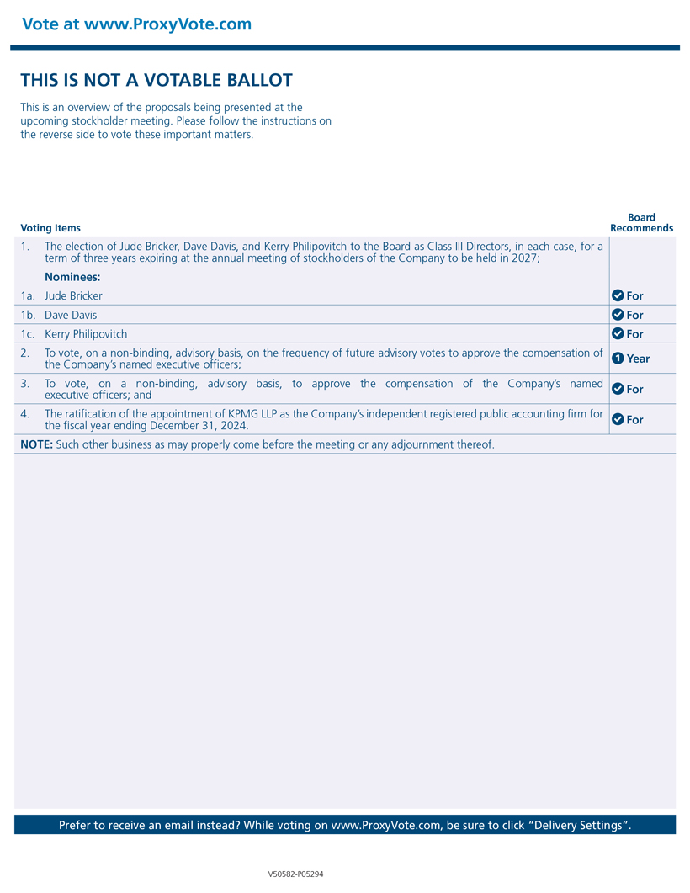
Vote at www.ProxyVote.com THIS IS NOT A VOTABLE BALLOT This is an overview of the proposals being presented at the upcoming stockholder meeting. Please follow the instructions on the reverse side to vote these important matters. Board Voting Items Recommends 1. The election of Jude Bricker, Dave Davis, and Kerry Philipovitch to the Board as Class III Directors, in each case, for a term of three years expiring at the annual meeting of stockholders of the Company to be held in 2027; Nominees: 1a. Jude Bricker For 1b. Dave Davis For 1c. Kerry Philipovitch For 2. To vote, on a non-binding, advisory basis, on the frequency of future advisory votes to approve the compensation of 1 Year the Companys named executive officers; 3. To vote, on a non-binding, advisory basis, to approve the compensation of the Companys named For executive officers; and 4. The ratification of the appointment of KPMG LLP as the Companys independent registered public accounting firm for For the fiscal year ending December 31, 2024. NOTE: Such other business as may properly come before the meeting or any adjournment thereof. Prefer to receive an email instead? While voting on www.ProxyVote.com, be sure to click Delivery Settings. V50582-P05294

