FILED BY ALLEGIANT TRAVEL COMPANY
PURSUANT TO RULE 425 UNDER THE SECURITIES ACT OF 1933
AND DEEMED FILED PURSUANT TO RULE 14a-12
UNDER THE SECURITIES EXCHANGE ACT OF 1934

SUBJECT COMPANY: SUN COUNTRY AIRLINES HOLDINGS, INC.
COMMISSION FILE NO. 001-40217

The following is a transcript of a joint investor presentation held by Greg Anderson, CEO of Allegiant Travel Company (“Allegiant”), Robert Neal, President & CFO of Allegiant and Jude Bricker, CEO of Sun Country Airlines Holdings, Inc. (“Sun Country”) on January 12, 2026 at 8:30 a.m. ET regarding the acquisition of Sun Country by Allegiant:

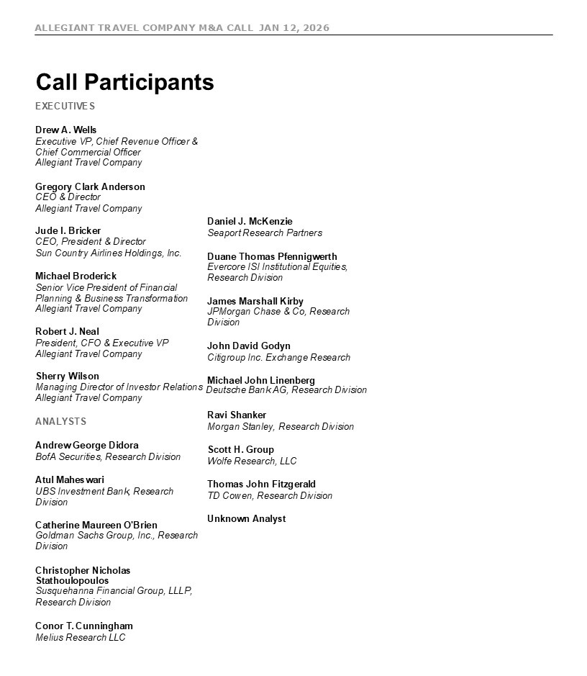
ALLEGIANT TRAVEL COMPANY M&A CALL JAN 12, 2026 3 Call Participants EXECUTIVES Drew A. Wells Executive VP, Chief Revenue Officer & Chief Commercial Officer Allegiant Travel Company Gregory Clark Anderson CEO & Director Allegiant Travel Company Jude I. Bricker CEO, President & Director Sun Country Airlines Holdings, Inc. Michael Broderick Senior Vice President of Financial Planning & Business Transformation Allegiant Travel Company Robert J. Neal President, CFO & Executive VP Allegiant Travel Company Sherry Wilson Allegiant Travel Company ANALYSTS Andrew George Didora BofA Securities, Research Division Atul Maheswari UBS Investment Bank, Research Division Catherine Maureen O'Brien Goldman Sachs Group, Inc., Research Division Christopher Nicholas Stathoulopoulos Susquehanna Financial Group, LLLP, Research Division Conor T. Cunningham Melius Research LLC Daniel J. McKenzie Seaport Research Partners Duane Thomas Pfennigwerth Evercore ISI Institutional Equities, Research Division James Marshall Kirby JPMorgan Chase & Co, Research Division John David Godyn Citigroup Inc. Exchange Research Michael John Linenberg Managing Director of Investor Relations Deutsche Bank AG, Research Division Ravi Shanker Morgan Stanley, Research Division Scott H. Group Wolfe Research, LLC Thomas John Fitzgerald TD Cowen, Research Division Unknown Analyst

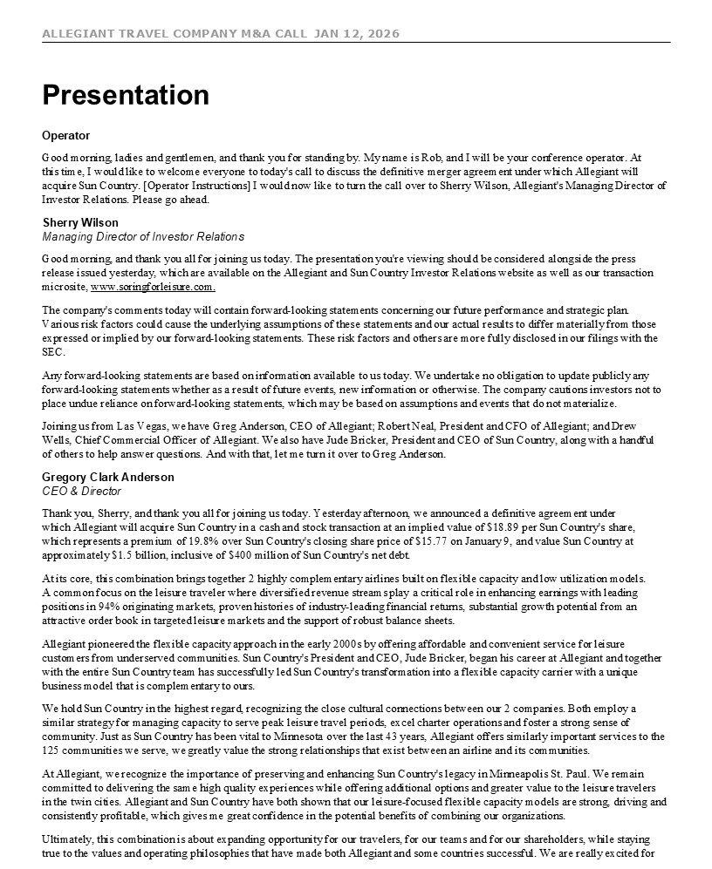
ALLEGIANT TRAVEL COMPANY M&A CALL JAN 12, 2026 4 Presentation Operator Good morning, ladies and gentlemen, and thank you for standing by. My name is Rob, and I will be your conference operator. At this time, I would like to welcome everyone to today's call to discuss the definitive merger agreement under which Allegiant will acquire Sun Country. [Operator Instructions] I would now like to turn the call over to Sherry Wilson, Allegiant's Managing Director of Investor Relations. Please go ahead. Sherry Wilson Managing Director of Investor Relations Good morning, and thank you all for joining us today. The presentation you're viewing should be considered alongside the press release issued yesterday, which are available on the Allegiant and Sun Country Investor Relations website as well as our transaction microsite, www.soringforleisure.com. The company's comments today will contain forward-looking statements concerning our future performance and strategic plan. Various risk factors could cause the underlying assumptions of these statements and our actual results to differ materially from those expressed or implied by our forward-looking statements. These risk factors and others are more fully disclosed in our filings with the SEC. Any forward-looking statements are based on information available to us today. We undertake no obligation to update publicly any forward-looking statements whether as a result of future events, new information or otherwise. The company cautions investors not to place undue reliance on forward-looking statements, which may be based on assumptions and events that do not materialize. Joining us from Las Vegas, we have Greg Anderson, CEO of Allegiant; Robert Neal, President and CFO of Allegiant; and Drew Wells, Chief Commercial Officer of Allegiant. We also have Jude Bricker, President and CEO of Sun Country, along with a handful of others to help answer questions. And with that, let me turn it over to Greg Anderson. Gregory Clark Anderson CEO & Director Thank you, Sherry, and thank you all for joining us today. Yesterday afternoon, we announced a definitive agreement under which Allegiant will acquire Sun Country in a cash and stock transaction at an implied value of $18.89 per Sun Country's share, which represents a premium of 19.8% over Sun Country's closing share price of $15.77 on January 9, and value Sun Country at approximately $1.5 billion, inclusive of $400 million of Sun Country's net debt. At its core, this combination brings together 2 highly complementary airlines built on flexible capacity and low utilization models. A common focus on the leisure traveler where diversified revenue streams play a critical role in enhancing earnings with leading positions in 94% originating markets, proven histories of industry-leading financial returns, substantial growth potential from an attractive order book in targeted leisure markets and the support of robust balance sheets. Allegiant pioneered the flexible capacity approach in the early 2000s by offering affordable and convenient service for leisure customers from underserved communities. Sun Country's President and CEO, Jude Bricker, began his career at Allegiant and together with the entire Sun Country team has successfully led Sun Country's transformation into a flexible capacity carrier with a unique business model that is complementary to ours. We hold Sun Country in the highest regard, recognizing the close cultural connections between our 2 companies. Both employ a similar strategy for managing capacity to serve peak leisure travel periods, excel charter operations and foster a strong sense of community. Just as Sun Country has been vital to Minnesota over the last 43 years, Allegiant offers similarly important services to the 125 communities we serve, we greatly value the strong relationships that exist between an airline and its communities. At Allegiant, we recognize the importance of preserving and enhancing Sun Country's legacy in Minneapolis St. Paul. We remain committed to delivering the same high quality experiences while offering additional options and greater value to the leisure travelers in the twin cities. Allegiant and Sun Country have both shown that our leisure-focused flexible capacity models are strong, driving and consistently profitable, which gives me great confidence in the potential benefits of combining our organizations. Ultimately, this combination is about expanding opportunity for our travelers, for our teams and for our shareholders, while staying true to the values and operating philosophies that have made both Allegiant and some countries successful. We are really excited for

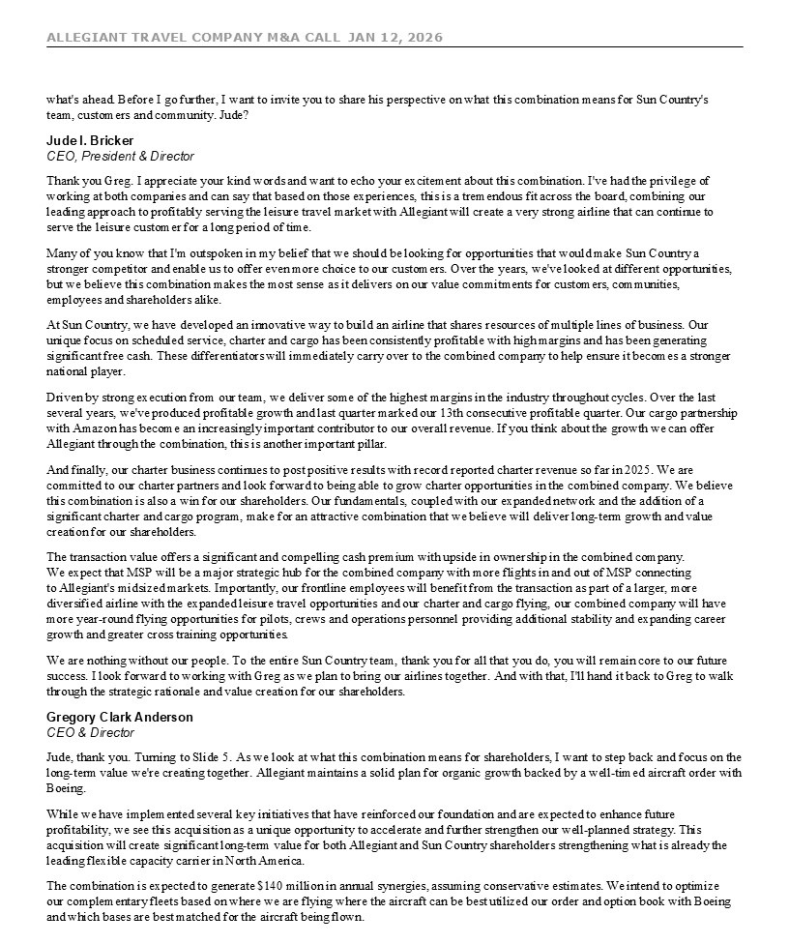
ALLEGIANT TRAVEL COMPANY M&A CALL JAN 12, 2026 5 what's ahead. Before I go further, I want to invite you to share his perspective on what this combination means for Sun Country's team, customers and community. Jude? Jude I. Bricker CEO, President & Director Thank you Greg. I appreciate your kind words and want to echo your excitement about this combination. I've had the privilege of working at both companies and can say that based on those experiences, this is a tremendous fit across the board, combining our leading approach to profitably serving the leisure travel market with Allegiant will create a very strong airline that can continue to serve the leisure customer for a long period of time. Many of you know that I'm outspoken in my belief that we should be looking for opportunities that would make Sun Country a stronger competitor and enable us to offer even more choice to our customers. Over the years, we've looked at different opportunities, but we believe this combination makes the most sense as it delivers on our value commitments for customers, communities, employees and shareholders alike. At Sun Country, we have developed an innovative way to build an airline that shares resources of multiple lines of business. Our unique focus on scheduled service, charter and cargo has been consistently profitable with high margins and has been generating significant free cash. These differentiators will immediately carry over to the combined company to help ensure it becomes a stronger national player. Driven by strong execution from our team, we deliver some of the highest margins in the industry throughout cycles. Over the last several years, we've produced profitable growth and last quarter marked our 13th consecutive profitable quarter. Our cargo partnership with Amazon has become an increasingly important contributor to our overall revenue. If you think about the growth we can offer Allegiant through the combination, this is another important pillar. And finally, our charter business continues to post positive results with record reported charter revenue so far in 2025. We are committed to our charter partners and look forward to being able to grow charter opportunities in the combined company. We believe this combination is also a win for our shareholders. Our fundamentals, coupled with our expanded network and the addition of a significant charter and cargo program, make for an attractive combination that we believe will deliver long-term growth and value creation for our shareholders. The transaction value offers a significant and compelling cash premium with upside in ownership in the combined company. We expect that MSP will be a major strategic hub for the combined company with more flights in and out of MSP connecting to Allegiant's midsized markets. Importantly, our frontline employees will benefit from the transaction as part of a larger, more diversified airline with the expanded leisure travel opportunities and our charter and cargo flying, our combined company will have more year-round flying opportunities for pilots, crews and operations personnel providing additional stability and expanding career growth and greater cross training opportunities. We are nothing without our people. To the entire Sun Country team, thank you for all that you do, you will remain core to our future success. I look forward to working with Greg as we plan to bring our airlines together. And with that, I'll hand it back to Greg to walk through the strategic rationale and value creation for our shareholders. Gregory Clark Anderson CEO & Director Jude, thank you. Turning to Slide 5. As we look at what this combination means for shareholders, I want to step back and focus on the long-term value we're creating together. Allegiant maintains a solid plan for organic growth backed by a well-timed aircraft order with Boeing. While we have implemented several key initiatives that have reinforced our foundation and are expected to enhance future profitability, we see this acquisition as a unique opportunity to accelerate and further strengthen our well-planned strategy. This acquisition will create significant long-term value for both Allegiant and Sun Country shareholders strengthening what is already the leading flexible capacity carrier in North America. The combination is expected to generate $140 million in annual synergies, assuming conservative estimates. We intend to optimize our complementary fleets based on where we are flying where the aircraft can be best utilized our order and option book with Boeing and which bases are best matched for the aircraft being flown.

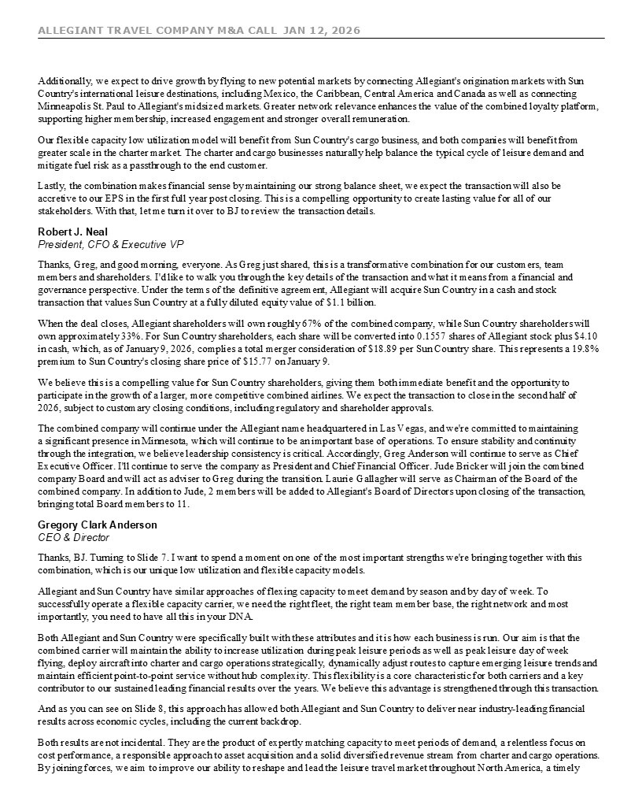
ALLEGIANT TRAVEL COMPANY M&A CALL JAN 12, 2026 6 Additionally, we expect to drive growth by flying to new potential markets by connecting Allegiant's origination markets with Sun Country's international leisure destinations, including Mexico, the Caribbean, Central America and Canada as well as connecting Minneapolis St. Paul to Allegiant's midsized markets. Greater network relevance enhances the value of the combined loyalty platform, supporting higher membership, increased engagement and stronger overall remuneration. Our flexible capacity low utilization model will benefit from Sun Country's cargo business, and both companies will benefit from greater scale in the charter market. The charter and cargo businesses naturally help balance the typical cycle of leisure demand and mitigate fuel risk as a passthrough to the end customer. Lastly, the combination makes financial sense by maintaining our strong balance sheet, we expect the transaction will also be accretive to our EPS in the first full year post closing. This is a compelling opportunity to create lasting value for all of our stakeholders. With that, let me turn it over to BJ to review the transaction details. Robert J. Neal President, CFO & Executive VP Thanks, Greg, and good morning, everyone. As Greg just shared, this is a transformative combination for our customers, team members and shareholders. I'd like to walk you through the key details of the transaction and what it means from a financial and governance perspective. Under the terms of the definitive agreement, Allegiant will acquire Sun Country in a cash and stock transaction that values Sun Country at a fully diluted equity value of $1.1 billion. When the deal closes, Allegiant shareholders will own roughly 67% of the combined company, while Sun Country shareholders will own approximately 33%. For Sun Country shareholders, each share will be converted into 0.1557 shares of Allegiant stock plus $4.10 in cash, which, as of January 9, 2026, complies a total merger consideration of $18.89 per Sun Country share. This represents a 19.8% premium to Sun Country's closing share price of $15.77 on January 9. We believe this is a compelling value for Sun Country shareholders, giving them both immediate benefit and the opportunity to participate in the growth of a larger, more competitive combined airlines. We expect the transaction to close in the second half of 2026, subject to customary closing conditions, including regulatory and shareholder approvals. The combined company will continue under the Allegiant name headquartered in Las Vegas, and we're committed to maintaining a significant presence in Minnesota, which will continue to be an important base of operations. To ensure stability and continuity through the integration, we believe leadership consistency is critical. Accordingly, Greg Anderson will continue to serve as Chief Executive Officer. I'll continue to serve the company as President and Chief Financial Officer. Jude Bricker will join the combined company Board and will act as adviser to Greg during the transition. Laurie Gallagher will serve as Chairman of the Board of the combined company. In addition to Jude, 2 members will be added to Allegiant's Board of Directors upon closing of the transaction, bringing total Board members to 11. Gregory Clark Anderson CEO & Director Thanks, BJ. Turning to Slide 7. I want to spend a moment on one of the most important strengths we're bringing together with this combination, which is our unique low utilization and flexible capacity models. Allegiant and Sun Country have similar approaches of flexing capacity to meet demand by season and by day of week. To successfully operate a flexible capacity carrier, we need the right fleet, the right team member base, the right network and most importantly, you need to have all this in your DNA. Both Allegiant and Sun Country were specifically built with these attributes and it is how each business is run. Our aim is that the combined carrier will maintain the ability to increase utilization during peak leisure periods as well as peak leisure day of week flying, deploy aircraft into charter and cargo operations strategically, dynamically adjust routes to capture emerging leisure trends and maintain efficient point-to-point service without hub complexity. This flexibility is a core characteristic for both carriers and a key contributor to our sustained leading financial results over the years. We believe this advantage is strengthened through this transaction. And as you can see on Slide 8, this approach has allowed both Allegiant and Sun Country to deliver near industry-leading financial results across economic cycles, including the current backdrop. Both results are not incidental. They are the product of expertly matching capacity to meet periods of demand, a relentless focus on cost performance, a responsible approach to asset acquisition and a solid diversified revenue stream from charter and cargo operations. By joining forces, we aim to improve our ability to reshape and lead the leisure travel market throughout North America, a timely

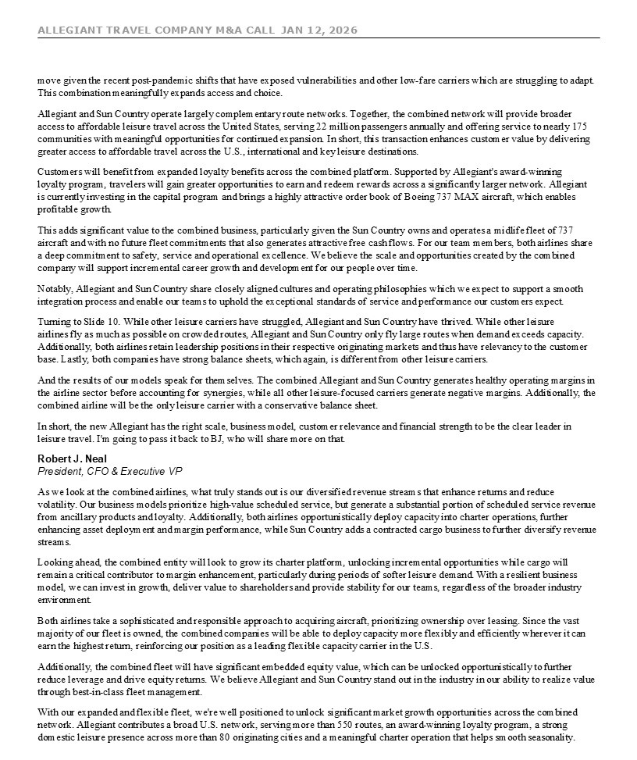
ALLEGIANT TRAVEL COMPANY M&A CALL JAN 12, 2026 7 move given the recent post-pandemic shifts that have exposed vulnerabilities and other low-fare carriers which are struggling to adapt. This combination meaningfully expands access and choice. Allegiant and Sun Country operate largely complementary route networks. Together, the combined network will provide broader access to affordable leisure travel across the United States, serving 22 million passengers annually and offering service to nearly 175 communities with meaningful opportunities for continued expansion. In short, this transaction enhances customer value by delivering greater access to affordable travel across the U.S., international and key leisure destinations. Customers will benefit from expanded loyalty benefits across the combined platform. Supported by Allegiant's award-winning loyalty program, travelers will gain greater opportunities to earn and redeem rewards across a significantly larger network. Allegiant is currently investing in the capital program and brings a highly attractive order book of Boeing 737 MAX aircraft, which enables profitable growth. This adds significant value to the combined business, particularly given the Sun Country owns and operates a midlife fleet of 737 aircraft and with no future fleet commitments that also generates attractive free cash flows. For our team members, both airlines share a deep commitment to safety, service and operational excellence. We believe the scale and opportunities created by the combined company will support incremental career growth and development for our people over time. Notably, Allegiant and Sun Country share closely aligned cultures and operating philosophies which we expect to support a smooth integration process and enable our teams to uphold the exceptional standards of service and performance our customers expect. Turning to Slide 10. While other leisure carriers have struggled, Allegiant and Sun Country have thrived. While other leisure airlines fly as much as possible on crowded routes, Allegiant and Sun Country only fly large routes when demand exceeds capacity. Additionally, both airlines retain leadership positions in their respective originating markets and thus have relevancy to the customer base. Lastly, both companies have strong balance sheets, which again, is different from other leisure carriers. And the results of our models speak for themselves. The combined Allegiant and Sun Country generates healthy operating margins in the airline sector before accounting for synergies, while all other leisure-focused carriers generate negative margins. Additionally, the combined airline will be the only leisure carrier with a conservative balance sheet. In short, the new Allegiant has the right scale, business model, customer relevance and financial strength to be the clear leader in leisure travel. I'm going to pass it back to BJ, who will share more on that. Robert J. Neal President, CFO & Executive VP As we look at the combined airlines, what truly stands out is our diversified revenue streams that enhance returns and reduce volatility. Our business models prioritize high-value scheduled service, but generate a substantial portion of scheduled service revenue from ancillary products and loyalty. Additionally, both airlines opportunistically deploy capacity into charter operations, further enhancing asset deployment and margin performance, while Sun Country adds a contracted cargo business to further diversify revenue streams. Looking ahead, the combined entity will look to grow its charter platform, unlocking incremental opportunities while cargo will remain a critical contributor to margin enhancement, particularly during periods of softer leisure demand. With a resilient business model, we can invest in growth, deliver value to shareholders and provide stability for our teams, regardless of the broader industry environment. Both airlines take a sophisticated and responsible approach to acquiring aircraft, prioritizing ownership over leasing. Since the vast majority of our fleet is owned, the combined companies will be able to deploy capacity more flexibly and efficiently wherever it can earn the highest return, reinforcing our position as a leading flexible capacity carrier in the U.S. Additionally, the combined fleet will have significant embedded equity value, which can be unlocked opportunistically to further reduce leverage and drive equity returns. We believe Allegiant and Sun Country stand out in the industry in our ability to realize value through best-in-class fleet management. With our expanded and flexible fleet, we're well positioned to unlock significant market growth opportunities across the combined network. Allegiant contributes a broad U.S. network, serving more than 550 routes, an award-winning loyalty program, a strong domestic leisure presence across more than 80 originating cities and a meaningful charter operation that helps smooth seasonality.

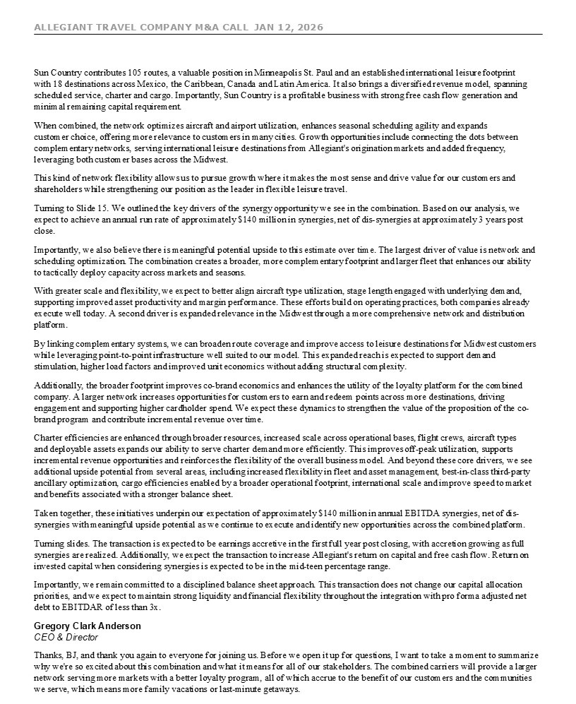
ALLEGIANT TRAVEL COMPANY M&A CALL JAN 12, 2026 8 Sun Country contributes 105 routes, a valuable position in Minneapolis St. Paul and an established international leisure footprint with 18 destinations across Mexico, the Caribbean, Canada and Latin America. It also brings a diversified revenue model, spanning scheduled service, charter and cargo. Importantly, Sun Country is a profitable business with strong free cash flow generation and minimal remaining capital requirement. When combined, the network optimizes aircraft and airport utilization, enhances seasonal scheduling agility and expands customer choice, offering more relevance to customers in many cities. Growth opportunities include connecting the dots between complementary networks, serving international leisure destinations from Allegiant's origination markets and added frequency, leveraging both customer bases across the Midwest. This kind of network flexibility allows us to pursue growth where it makes the most sense and drive value for our customers and shareholders while strengthening our position as the leader in flexible leisure travel. Turning to Slide 15. We outlined the key drivers of the synergy opportunity we see in the combination. Based on our analysis, we expect to achieve an annual run rate of approximately $140 million in synergies, net of dis-synergies at approximately 3 years post close. Importantly, we also believe there is meaningful potential upside to this estimate over time. The largest driver of value is network and scheduling optimization. The combination creates a broader, more complementary footprint and larger fleet that enhances our ability to tactically deploy capacity across markets and seasons. With greater scale and flexibility, we expect to better align aircraft type utilization, stage length engaged with underlying demand, supporting improved asset productivity and margin performance. These efforts build on operating practices, both companies already execute well today. A second driver is expanded relevance in the Midwest through a more comprehensive network and distribution platform. By linking complementary systems, we can broaden route coverage and improve access to leisure destinations for Midwest customers while leveraging point-to-point infrastructure well suited to our model. This expanded reach is expected to support demand stimulation, higher load factors and improved unit economics without adding structural complexity. Additionally, the broader footprint improves co-brand economics and enhances the utility of the loyalty platform for the combined company. A larger network increases opportunities for customers to earn and redeem points across more destinations, driving engagement and supporting higher cardholder spend. We expect these dynamics to strengthen the value of the proposition of the co-brand program and contribute incremental revenue over time. Charter efficiencies are enhanced through broader resources, increased scale across operational bases, flight crews, aircraft types and deployable assets expands our ability to serve charter demand more efficiently. This improves off-peak utilization, supports incremental revenue opportunities and reinforces the flexibility of the overall business model. And beyond these core drivers, we see additional upside potential from several areas, including increased flexibility in fleet and asset management, best-in-class third-party ancillary optimization, cargo efficiencies enabled by a broader operational footprint, international scale and improve speed to market and benefits associated with a stronger balance sheet. Taken together, these initiatives underpin our expectation of approximately $140 million in annual EBITDA synergies, net of dis-synergies with meaningful upside potential as we continue to execute and identify new opportunities across the combined platform. Turning slides. The transaction is expected to be earnings accretive in the first full year post closing, with accretion growing as full synergies are realized. Additionally, we expect the transaction to increase Allegiant's return on capital and free cash flow. Return on invested capital when considering synergies is expected to be in the mid-teen percentage range. Importantly, we remain committed to a disciplined balance sheet approach. This transaction does not change our capital allocation priorities, and we expect to maintain strong liquidity and financial flexibility throughout the integration with pro forma adjusted net debt to EBITDAR of less than 3x. Gregory Clark Anderson CEO & Director Thanks, BJ, and thank you again to everyone for joining us. Before we open it up for questions, I want to take a moment to summarize why we're so excited about this combination and what it means for all of our stakeholders. The combined carriers will provide a larger network serving more markets with a better loyalty program, all of which accrue to the benefit of our customers and the communities we serve, which means more family vacations or last-minute getaways.

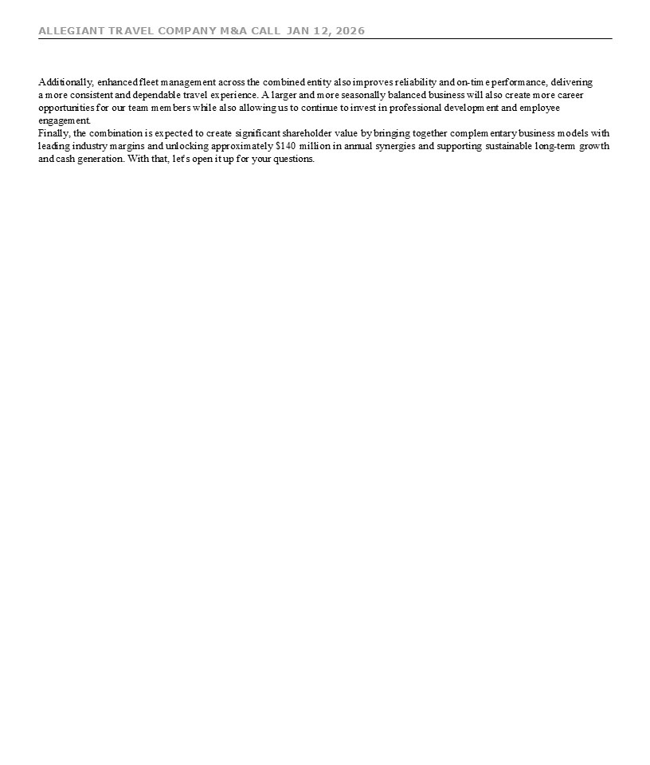
ALLEGIANT TRAVEL COMPANY M&A CALL JAN 12, 2026 9 Additionally, enhanced fleet management across the combined entity also improves reliability and on-time performance, delivering a more consistent and dependable travel experience. A larger and more seasonally balanced business will also create more career opportunities for our team members while also allowing us to continue to invest in professional development and employee engagement. Finally, the combination is expected to create significant shareholder value by bringing together complementary business models with leading industry margins and unlocking approximately $140 million in annual synergies and supporting sustainable long-term growth and cash generation. With that, let's open it up for your questions.

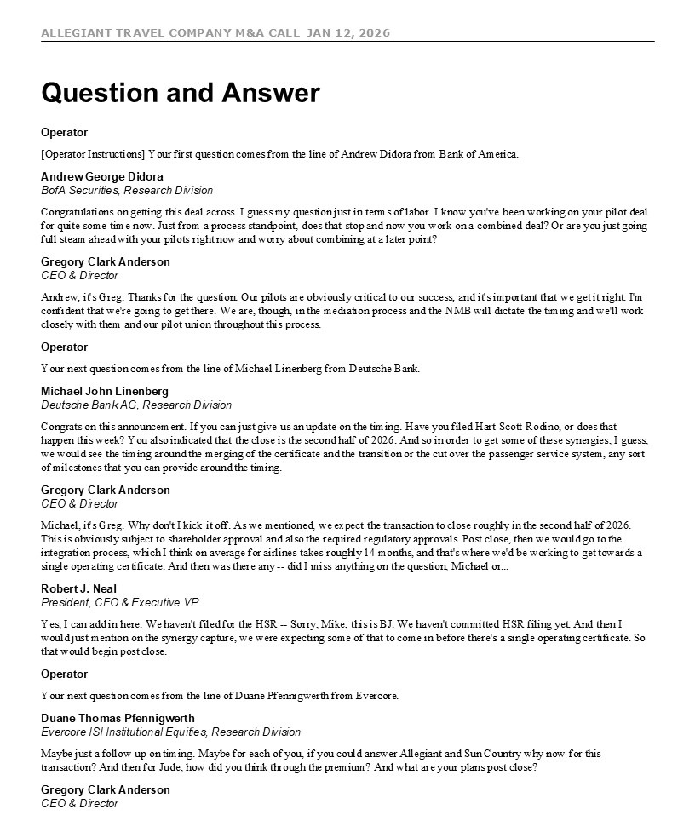
ALLEGIANT TRAVEL COMPANY M&A CALL JAN 12, 2026 10 Question and Answer Operator [Operator Instructions] Your first question comes from the line of Andrew Didora from Bank of America. Andrew George Didora BofA Securities, Research Division Congratulations on getting this deal across. I guess my question just in terms of labor. I know you've been working on your pilot deal for quite some time now. Just from a process standpoint, does that stop and now you work on a combined deal? Or are you just going full steam ahead with your pilots right now and worry about combining at a later point? Gregory Clark Anderson CEO & Director Andrew, it's Greg. Thanks for the question. Our pilots are obviously critical to our success, and it's important that we get it right. I'm confident that we're going to get there. We are, though, in the mediation process and the NMB will dictate the timing and we'll work closely with them and our pilot union throughout this process. Operator Your next question comes from the line of Michael Linenberg from Deutsche Bank. Michael John Linenberg Deutsche Bank AG, Research Division Congrats on this announcement. If you can just give us an update on the timing. Have you filed Hart-Scott-Rodino, or does that happen this week? You also indicated that the close is the second half of 2026. And so in order to get some of these synergies, I guess, we would see the timing around the merging of the certificate and the transition or the cut over the passenger service system, any sort of milestones that you can provide around the timing. Gregory Clark Anderson CEO & Director Michael, it's Greg. Why don't I kick it off. As we mentioned, we expect the transaction to close roughly in the second half of 2026. This is obviously subject to shareholder approval and also the required regulatory approvals. Post close, then we would go to the integration process, which I think on average for airlines takes roughly 14 months, and that's where we'd be working to get towards a single operating certificate. And then was there any -- did I miss anything on the question, Michael or... Robert J. Neal President, CFO & Executive VP Yes, I can add in here. We haven't filed for the HSR -- Sorry, Mike, this is BJ. We haven't committed HSR filing yet. And then I would just mention on the synergy capture, we were expecting some of that to come in before there's a single operating certificate. So that would begin post close. Operator Your next question comes from the line of Duane Pfennigwerth from Evercore. Duane Thomas Pfennigwerth Evercore ISI Institutional Equities, Research Division Maybe just a follow-up on timing. Maybe for each of you, if you could answer Allegiant and Sun Country why now for this transaction? And then for Jude, how did you think through the premium? And what are your plans post close? Gregory Clark Anderson CEO & Director

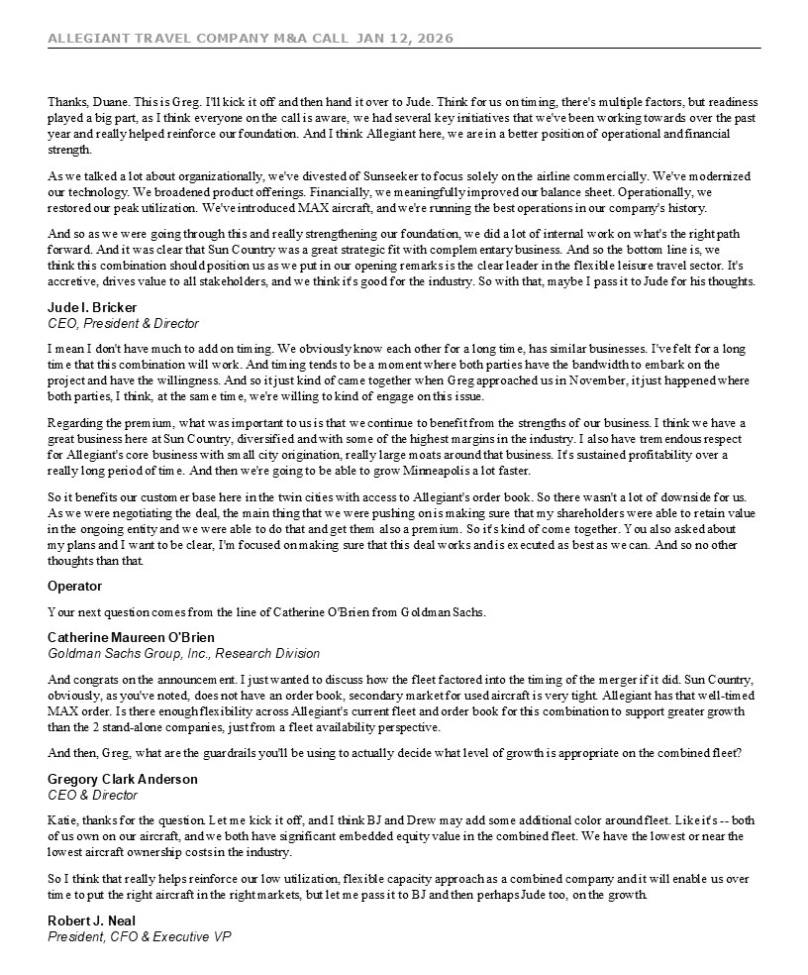
ALLEGIANT TRAVEL COMPANY M&A CALL JAN 12, 2026 11 Thanks, Duane. This is Greg. I'll kick it off and then hand it over to Jude. Think for us on timing, there's multiple factors, but readiness played a big part, as I think everyone on the call is aware, we had several key initiatives that we've been working towards over the past year and really helped reinforce our foundation. And I think Allegiant here, we are in a better position of operational and financial strength. As we talked a lot about organizationally, we've divested of Sunseeker to focus solely on the airline commercially. We've modernized our technology. We broadened product offerings. Financially, we meaningfully improved our balance sheet. Operationally, we restored our peak utilization. We've introduced MAX aircraft, and we're running the best operations in our company's history. And so as we were going through this and really strengthening our foundation, we did a lot of internal work on what's the right path forward. And it was clear that Sun Country was a great strategic fit with complementary business. And so the bottom line is, we think this combination should position us as we put in our opening remarks is the clear leader in the flexible leisure travel sector. It's accretive, drives value to all stakeholders, and we think it's good for the industry. So with that, maybe I pass it to Jude for his thoughts. Jude I. Bricker CEO, President & Director I mean I don't have much to add on timing. We obviously know each other for a long time, has similar businesses. I've felt for a long time that this combination will work. And timing tends to be a moment where both parties have the bandwidth to embark on the project and have the willingness. And so it just kind of came together when Greg approached us in November, it just happened where both parties, I think, at the same time, we're willing to kind of engage on this issue. Regarding the premium, what was important to us is that we continue to benefit from the strengths of our business. I think we have a great business here at Sun Country, diversified and with some of the highest margins in the industry. I also have tremendous respect for Allegiant's core business with small city origination, really large moats around that business. It's sustained profitability over a really long period of time. And then we're going to be able to grow Minneapolis a lot faster. So it benefits our customer base here in the twin cities with access to Allegiant's order book. So there wasn't a lot of downside for us. As we were negotiating the deal, the main thing that we were pushing on is making sure that my shareholders were able to retain value in the ongoing entity and we were able to do that and get them also a premium. So it's kind of come together. You also asked about my plans and I want to be clear, I'm focused on making sure that this deal works and is executed as best as we can. And so no other thoughts than that. Operator Your next question comes from the line of Catherine O'Brien from Goldman Sachs. Catherine Maureen O'Brien Goldman Sachs Group, Inc., Research Division And congrats on the announcement. I just wanted to discuss how the fleet factored into the timing of the merger if it did. Sun Country, obviously, as you've noted, does not have an order book, secondary market for used aircraft is very tight. Allegiant has that well-timed MAX order. Is there enough flexibility across Allegiant's current fleet and order book for this combination to support greater growth than the 2 stand-alone companies, just from a fleet availability perspective. And then, Greg, what are the guardrails you'll be using to actually decide what level of growth is appropriate on the combined fleet? Gregory Clark Anderson CEO & Director Katie, thanks for the question. Let me kick it off, and I think BJ and Drew may add some additional color around fleet. Like it's -- both of us own on our aircraft, and we both have significant embedded equity value in the combined fleet. We have the lowest or near the lowest aircraft ownership costs in the industry. So I think that really helps reinforce our low utilization, flexible capacity approach as a combined company and it will enable us over time to put the right aircraft in the right markets, but let me pass it to BJ and then perhaps Jude too, on the growth. Robert J. Neal President, CFO & Executive VP

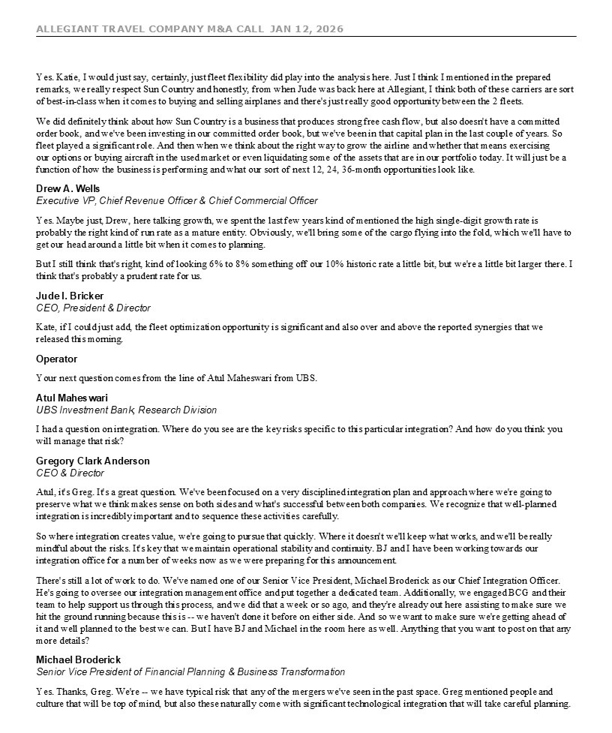
ALLEGIANT TRAVEL COMPANY M&A CALL JAN 12, 2026 12 Yes. Katie, I would just say, certainly, just fleet flexibility did play into the analysis here. Just I think I mentioned in the prepared remarks, we really respect Sun Country and honestly, from when Jude was back here at Allegiant, I think both of these carriers are sort of best-in-class when it comes to buying and selling airplanes and there's just really good opportunity between the 2 fleets. We did definitely think about how Sun Country is a business that produces strong free cash flow, but also doesn't have a committed order book, and we've been investing in our committed order book, but we've been in that capital plan in the last couple of years. So fleet played a significant role. And then when we think about the right way to grow the airline and whether that means exercising our options or buying aircraft in the used market or even liquidating some of the assets that are in our portfolio today. It will just be a function of how the business is performing and what our sort of next 12, 24, 36-month opportunities look like. Drew A. Wells Executive VP, Chief Revenue Officer & Chief Commercial Officer Yes. Maybe just, Drew, here talking growth, we spent the last few years kind of mentioned the high single-digit growth rate is probably the right kind of run rate as a mature entity. Obviously, we'll bring some of the cargo flying into the fold, which we'll have to get our head around a little bit when it comes to planning. But I still think that's right, kind of looking 6% to 8% something off our 10% historic rate a little bit, but we're a little bit larger there. I think that's probably a prudent rate for us. Jude I. Bricker CEO, President & Director Kate, if I could just add, the fleet optimization opportunity is significant and also over and above the reported synergies that we released this morning. Operator Your next question comes from the line of Atul Maheswari from UBS. Atul Maheswari UBS Investment Bank, Research Division I had a question on integration. Where do you see are the key risks specific to this particular integration? And how do you think you will manage that risk? Gregory Clark Anderson CEO & Director Atul, it's Greg. It's a great question. We've been focused on a very disciplined integration plan and approach where we're going to preserve what we think makes sense on both sides and what's successful between both companies. We recognize that well-planned integration is incredibly important and to sequence these activities carefully. So where integration creates value, we're going to pursue that quickly. Where it doesn't we'll keep what works, and we'll be really mindful about the risks. It's key that we maintain operational stability and continuity. BJ and I have been working towards our integration office for a number of weeks now as we were preparing for this announcement. There's still a lot of work to do. We've named one of our Senior Vice President, Michael Broderick as our Chief Integration Officer. He's going to oversee our integration management office and put together a dedicated team. Additionally, we engaged BCG and their team to help support us through this process, and we did that a week or so ago, and they're already out here assisting to make sure we hit the ground running because this is -- we haven't done it before on either side. And so we want to make sure we're getting ahead of it and well planned to the best we can. But I have BJ and Michael in the room here as well. Anything that you want to post on that any more details? Michael Broderick Senior Vice President of Financial Planning & Business Transformation Yes. Thanks, Greg. We're -- we have typical risk that any of the mergers we've seen in the past space. Greg mentioned people and culture that will be top of mind, but also these naturally come with significant technological integration that will take careful planning.

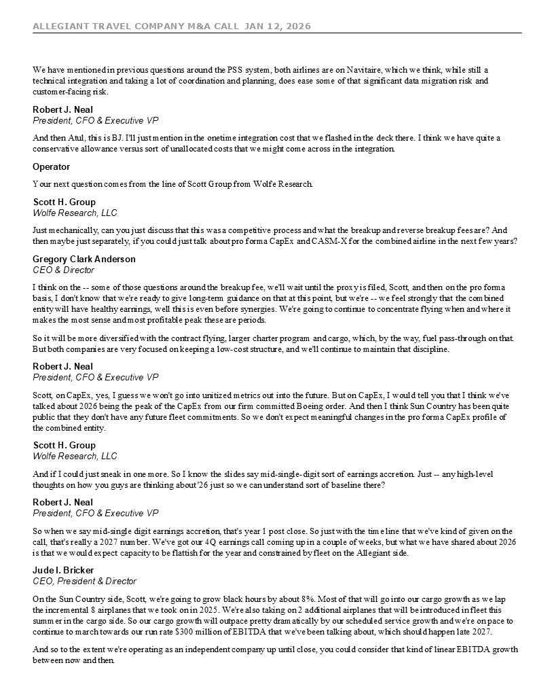
ALLEGIANT TRAVEL COMPANY M&A CALL JAN 12, 2026 13 We have mentioned in previous questions around the PSS system, both airlines are on Navitaire, which we think, while still a technical integration and taking a lot of coordination and planning, does ease some of that significant data migration risk and customer-facing risk. Robert J. Neal President, CFO & Executive VP And then Atul, this is BJ. I'll just mention in the onetime integration cost that we flashed in the deck there. I think we have quite a conservative allowance versus sort of unallocated costs that we might come across in the integration. Operator Your next question comes from the line of Scott Group from Wolfe Research. Scott H. Group Wolfe Research, LLC Just mechanically, can you just discuss that this was a competitive process and what the breakup and reverse breakup fees are? And then maybe just separately, if you could just talk about pro forma CapEx and CASM-X for the combined airline in the next few years? Gregory Clark Anderson CEO & Director I think on the -- some of those questions around the breakup fee, we'll wait until the proxy is filed, Scott, and then on the pro forma basis, I don't know that we're ready to give long-term guidance on that at this point, but we're -- we feel strongly that the combined entity will have healthy earnings, well this is even before synergies. We're going to continue to concentrate flying when and where it makes the most sense and most profitable peak these are periods. So it will be more diversified with the contract flying, larger charter program and cargo, which, by the way, fuel pass-through on that. But both companies are very focused on keeping a low-cost structure, and we'll continue to maintain that discipline. Robert J. Neal President, CFO & Executive VP Scott, on CapEx, yes, I guess we won't go into unitized metrics out into the future. But on CapEx, I would tell you that I think we've talked about 2026 being the peak of the CapEx from our firm committed Boeing order. And then I think Sun Country has been quite public that they don't have any future fleet commitments. So we don't expect meaningful changes in the pro forma CapEx profile of the combined entity. Scott H. Group Wolfe Research, LLC And if I could just sneak in one more. So I know the slides say mid-single-digit sort of earnings accretion. Just -- any high-level thoughts on how you guys are thinking about '26 just so we can understand sort of baseline there? Robert J. Neal President, CFO & Executive VP So when we say mid-single digit earnings accretion, that's year 1 post close. So just with the time line that we've kind of given on the call, that's really a 2027 number. We've got our 4Q earnings call coming up in a couple of weeks, but what we have shared about 2026 is that we would expect capacity to be flattish for the year and constrained by fleet on the Allegiant side. Jude I. Bricker CEO, President & Director On the Sun Country side, Scott, we're going to grow black hours by about 8%. Most of that will go into our cargo growth as we lap the incremental 8 airplanes that we took on in 2025. We're also taking on 2 additional airplanes that will be introduced in fleet this summer in the cargo side. So our cargo growth will outpace pretty dramatically by our scheduled service growth and we're on pace to continue to march towards our run rate $300 million of EBITDA that we've been talking about, which should happen late 2027. And so to the extent we're operating as an independent company up until close, you could consider that kind of linear EBITDA growth between now and then.

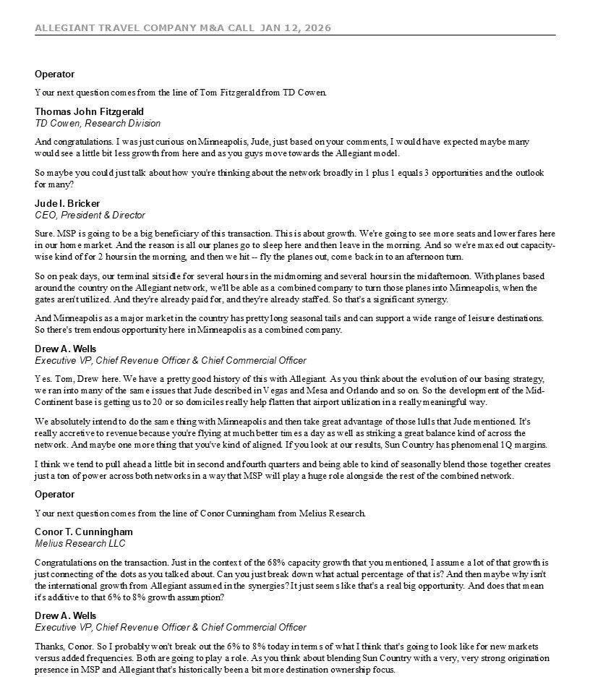
ALLEGIANT TRAVEL COMPANY M&A CALL JAN 12, 2026 14 Operator Your next question comes from the line of Tom Fitzgerald from TD Cowen. Thomas John Fitzgerald TD Cowen, Research Division And congratulations. I was just curious on Minneapolis, Jude, just based on your comments, I would have expected maybe many would see a little bit less growth from here and as you guys move towards the Allegiant model. So maybe you could just talk about how you're thinking about the network broadly in 1 plus 1 equals 3 opportunities and the outlook for many? Jude I. Bricker CEO, President & Director Sure. MSP is going to be a big beneficiary of this transaction. This is about growth. We're going to see more seats and lower fares here in our home market. And the reason is all our planes go to sleep here and then leave in the morning. And so we're maxed out capacity-wise kind of for 2 hours in the morning, and then we hit -- fly the planes out, come back in to an afternoon turn. So on peak days, our terminal sits idle for several hours in the midmorning and several hours in the midafternoon. With planes based around the country on the Allegiant network, we'll be able as a combined company to turn those planes into Minneapolis, when the gates aren't utilized. And they're already paid for, and they're already staffed. So that's a significant synergy. And Minneapolis as a major market in the country has pretty long seasonal tails and can support a wide range of leisure destinations. So there's tremendous opportunity here in Minneapolis as a combined company. Drew A. Wells Executive VP, Chief Revenue Officer & Chief Commercial Officer Yes. Tom, Drew here. We have a pretty good history of this with Allegiant. As you think about the evolution of our basing strategy, we ran into many of the same issues that Jude described in Vegas and Mesa and Orlando and so on. So the development of the Mid-Continent base is getting us to 20 or so domiciles really help flatten that airport utilization in a really meaningful way. We absolutely intend to do the same thing with Minneapolis and then take great advantage of those lulls that Jude mentioned. It's really accretive to revenue because you're flying at much better times a day as well as striking a great balance kind of across the network. And maybe one more thing that you've kind of aligned. If you look at our results, Sun Country has phenomenal 1Q margins. I think we tend to pull ahead a little bit in second and fourth quarters and being able to kind of seasonally blend those together creates just a ton of power across both networks in a way that MSP will play a huge role alongside the rest of the combined network. Operator Your next question comes from the line of Conor Cunningham from Melius Research. Conor T. Cunningham Melius Research LLC Congratulations on the transaction. Just in the context of the 68% capacity growth that you mentioned, I assume a lot of that growth is just connecting of the dots as you talked about. Can you just break down what actual percentage of that is? And then maybe why isn't the international growth from Allegiant assumed in the synergies? It just seems like that's a real big opportunity. And does that mean it's additive to that 6% to 8% growth assumption? Drew A. Wells Executive VP, Chief Revenue Officer & Chief Commercial Officer Thanks, Conor. So I probably won't break out the 6% to 8% today in terms of what I think that's going to look like for new markets versus added frequencies. Both are going to play a role. As you think about blending Sun Country with a very, very strong origination presence in MSP and Allegiant that's historically been a bit more destination ownership focus.

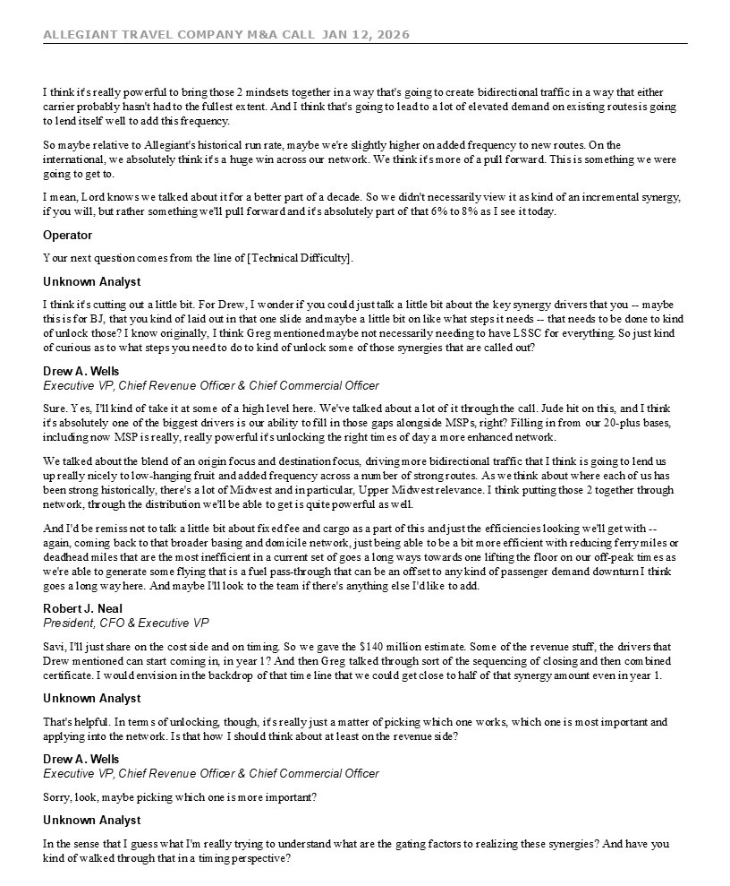
ALLEGIANT TRAVEL COMPANY M&A CALL JAN 12, 2026 15 I think it's really powerful to bring those 2 mindsets together in a way that's going to create bidirectional traffic in a way that either carrier probably hasn't had to the fullest extent. And I think that's going to lead to a lot of elevated demand on existing routes is going to lend itself well to add this frequency. So maybe relative to Allegiant's historical run rate, maybe we're slightly higher on added frequency to new routes. On the international, we absolutely think it's a huge win across our network. We think it's more of a pull forward. This is something we were going to get to. I mean, Lord knows we talked about it for a better part of a decade. So we didn't necessarily view it as kind of an incremental synergy, if you will, but rather something we'll pull forward and it's absolutely part of that 6% to 8% as I see it today. Operator Your next question comes from the line of [Technical Difficulty]. Unknown Analyst I think it's cutting out a little bit. For Drew, I wonder if you could just talk a little bit about the key synergy drivers that you -- maybe this is for BJ, that you kind of laid out in that one slide and maybe a little bit on like what steps it needs -- that needs to be done to kind of unlock those? I know originally, I think Greg mentioned maybe not necessarily needing to have LSSC for everything. So just kind of curious as to what steps you need to do to kind of unlock some of those synergies that are called out? Drew A. Wells Executive VP, Chief Revenue Officer & Chief Commercial Officer Sure. Yes, I'll kind of take it at some of a high level here. We've talked about a lot of it through the call. Jude hit on this, and I think it's absolutely one of the biggest drivers is our ability to fill in those gaps alongside MSPs, right? Filling in from our 20-plus bases, including now MSP is really, really powerful it's unlocking the right times of day a more enhanced network. We talked about the blend of an origin focus and destination focus, driving more bidirectional traffic that I think is going to lend us up really nicely to low-hanging fruit and added frequency across a number of strong routes. As we think about where each of us has been strong historically, there's a lot of Midwest and in particular, Upper Midwest relevance. I think putting those 2 together through network, through the distribution we'll be able to get is quite powerful as well. And I'd be remiss not to talk a little bit about fixed fee and cargo as a part of this and just the efficiencies looking we'll get with --again, coming back to that broader basing and domicile network, just being able to be a bit more efficient with reducing ferry miles or deadhead miles that are the most inefficient in a current set of goes a long ways towards one lifting the floor on our off-peak times as we're able to generate some flying that is a fuel pass-through that can be an offset to any kind of passenger demand downturn I think goes a long way here. And maybe I'll look to the team if there's anything else I'd like to add. Robert J. Neal President, CFO & Executive VP Savi, I'll just share on the cost side and on timing. So we gave the $140 million estimate. Some of the revenue stuff, the drivers that Drew mentioned can start coming in, in year 1? And then Greg talked through sort of the sequencing of closing and then combined certificate. I would envision in the backdrop of that time line that we could get close to half of that synergy amount even in year 1. Unknown Analyst That's helpful. In terms of unlocking, though, it's really just a matter of picking which one works, which one is most important and applying into the network. Is that how I should think about at least on the revenue side? Drew A. Wells Executive VP, Chief Revenue Officer & Chief Commercial Officer Sorry, look, maybe picking which one is more important? Unknown Analyst In the sense that I guess what I'm really trying to understand what are the gating factors to realizing these synergies? And have you kind of walked through that in a timing perspective?

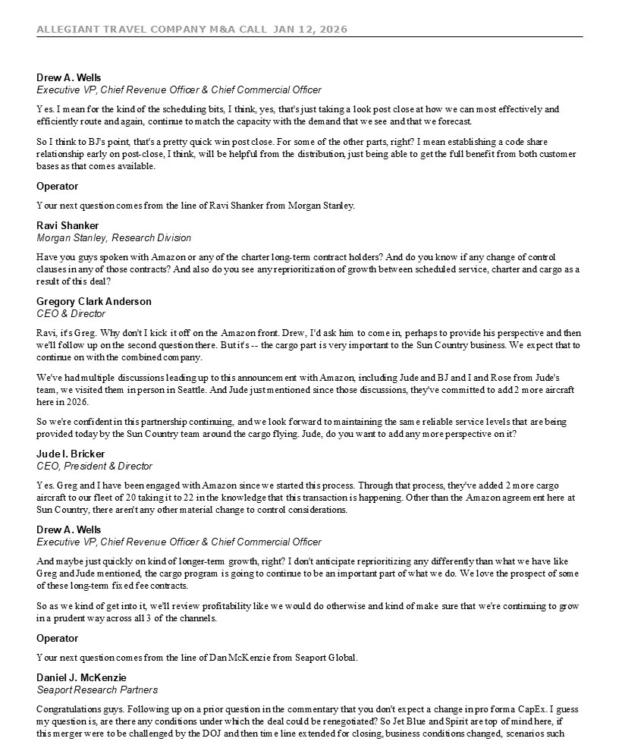
ALLEGIANT TRAVEL COMPANY M&A CALL JAN 12, 2026 16 Drew A. Wells Executive VP, Chief Revenue Officer & Chief Commercial Officer Yes. I mean for the kind of the scheduling bits, I think, yes, that's just taking a look post close at how we can most effectively and efficiently route and again, continue to match the capacity with the demand that we see and that we forecast. So I think to BJ's point, that's a pretty quick win post close. For some of the other parts, right? I mean establishing a code share relationship early on post-close, I think, will be helpful from the distribution, just being able to get the full benefit from both customer bases as that comes available. Operator Your next question comes from the line of Ravi Shanker from Morgan Stanley. Ravi Shanker Morgan Stanley, Research Division Have you guys spoken with Amazon or any of the charter long-term contract holders? And do you know if any change of control clauses in any of those contracts? And also do you see any reprioritization of growth between scheduled service, charter and cargo as a result of this deal? Gregory Clark Anderson CEO & Director Ravi, it's Greg. Why don't I kick it off on the Amazon front. Drew, I'd ask him to come in, perhaps to provide his perspective and then we'll follow up on the second question there. But it's -- the cargo part is very important to the Sun Country business. We expect that to continue on with the combined company. We've had multiple discussions leading up to this announcement with Amazon, including Jude and BJ and I and Rose from Jude's team, we visited them in person in Seattle. And Jude just mentioned since those discussions, they've committed to add 2 more aircraft here in 2026. So we're confident in this partnership continuing, and we look forward to maintaining the same reliable service levels that are being provided today by the Sun Country team around the cargo flying. Jude, do you want to add any more perspective on it? Jude I. Bricker CEO, President & Director Yes. Greg and I have been engaged with Amazon since we started this process. Through that process, they've added 2 more cargo aircraft to our fleet of 20 taking it to 22 in the knowledge that this transaction is happening. Other than the Amazon agreement here at Sun Country, there aren't any other material change to control considerations. Drew A. Wells Executive VP, Chief Revenue Officer & Chief Commercial Officer And maybe just quickly on kind of longer-term growth, right? I don't anticipate reprioritizing any differently than what we have like Greg and Jude mentioned, the cargo program is going to continue to be an important part of what we do. We love the prospect of some of these long-term fixed fee contracts. So as we kind of get into it, we'll review profitability like we would do otherwise and kind of make sure that we're continuing to grow in a prudent way across all 3 of the channels. Operator Your next question comes from the line of Dan McKenzie from Seaport Global. Daniel J. McKenzie Seaport Research Partners Congratulations guys. Following up on a prior question in the commentary that you don't expect a change in pro forma CapEx. I guess my question is, are there any conditions under which the deal could be renegotiated? So Jet Blue and Spirit are top of mind here, if this merger were to be challenged by the DOJ and then time line extended for closing, business conditions changed, scenarios such

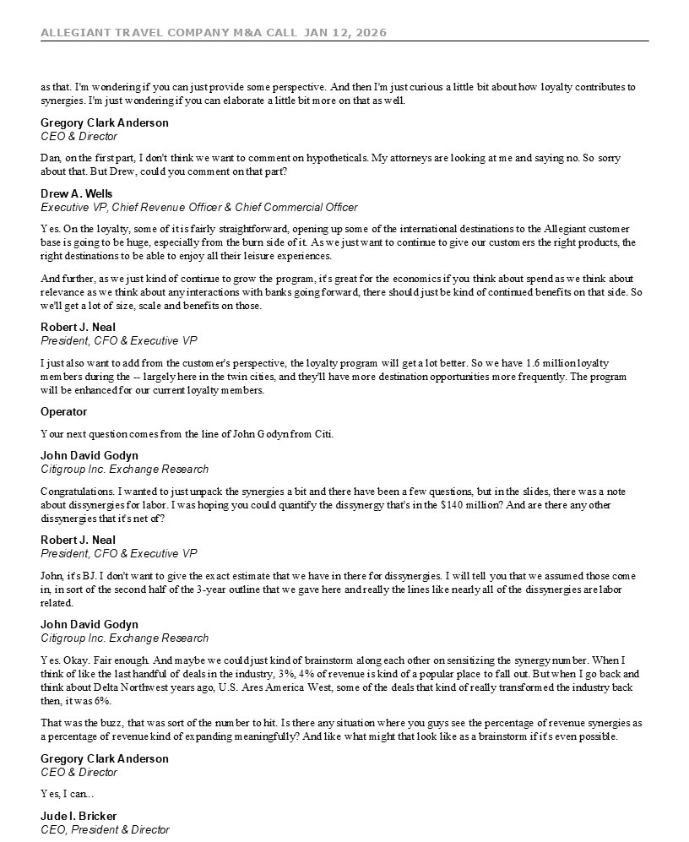
ALLEGIANT TRAVEL COMPANY M&A CALL JAN 12, 2026 17 as that. I'm wondering if you can just provide some perspective. And then I'm just curious a little bit about how loyalty contributes to synergies. I'm just wondering if you can elaborate a little bit more on that as well. Gregory Clark Anderson CEO & Director Dan, on the first part, I don't think we want to comment on hypotheticals. My attorneys are looking at me and saying no. So sorry about that. But Drew, could you comment on that part? Drew A. Wells Executive VP, Chief Revenue Officer & Chief Commercial Officer Yes. On the loyalty, some of it is fairly straightforward, opening up some of the international destinations to the Allegiant customer base is going to be huge, especially from the burn side of it. As we just want to continue to give our customers the right products, the right destinations to be able to enjoy all their leisure experiences. And further, as we just kind of continue to grow the program, it's great for the economics if you think about spend as we think about relevance as we think about any interactions with banks going forward, there should just be kind of continued benefits on that side. So we'll get a lot of size, scale and benefits on those. Robert J. Neal President, CFO & Executive VP I just also want to add from the customer's perspective, the loyalty program will get a lot better. So we have 1.6 million loyalty members during the -- largely here in the twin cities, and they'll have more destination opportunities more frequently. The program will be enhanced for our current loyalty members. Operator Your next question comes from the line of John Godyn from Citi. John David Godyn Citigroup Inc. Exchange Research Congratulations. I wanted to just unpack the synergies a bit and there have been a few questions, but in the slides, there was a note about dissynergies for labor. I was hoping you could quantify the dissynergy that's in the $140 million? And are there any other dissynergies that it's net of? Robert J. Neal President, CFO & Executive VP John, it's BJ. I don't want to give the exact estimate that we have in there for dissynergies. I will tell you that we assumed those come in, in sort of the second half of the 3-year outline that we gave here and really the lines like nearly all of the dissynergies are labor related. John David Godyn Citigroup Inc. Exchange Research Yes. Okay. Fair enough. And maybe we could just kind of brainstorm along each other on sensitizing the synergy number. When I think of like the last handful of deals in the industry, 3%, 4% of revenue is kind of a popular place to fall out. But when I go back and think about Delta Northwest years ago, U.S. Ares America West, some of the deals that kind of really transformed the industry back then, it was 6%. That was the buzz, that was sort of the number to hit. Is there any situation where you guys see the percentage of revenue synergies as a percentage of revenue kind of expanding meaningfully? And like what might that look like as a brainstorm if it's even possible. Gregory Clark Anderson CEO & Director Yes, I can... Jude I. Bricker CEO, President & Director

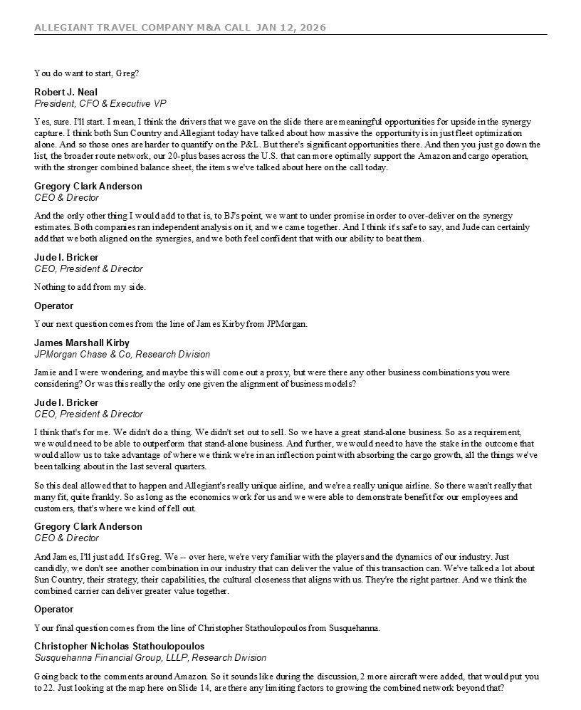
ALLEGIANT TRAVEL COMPANY M&A CALL JAN 12, 2026 18 You do want to start, Greg? Robert J. Neal President, CFO & Executive VP Yes, sure. I'll start. I mean, I think the drivers that we gave on the slide there are meaningful opportunities for upside in the synergy capture. I think both Sun Country and Allegiant today have talked about how massive the opportunity is in just fleet optimization alone. And so those ones are harder to quantify on the P&L. But there's significant opportunities there. And then you just go down the list, the broader route network, our 20-plus bases across the U.S. that can more optimally support the Amazon and cargo operation, with the stronger combined balance sheet, the items we've talked about here on the call today. Gregory Clark Anderson CEO & Director And the only other thing I would add to that is, to BJ's point, we want to under promise in order to over-deliver on the synergy estimates. Both companies ran independent analysis on it, and we came together. And I think it's safe to say, and Jude can certainly add that we both aligned on the synergies, and we both feel confident that with our ability to beat them. Jude I. Bricker CEO, President & Director Nothing to add from my side. Operator Your next question comes from the line of James Kirby from JPMorgan. James Marshall Kirby JPMorgan Chase & Co, Research Division Jamie and I were wondering, and maybe this will come out a proxy, but were there any other business combinations you were considering? Or was this really the only one given the alignment of business models? Jude I. Bricker CEO, President & Director I think that's for me. We didn't do a thing. We didn't set out to sell. So we have a great stand-alone business. So as a requirement, we would need to be able to outperform that stand-alone business. And further, we would need to have the stake in the outcome that would allow us to take advantage of where we think we're in an inflection point with absorbing the cargo growth, all the things we've been talking about in the last several quarters. So this deal allowed that to happen and Allegiant's really unique airline, and we're a really unique airline. So there wasn't really that many fit, quite frankly. So as long as the economics work for us and we were able to demonstrate benefit for our employees and customers, that's where we kind of fell out. Gregory Clark Anderson CEO & Director And James, I'll just add. It's Greg. We -- over here, we're very familiar with the players and the dynamics of our industry. Just candidly, we don't see another combination in our industry that can deliver the value of this transaction can. We've talked a lot about Sun Country, their strategy, their capabilities, the cultural closeness that aligns with us. They're the right partner. And we think the combined carrier can deliver greater value together. Operator Your final question comes from the line of Christopher Stathoulopoulos from Susquehanna. Christopher Nicholas Stathoulopoulos Susquehanna Financial Group, LLLP, Research Division Going back to the comments around Amazon. So it sounds like during the discussion, 2 more aircraft were added, that would put you to 22. Just looking at the map here on Slide 14, are there any limiting factors to growing the combined network beyond that?

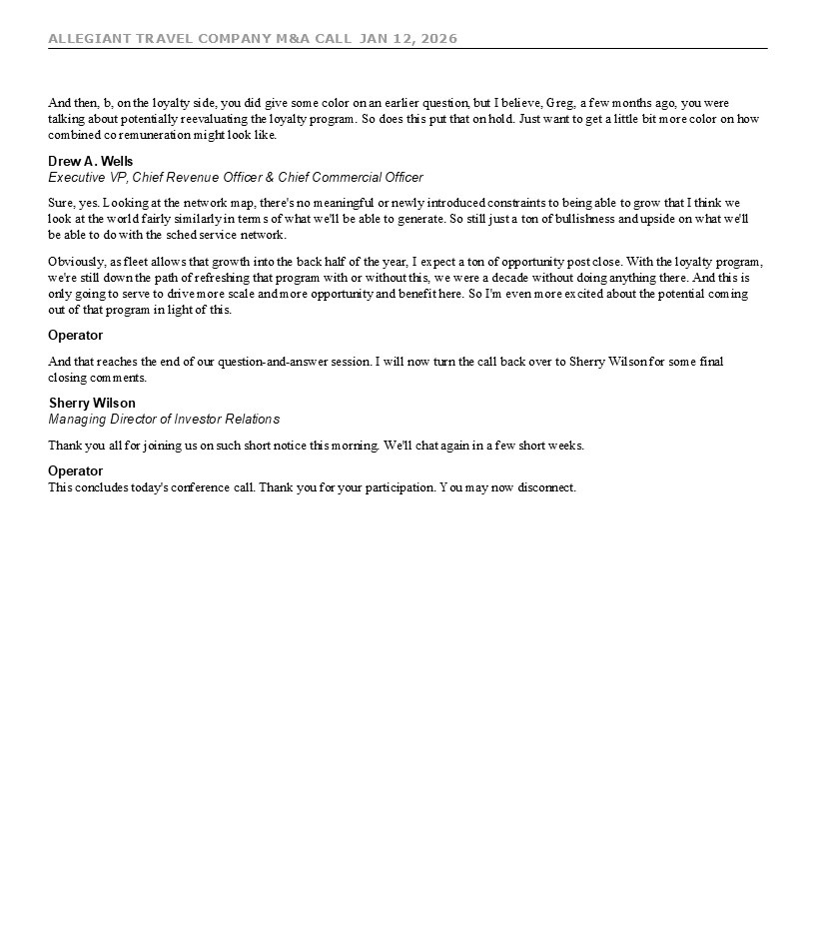
ALLEGIANT TRAVEL COMPANY M&A CALL JAN 12, 2026 19 And then, b, on the loyalty side, you did give some color on an earlier question, but I believe, Greg, a few months ago, you were talking about potentially reevaluating the loyalty program. So does this put that on hold. Just want to get a little bit more color on how combined co remuneration might look like. Drew A. Wells Executive VP, Chief Revenue Officer & Chief Commercial Officer Sure, yes. Looking at the network map, there's no meaningful or newly introduced constraints to being able to grow that I think we look at the world fairly similarly in terms of what we'll be able to generate. So still just a ton of bullishness and upside on what we'll be able to do with the sched service network. Obviously, as fleet allows that growth into the back half of the year, I expect a ton of opportunity post close. With the loyalty program, we're still down the path of refreshing that program with or without this, we were a decade without doing anything there. And this is only going to serve to drive more scale and more opportunity and benefit here. So I'm even more excited about the potential coming out of that program in light of this. Operator And that reaches the end of our question-and-answer session. I will now turn the call back over to Sherry Wilson for some final closing comments. Sherry Wilson Managing Director of Investor Relations Thank you all for joining us on such short notice this morning. We'll chat again in a few short weeks. Operator This concludes today's conference call. Thank you for your participation. You may now disconnect.

Cautionary Statement Regarding Forward-Looking Statements

This communication contains forward-looking statements under the safe harbor provisions of Section 21E of the Securities Exchange Act of 1934, Section 27A of the Securities Act of 1933 and the Private Securities Litigation Reform Act of 1995. Forward-looking statements include all statements that are not historical facts and often can be identified by the use of forward-looking terminology such as the words “believe,” “expect,” “guidance,” “anticipate,” “intend,” “plan,” “estimate”, “project”, “hope” or similar expressions. Forward-looking statements in this communication are based on Allegiant’s and Sun Country’s current expectations, estimates and projections about the expected date of closing of the proposed transaction and the potential benefits thereof, their respective businesses and industries, management’s beliefs and certain assumptions made by Allegiant and Sun Country, all of which are subject to change. Forward-looking statements in this communication may relate to, without limitation, the benefits of the proposed transaction, including future financial and operating results; the parties’ respective plans, objectives, expectations and intentions; the expected timing and likelihood of completion of the proposed transaction; expected synergies of the proposed transaction; the timing and result of various regulatory proceedings related to the proposed transaction; the ability to execute and finance current and long-term business, operational, capital expenditures and growth plans and strategies; the impact of increased or increasing transaction and financing costs associated with the proposed transaction or otherwise, as well as inflation and interest rates; and the ability to access debt and equity capital markets.

Forward-looking statements involve risks, uncertainties and assumptions that could cause actual results to differ materially from those expressed in any forward-looking statements. Accordingly, there are or will be important factors that could cause actual results to differ materially from those indicated in such statements and, therefore, you should not place undue reliance on any such statements and caution must be exercised in relying on forward-looking statements. Important risk factors that may cause such a difference include, but are not limited to, the following: the occurrence of any event, change or other circumstance that could give rise to the right of one or both of the parties to terminate the definitive merger agreement for the proposed transaction; the risk that potential legal proceedings may be instituted against Allegiant or Sun Country and result in significant costs of defense, indemnification or liability; the possibility that the proposed transaction does not close when expected or at all because required stockholder approvals, required regulatory approvals or other conditions to closing are not received or satisfied on a timely basis or at all (and the risk that such regulatory approvals may result in the imposition of conditions that could adversely affect the combined company or the expected benefits of the proposed transaction); the risk that the combined company will not realize expected benefits, cost savings, accretion, synergies and/or growth from the proposed transaction or that any of the foregoing may take longer to realize or be more costly to achieve than expected; disruption to the parties’ businesses as a result of the announcement and pendency of the proposed transaction; the costs associated with the anticipated length of time of the pendency of the proposed transaction, including the restrictions contained in the definitive merger agreement on the ability of each of Sun Country and Allegiant to operate their respective businesses outside the ordinary course consistent with past practice during the pendency of the proposed transaction; the diversion of Allegiant’s and Sun Country’s respective management teams’ attention and time from ongoing business operations and opportunities on acquisition-related matters; the risk that the integration of Sun Country’s operations will be materially delayed or will be more costly or difficult than expected or that Allegiant is otherwise unable to successfully integrate Sun Country’s businesses into its businesses; the possibility that the proposed transaction may be more expensive to complete than anticipated, including as a result of unexpected factors or events; reputational risk and potential adverse reactions of Allegiant’s or Sun Country’s customers, suppliers, employees, labor unions or other business partners, including those resulting from the announcement or completion of the proposed transaction; the dilution caused by Allegiant’s issuance of additional shares of its common stock in connection with the consummation of the proposed transaction; a material adverse change in the business, condition or results of operations of Allegiant or Sun Country; changes in domestic or international economic, political or business conditions, including those impacting the airline industry (including customers, employees and supply chains); Allegiant’s and Sun Country’s ability to successfully implement their respective operational, productivity and strategic initiatives; the outcome of claims, litigation, governmental proceedings and investigations involving Allegiant or Sun Country; and a cybersecurity incident or other disruption to Sun Country’s or Allegiant’s technology infrastructure.

Forward-looking statements in this communication are qualified by and should be read together with, the risk factors set forth above and the risk factors included in Allegiant’s and Sun Country’s respective annual and quarterly reports as filed with the Securities and Exchange Commission (the “SEC”), and readers should refer to such risks, uncertainties and risk factors in evaluating such forward-looking statements. In addition, the risk factors discussed above are not exhaustive and they, along with other risk factors, will be more fully discussed in the registration statement and joint proxy statement/prospectus to be filed with the SEC in connection with the proposed transaction.

The forward-looking statements in this communication are made only as of the date they were first issued, and unless otherwise required by applicable securities laws, Allegiant and Sun Country disclaim any intention or obligation to update or revise any forward-looking statements, whether as a result of new information, future events, or otherwise.

Important Additional Information and Where to Find It

In connection with the proposed transaction, Allegiant intends to file with the SEC a registration statement on Form S-4 (the “Registration Statement”), which will include a prospectus with respect to the shares of Allegiant’s common stock to be issued in the proposed transaction and a joint proxy statement for Allegiant’s and Sun Country’s respective stockholders (the “Joint Proxy Statement/Prospectus”). The definitive joint proxy statement (if and when available) will be mailed to stockholders of Allegiant and Sun Country. Each of Allegiant and Sun Country may also file with or furnish to the SEC other relevant documents regarding the proposed transaction. This communication is not a substitute for the Registration Statement, the Joint Proxy Statement/Prospectus or any other document that Allegiant or Sun Country may file with the SEC or send to their respective stockholders in connection with the proposed transaction. INVESTORS AND SECURITY HOLDERS OF ALLEGIANT AND SUN COUNTRY ARE URGED TO READ THE REGISTRATION STATEMENT AND THE JOINT PROXY STATEMENT/PROSPECTUS INCLUDED WITHIN THE REGISTRATION WHEN THEY BECOME AVAILABLE, AS WELL AS ANY OTHER RELEVANT DOCUMENTS FILED WITH THE SEC IN CONNECTION WITH THE PROPOSED TRANSACTION OR INCORPORATED BY REFERENCE INTO THE REGISTRATION STATEMENT AND THE JOINT PROXY STATEMENT/PROSPECTUS (INCLUDING ANY AMENDMENTS OR SUPPLEMENTS THERETO), BECAUSE THEY WILL CONTAIN IMPORTANT INFORMATION REGARDING ALLEGIANT, SUN COUNTRY, THE PROPOSED TRANSACTION AND RELATED MATTERS. Investors and security holders of Allegiant and Sun Country may obtain free copies of these documents and other documents filed with the SEC by Allegiant or Sun Country through the website maintained by the SEC at http://www.sec.gov or from Allegiant at its website, https://ir.allegiantair.com/financials/sec-filings/default.aspx, or from Sun Country at its website, https://ir.suncountry.com/financials/sec-filings. Documents filed with the SEC by Allegiant will be available free of charge by accessing Allegiant’s website at https://ir.allegiantair.com/financials/sec-filings/default.aspx, or alternatively by directing a request by mail to Allegiant’s Investor Relations department, 1201 North Town Center Drive, Las Vegas, NV 89144, and documents filed with the SEC by Sun Country will be available free of charge by accessing Sun Country’s website at https://ir.suncountry.com/financials/sec-filings, or alternatively by directing a request by mail to Sun Country’s Investor Relations department, 2005 Cargo Road, Minneapolis, MN 55450.

Participants In The Solicitation

Allegiant, Sun Country and certain of their respective directors and executive officers may be deemed to be participants in the solicitation of proxies from the stockholders of Allegiant and Sun Country in connection with the proposed transaction under the rules of the SEC.

Information about the interests of the directors and executive officers of Allegiant and Sun Country and other persons who may be deemed to be participants in the solicitation of stockholders of Allegiant and Sun Country in connection with the proposed transaction and a description of their direct and indirect interests, by security holdings or otherwise, will be included in the Joint Proxy Statement/Prospectus, which will be filed with the SEC.

Information about the directors and executive officers of Allegiant, their ownership of Allegiant common stock and Allegiant’s transactions with related persons can also be found in the Allegiant Annual Report and Allegiant’s definitive proxy statement in connection with its 2025 annual meeting of stockholders, as filed with the SEC on Schedule 14A on April 30, 2025 (the “Allegiant 2025 Proxy Statement”), and other documents subsequently filed by Allegiant with the SEC, which are available on its website, https://ir.allegiantair.com/financials/sec-filings/default.aspx. Such information is set forth in the sections entitled “Proposal No. 1 – Election of Directors”, “Proposal No. 2 – Advisory (non-binding) Vote on Executive Compensation”, “Proposal No. 3 – Approval of Amendment to Allegiant 2022 Long-Term Incentive Plan to Increase Number of Shares Available”, “Executive Compensation” and “Related Party Transactions” of the Allegiant 2025 Proxy Statement. To the extent holdings of Allegiant common stock by the directors and executive officers of Allegiant have changed from the amounts of Allegiant common stock held by such persons as reflected therein, such changes have been or will be reflected on Statements of Change in Ownership on Form 4 filed with the SEC, which are available at https://www.sec.gov/edgar/browse/?CIK=1362468&owner=exclude under the tab “Ownership Disclosures”.

Information about the directors and executive officers of Sun Country, their ownership of Sun Country common stock and Sun Country’s transactions with related persons can also be found in the definitive proxy statement for Sun Country’s 2025 annual meeting of stockholders, as filed with the SEC on Schedule 14A on April 25, 2025 (which is available at https://ir.suncountry.com/financials/sec-filings), and other documents subsequently filed by Sun Country with the SEC. Such information is set forth in the sections entitled “Proposal 1– Reelection of Directors”, “Proposal 2 – Non-binding (Advisory) Vote to Approve the Compensation of Our Named Executive Officers”, “Executive Compensation”, “Certain Relationships and Related Person Transactions” and “Security Ownership of Certain Beneficial Owners and Management” of such definitive proxy statement. Please also refer to Sun Country’s subsequent Current Reports, as filed with the SEC on Form 8-K on September 22, 2025 (which is available at https://ir.suncountry.com/financials/sec-filings) and on October 30, 2025, regarding subsequent changes to Sun Country’s Board of Directors and executive management following the filing of such definitive proxy statement. To the extent holdings of Sun Country common stock by the directors and executive officers of Sun Country have changed from the amounts of Sun Country common stock held by such persons as reflected in the definitive proxy statement, such changes have been or will be reflected on Statements of Change in Ownership on Form 4 filed with the SEC, which are available at https://www.sec.gov/edgar/browse/?CIK=1743907&owner=exclude under the tab “Ownership Disclosures”.

Free copies of these documents may be obtained as described above.

No Offer or Solicitation

This communication is for informational purposes only and does not constitute, or form a part of, an offer to sell, an offer to buy, or the solicitation of an offer to sell or the solicitation of an offer to buy any securities, and there shall be no sale of securities, in any jurisdiction in which such offer, solicitation or sale would be unlawful prior to registration or qualification under the securities laws of any such jurisdiction. No offer of securities shall be made except by means of a prospectus meeting the requirements of Section 10 of the Securities Act of 1933, as amended, and otherwise in accordance with applicable law.

