FORM OF 425 FILING (PRIOR TO FILING OF FORM S-4)

FILED BY SUN COUNTRY AIRLINES HOLDINGS, INC. PURSUANT TO RULE 425 UNDER THE SECURITIES ACT OF 1933 AND DEEMED FILED PURSUANT TO RULE 14a-12 UNDER THE SECURITIES EXCHANGE ACT OF 1934

SUBJECT COMPANY: SUN COUNTRY AIRLINES HOLDINGS, INC. COMMISSION FILE NO. 001-40217
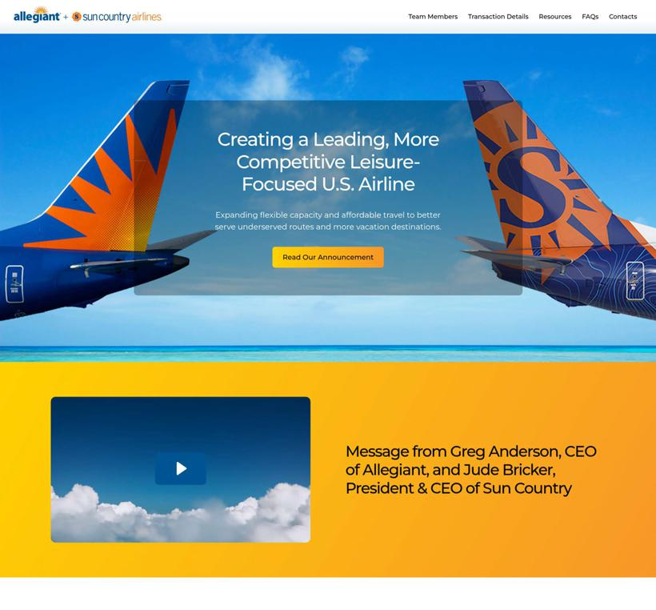



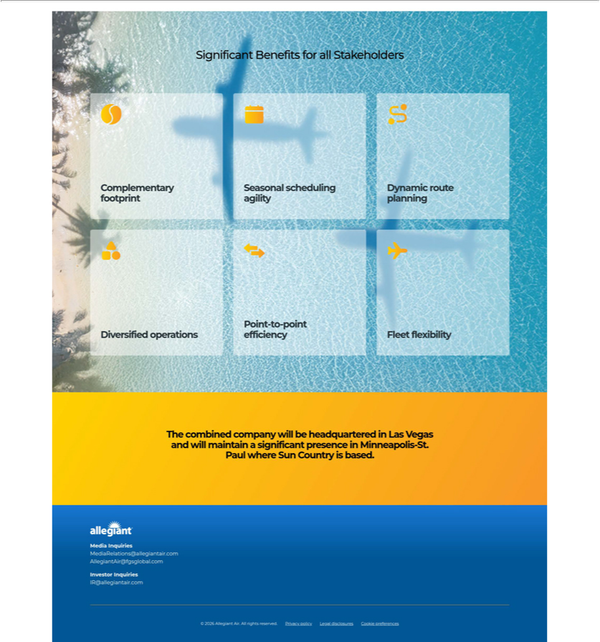

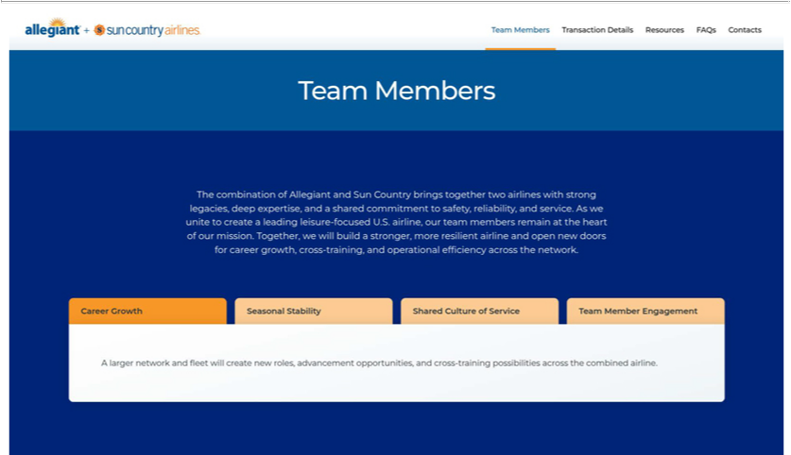

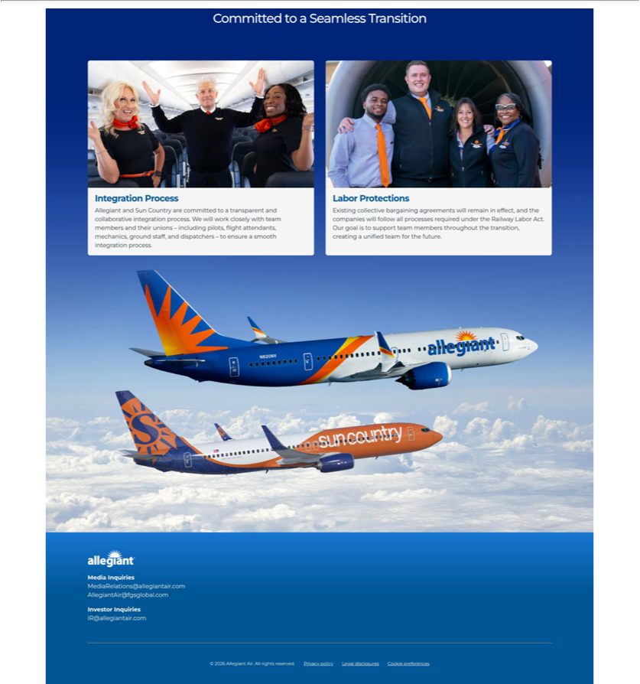

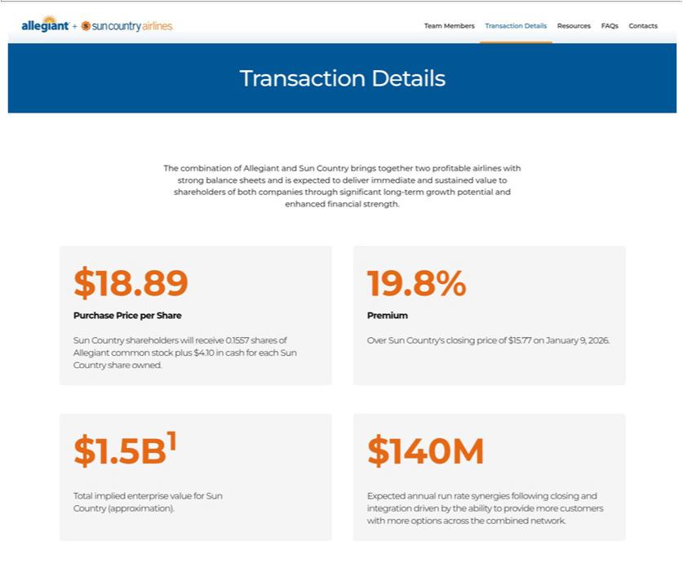

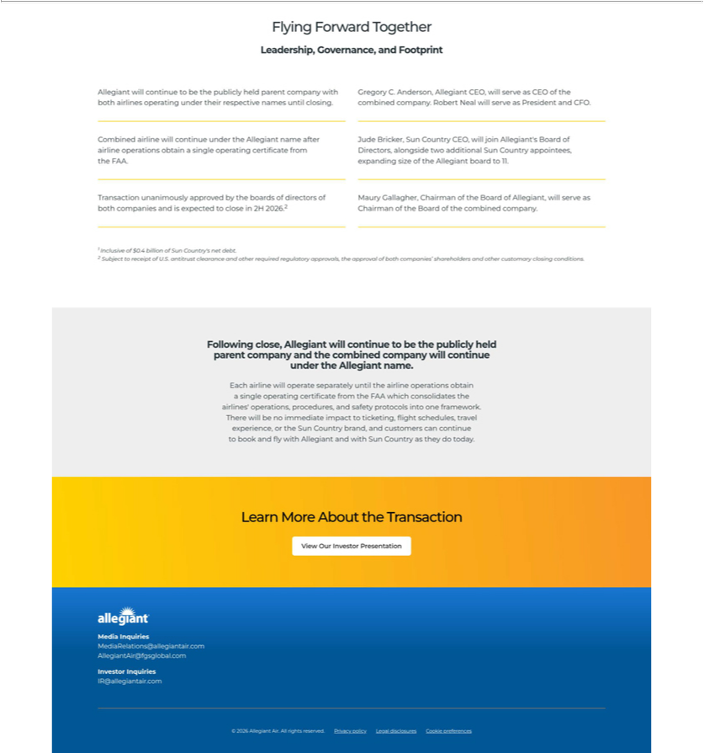

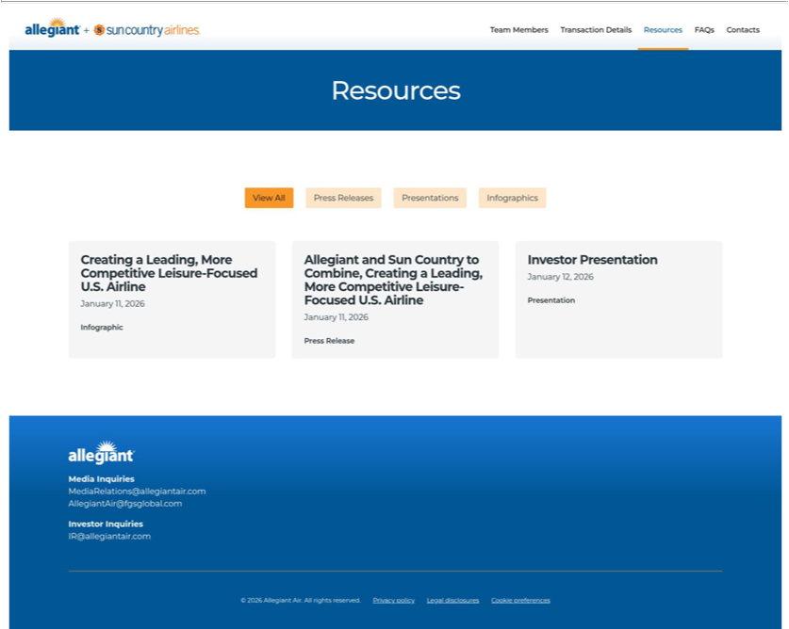

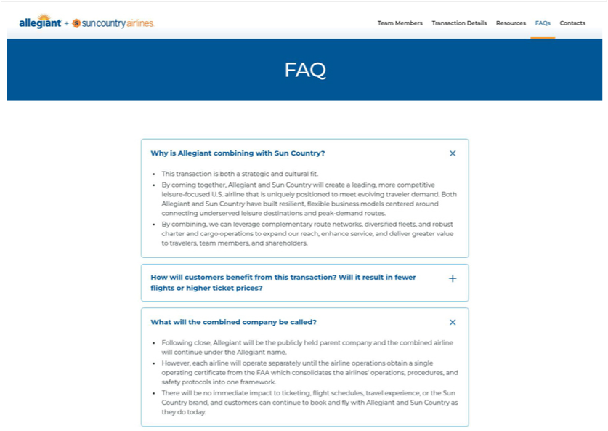

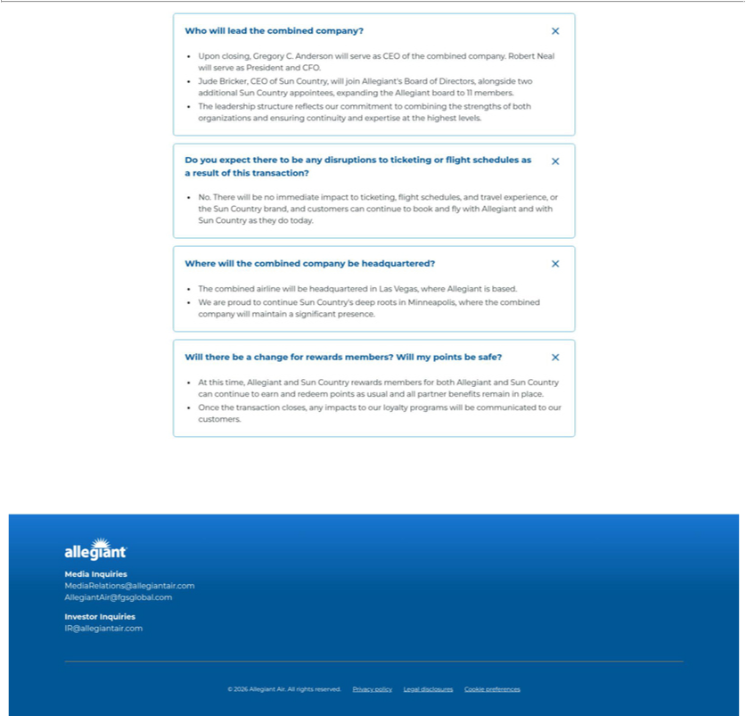

Cautionary Statement Regarding Forward-Looking Statements

This communication contains forward-looking statements under the safe harbor provisions of Section 21E of the Securities Exchange Act of 1934, Section 27A of the Securities Act of 1933 and the Private Securities Litigation Reform Act of 1995. Forward-looking statements include all statements that are not historical facts and often can be identified by the use of forward-looking terminology such as the words “believe,” “expect,” “guidance,” “anticipate,” “intend,” “plan,” “estimate”, “project”, “hope” or similar expressions. Forward-looking statements in this communication are based on Allegiant’s and Sun Country’s current expectations, estimates and projections about the expected date of closing of the proposed transaction and the potential benefits thereof, their respective businesses and industries, management’s beliefs and certain assumptions made by Allegiant and Sun Country, all of which are subject to change. Forward-looking statements in this communication may relate to, without limitation, the benefits of the proposed transaction, including future financial and operating results; the parties’ respective plans, objectives, expectations and intentions; the expected timing and likelihood of completion of the proposed transaction; expected synergies of the proposed transaction; the timing and result of various regulatory proceedings related to the proposed transaction; the ability to execute and finance current and long-term business, operational, capital expenditures and growth plans and strategies; the impact of increased or increasing transaction and financing costs associated with the proposed transaction or otherwise, as well as inflation and interest rates; and the ability to access debt and equity capital markets.

Forward-looking statements involve risks, uncertainties and assumptions that could cause actual results to differ materially from those expressed in any forward-looking statements. Accordingly, there are or will be important factors that could cause actual results to differ materially from those indicated in such statements and, therefore, you should not place undue reliance on any such statements and caution must be exercised in relying on forward-looking statements. Important risk factors that may cause such a difference include, but are not limited to, the following: the occurrence of any event, change or other circumstance that could give rise to the right of one or both of the parties to terminate the definitive merger agreement for the proposed transaction; the risk that potential legal proceedings may be instituted against Allegiant or Sun Country and result in significant costs of defense, indemnification or liability; the possibility that the proposed transaction does not close when expected or at all because required stockholder approvals, required regulatory approvals or other conditions to closing are not received or satisfied on a timely basis or at all (and the risk that such regulatory approvals may result in the imposition of conditions that could adversely affect the combined company or the expected benefits of the proposed transaction); the risk that the combined company will not realize expected benefits, cost savings, accretion, synergies and/or growth from the proposed transaction or that any of the foregoing may take longer to realize or be more costly to achieve than expected; disruption to the parties’ businesses as a result of the announcement and pendency of the proposed transaction; the costs associated with the anticipated length of time of the pendency of the proposed transaction, including the restrictions contained in the definitive merger agreement on the ability of each of Sun Country and Allegiant to operate their respective businesses outside the ordinary course consistent with past practice during the pendency of the proposed transaction; the diversion of Allegiant’s or Sun Country’s respective management teams’ attention and time from ongoing business operations and opportunities on acquisition-related matters; the risk that the integration of Sun Country’s operations will be materially delayed or will be more costly or difficult than expected or that Allegiant is otherwise unable to successfully integrate Sun Country’s businesses into its businesses; the possibility that the proposed transaction may be more expensive to complete than anticipated, including as a result of unexpected factors or events; reputational risk and potential adverse reactions of Allegiant’s or Sun Country’s customers, suppliers, employees, labor unions or other business partners, including those resulting from the announcement or completion of the proposed transaction; the dilution caused by Allegiant’s issuance of additional shares of its common stock in connection with the consummation of the proposed transaction; a material adverse change in the business, condition or results of operations of Allegiant or Sun Country; changes in domestic or international economic, political or business conditions, including those impacting the airline industry (including customers, employees and supply chains); Allegiant’s and Sun Country’s ability to successfully implement their respective operational, productivity and strategic initiatives; the outcome of claims, litigation, governmental proceedings and investigations involving Allegiant or Sun Country; and a cybersecurity incident or other disruption to Sun Country’s or Allegiant’s technology infrastructure.

Forward-looking statements in this communication are qualified by and should be read together with, the risk factors set forth above and the risk factors included in Allegiant’s and Sun Country’s respective annual and quarterly reports as filed with the Securities and Exchange Commission (the “SEC”), and readers should refer to such risks, uncertainties and risk factors in evaluating such forward-looking statements. In addition, the risk factors discussed above are not exhaustive and they, along with other risk factors, will be more fully discussed in the registration statement and joint proxy statement/prospectus to be filed with the SEC in connection with the proposed transaction.

The forward-looking statements in this communication are made only as of the date they were first issued, and unless otherwise required by applicable securities laws, Allegiant and Sun Country disclaim any intention or obligation to update or revise any forward-looking statements, whether as a result of new information, future events, or otherwise.

Important Additional Information and Where to Find It

In connection with the proposed transaction, Allegiant intends to file with the SEC a registration statement on Form S-4 (the “Registration Statement”), which will include a prospectus with respect to the shares of Allegiant’s common stock to be issued in the proposed transaction and a joint proxy statement for Allegiant’s and Sun Country’s respective stockholders (the “Joint Proxy Statement/Prospectus”). The definitive joint proxy statement (if and when available) will be mailed to stockholders of Allegiant and Sun Country. Each of Allegiant and Sun Country may also file with or furnish to the SEC other relevant documents regarding the proposed transaction. This communication is not a substitute for the Registration Statement, the Joint Proxy Statement/Prospectus or any other document that Allegiant or Sun Country may file with the SEC or send to their respective stockholders in connection with the proposed transaction. INVESTORS AND SECURITY HOLDERS OF ALLEGIANT AND SUN COUNTRY ARE URGED TO READ

THE REGISTRATION STATEMENT AND THE JOINT PROXY STATEMENT/PROSPECTUS INCLUDED WITHIN THE REGISTRATION WHEN THEY BECOME AVAILABLE, AS WELL AS ANY OTHER RELEVANT DOCUMENTS FILED WITH THE SEC IN CONNECTION WITH THE PROPOSED TRANSACTION OR INCORPORATED BY REFERENCE INTO THE REGISTRATION STATEMENT AND THE JOINT PROXY STATEMENT/PROSPECTUS (INCLUDING ANY AMENDMENTS OR SUPPLEMENTS THERETO), BECAUSE THEY WILL CONTAIN IMPORTANT INFORMATION REGARDING ALLEGIANT, SUN COUNTRY, THE PROPOSED TRANSACTION AND RELATED MATTERS. Investors and security holders of Allegiant and Sun Country may obtain free copies of these documents and other documents filed with the SEC by Allegiant or Sun Country through the website maintained by the SEC at http://www.sec.gov or from Allegiant at its website, https://ir.allegiantair.com/financials/sec-filings/default.aspx, or from Sun Country at its website, https://ir.suncountry.com/financials/sec-filings. Documents filed with the SEC by Allegiant will be available free of charge by accessing Allegiant’s website at https://ir.allegiantair.com/financials/sec-filings/default.aspx, or alternatively by directing a request by mail to Allegiant’s Investor Relations department, 1201 North Town Center Drive, Las Vegas, NV 89144, and documents filed with the SEC by Sun Country will be available free of charge by accessing Sun Country’s website at https://ir.suncountry.com/financials/sec-filings, or alternatively by directing a request by mail to Sun Country’s Investor Relations department, 2005 Cargo Road, Minneapolis, MN 55450.

Participants In The Solicitation

Allegiant, Sun Country and certain of their respective directors and executive officers may be deemed to be participants in the solicitation of proxies from the stockholders of Allegiant and Sun Country in connection with the proposed transaction under the rules of the SEC.

Information about the interests of the directors and executive officers of Allegiant and Sun Country and other persons who may be deemed to be participants in the solicitation of stockholders of Allegiant and Sun Country in connection with the proposed transaction and a description of their direct and indirect interests, by security holdings or otherwise, will be included in the Joint Proxy Statement/Prospectus, which will be filed with the SEC.

Information about the directors and executive officers of Allegiant, their ownership of Allegiant common stock and Allegiant’s transactions with related persons can also be found in the Allegiant Annual Report and Allegiant’s definitive proxy statement in connection with its 2025 annual meeting of stockholders, as filed with the SEC on Schedule 14A on April 30, 2025 (the “Allegiant 2025 Proxy Statement”), and other documents subsequently filed by Allegiant with the SEC, which are available on its website, https://ir.allegiantair.com/financials/sec-filings/default.aspx. Such information is set forth in the sections entitled “Proposal No. 1 – Election of Directors”, “Proposal No. 2 – Advisory (non-binding) Vote on Executive Compensation”, “Proposal No. 3 – Approval of Amendment to Allegiant 2022 Long-Term Incentive Plan to Increase Number of Shares Available”, “Executive Compensation” and “Related Party Transactions” of the Allegiant 2025 Proxy Statement. To the extent holdings of Allegiant common stock by the directors and executive officers of Allegiant have changed from the amounts of Allegiant common stock held by such persons as reflected therein, such changes have been or will be reflected on Statements of Change in Ownership on Form 4 filed with the SEC, which are available at https://www.sec.gov/edgar/browse/?CIK=1362468&owner=exclude under the tab “Ownership Disclosures”.

Information about the directors and executive officers of Sun Country, their ownership of Sun Country common stock and Sun Country’s transactions with related persons can also be found in the definitive proxy statement for Sun Country’s 2025 annual meeting of stockholders, as filed with the SEC on Schedule 14A on April 25, 2025 (which is available at https://ir.suncountry.com/financials/sec-filings), and other documents subsequently filed by Sun Country with the SEC. Such information is set forth in the sections entitled “Proposal 1– Reelection of Directors”, “Proposal 2 – Non-binding (Advisory) Vote to Approve the Compensation of Our Named Executive Officers”, “Executive Compensation”, “Certain Relationships and Related Person Transactions” and “Security Ownership of Certain Beneficial Owners and Management” of such definitive proxy statement. Please also refer to Sun Country’s subsequent Current Reports, as filed with the SEC on Form 8-K on September 22, 2025 (which is available at https://ir.suncountry.com/financials/sec-filings) and on October 30, 2025, regarding subsequent changes to Sun Country’s Board of Directors and executive management following the filing of such definitive proxy statement. To the extent holdings of Sun Country common stock by the directors and executive officers of Sun Country have changed from the amounts of Sun Country common stock held by such persons as reflected in the definitive proxy statement, such changes have been or will be reflected on Statements of Change in Ownership on Form 4 filed with the SEC, which are available at https://www.sec.gov/edgar/browse/?CIK=1743907&owner=exclude under the tab “Ownership Disclosures”.

Free copies of these documents may be obtained as described above.

No Offer or Solicitation

This communication is for informational purposes only and does not constitute, or form a part of, an offer to sell or the solicitation of an offer to sell or an offer to buy or the solicitation of an offer to buy any securities, and there shall be no sale of securities, in any jurisdiction in which such offer, solicitation or sale would be unlawful prior to registration or qualification under the securities laws of any such jurisdiction. No offer of securities shall be made except by means of a prospectus meeting the requirements of Section 10 of the Securities Act of 1933, as amended, and otherwise in accordance with applicable law.

