FILED BY ALLEGIANT TRAVEL COMPANY
PURSUANT TO RULE 425 UNDER THE SECURITIES ACT OF 1933
AND DEEMED FILED PURSUANT TO RULE 14a-12
UNDER THE SECURITIES EXCHANGE ACT OF 1934
SUBJECT COMPANY: SUN COUNTRY AIRLINES HOLDINGS, INC.
COMMISSION FILE NO. 001-40217

The following is a transcript of a town hall meeting held for employees of Sun Country Airlines Holdings, Inc. (“Sun Country”) on February 12, 2026, and an accompanying presentation, regarding the pending acquisition of Sun Country by Allegiant Travel Company (“Allegiant”). A video of the town hall meeting and accompanying presentation was made available beginning on February 16, 2026:

Sun Country Town Hall Presentation

11:00 a.m., 12 February 2026

Wendy Burt (Senior Director, Communications and Brand, Sun Country)

Welcome everybody. Welcome to our Allegiant leaders for coming today and thanks for those of you coming in person and I hope we have a good live stream audience happening too back at the offices.

First of all, I want to just cover the format a little bit. We’ll have presentations from Greg Anderson, the CEO of Allegiant, as we as you learned from our emails about this and then we will take some Q&A from both Sun Country Leaders and Allegiant and we have a tool that we’re using today similar to Microsoft Teams. So I would encourage you all to download the QR code and that will put you into a system to ask your question - to type in your question.

And then we will try to answer as many questions as we get. I’m sure some of the questions will be the same. So we’ll be doing a little bit of curating the questions as quickly as we can to get to what you all want to hear today.

One reminder, if you took a bus over from the hangar from HQ, those buses will depart here at 12:30, so you’ll have a little bit of time if you want to mingle when we’re done with the town hall, but then the buses will leave around 12:30.

Ok, I am going to bring out Jude to talk about who we’re going to hear from today.

Jude Bricker (CEO, Sun Country)

Thank you, everybody.

So I’m before the main event. I just wanted to give you a couple thoughts on why this is such a great thing. And I’ve had town halls with all of you guys and hopefully you’ve afforded yourself the ability to hear me talk about why this is happening and why it makes such good sense.

You probably know I’ve spent some time in Allegiant. I just want to give you a couple thoughts on that business and why it’s so special and talk a little bit of shit about the management team.

So first of all, I think there were two really impressive stories in aviation since the turn of this century and one is Sun Country and we went from the worst performing airline in 2017 to the best performing airline by operating margin today, or EBITDA margin. Delta beat us this past year, but it was really a fantastic turnaround. We really become even more vital to the community we serve. It’s such a great story and I’m obviously proud of all the work you guys have done in the pursuit of that.

The other one is Allegiant. Allegiant was a two-airline operator and not too dissimilar from Sun Country right after September 11th, trying to get by with a charter program that was supporting Caesar’s at the time, or Harrah’s at the time, and from that basis they became what they are today with 125 some-odd airplanes. We were an MD-80 operator and then a 757 operator, and now a 320 and 737 operator touching nearly every state with 525 markets. It’s a national presence and I think those two stories are just the standouts of the 2000s and airlines in the US.

And now we’re putting those two businesses together and I think it’s great. And I think we should all be really excited about what the future holds because a lot of the people that sometimes we talk about as competitors like Spirit and Frontier are fading away. And that’s going to mean, you know, now with our national presence, the opportunity for this airline is really, really exciting for growth, for advancement for each of us. I think it’s going to be really, really great.

I’m introducing Greg. Greg and I worked together at Allegiant, before I came here to Sun Country. He is just a fantastic human being, which I think is a requirement to be a good CEO. He’s a great father to his kids and I think I’m just really excited to see where he takes us in the future. And I hope, as I will, that you also extend him your support. He’s a really fantastic guy. And with that, Greg, why don’t you come up?

Greg Andreson (CEO, Allegiant)

Jude, thank you so much. It has been such a privilege over the past few months working closely with you again and I can’t thank you enough for the continued support. We appreciate that so much. And thank you everybody for coming out, taking time out of your busy day to come over and hear what we have to say. We really appreciate it. It means a lot.

And before I get started, I want to brag on Jude a little bit. Jude and I go back quite a bit. I think I’ve known Jude roughly 20 years. And I can say this confidently that there’s few people that have helped shape my career in the right ways like Jude did. And I have several examples that I could provide, but I want to just hit on one, and that’s when I started at Allegiant or shortly thereafter, this is about 2010. I was in the accounting department. Jude was in the corporate finance and he was the treasurer at the time, about 2010-ish and we were working on our very first corporate bond and going out to the capital markets.

And Jude, I knew him from before. I was an auditor at EY auditing Allegiant. So I knew Jude from before. And he came up to me and said, hey Greg, we’re doing this bond, this corporate bond. And what do you think about being the book runner and helping out with it? I said, Jude, I love books. I think this is great. Let’s do this. And he said, whoa, let me just explain to you what the role is a little bit more. And it’s a lot of grunt work, a lot of chasing signatures, a lot of ticking and tying and just kind of working behind the scenes. But it’s a lot of work. I said, Jude, I’m in, let’s do it. I’m honored that you asked me to do this. And then he said, well, there’s more to it though, Greg. You don’t report to me, so you have to maintain your current responsibilities within accounting. You cannot slough on those. So that means you’re going to have to work late nights and you’re going to have to work weekends. By the way, you’re not going to get paid for it. What you’re going to get paid is the opportunity to work closely with our bankers and with me. I said, Jude – that’s a true story – I said Jude, I’m in. And he said OK and then boy, was he right, the opportunities I had throughout that process to learn to understand better about the capital markets.

But what it really set up is for the next seven years, I got to work more closely with Jude and other members from the management team and learn and listen. And I’ll tell you what they lived by then and he still lives by today. And I see this same kind of mantra or foundational characteristics as I’ve gotten the opportunity to work with so many of you thus far. It’s pretty simple. Know your stuff, work hard, and do the right thing. And Jude instilled that in so many of us at Allegiant. And the company is much stronger as a result of that and others on the leadership team.

But what I’d say is as we fast forward and we’re here today, I continue to see that – I’ve had the opportunity two weeks ago. We were able to come out and visit and meet many of you and see what operations you have here. And it was the same vibe. Know your stuff, work hard and do the right thing. We saw that. And as we think about the combined company, as I think about it, I get more and more energized seeing the culture you built. Eric Levenhagen shared with me your employee value proposition. It was very similar in so many ways to how we view it at Allegiant. There was a line in there, I love the choice of words: we are not your average airline. And boy, you’re not your average airline. You are unique, you’re agile, you’re resilient.

And one of the things that I see is the teamwork. You understand that this is the ultimate team sport and it’s about the name on the front of the jersey and not the back of the jersey. And I am so excited to put our two organizations together to continue to build off of our strengths. And so, if we go to the next page, just want to talk about a little bit why we’re here.

We understand that with the integration like this, there’s going to be uncertainty. We know that, but we’re here to talk about a few things to try and provide more detail and transparency to help with that uncertainty. So what we want to do is one update on the progress we’ve made thus far.

I can’t believe it’s already been a month since we’ve announced this transaction. And the teams are hard at work. There’s so many different parallel paths that are being running right now concurrently. But one of the most important things, and you’re going to hear more about it, is the Integration Management Office.

We’re going to talk in a little bit more detail about the IMO. And two, we want to share more on the path ahead. There’s answers that we’re going to be able to share with you today, but there’s also answers we just don’t have yet to your questions. And on top of that, there’s some legalese that restricts us from certain providing certain answers that we have to be mindful of. But our goal and our approach is that we want to make sure that we are providing transparent and up-to-date information when we can.

And last and certainly not least for today, we put a QR code on the screen. I can see it here. We want to hear from you what matters most in your questions. So if you want to take a minute, maybe you already have, and scan that QR code and then submit questions and at the end of the presentations, we’re going to have a live Q&A. And all questions will be anonymous.

So if we want to go to the next slide, just real quick, here’s the lineup. I’m going to kick it off, talk about the why. Michael Broderick is going to come in. He’s our Senior Vice President and Chief Integration Officer for Allegiant. And Michael’s going to come in and talk a little bit more about the how, and the IMO process, which I think is going to be really important. So Michael will come up shortly. After Michael, BJ Neal, who’s here, he’s our president and CFO. He’s going to talk about what to expect and probably as important what not to expect. And then batting cleanup we’ll bring Jude and Eric and everybody back up take your live Q&A. Sound good? All right.

This slide was part of the investor presentation about a month ago. I’m not going to speak to the specifics of this slide. What I think is worth reminding is just the utmost respect for what you have built, that we have for Sun Country and what you’ve built in the special company that you have.

And this integration is about building on strengths, not weaknesses. I thought Jude’s opening was spot on and we believe that together the sum is greater than the parts and that together we have the opportunity to build off what we have – our complementary strengths, but also distinctive strengths. And if we build off of those strengths then we can unlock more opportunity, more growth and more value. And that’s how we’re imagining this integration and that we can do it together better than when we could do on our own - or more than what we could do on our own.

But what’s been really reassuring for me as I’ve been going through this process, going through and meeting with folks, is the close cultural connection, the shared values that we have.

I believe we’re more similar than we are different. I truly believe that. And I think when we come together with those shared values, we’ll be able to provide better service for those communities that we serve. Just like here in MSP, you have served Minneapolis / Saint Paul for 43 years successfully. This integration is about building on your success, providing more growth, more opportunities and this will be the largest operating base of the combined company and we’re going to continue to make sure that we’re seeing it being strengthened and continue to find success within it.

So if we go to the next page: we’ve already made significant progress since our announcement. Three things I wanted to highlight. One, I already mentioned Michael Broderick. He will be the Chief Integration Officer for Sun Country. Eric Levenhagen has taken on the Chief Integration Officer role. I’m sorry, Michael will be for Allegiant. I think I said Sun Country – I apologize. Eric will take on the role for Sun Country. And exciting that I have an announcement to make right now, which is that Eric has also agreed that post close – so when we get to the close state – Eric will take on the President and Chief Integration Officer role for Sun Country, and we’ll work very closely with Eric. He’s uniquely situated to help us ensure this is a smooth transaction or integration as possible. So Eric, thank you. If you don’t mind, can we give Eric a round of applause?

And Eric and Michael have both been hard at work. They’ve been hard at work recruiting leaders to join the IMO team or the Integration Management Office. Michael will talk and announce who those team members are. But I had the opportunity last week to spend some time with the combined Integration Management Office in Vegas. It was for a kickoff session and it was really energizing to see that the teams come together already hard at work and planning on how we best prepare for this integration. The feedback that I provided, for what it’s worth, I just said, hey, this is about building on strengths in my mind. And so it’s really important that both teams come together. They listen, they learn and they understand where strengths are on this side, where strengths are on that, on our side, both, you know, between the two airlines.

And we protect those strengths and we build on top of them to create an even stronger airline on the other side. And I’m incredibly confident that the IMO team, we got the right people in the right place to execute accordingly.
And then as important as anything is the right plan. I also challenged Michael and Eric, who are leading this integration efforts, that we need to have the most seamless integration ever in aviation history. I think we’re well set up to do that just for some unique characteristics. But we’re not going to do that without the right plan and executing towards that plan. So they’re working closely with the IMO team to put that plan into place and make sure that execution is as solid as we can see it. Because in my view, the better the execution, the better the experience is going to be for all team members being impacted.

So that’s really important that we that we hit on the execution front. So if we go to the next slide.

Throughout this process, we will be led by three different principles. One, first and foremost, stability.

We want to make sure that we don’t disrupt what we’re doing operationally, what we’re doing. We’re both financially healthy. We don’t need to disrupt that. Let’s continue to operate the way we’re both operating. Let’s take care of our customers and make sure that we’re building on strength, that there’s going to be no harm as we move this together.

On the on the middle point here, the fairness and transparency, this is going to be a process. There’s going to be a lot of decisions that are going to be made. Most of these decisions will be made through the IMO team. And when we were talking last week and I had the opportunity to hear and learn more from them, what’s really important and what I love and how they’re setting up the framework is that as they go through and make decisions, these are going to be informed decisions based on data, based on information to get to the right point that’s going to be debated because what’s inevitably going to happen, certain decisions are going to be made that not everyone’s going to agree with, but what’s important is that at least we’ll be able to explain why we made such decisions and then in an effort to hopefully align with those decisions. Really like what the team’s setting up in terms of their process though in the decision making throughout this integration and this journey of an integration which is going to be a multi year journey.

And last but not least on this page the disciplined execution. It’s incredibly important that we execute with discipline because discipline will lead to predictability, which will lead to consistency. As we go through this process, we have to do what we say and say what we do. We have to earn credibility each and every day from all from all stakeholders. So that discipline is going to be incredibly important and the team’s definitely up for the for that.

So I’m going to end on this slide and bring up Michael shortly after. But talking with Eric and Rose and other members from the management team, we know there’s questions that are important to you. We have some of those answers today.

One on severance, we understand that there’s going to be changes in the combined company. There will be severance. That is going to happen. If there’s a change, there will be severance. I don’t have the exact details. We’ll roll that out in March. This is more towards corporate team members.

We think from the line – the front line there – we expect no impact in terms of positions just given the unique natures of bases, domiciles. So we don’t expect impact on the front line, but from corporate there will be and that leads into the relocation. We expect corporate roles to primarily, if not all, be based in Las Vegas. We expect to be able to offer the majority of the folks on the corporate side roles in Las Vegas. We don’t know that’s going to be the right fit for you though. We understand that and if it is, there will be relocation assistance provided and we’re not going to ask you to move day one post closed. We’re going to give a proper time frame so that you can move in an appropriate time manner and not disrupt to the level that we want to avoid. We want to make sure it’s a smooth opportunity to move to Vegas. But if you choose not to, if you’re offered a role in corporate and you choose not to accept that role, we understand and the severance will still be there. So that’s still going to be there. We want to make sure we’re making it as a soft transition as we can. And last but certainly not least, I hit on this a little bit before, but for the combined company, the Twin Cities are going to be our largest operating base.

We want to continue to use our strengths, combined strengths to grow and improve and strengthen. You’ve done a terrific job, and what this is about is building on those strengths. Eric mentioned to me, is there any plans of shrinking MSP? Absolutely not. It’s the opposite. And if we have frontline team members and T2 that have asked what are we going to do with our roles there, we are not looking to outsource anything. Everything is staying as is. You have built a very successful business here. We don’t want to mess with that. So I’m going to pause there. I’m going to ask Michael Broderick to join me on the stage. Michael will talk about the IMO, and if you would do me a huge favor and give Michael a warm round of applause.

Michael Broderick (Chief Integration Officer, Allegiant)

Thank you, Greg. It’s my pleasure to be here today. I thought I’d start off my remarks and just give a brief introduction. So I’ve been at Allegiant for nine years and I’ve been in the airline industry for almost 20. And one of the best things about being in the airline industry, as I’m sure you all will attest is the enhanced ability to travel. I’ve had the opportunity to take my family on many adventures. I have a large family, I have five children, and whenever I mentioned travel with so many children, a look of horror and shock comes over people’s faces and say, well, do you travel standby with them?

And the answer is yes. You can believe me when I say that there’s no sweeter sound to hear when you’re at an airport waiting for seat assignment than to hear, “Broderick, party of seven. Please come up.”

What’s funny about this process, though, is that when this happens, the kids look up from their devices and they’re like, finally. And what they don’t realize is like, that was a miracle that just happened.

So today I want to give an overview of the Integration Management Office or the IMO, and I want to focus on five areas of focus that we’re going to be working towards. The first is leading our preparation for day one, or deal close. This is the same term. And what this means is that when the deal is regulatory-approved, we will become one legal entity. And it’s important that process happens smoothly. And so we’ve already begun planning and preparation towards that day.

The second is to ensure that we are following all the legal and regulatory compliance guidelines and rules out there.

The third is minimal disruption for our customers. You’ve heard Greg speak about this. Both Allegiant and Sun Country have earned great reputations with their customer base for solid operations and great frontline customer service. We don’t want to undermine the goodwill that so many of you have labored over many years to achieve, and as a result, that’s a guiding principle for us, that we’ll have minimal disruption for our customers. Fourth is to foster a world-class culture. We’ve known about the results that you all have achieved here and as Greg mentioned and I’ll echo that, the culture that has built that is very impressive. And as I’ve had an opportunity to meet some of you over the last month or so, I’ve been really impressed with that culture and that sense of teamwork and that pride in what you’ve done. And that’s really going to be one of the most gratifying aspects about working on in the IMO is to build on the strengths of both cultures as we as we embark on this new airline and embark on being the leading leisure airline in the United States.

Fifth and finally, we know this process will introduce a lot of questions and uncertainty, and the role of the IMO is to provide you those answers in that clarity. We’ll explain what’s happening, when it’s going to happen, what will happen next to ensure that you have the clarity that you need as we move forward together.

So I want to spend a minute and talk about how we’re going to organize our efforts for the integration. And what I can explain or say up front is what it will not be. So the integration will not be run by a select few number of individuals making all the decisions for the airline, but rather what it will be is empowering existing leaders from both organizations. As we break down the topics and the work that needs to happen for the integration, we’ll leverage the experienced team members on both sides to work on those respective plans and enable them to make decisions. At times those decisions will need to funnel up through Greg, but the majority of the decisions and the recommendations will happen with the existing leadership as they work on their respective work streams.

I want to take a moment now to introduce both integration teams. As the Allegiant team is not or mostly not here today, I’ll introduce them in summary. We have something like 100 years of combined airline experience working in the integration office and these range from finance, fleet, supply chain, operations, communication, program management and many others. And on the Sun Country side, it’s equally as impressive, spanning something like 60 years of combined airline experience from many of the same topics that I mentioned, including people, leadership, customer communication, legal, operations, technology and many others.

And I wanted to just take a moment to recognize the members of the Sun Country IMO team. So as I read your name, invite you to stand up so you can be recognized by your peers. Of course, we’ll have Eric as the integration leader for Sun Country.

I didn’t warn them of this, by the way. So: Sheena Henry. Molly Murphy - not here. Roy Fan. Bridgette Toufar. Holly Buck. Taylor Davis - on vacation as well. Great time to be on vacation in Minnesota, I’ve heard. Chris Corona – there in the back. Rose Neale. Brian Scudds. And Chris Maccarone.

As Greg mentioned, we had an opportunity to have most of that team on site at Allegiant headquarters last week and it was really our privilege to get to know this team better.

As the integration spans multiple years, I wanted to just take a moment to explain how that process will work and how we think about it in its distinct phases. So we’re currently in phase one, the integration setup and blueprint phase. And as that name implies, this effort is really about organizing how we’re going to work. So we’re standing up both integration offices. We’re designing these guiding principles that will inform how we’ll make decisions as we move along through this journey.

Phase one will conclude at the end of February and then we’ll move into phase two, the design detail planning and day one readiness phase. And again, as this name implies, this is where we start to put together the plans for both day one readiness, but also for how we’ll begin the sequence of integration steps that will happen after we close.

In phase three, that happens once the deal is approved and we close, this is where you’ll start to see the integration happening. So we’ll start to see the integration of the operation, integration of teams, integration of tools and systems. And one thing that I want to be very clear on as we begin this integration is there are two important principles that we will not violate. The first is we will never move at a pace which jeopardizes safety. That’s top of mind, and the top concern that the integration will ensure that we do not move at any pace that makes anybody feel unsafe in the operation. Second is again around this principle of minimal disruption for our customers. We want to ensure that not only are we not impacting our customers, but also that we’re not disrupting our team members who have to go out and serve customers every day.

Moving on to phase four, once we finally integrated, we’ll be truly one airline and so you’ll see us operating with a single operation, one set of tools and as one team. And as this combined airline, we’ll have an enhanced strength and be able to offer a greater customer proposition than what either airline could offer customers independently. Also, as a combined airline and this increased strength, we’ll be able to offer our team members growth opportunities again at a greater pace than what either airline could have offered independently.

Now I want to conclude my remarks and just hit upon three other milestones that may be top of mind as we go through this integration process. The first is to again highlight what Greg said about severance. So we know this is an important topic we want to try to put minds at ease as much as we can about that. And the principles that we’re working on as worth as we’re designing the severance is about being fair and transparent and ensuring that we’re honoring the contributions that for those people who elect not to move to Vegas, that they were honoring their contributions that they built and helped make Sun Country what it is today.

The second important milestone is Single Operating Certificate, or SOC as you might hear it. This is where truly the airlines can start to begin operating as one operation. And as this is an important effort, we’re going to be starting our planning and efforts on this in the next coming weeks. Both teams will nominate a number of subject matter experts from the various areas of the operation to ensure that we’re making the plans necessary to one day become a single operation.

And then finally is around brand. Again, just to repeat, we have tremendous respect for the Sun Country brand and we know the amount of effort and dedication it takes to earn the respect that the customers have for the Sun Country brand and what it means to them. As we project forward, we’ve decided that it’s important to be able to clearly communicate the value proposition to our customers of the combined airline in an efficient way. And as a result of that, we’ve decided to have just one brand moving forward, at a future date, and that will be the Allegiant brand.

Now when we get there, we’ll offer up more information about how that will look. But in the interim, we’re going to operate as both distinct brands for the foreseeable future.

Now I want to now turn the time over to BJ Neal, our President and CFO, who’s going to give us some more information about what changes to expect in the short term and what things are going to remain the same.

Robert “BJ” Neal (President and CFO, Allegiant)

Thanks, Michael. Hi, everybody. I’m BJ, President and CFO at Allegiant. Just want to start by telling you what a true honor and privilege it is to be here today and be working on this with all of you. Going through this process I’ve had a really incredible opportunity to get to know some of your leaders, to have a tour of the Minneapolis operation. What you all do here is impressive and extremely respectable. I’m really looking forward to working together on this.

Before I jump into the slides, just get a little bit of background on myself. So I’ve been at the company about 18 years. I started in our airport affairs group and then I managed our charter business for a little while and then I moved over to the fleet planning department where I spent about 10 years before I started taking on additional roles in various areas of finance. It was in the fleet planning group where I was actually recruited by Mr. Jude Bricker. I got to learn all the ropes of buying and selling used airplanes, traveling around the world looking for MD-80s that essentially no one else wanted anymore. Eventually we did some 757s and then our first A320 transactions. I had planned to come up here and tell you some stories about being on the road with Jude looking for these airplanes. But as I was thinking through it, I realized that most of the mishaps were greater unfortune to me than they were to Jude. So I won’t go through all of them, but I will tell you there was one with three guys, one hotel room and one bar of soap. So with that, let’s get into this slide.

So Greg came up and he gave you the why he talked about the strategic rationale for the combination. Michael gave a lot of detail on how we’re going to do this and how we’re going to integrate successfully. I’m going to take just this one slide to tell you what you can expect on day one, so immediately on the financial or the legal close, and then what we will evolve overtime.

So we’ll just go through the list here. The first is business continuity. We’ve talked at length about that already today. Both airlines are running strong businesses, strong operations and putting up industry leading margins. There’s no reason for us to disrupt that.

Next on the list is customer service, which is potentially the most critical, one of the most critical pieces of business continuity. Sun Country has earned a reputation here for reliable and friendly customer service. Again, there’s just no reason to disrupt that, as Michael said. We’re going to move at the right pace to allow for minimal disruption and to allow for that customer service to continue to be felt, especially here in your home market of Minneapolis.

One that I know is important to everybody in this room: pay and benefits for team members. So on day one, we don’t expect any changes to benefits or compensation programs for anybody on the Sun Country or Allegiant side. Now over time you can imagine as we do integrate the organization, there will be a day when there are new compensation and benefits programs that we’ll need to roll out for the entire population, but I’ve also got to imagine that those bring improvements as we’re a larger combined workforce.

And then as Michael mentioned, there is a plan eventually to transition to the Allegiant brand, but we’re going to do that at the right time. There is not a plan on day one to immediately move away from the Sun Country brand. We know how important that is here in Minneapolis. We know how important that is to all of you.

And Speaking of Minneapolis, as Greg mentioned, Minneapolis is going to be the largest base of operations and I think probably the largest customer origination market. So it is critical that we get that right. So we are not in a rush to do anything with the brand.

OK. So let’s talk a little bit about how that will evolve, or what will evolve over time then.

So first is the organizational structure. So as you can imagine, when we bring the two organizations together to become one, we’re all going to come together under a new organizational structure. Having been through org changes many times at Allegiant, I know sometimes they’re uncomfortable, sometimes they bring uncertainty during the process. But what I would ask you to think about here is just be reminded that this combination is about growth. There was no other airline combination in the US that made as much sense as this one. This is about growing Minneapolis and growing outside of Minneapolis. And when we put these two airlines together, it’s going to be a very, very powerful leisure carrier in the US that I think will create new opportunities for many of us over time that we likely wouldn’t have had in our in our standalone businesses.

Now as we integrate those, as we integrate the organizations, we are going to have to learn how we work together as a single company. We each have our own ways of working. I think Greg talked about how Sun Country does some things really well, Allegiant does some things really well. We have the unique opportunity to play to the strengths of both carriers.

And then lastly is just unification under the Allegiant brand. I already really spoke about this, but I just want to want to assure you that we intend to take the right amount of time to get that done the right way. There’s not a rush to move to the Allegiant brand, but we do think it is important for our customers and really all of our stakeholders, for that matter, to recognize the brand of one large combined entity.

Before I before I hand it back to Greg, just two things I wanted to mention. One is just reiterate what Greg and Michael have said about our commitment to you to be transparent and to be fair throughout the process. There’s nothing more important to us. And then the other thing is just to share my excitement for this combination. I mentioned earlier, there was no combination of two airlines in the US that makes as much sense as this one. Our business models are already largely similar. Sun Country brings a lot of complementary benefit to Allegiant, in particular in my mind in the form of cargo and charter segments and the balance that provides throughout the year. Allegiant brings to the combined entity an aircraft order that has fleet delivery scheduled, many of which are options early into the next part of the decade.

And so together, I just feel really bullish on the opportunity that we have here to be the country’s leading leisure airline. Greg?

Greg Anderson (CEO, Allegiant)

Thank you, BJ. I just have a couple more points to make and then we’ll invite Jude and Eric to join us on the stage to take your questions. On this page, let me just back up. The intent of us coming out and going through the information and hopefully it was helpful to show what the process, how we’re thinking about things and what the process is going to be like. We know there’s still a lot of unanswered questions. But we’re committed to working diligently to get to those answers and providing information timely and being transparent.

But we have a few asks as well, and the first one for you, our ask is continue doing what you do. That’s running a great operation safely and reliably, taking care of your customers, taking care of one another. That’s job one. Two, we introduced the IMO team, the leadership on the IMO team. They’re going to need help. They’re going to ask and come to you for different either items or opinions or views or work. Please support them. Your voice matters and it’s going to be helpful in us shaping the combined company and the culture and the strengths of the combined company. So please support those IMO leads. And we also want to hear from you. So whether it’s through the IMO leads or whether it’s through your manager or there’s an email here: announcements@suncountry.com. Please provide us your feedback. It helps us provide information that may be important to you that we’re not aware of, or it helps us continue to move things forward. So we ask that you be mindful of that and continue to provide us feedback throughout this integration journey.

And the last slide I’ll just talk about is just what to expect in the months ahead. We’ve come out and publicly said that we expect the transaction to close in the back half of the year. Could be sooner, could be later. The team, the integration team is working towards making sure that we’re not caught flat-footed if it comes sooner. But we expect in the back half of the year, in the coming weeks, we’ll file our HSR application with the regulatory bodies. We’ll also file our proxy with the SEC. That’s for shareholder approval, but that’s going to start the process and we’re going to continue to work towards the planning until we get to close and then that’s when day one, that’s when the integration begins post close. And what we’ve asked the IMO team to do, and we’ll just reiterate it one last time, is to continue to provide update and information when we’re ready and it’s available and that includes plans for the combined company. So we’ll continue to find the right format to disseminate this information and keep you appraised.

And with that, I would like to ask or invite Eric Levenhagen and Jude Bricker to join us back on the stage and we’re ready to take your questions.

***

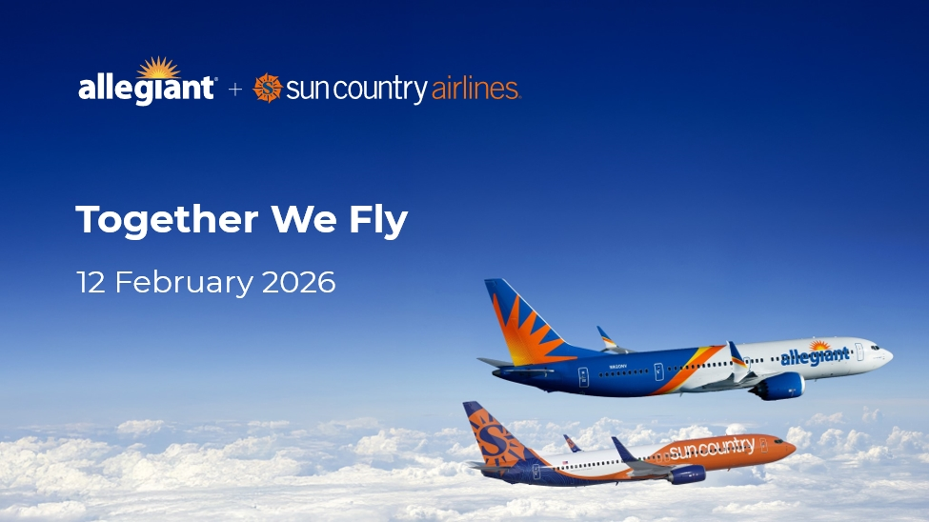

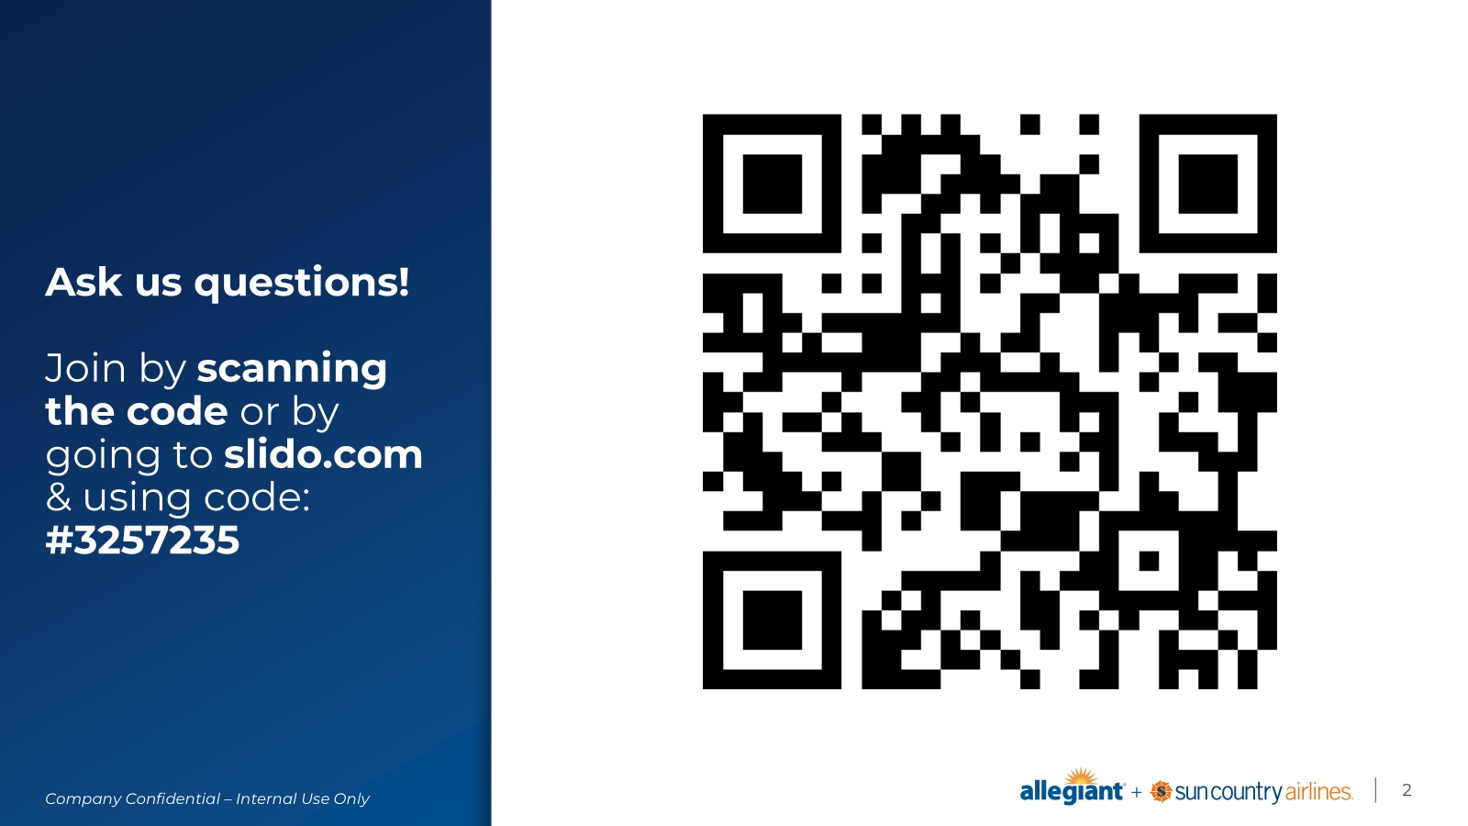

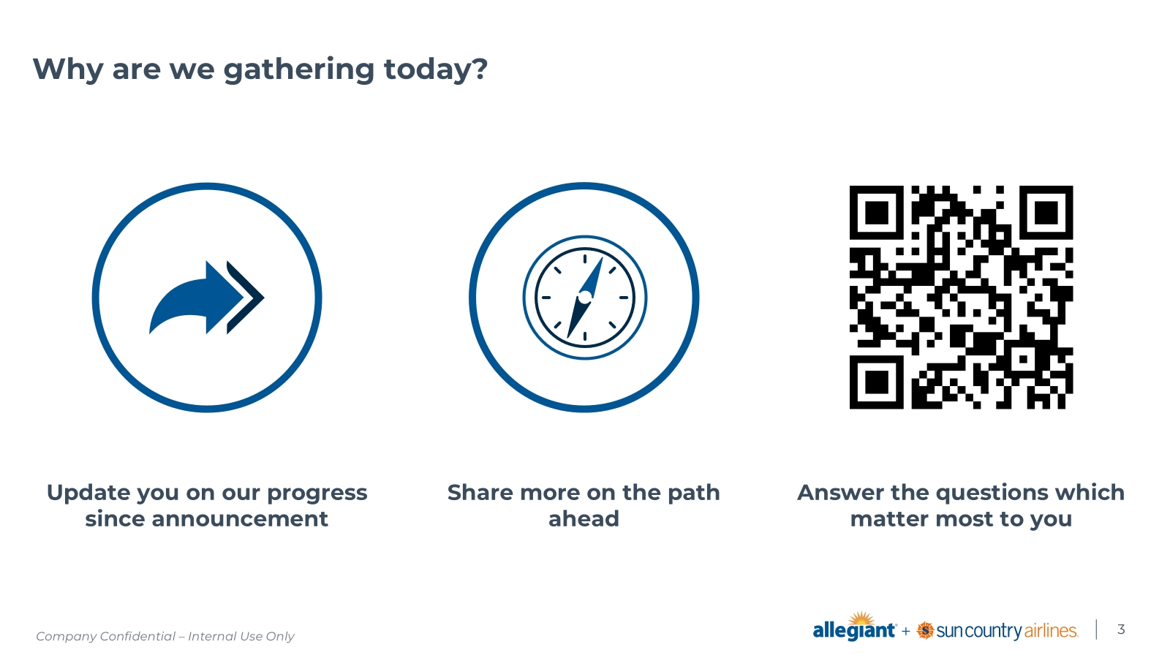

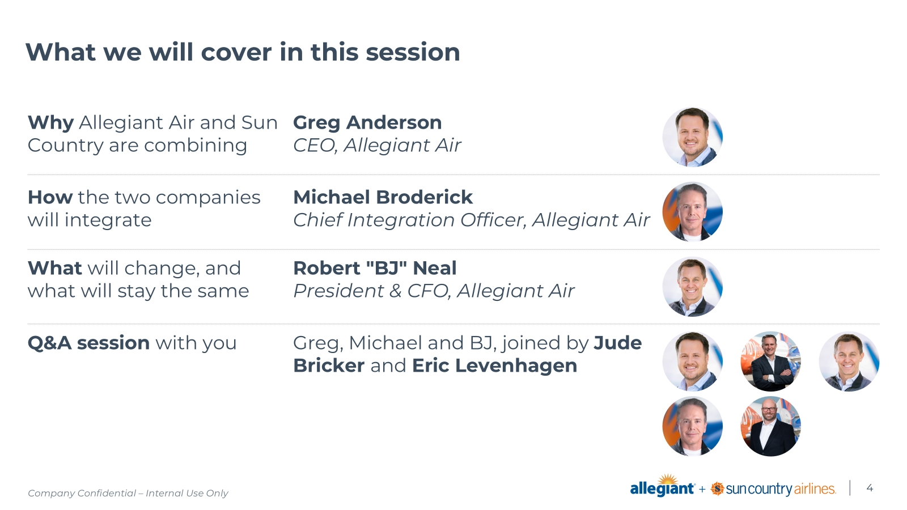

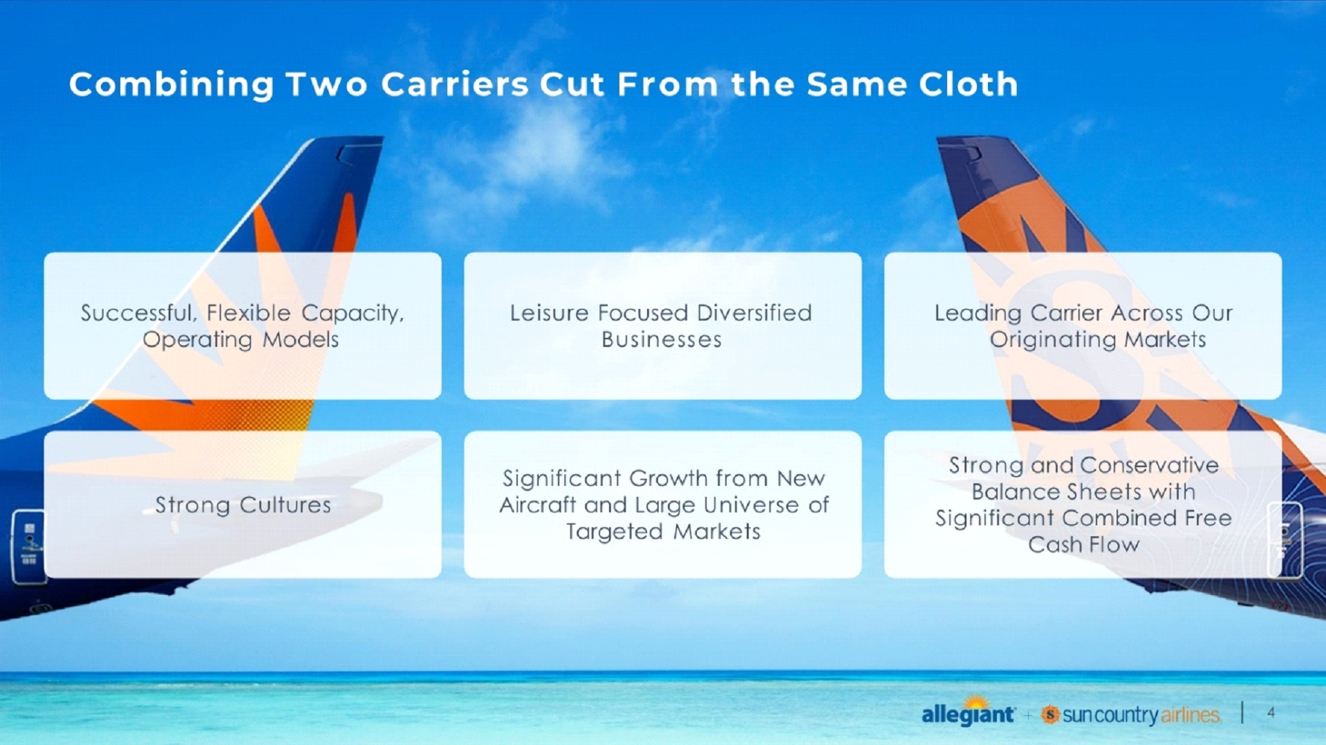

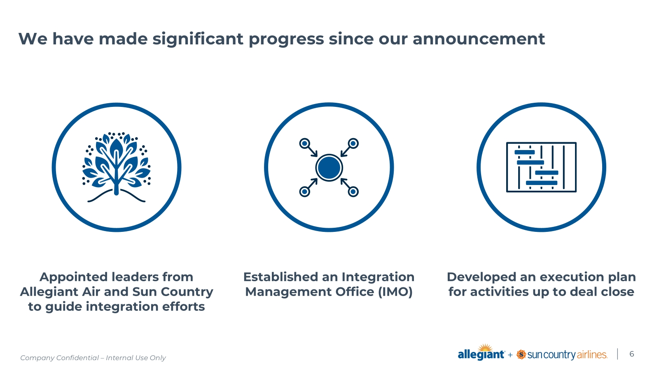

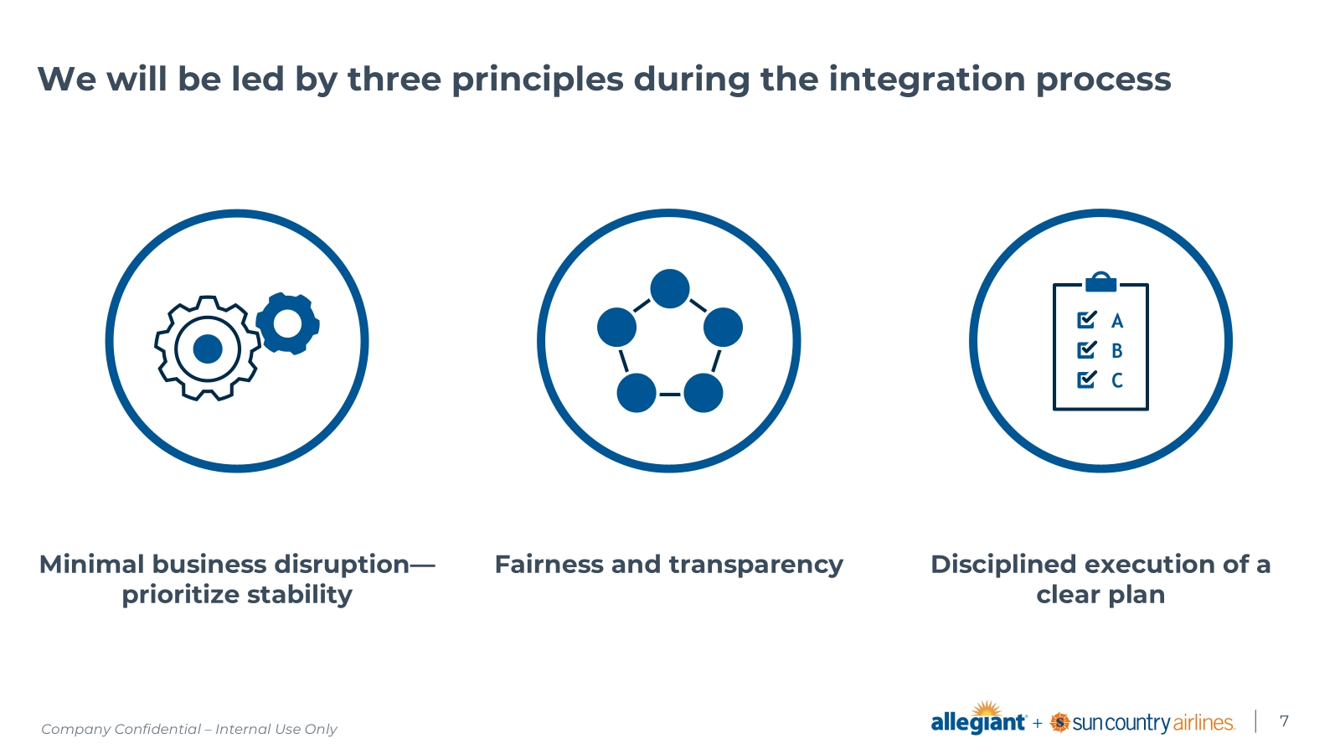

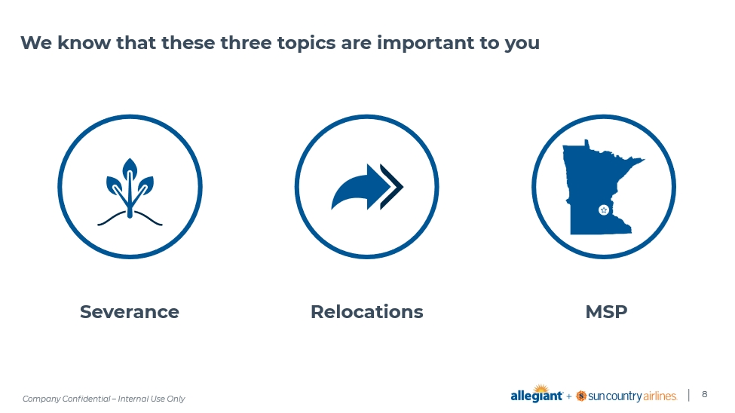

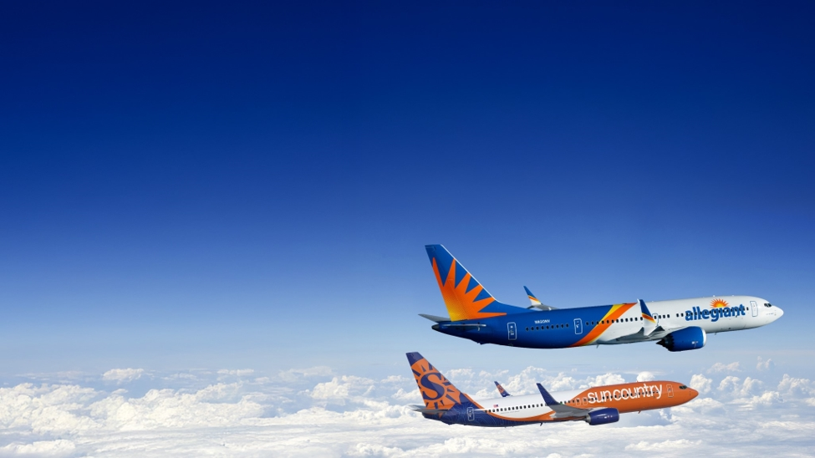

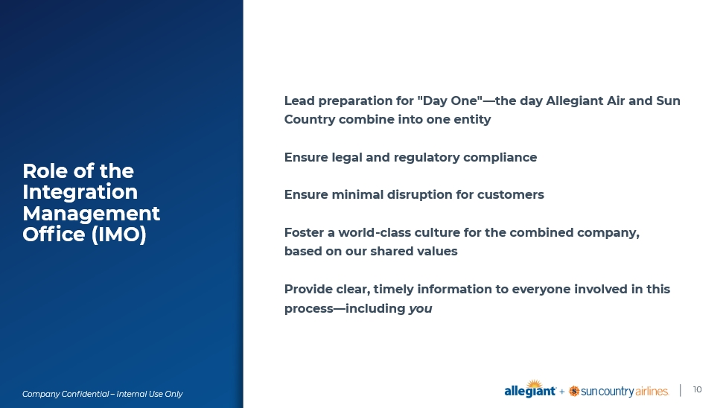

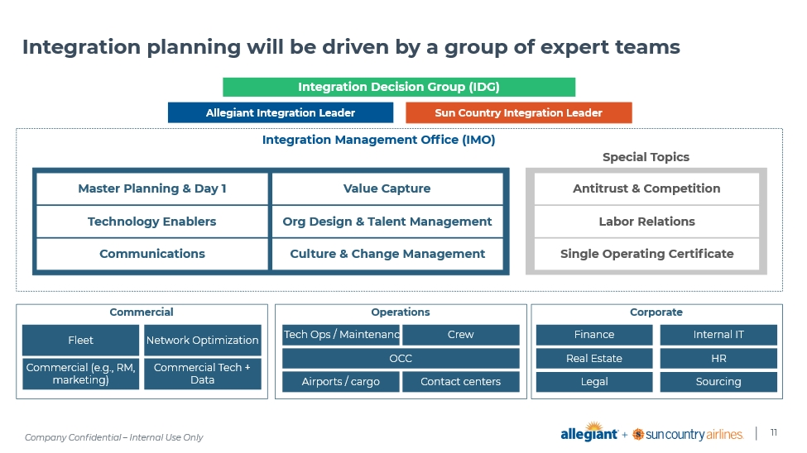

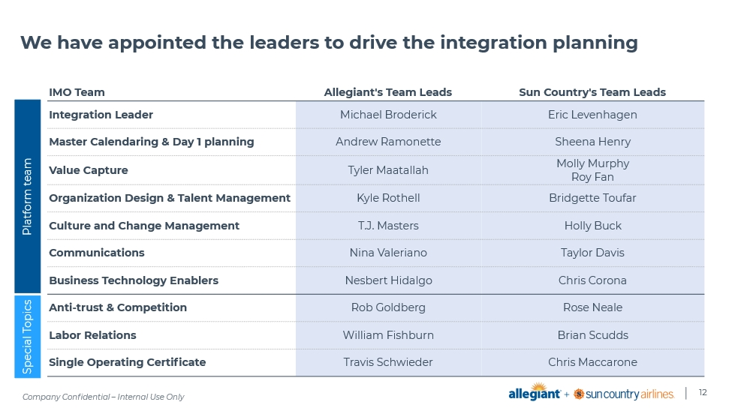

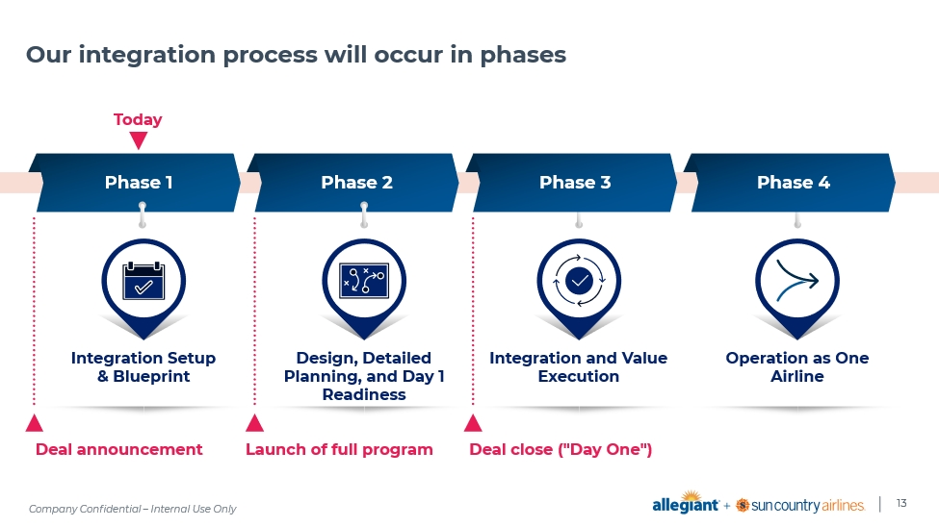

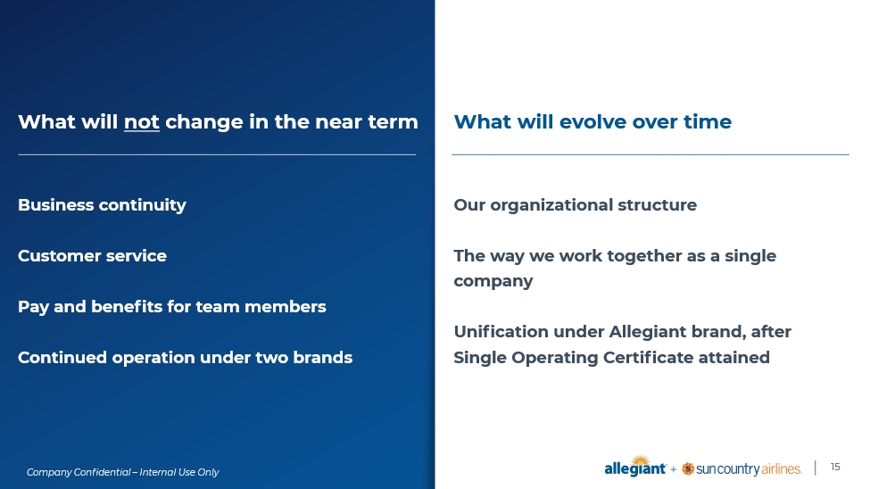

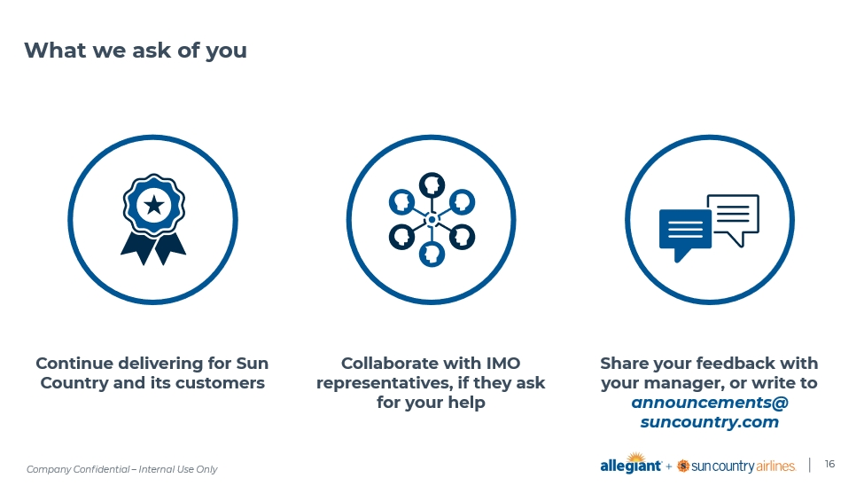

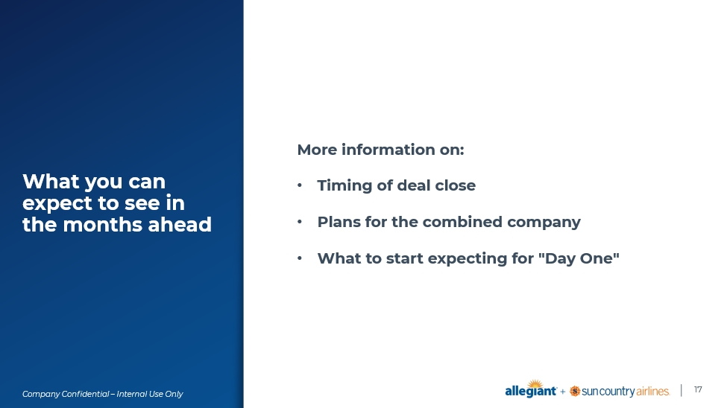

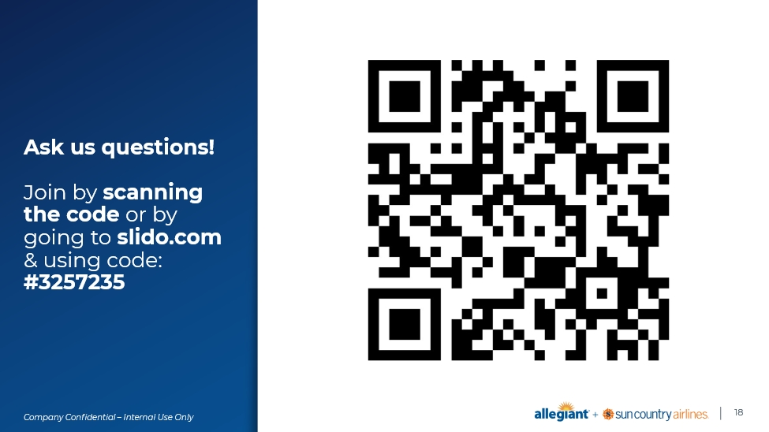

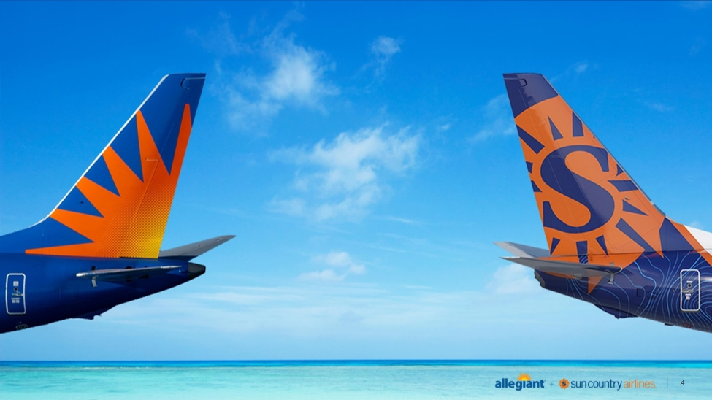

Cautionary Statement Regarding Forward-Looking Statements

This communication contains forward-looking statements under the safe harbor provisions of Section 21E of the Securities Exchange Act of 1934, Section 27A of the Securities Act of 1933 and the Private Securities Litigation Reform Act of 1995. Forward-looking statements include all statements that are not historical facts and often can be identified by the use of forward-looking terminology such as the words “believe,” “expect,” “guidance,” “anticipate,” “intend,” “plan,” “estimate”, “project”, “hope” or similar expressions. Forward-looking statements in this communication are based on Allegiant’s and Sun Country’s current expectations, estimates and projections about the expected date of closing of the proposed transaction and the potential benefits thereof, their respective businesses and industries, management’s beliefs and certain assumptions made by Allegiant and Sun Country, all of which are subject to change. Forward-looking statements in this communication may relate to, without limitation, the benefits of the proposed transaction, including future financial and operating results; the parties’ respective plans, objectives, expectations and intentions; the expected timing and likelihood of completion of the proposed transaction; expected synergies of the proposed transaction; the timing and result of various regulatory proceedings related to the proposed transaction; the ability to execute and finance current and long-term business, operational, capital expenditures and growth plans and strategies; the impact of increased or increasing transaction and financing costs associated with the proposed transaction or otherwise, as well as inflation and interest rates; and the ability to access debt and equity capital markets.

Forward-looking statements involve risks, uncertainties and assumptions that could cause actual results to differ materially from those expressed in any forward-looking statements. Accordingly, there are or will be important factors that could cause actual results to differ materially from those indicated in such statements and, therefore, you should not place undue reliance on any such statements and caution must be exercised in relying on forward-looking statements. Important risk factors that may cause such a difference include, but are not limited to, the following: the occurrence of any event, change or other circumstance that could give rise to the right of one or both of the parties to terminate the definitive merger agreement for the proposed transaction; the risk that potential legal proceedings may be instituted against Allegiant or Sun Country and result in significant costs of defense, indemnification or liability; the possibility that the proposed transaction does not close when expected or at all because required stockholder approvals, required regulatory approvals or other conditions to closing are not received or satisfied on a timely basis or at all (and the risk that such regulatory approvals may result in the imposition of conditions that could adversely affect the combined company or the expected benefits of the proposed transaction); the risk that the combined company will not realize expected benefits, cost savings, accretion, synergies and/or growth from the proposed transaction or that any of the foregoing may take longer to realize or be more costly to achieve than expected; disruption to the parties’ businesses as a result of the announcement and pendency of the proposed transaction; the costs associated with the anticipated length of time of the pendency of the proposed transaction, including the restrictions contained in the definitive merger agreement on the ability of each of Sun Country and Allegiant to operate their respective businesses outside the ordinary course consistent with past practice during the pendency of the proposed transaction; the diversion of Allegiant’s and Sun Country’s respective management teams’ attention and time from ongoing business operations and opportunities on acquisition-related matters; the risk that the integration of Sun Country’s operations will be materially delayed or will be more costly or difficult than expected or that Allegiant is otherwise unable to successfully integrate Sun Country’s businesses into its businesses; the possibility that the proposed transaction may be more expensive to complete than anticipated, including as a result of unexpected factors or events; reputational risk and potential adverse reactions of Allegiant’s or Sun Country’s customers, suppliers, employees, labor unions or other business partners, including those resulting from the announcement or completion of the proposed transaction; the dilution caused by Allegiant’s issuance of additional shares of its common stock in connection with the consummation of the proposed transaction; a material adverse change in the business, condition or results of operations of Allegiant or Sun Country; changes in domestic or international economic, political or business conditions, including those impacting the airline industry (including customers, employees and supply chains); Allegiant’s and Sun Country’s ability to successfully implement their respective operational, productivity and strategic initiatives; the outcome of claims, litigation, governmental proceedings and investigations involving Allegiant or Sun Country; and a cybersecurity incident or other disruption to Sun Country’s or Allegiant’s technology infrastructure.

Forward-looking statements in this communication are qualified by and should be read together with, the risk factors set forth above and the risk factors included in Allegiant’s and Sun Country’s respective annual and quarterly reports as filed with the Securities and Exchange Commission (the “SEC”), and readers should refer to such risks, uncertainties and risk factors in evaluating such forward-looking statements. In addition, the risk factors discussed above are not exhaustive and they, along with other risk factors, will be more fully discussed in the registration statement and joint proxy statement/prospectus to be filed with the SEC in connection with the proposed transaction.

The forward-looking statements in this communication are made only as of the date they were first issued, and unless otherwise required by applicable securities laws, Allegiant and Sun Country disclaim any intention or obligation to update or revise any forward-looking statements, whether as a result of new information, future events, or otherwise.

Important Additional Information and Where to Find It

In connection with the proposed transaction, Allegiant intends to file with the SEC a registration statement on Form S-4 (the “Registration Statement”), which will include a prospectus with respect to the shares of Allegiant’s common stock to be issued in the proposed transaction and a joint proxy statement for Allegiant’s and Sun Country’s respective stockholders (the “Joint Proxy Statement/Prospectus”). The definitive joint proxy statement (if and when available) will be mailed to stockholders of Allegiant and Sun Country. Each of Allegiant and Sun Country may also file with or furnish to the SEC other relevant documents regarding the proposed transaction. This communication is not a substitute for the Registration Statement, the Joint Proxy Statement/Prospectus or any other document that Allegiant or Sun Country may file with the SEC or send to their respective stockholders in connection with the proposed transaction. INVESTORS AND SECURITY HOLDERS OF ALLEGIANT AND SUN COUNTRY ARE URGED TO READ THE REGISTRATION STATEMENT AND THE JOINT PROXY STATEMENT/PROSPECTUS INCLUDED WITHIN THE REGISTRATION WHEN THEY BECOME AVAILABLE, AS WELL AS ANY OTHER RELEVANT DOCUMENTS FILED WITH THE SEC IN CONNECTION WITH THE PROPOSED TRANSACTION OR INCORPORATED BY REFERENCE INTO THE REGISTRATION STATEMENT AND THE JOINT PROXY STATEMENT/PROSPECTUS (INCLUDING ANY AMENDMENTS OR SUPPLEMENTS THERETO), BECAUSE THEY WILL CONTAIN IMPORTANT INFORMATION REGARDING ALLEGIANT, SUN COUNTRY, THE PROPOSED TRANSACTION AND RELATED MATTERS. Investors and security holders of Allegiant and Sun Country may obtain free copies of these documents and other documents filed with the SEC by Allegiant or Sun Country through the website maintained by the SEC at http://www.sec.gov or from Allegiant at its website, https://ir.allegiantair.com/financials/sec-filings/default.aspx, or from Sun Country at its website, https://ir.suncountry.com/financials/sec-filings. Documents filed with the SEC by Allegiant will be available free of charge by accessing Allegiant’s website at https://ir.allegiantair.com/financials/sec-filings/default.aspx, or alternatively by directing a request by mail to Allegiant’s Investor Relations department, 1201 North Town Center Drive, Las Vegas, NV 89144, and documents filed with the SEC by Sun Country will be available free of charge by accessing Sun Country’s website at https://ir.suncountry.com/financials/sec-filings, or alternatively by directing a request by mail to Sun Country’s Investor Relations department, 2005 Cargo Road, Minneapolis, MN 55450.

Participants In The Solicitation

Allegiant, Sun Country and certain of their respective directors and executive officers may be deemed to be participants in the solicitation of proxies from the stockholders of Allegiant and Sun Country in connection with the proposed transaction under the rules of the SEC.

Information about the interests of the directors and executive officers of Allegiant and Sun Country and other persons who may be deemed to be participants in the solicitation of stockholders of Allegiant and Sun Country in connection with the proposed transaction and a description of their direct and indirect interests, by security holdings or otherwise, will be included in the Joint Proxy Statement/Prospectus, which will be filed with the SEC.

Information about the directors and executive officers of Allegiant, their ownership of Allegiant common stock and Allegiant’s transactions with related persons can also be found in the Allegiant Annual Report and Allegiant’s definitive proxy statement in connection with its 2025 annual meeting of stockholders, as filed with the SEC on Schedule 14A on April 30, 2025 (the “Allegiant 2025 Proxy Statement”), and other documents subsequently filed by Allegiant with the SEC, which are available on its website, https://ir.allegiantair.com/financials/sec-filings/default.aspx. Such information is set forth in the sections entitled “Proposal No. 1 – Election of Directors”, “Proposal No. 2 – Advisory (non-binding) Vote on Executive Compensation”, “Proposal No. 3 – Approval of Amendment to Allegiant 2022 Long-Term Incentive Plan to Increase Number of Shares Available”, “Executive Compensation” and “Related Party Transactions” of the Allegiant 2025 Proxy Statement. To the extent holdings of Allegiant common stock by the directors and executive officers of Allegiant have changed from the amounts of Allegiant common stock held by such persons as reflected therein, such changes have been or will be reflected on Statements of Change in Ownership on Form 4 filed with the SEC, which are available at https://www.sec.gov/edgar/browse/?CIK=1362468&owner=exclude under the tab “Ownership Disclosures”.

Information about the directors and executive officers of Sun Country, their ownership of Sun Country common stock and Sun Country’s transactions with related persons can also be found in the definitive proxy statement for Sun Country’s 2025 annual meeting of stockholders, as filed with the SEC on Schedule 14A on April 25, 2025 (which is available at https://ir.suncountry.com/financials/sec-filings), and other documents subsequently filed by Sun Country with the SEC. Such information is set forth in the sections entitled “Proposal 1– Reelection of Directors”, “Proposal 2 – Non-binding (Advisory) Vote to Approve the Compensation of Our Named Executive Officers”, “Executive Compensation”, “Certain Relationships and Related Person Transactions” and “Security Ownership of Certain Beneficial Owners and Management” of such definitive proxy statement. Please also refer to Sun Country’s subsequent Current Reports, as filed with the SEC on Form 8-K on September 22, 2025 (which is available at https://ir.suncountry.com/financials/sec-filings) and on October 30, 2025, regarding subsequent changes to Sun Country’s Board of Directors and executive management following the filing of such definitive proxy statement. To the extent holdings of Sun Country common stock by the directors and executive officers of Sun Country have changed from the amounts of Sun Country common stock held by such persons as reflected in the definitive proxy statement, such changes have been or will be reflected on Statements of Change in Ownership on Form 4 filed with the SEC, which are available at https://www.sec.gov/edgar/browse/?CIK=1743907&owner=exclude under the tab “Ownership Disclosures”.

Free copies of these documents may be obtained as described above.

No Offer or Solicitation

This communication is for informational purposes only and does not constitute, or form a part of, an offer to sell, an offer to buy, or the solicitation of an offer to sell or the solicitation of an offer to buy any securities, and there shall be no sale of securities, in any jurisdiction in which such offer, solicitation or sale would be unlawful prior to registration or qualification under the securities laws of any such jurisdiction. No offer of securities shall be made except by means of a prospectus meeting the requirements of Section 10 of the Securities Act of 1933, as amended, and otherwise in accordance with applicable law.

