UNITED STATES
SECURITIES AND EXCHANGE COMMISSION
WASHINGTON, D.C. 20549

FORM 8-K

CURRENT REPORT
Pursuant to Section 13 or 15(d) of the Securities Exchange Act of 1934

Date of Report (Date of earliest event reported): January 11, 2026

ALLEGIANT TRAVEL COMPANY
(Exact name of registrant as specified in its charter)
Nevada |  | 001-33166 |  | 20-4745737
(State or other jurisdiction of  incorporation or organization) |  | (Commission  File Number) |  | (I.R.S. Employer  Identification No.)
1201 North Town Center Drive
Las Vegas, NV |  |  |  | 89144
(Address of principal executive offices) |  |  |  | (Zip Code)

(702) 851-7300
(Registrant’s telephone number, including area code)

N/A
(Former name or former address,
if changed since last report)

Check the appropriate box below if the Form 8-K filing is intended to simultaneously satisfy the filing obligation of the registrant under any of the following provisions (see General Instruction A.2.):

☒ | Written communications pursuant to Rule 425 under the Securities Act (17 CFR 230.425)

☐ | Soliciting material pursuant to Rule 14a-12 under the Exchange Act (17 CFR 240.14a-12)

☐ | Pre-commencement communications pursuant to Rule 14d-2(b) under the Exchange Act (17 CFR 240.14d-2(b))

☐ | Pre-commencement communications pursuant to Rule 13e-4(c) under the Exchange Act (17 CFR 240.13e-4(c))

Securities registered pursuant to Section 12(b) of the Act:

Title of each class | Trading Symbol(s) | Name of each exchange on which registered
Common stock, par value $0.001 | ALGT | NASDAQ Stock Market

Indicate by check mark whether the registrant is an emerging growth company as defined in Rule 405 of the Securities Act of 1933 (§230.405 of this chapter) or Rule 12b-2 of the Securities Exchange Act of 1934 (§240.12b-2 of this chapter).

Emerging growth company ☐

If an emerging growth company, indicate by check mark if the registrant has elected not to use the extended transition period for complying with any new or revised financial accounting standards provided pursuant to Section 13(a) of the Exchange Act. ☐

Item 1.01. | Entry into a Material Definitive Agreement.

On January 11, 2026, Allegiant Travel Company, a Nevada corporation (“Allegiant”), entered into an Agreement and Plan of Merger (the “Merger Agreement”) with Sun Country Airlines Holdings, Inc., a Delaware corporation (“Sun Country”), Mirage Merger Sub, Inc., a Delaware corporation and a direct wholly owned subsidiary of Allegiant (“Merger Sub 1”), and Sawdust Merger Sub, LLC, a Nevada limited liability company and a direct wholly owned subsidiary of Allegiant (“Merger Sub 2”, together with Merger Sub 1, the “Merger Subs”), providing for the merger of Merger Sub 1 with and into Sun Country (the “First Merger”), with Sun Country surviving the First Merger as a direct wholly owned subsidiary of Allegiant and immediately following the First Merger, the merger of Sun Country with and into Merger Sub 2 (the “Second Merger” and, together with the First Merger, the “Mergers”), with Merger Sub 2 surviving the Second Merger as a direct, wholly owned subsidiary of Allegiant. Capitalized terms used herein but not otherwise defined have the meanings set forth in the Merger Agreement.

As a result of the First Merger, each existing share (“Share”) of common stock, par value $0.01 per share of Sun Country (“Sun Country Common Stock”), will be converted into the right to receive (i) $4.10 in cash, without interest (the “Per Share Cash Consideration”) and (ii) 0.1557 (the “Merger Exchange Ratio”) shares of Allegiant common stock (“Allegiant Common Stock”), par value $0.001 per share (the “Per Share Stock Consideration” and, together with the Per Share Cash Consideration, the “Merger Consideration”).

The Merger Agreement also provides that, effective as of immediately prior to the First Effective Time, by virtue of the Mergers:

 | • | All outstanding stock options to purchase a share of Sun Country Common Stock granted pursuant to any Company Equity Award Plan, regardless of exercise price, will automatically convert into stock options for Allegiant immediately before the closing, with no action required by the holder (the “Converted Options” and each a “Converted Option”). Each Converted Option will cover a proportionately adjusted number of shares of Allegiant Common Stock based on the Merger Exchange Ratio (as adjusted and as determined under the Merger Agreement) and will have a proportionately adjusted exercise price and will otherwise be subject to the same terms and conditions;

 | • | Each outstanding Company RSU Award will be assumed by Allegiant and converted into a Parent RSU Award based on the Merger Exchange Ratio (as adjusted and as determined under the Merger Agreement). The Parent RSU Awards will continue to have the same terms and conditions as the Company RSU Awards, including any double-trigger vesting protections;

 | • | Each outstanding Company PRSU award will be assumed by Allegiant and converted into a Parent PRSU Award, based on the Merger Exchange Ratio (as adjusted and as determined under the Merger Agreement) and converted based on an average performance factor of 125% The Parent PRSU Awards will continue to have the same terms and conditions as the Company PRSU Awards, including any double-trigger vesting protections, provided that there will no longer be any performance-based vesting conditions, and the Parent PRSU Award will be a time-vesting award eligible to vest on the last day of the performance period applicable to the Company PRSU Award; and

 | • | With respect to non-employee Sun Country board members and former employees/service providers to Sun Country, each Company Equity Award held by such individuals will become fully vested (to the extent not yet vested), cancelled and converted into the right to receive the Merger Consideration.

If the Mergers are consummated, the Sun Country Common Stock will be delisted from The NASDAQ Stock Market LLC and deregistered under the Securities Exchange Act of 1934, as amended (the “Exchange Act”), as promptly as practicable following the Closing.

The Merger Agreement provides that, as of immediately following the effective time of the Second Merger, Allegiant will increase the size of its board of directors (the “Allegiant Board”) by three (3) members and three (3) directors designated by Sun Country, one (1) of whom will be Jude Bricker, the President and CEO of Sun Country, and two (2) of whom will be current members of Sun Country’s board of directors (the “Sun Country Board”) and reasonably acceptable to the nominating and governance committee of the Allegiant Board, will join the Allegiant Board.

Completion of the Merger is subject to the satisfaction or waiver of certain closing conditions, including, among other things, (1) adoption of the Merger Agreement by Sun Country stockholders (the “Sun Country Stockholder Approval”), (2) approval of the issuance of shares of Allegiant Common Stock pursuant to the Merger Agreement by Allegiant stockholders (the “Allegiant Stockholder Approval” and, together with the Sun Country Stockholder Approval, the “Stockholder Approvals”), (3) receipt of applicable regulatory approvals, including approvals from the U.S. Federal Aviation Administration, the U.S. Department of Transportation and the U.S. Department of Homeland Security, including the TSA, and the expiration or early termination of the statutory waiting period under the Hart-Scott-Rodino Antitrust Improvements Act of 1976, as amended (the “HSR Act”); (4) the absence of any law or order prohibiting the consummation of the transactions; (5) the effectiveness of the registration statement to be filed by Allegiant and Sun Country with the Securities and Exchange Commission (the “SEC”) pursuant to the Merger Agreement; (6) the authorization and approval for listing on NASDAQ of the shares of Allegiant Common Stock to be issued to holders of Sun Country Common Stock in the Merger; and (7) the absence of any Company Material Adverse Effect or Parent Material Adverse Effect.

Sun Country, Allegiant and the Merger Subs each make certain customary representations, warranties and covenants, as applicable, in the Merger Agreement, including, among others, covenants regarding the conduct of their respective businesses during the pendency of the transactions contemplated by the Merger Agreement.

In addition, Sun Country and Allegiant have agreed, among other things, that neither they nor any of their directors, officers, employees and representatives will (1) solicit alternative transactions, (2) participate in or facilitate any discussions or negotiations relating to alternative transactions, (3) furnish any non-public information in connection with alternative transactions or (4) enter into any agreement relating to alternative transactions, except under limited circumstances described in the Merger Agreement. However, in certain circumstances, Sun Country or Allegiant may terminate the Merger Agreement to enter into a definitive agreement for a Superior Proposal.

The Merger Agreement contains certain customary termination rights for Sun Country and Allegiant, including, without limitation, a right for either party to terminate if the Merger is not consummated on or before January 11, 2027, subject to certain extensions if needed to obtain required regulatory approvals, or if a Stockholder Approval is not obtained. If the Merger Agreement is terminated under certain circumstances relating to a Change of Recommendation by the Allegiant Board or Allegiant’s entry into a definitive agreement for a Superior Proposal, Allegiant will be required to pay Sun Country a termination fee of $52,230,000. Conversely, if the Merger Agreement is terminated under certain circumstances relating to a Change of Recommendation by the Sun Country Board or Sun Country’s entry into a definitive agreement for a Superior Proposal, Sun Country will be required to pay Allegiant a termination fee of $33,020,000. In addition, Allegiant will be required to pay Sun Country a termination fee of $30,000,000 if the Merger Agreement is terminated under certain circumstances relating to the failure of the parties to obtain the expiration or termination of the waiting period under the HSR Act (“HSR Clearance”), or if there is a final, non-appealable law or order prohibiting the consummation of the transactions relating to HSR Clearance.

If the Merger Agreement is terminated under certain circumstances in which a Stockholder Approval is not obtained, either party may be required to reimburse the other party’s expenses up to $11,000,000. The Merger Agreement also provides the methodology by which certain expenses will be borne.

The foregoing description of the Merger Agreement does not purport to be complete and is qualified in its entirety by reference to full text of the Merger Agreement, which is filed as Exhibit 2.1 to this Current Report on Form 8-K and is incorporated herein by reference.

The Merger Agreement has been included to provide investors with information regarding its terms. It is not intended to provide any other factual information about Sun Country, Allegiant or Merger Subs. The representations, warranties, covenants and agreements contained in the Merger Agreement were made only for purposes of the Merger Agreement, as of the specific dates therein, were solely for the benefit of the parties to the Merger Agreement and the parties expressly identified as third-party beneficiaries thereto, as applicable (except as expressly provided therein), may be subject to limitations agreed upon by the contracting parties, including being qualified by confidential disclosures made for the purposes of allocating contractual risk between the parties to the Merger Agreement instead of establishing these matters as facts, and may be subject to standards of materiality applicable to the contracting parties that differ from those applicable to investors. Investors are not third-party beneficiaries under the Merger Agreement and should not rely on the representations, warranties, covenants and agreements therein or any descriptions thereof as characterizations of the actual state of facts or condition of the parties thereto or any of their respective subsidiaries or affiliates. Moreover, information concerning the subject matter of representations and warranties may change after the date of the Merger Agreement, which subsequent information may or may not be fully reflected in Sun Country and Allegiant’s respective public disclosures.

Item 7.01. | Regulation FD Disclosure.

On January 11, 2026, Allegiant and Sun Country issued a joint press release announcing the execution of the Merger Agreement. The full text of the joint press release issued in connection with the announcement is furnished as Exhibit 99.1 to this Current Report on Form 8-K and is incorporated by reference herein.

Also on January 11, 2026, Allegiant provided supplemental information regarding the Merger in social media posts, on a website relating to the Merger and in communications to employees, customers, suppliers, unions, investors and analysts. Copies of those communications are furnished as Exhibits 99.2, 99.3, 99.4, 99.5, 99.6, 99.7, 99.8, 99.9 and 99.10 and are incorporated herein by reference. On January 12, 2026, Allegiant and Sun Country will host a joint investor presentation relating to the Merger. The full text of the joint investor presentation is furnished as Exhibit 99.11 to this Current Report on Form 8-K and is incorporated herein by reference.

The information contained in Item 7.01 of this report, including the communications attached as Exhibits 99.1, 99.2, 99.3, 99.4, 99.5, 99.6, 99.7, 99.8, 99.9, 99.10 and 99.11, is furnished pursuant to Item 7.01 of Form 8-K and shall not be deemed “filed” for purposes of Section 18 of the Exchange Act, or otherwise subject to the liability of such section, nor shall such exhibit be deemed incorporated by reference in any filing under the Securities Act of 1933, as amended, or the Exchange Act.

Item 9.01. | Financial Statements and Exhibits.

(d) | Exhibits

Exhibit  No. |  | Description
2.1 |  | Agreement and Plan of Merger, dated as of January 11, 2026, by and among Allegiant Travel Company, Mirage Merger Sub, Inc., Sawdust Merger Sub, LLC and Sun Country Airlines Holdings, Inc.*
99.1 |  | Press Release, dated January 11, 2026
99.2 |  | Social Media Posts
99.3 |  | Transaction Website
99.4 |  | Transcript of Transaction Video
99.5 |  | Gregory C. Anderson Letter to Employees of Allegiant
99.6 |  | Gregory C. Anderson Letter to Employees of Sun Country
99.7 |  | FAQs for Pilots & Union Leadership
99.8 |  | Letter to Allegiant Customers
99.9 |  | Talking Points for Allegiant Agents & Customer Care
99.10 |  | Letter to Allegiant Suppliers & Partners
99.11 |  | Joint Investor Presentation
104 |  | Cover Page Interactive Data File (embedded within the Inline XBRL document)
* |  | The schedules and exhibits have been omitted pursuant to Item 601(a)(5) of Regulation S-K. A copy of any omitted schedule or exhibit will be furnished to the Securities and Exchange Commission upon request.

Cautionary Statement Regarding Forward-Looking Statements

This communication contains forward-looking statements under the safe harbor provisions of Section 21E of the Securities Exchange Act of 1934, Section 27A of the Securities Act of 1933 and the Private Securities Litigation Reform Act of 1995. Forward-looking statements include all statements that are not historical facts and often can be identified by the use of forward-looking terminology such as the words “believe,” “expect,” “guidance,” “anticipate,” “intend,” “plan,” “estimate”, “project”, “hope” or similar expressions. Forward-looking statements in this communication are based on Allegiant’s and Sun Country’s current expectations, estimates and projections about the expected date of closing of the proposed transaction and the potential benefits thereof, their respective businesses and industries, management’s beliefs and certain assumptions made by Allegiant and Sun Country, all of which are subject to change. Forward-looking statements in this communication may relate to, without limitation, the benefits of the proposed transaction, including future financial and operating results; the parties’ respective plans, objectives, expectations and intentions; the expected timing and likelihood of completion of the proposed transaction; expected synergies of the proposed transaction; the timing and result of various regulatory proceedings related to the proposed transaction; the ability to execute and finance current and long-term business, operational, capital expenditures and growth plans and strategies; the impact of increased or increasing transaction and financing costs associated with the proposed transaction or otherwise, as well as inflation and interest rates; and the ability to access debt and equity capital markets.

Forward-looking statements involve risks, uncertainties and assumptions that could cause actual results to differ materially from those expressed in any forward-looking statements. Accordingly, there are or will be important factors that could cause actual results to differ materially from those indicated in such statements and, therefore, you should not place undue reliance on any such statements and caution must be exercised in relying on forward-looking statements. Important risk factors that may cause such a difference include, but are not limited to, the following: the occurrence of any event, change or other circumstance that could give rise to the right of one or both of the parties to terminate the definitive merger agreement for the proposed transaction; the risk that potential legal proceedings may be instituted against Allegiant or Sun Country and result in significant costs of defense, indemnification or liability; the possibility that the proposed transaction does not close when expected or at all because required stockholder approvals, required regulatory approvals or other conditions to closing are not received or satisfied on a timely basis or at all (and the risk that such regulatory approvals may result in the imposition of conditions that could adversely affect the combined company or the expected benefits of the proposed transaction); the risk that the combined company will not realize expected benefits, cost savings, accretion, synergies and/or growth from the proposed transaction or that any of the foregoing may take longer to realize or be more costly to achieve than expected; disruption to the parties’ businesses as a result of the announcement and pendency of the proposed transaction; the costs associated with the anticipated length of time of the pendency of the proposed transaction, including the restrictions contained in the definitive merger agreement on the ability of each of Sun Country and Allegiant to operate their respective businesses outside the ordinary course consistent with past practice during the pendency of the proposed transaction; the diversion of Allegiant’s and Sun Country’s respective management teams’ attention and time from ongoing business operations and opportunities on acquisition-related matters; the risk that the integration of Sun Country’s operations will be materially delayed or will be more costly or difficult than expected or that Allegiant is otherwise unable to successfully integrate Sun Country’s businesses into its businesses; the possibility that the proposed transaction may be more expensive to complete than anticipated, including as a result of unexpected factors or events; reputational risk and potential adverse reactions of Allegiant’s or Sun Country’s customers, suppliers, employees, labor unions or other business partners, including those resulting from the announcement or completion of the proposed transaction; the dilution caused by Allegiant’s issuance of additional shares of its common stock in connection with the consummation of the proposed transaction; a material adverse change in the business, condition or results of operations of Allegiant or Sun Country; changes in domestic or international economic, political or business conditions, including those impacting the airline industry (including customers, employees and supply chains); Allegiant’s and Sun Country’s ability to successfully implement their respective operational, productivity and strategic initiatives; the outcome of claims, litigation, governmental proceedings and investigations involving Allegiant or Sun Country; and a cybersecurity incident or other disruption to Sun Country’s or Allegiant’s technology infrastructure.

Forward-looking statements in this communication are qualified by and should be read together with, the risk factors set forth above and the risk factors included in Allegiant’s and Sun Country’s respective annual and quarterly reports as filed with the Securities and Exchange Commission (the “SEC”), and readers should refer to such risks, uncertainties and risk factors in evaluating such forward-looking statements. In addition, the risk factors discussed above are not exhaustive and they, along with other risk factors, will be more fully discussed in the registration statement and joint proxy statement/prospectus to be filed with the SEC in connection with the proposed transaction.

The forward-looking statements in this communication are made only as of the date they were first issued, and unless otherwise required by applicable securities laws, Allegiant and Sun Country disclaim any intention or obligation to update or revise any forward-looking statements, whether as a result of new information, future events, or otherwise.

Important Additional Information and Where to Find It

In connection with the proposed transaction, Allegiant intends to file with the SEC a registration statement on Form S-4 (the “Registration Statement”), which will include a prospectus with respect to the shares of Allegiant’s common stock to be issued in the proposed transaction and a joint proxy statement for Allegiant’s and Sun Country’s respective stockholders (the “Joint Proxy Statement/Prospectus”). The definitive joint proxy statement (if and when available) will be mailed to stockholders of Allegiant and Sun Country. Each of Allegiant and Sun Country may also file with or furnish to the SEC other relevant documents regarding the proposed transaction. This communication is not a substitute for the Registration Statement, the Joint Proxy Statement/Prospectus or any other document that Allegiant or Sun Country may file with the SEC or send to their respective stockholders in connection with the proposed transaction. INVESTORS AND SECURITY HOLDERS OF ALLEGIANT AND SUN COUNTRY ARE URGED TO READ THE REGISTRATION STATEMENT AND THE JOINT PROXY STATEMENT/PROSPECTUS INCLUDED WITHIN THE REGISTRATION WHEN THEY BECOME AVAILABLE, AS WELL AS ANY OTHER RELEVANT DOCUMENTS FILED WITH THE SEC IN CONNECTION WITH THE PROPOSED TRANSACTION OR INCORPORATED BY REFERENCE INTO THE REGISTRATION STATEMENT AND THE JOINT PROXY STATEMENT/PROSPECTUS (INCLUDING ANY AMENDMENTS OR SUPPLEMENTS THERETO), BECAUSE THEY WILL CONTAIN IMPORTANT INFORMATION REGARDING ALLEGIANT, SUN COUNTRY, THE PROPOSED TRANSACTION AND RELATED MATTERS. Investors and security holders of Allegiant and Sun Country may obtain free copies of these documents and other documents filed with the SEC by Allegiant or Sun Country through the website maintained by the SEC at http://www.sec.gov or from Allegiant at its website, https://ir.allegiantair.com/financials/sec-filings/default.aspx, or from Sun Country at its website, https://ir.suncountry.com/financials/sec-filings. Documents filed with the SEC by Allegiant will be available free of charge by accessing Allegiant’s website at https://ir.allegiantair.com/financials/sec-filings/default.aspx, or alternatively by directing a request by mail to Allegiant’s Investor Relations department, 1201 North Town Center Drive, Las Vegas, NV 89144, and documents filed with the SEC by Sun Country will be available free of charge by accessing Sun Country’s website at https://ir.suncountry.com/financials/sec-filings, or alternatively by directing a request by mail to Sun Country’s Investor Relations department, 2005 Cargo Road, Minneapolis, MN 55450.

Participants In The Solicitation

Allegiant, Sun Country and certain of their respective directors and executive officers may be deemed to be participants in the solicitation of proxies from the stockholders of Allegiant and Sun Country in connection with the proposed transaction under the rules of the SEC.

Information about the interests of the directors and executive officers of Allegiant and Sun Country and other persons who may be deemed to be participants in the solicitation of stockholders of Allegiant and Sun Country in connection with the proposed transaction and a description of their direct and indirect interests, by security holdings or otherwise, will be included in the Joint Proxy Statement/Prospectus, which will be filed with the SEC.

Information about the directors and executive officers of Allegiant, their ownership of Allegiant common stock and Allegiant’s transactions with related persons can also be found in the Allegiant Annual Report and Allegiant’s definitive proxy statement in connection with its 2025 annual meeting of stockholders, as filed with the SEC on Schedule 14A on April 30, 2025 (the “Allegiant 2025 Proxy Statement”), and other documents subsequently filed by Allegiant with the SEC, which are available on its website, https://ir.allegiantair.com/financials/sec-filings/default.aspx. Such information is set forth in the sections entitled “Proposal No. 1 – Election of Directors”, “Proposal No. 2 – Advisory (non-binding) Vote on Executive Compensation”, “Proposal No. 3 – Approval of Amendment to Allegiant 2022 Long-Term Incentive Plan to Increase Number of Shares Available”, “Executive Compensation” and “Related Party Transactions” of the Allegiant 2025 Proxy Statement. To the extent holdings of Allegiant common stock by the directors and executive officers of Allegiant have changed from the amounts of Allegiant common stock held by such persons as reflected therein, such changes have been or will be reflected on Statements of Change in Ownership on Form 4 filed with the SEC, which are available at https://www.sec.gov/edgar/browse/?CIK=1362468&owner=exclude under the tab “Ownership Disclosures”.

Information about the directors and executive officers of Sun Country, their ownership of Sun Country common stock and Sun Country’s transactions with related persons can also be found in the definitive proxy statement for Sun Country’s 2025 annual meeting of stockholders, as filed with the SEC on Schedule 14A on April 25, 2025 (which is available at https://ir.suncountry.com/financials/sec-filings), and other documents subsequently filed by Sun Country with the SEC. Such information is set forth in the sections entitled “Proposal 1– Reelection of Directors”, “Proposal 2 – Non-binding (Advisory) Vote to Approve the Compensation of Our Named Executive Officers”, “Executive Compensation”, “Certain Relationships and Related Person Transactions” and “Security Ownership of Certain Beneficial Owners and Management” of such definitive proxy statement. Please also refer to Sun Country’s subsequent Current Reports, as filed with the SEC on Form 8-K on September 22, 2025 (which is available at https://ir.suncountry.com/financials/sec-filings) and on October 30, 2025, regarding subsequent changes to Sun Country’s Board of Directors and executive management following the filing of such definitive proxy statement. To the extent holdings of Sun Country common stock by the directors and executive officers of Sun Country have changed from the amounts of Sun Country common stock held by such persons as reflected in the definitive proxy statement, such changes have been or will be reflected on Statements of Change in Ownership on Form 4 filed with the SEC, which are available at https://www.sec.gov/edgar/browse/?CIK=1743907&owner=exclude under the tab “Ownership Disclosures”.

Free copies of these documents may be obtained as described above.

No Offer or Solicitation

This communication is for informational purposes only and does not constitute, or form a part of, an offer to sell, an offer to buy, or the solicitation of an offer to sell or the solicitation of an offer to buy any securities, and there shall be no sale of securities, in any jurisdiction in which such offer, solicitation or sale would be unlawful prior to registration or qualification under the securities laws of any such jurisdiction. No offer of securities shall be made except by means of a prospectus meeting the requirements of Section 10 of the Securities Act of 1933, as amended, and otherwise in accordance with applicable law.

SIGNATURE

Pursuant to the requirements of the Securities Exchange Act of 1934, the registrant has duly caused this report to be signed on its behalf by the undersigned hereunto duly authorized.

 |  | ALLEGIANT TRAVEL COMPANY
Date: | January 12, 2026 | By: | /s/ Robert J. Neal
Robert J. Neal
President, Chief Financial Officer

Exhibit 2.1

Execution Version

AGREEMENT AND PLAN OF MERGER

among

ALLEGIANT TRAVEL COMPANY,

MIRAGE MERGER SUB, INC.,

SAWDUST MERGER SUB, LLC

and

SUN COUNTRY AIRLINES HOLDINGS, INC.

Dated as of January 11, 2026

 | TABLE OF CONTENTS
 |  |  | Page
ARTICLE 1
 |  | THE MERGER
 | 1.1 | The Mergers | 6
 | 1.2 | Closing and Effective Times of the Mergers | 8
ARTICLE 2
 |  | CONVERSION OF SECURITIES
 | 2.1 | Conversion of Securities | 8
 | 2.2 | No Fractional Shares | 9
 | 2.3 | Payment and Issuance of Merger Consideration; Surrender of Company Certificates | 10
 | 2.4 | Dissenting Shares | 13
 | 2.5 | Treatment of Company Equity Awards; Stock Plans | 13
 | 2.6 | Filing of Form S-8 | 15
 | 2.7 | Treatment of Company Warrant | 15
 | 2.8 | Certain Adjustments | 16
ARTICLE 3
 |  | REPRESENTATIONS AND WARRANTIES OF THE COMPANY
 | 3.1 | Organization and Qualification; Subsidiaries | 16
 | 3.2 | Capitalization | 17
 | 3.3 | Authority | 18
 | 3.4 | No Conflict | 18
 | 3.5 | Required Filings and Consents | 19
 | 3.6 | Permits; Compliance with Law | 19
 | 3.7 | SEC Filings; Financial Statements | 20
 | 3.8 | Internal Controls | 21
 | 3.9 | State Takeover Laws | 22
 | 3.10 | No Undisclosed Liabilities | 22
 | 3.11 | Absence of Certain Changes or Events | 22
 | 3.12 | Employee Benefit Plans | 22
 | 3.13 | Labor and Other Employment Matters | 24
 | 3.14 | Contracts | 26
 | 3.15 | Litigation | 28
 | 3.16 | Environmental Matters | 28
 | 3.17 | Intellectual Property; IT Assets | 29
 | 3.18 | Data Privacy and Security | 31
 | 3.19 | Tax Matters | 32
 | 3.20 | Insurance | 33

i

 | 3.21 | Real Property | 34
 | 3.22 | Related Party Transactions | 34
 | 3.23 | Aircraft | 34
 | 3.24 | Company Slots and Operating Authorizations | 35
 | 3.25 | Company Airports | 36
 | 3.26 | U.S. Citizen; Air Carrier | 36
 | 3.27 | Opinion of Financial Advisor | 36
 | 3.28 | Required Vote | 37
 | 3.29 | Brokers | 37
 | 3.30 | Information Supplied | 37
 | 3.31 | Ownership of Parent Common Stock | 37
ARTICLE 4
 |  | REPRESENTATIONS AND WARRANTIES OF PARENT AND MERGER SUB
 | 4.1 | Organization and Qualification; Subsidiaries | 38
 | 4.2 | Capitalization. | 38
 | 4.3 | Authority | 39
 | 4.4 | No Conflict | 40
 | 4.5 | Required Filings and Consents | 40
 | 4.6 | Permits; Compliance with Law | 40
 | 4.7 | SEC Filings; Financial Statements | 41
 | 4.8 | Internal Controls | 42
 | 4.9 | State Takeover Laws | 43
 | 4.10 | No Undisclosed Liabilities | 43
 | 4.11 | Absence of Certain Changes or Events | 43
 | 4.12 | Employee Benefit Plans | 43
 | 4.13 | Labor and Other Employment Matters | 45
 | 4.14 | Contracts | 46
 | 4.15 | Litigation | 48
 | 4.16 | Environmental Matters | 48
 | 4.17 | Intellectual Property; IT Assets | 49
 | 4.18 | Data Privacy and Security | 50
 | 4.19 | Tax Matters | 51
 | 4.20 | Insurance | 53
 | 4.21 | Real Property | 53
 | 4.22 | Related Party Transactions | 54
 | 4.23 | Aircraft | 54
 | 4.24 | Parent Slots and Operating Authorizations | 55
 | 4.25 | Parent Airports | 55
 | 4.26 | U.S. Citizen; Air Carrier | 55
 | 4.27 | Ownership of Company Common Stock | 55
 | 4.28 | Ownership of Merger Subs; No Prior Activities | 55
 | 4.29 | Management Arrangements | 55
 | 4.30 | Required Vote | 56
 | 4.31 | Brokers | 56
 | 4.32 | Information Supplied | 56
 | 4.33 | Opinion of Financial Advisor | 56
 | 4.34 | Sufficient Funds | 56

ii

ARTICLE 5
 |  | COVENANTS
 | 5.1 | Conduct of Business by the Company Pending the Closing | 57
 | 5.2 | Conduct of Business by Parent Pending the Closing | 61
 | 5.3 | Access to Information; Confidentiality | 63
 | 5.4 | No Solicitation; Board Recommendation | 64
 | 5.5 | Registration Statement, Information Statement and Joint Proxy Statement/Prospectus; Company Stockholder Meeting | 67
 | 5.6 | Appropriate Action; Consents; Filings | 71
 | 5.7 | Public Announcements | 73
 | 5.8 | Employee Benefit Matters | 73
 | 5.9 | Indemnification of Directors and Officers | 75
 | 5.10 | State Takeover Laws | 77
 | 5.11 | Parent Agreement Concerning Merger Subs | 78
 | 5.12 | Section 16 Matters | 78
 | 5.13 | Company Stock Exchange Delisting; Deregistration | 78
 | 5.14 | Stockholder Litigation | 78
 | 5.15 | Governance Matters | 79
 | 5.16 | Tax Matters | 79
 | 5.17 | Cooperation with Debt Financing | 80
 | 5.18 | Company Credit Agreement | 83
 | 5.19 | Notification of Certain Matters | 83
ARTICLE 6
 |  | CONDITIONS TO CONSUMMATION OF THE MERGER
 | 6.1 | Conditions to Obligations of Each Party Under This Agreement | 84
 | 6.2 | Conditions to Obligations of Parent and Merger Subs | 84
 | 6.3 | Conditions to Obligations of the Company | 85
ARTICLE 7
 |  | TERMINATION
 | 7.1 | Termination | 86
 | 7.2 | Manner and Effect of Termination; Termination Fees | 88
ARTICLE 8
 |  | GENERAL PROVISIONS
 | 8.1 | Amendment | 91
 | 8.2 | Waiver | 91
 | 8.3 | No Other Representations or Warranties; Non-Survival of Representations and Warranties | 91
 | 8.4 | Fees and Expenses | 92
 | 8.5 | Notices | 92
 | 8.6 | Definitions | 93

iii

 | 8.7 | Headings | 107
 | 8.8 | Severability | 107
 | 8.9 | Entire Agreement | 107
 | 8.10 | Assignment | 107
 | 8.11 | Mutual Drafting; Interpretation | 108
 | 8.12 | Governing Law; Consent to Jurisdiction; Waiver of Trial by Jury | 108
 | 8.13 | Counterparts | 109
 | 8.14 | Specific Performance | 109
 | 8.15 | Matters Concerning Acquisition Financing Sources | 110

Exhibit A | Form of Tax Representation Letters

iv

AGREEMENT AND PLAN OF MERGER

THIS AGREEMENT AND PLAN OF MERGER, dated as of January 11, 2026 (this “Agreement”), is entered into by and among Allegiant Travel Company, a Nevada corporation (“Parent”), Mirage Merger Sub, Inc., a Delaware corporation and a direct wholly owned Subsidiary of Parent (“Merger Sub 1”), Sawdust Merger Sub, LLC, a Nevada limited liability company and a direct wholly owned Subsidiary of Parent (“Merger Sub 2” and, together with Merger Sub 1, “Merger Subs”) and Sun Country Airlines Holdings, Inc., a Delaware corporation (the “Company” and, collectively with Parent and Merger Subs, the “Parties”).

RECITALS

WHEREAS, Parent and the Company desire to effect the acquisition of the Company by Parent on the terms and subject to the conditions set forth in this Agreement, pursuant to which (i) Merger Sub 1 will be merged with and into the Company (the “First Merger”), with the Company surviving the First Merger as a direct wholly owned subsidiary of Parent and (ii) immediately following the First Merger, the Company shall be merged with and into Merger Sub 2 (the “Second Merger” and, together with the First Merger, the “Mergers”), with Merger Sub 2 surviving the Second Merger as a direct, wholly owned subsidiary of Parent (Merger Sub 2, in its capacity as the surviving entity of the Second Merger, is sometimes referred to as the “Surviving Entity”), in accordance with the General Corporation Law of the State of Delaware (the “DGCL”) and Chapter 86 of the Nevada Revised Statutes (the “NLLCA”);

WHEREAS, the Board of Directors of the Company (the “Company Board”) has unanimously (i) determined that the terms hereof, the Mergers and the other transactions contemplated by this Agreement are fair to and in the best interests of the Company and its stockholders, (ii) approved and declared advisable this Agreement, the Mergers and the other transactions contemplated hereby in accordance with the requirements of the DGCL and NLLCA, (iii) directed that this Agreement be submitted to the holders of the Company Common Stock for adoption and (iv) resolved to recommend that the holders of the Company Common Stock vote their Shares in favor of the adoption of this Agreement (the “Company Board Recommendation”);

WHEREAS, the Board of Directors of Parent has unanimously (i) determined that the terms hereof, the Mergers and the other transactions contemplated by this Agreement are in the best interests of Parent, (ii) approved and declared advisable this Agreement, the Mergers and the other transactions contemplated hereby, (iii) directed that the issuance of shares of Parent Common Stock pursuant to this Agreement (such issuance, the “Parent Share Issuance”) be submitted to the holders of the Parent Common Stock for approval and (iv) resolved to recommend that the holders of the Parent Common Stock vote their shares in favor of the Parent Share Issuance (such recommendation, the “Parent Board Recommendation”);

WHEREAS, the Board of Directors of Merger Sub 1 has unanimously (i) determined that the terms hereof, the Mergers and the other transactions contemplated by this Agreement are in the best interests of Merger Sub 1 and Parent, its sole stockholder, and (ii) approved and declared advisable this Agreement, the Mergers and the other transactions contemplated hereby;

WHEREAS, the Board of Managers of Merger Sub 2 has unanimously approved this Agreement, the Mergers and other transactions contemplated hereby;

WHEREAS, Parent, in its capacity as the sole member of Merger Sub 2, has approved this Agreement, the Mergers and the other transactions contemplated hereby;

WHEREAS, for U.S. federal income Tax purposes, it is intended that the Mergers, taken together, qualify as a “reorganization” within the meaning of Section 368(a) of the Code (the “Intended Tax Treatment”) and this Agreement is intended to be, and is adopted as, a “plan of reorganization” within the meaning of Treasury Regulations Section 1.368-2(g);

WHEREAS, Parent, Merger Subs and the Company desire to make certain representations, warranties, covenants and agreements in connection with the Mergers and also to prescribe various conditions to the Mergers;

NOW, THEREFORE, in consideration of the mutual covenants and premises contained in this Agreement and for other good and valuable consideration, the receipt and adequacy of which are hereby acknowledged, the Parties, intending to be legally bound, agree as follows:

AGREEMENT

ARTICLE 1

THE MERGER

1.1 The Mergers.

(a) Upon the terms and subject to the conditions set forth in this Agreement, and in accordance with the DGCL, at the First Effective Time, Merger Sub 1 and the Company shall consummate the First Merger, pursuant to which Merger Sub 1 will be merged with and into the Company. As a result of the First Merger, the separate corporate existence of Merger Sub 1 will cease, and the Company will continue as the surviving corporation of the First Merger (the “Surviving Corporation”). The First Merger will have the effects set forth in the applicable provisions of the DGCL. Without limiting the generality of the foregoing, at the First Effective Time, all of the property, rights, privileges, immunities, powers and franchises of the Company and Merger Sub 1 will vest in the Surviving Corporation, and all of the debts, liabilities and duties of the Company and Merger Sub 1 will become the debts, liabilities and duties of the Surviving Corporation.

(b) Upon the terms and subject to the conditions set forth in this Agreement, and in accordance with the DGCL and NLLCA, at the Second Effective Time, Merger Sub 2 and the Surviving Corporation shall consummate the Second Merger, pursuant to which the Surviving Corporation shall be merged with and into Merger Sub 2. As a result of the Second Merger, the separate corporate existence of the Surviving Corporation will cease, and Merger Sub 2 shall continue as the Surviving Entity (provided that references herein to the Company or the Surviving Corporation in respect of periods after the Second Effective Time shall include the Surviving Entity). The Second Merger will have the effects set forth in the applicable provisions of the DGCL and NLLCA. Without limiting the generality of the foregoing, at the Second Effective Time, all of the property, rights, privileges, immunities, powers and franchises of the Surviving Corporation and Merger Sub 2 will vest in the Surviving Entity, and all of the debts, liabilities and duties of the Surviving Corporation and Merger Sub 2 will become the debts, liabilities and duties of the Surviving Entity.

(c) At the First Effective Time, (i) the certificate of incorporation of the Surviving Corporation will, by virtue of the First Merger, be amended and restated so as to be the same as the certificate of incorporation of Merger Sub 1 in effect immediately prior to the First Effective Time (except that the name of the Surviving Corporation shall be “Sun Country Airlines Holdings, Inc.”), until thereafter amended as provided therein or by applicable Law, and (ii) the bylaws of the Surviving Corporation will, by virtue of the First Merger, be amended and restated as of the First Effective Time to read as the bylaws of Merger Sub 1 as in effect immediately prior to the First Effective Time (except that the name of the Surviving Corporation shall be “Sun Country Airlines Holdings, Inc.”), until thereafter amended as provided therein or by applicable Law.

6

(d) At the Second Effective Time, (i) the articles of organization of Merger Sub 2 as in effect immediately prior to the Second Effective Time will, by virtue of the Second Merger, be the articles of organization of the Surviving Entity, until thereafter amended as provided therein or by applicable Law and (ii) the operating agreement of Merger Sub 2 as in effect immediately prior to the Second Effective Time will, by virtue of the Second Merger, be the operating agreement of the Surviving Entity (except that the name of the Surviving Entity shall be “Sun Country Airlines Holdings, LLC”), until thereafter amended as provided therein or by applicable Law.

(e) Unless otherwise determined by Parent, at the First Effective Time, (i) the directors of Merger Sub 1 immediately prior to the First Effective Time shall, from and after the First Effective Time until the Second Effective Time, be the directors of the Surviving Corporation, each to hold office in accordance with the certificate of incorporation and bylaws of the Surviving Corporation until their respective successors have been duly elected, designated or qualified, or until their earlier death, resignation or removal in accordance with the certificate of incorporation and bylaws of the Surviving Corporation and (ii) the officers of Merger Sub 1 immediately prior to the First Effective Time, shall, from and after the First Effective Time until the Second Effective Time, be the officers of the Surviving Corporation, each to hold the same office with the Surviving Corporation as such officer held with Merger Sub 1 immediately prior to the First Effective Time in accordance with the certificate of incorporation and bylaws of the Surviving Corporation until their respective successors have been duly elected, designated or qualified, or until their earlier death, resignation or removal in accordance with the certificate of incorporation and bylaws of the Surviving Corporation.

(f) Unless otherwise determined by Parent, at the Second Effective Time, the managers and officers of Merger Sub 2 immediately prior to the Second Effective Time shall, from and after the Second Effective Time, be the managers and officers of the Surviving Entity, each to hold office in accordance with the articles of organization and operating agreement of the Surviving Entity until their respective successors have been duly elected, designated or qualified, or until their earlier death, resignation or removal in accordance with the articles of organization and operating agreement of the Surviving Entity.

(g) If at any time after the First Effective Time, the Surviving Corporation determines, in its sole discretion, or is advised, that any deeds, bills of sale, instruments of conveyance, assignments, assurances or any other actions or things are necessary or desirable to vest, perfect or confirm of record or otherwise in the Surviving Corporation its right, title or interest in, to or under any of the rights, properties or assets of either of the Company or Merger Sub 1 acquired or to be acquired by the Surviving Corporation as a result of, or in connection with, the First Merger or otherwise to carry out this Agreement, then the officers and directors of the Surviving Corporation shall be authorized to execute and deliver, in the name and on behalf of either the Company or Merger Sub 1, all such deeds, bills of sale, instruments of conveyance, assignments and assurances and to take and do, in the name and on behalf of each of such corporations or otherwise, all such other actions and things as may be necessary or desirable to vest, perfect or confirm any and all right, title or interest in, to and under such rights, properties or assets in the Surviving Corporation or otherwise to carry out this Agreement.

7

(h) If at any time after the Second Effective Time, the Surviving Entity determines, in its sole discretion, or is advised, that any deeds, bills of sale, instruments of conveyance, assignments, assurances or any other actions or things are necessary or desirable to vest, perfect or confirm of record or otherwise in the Surviving Entity its right, title or interest in, to or under any of the rights, properties or assets of either of the Company or Merger Sub 2 acquired or to be acquired by the Surviving Entity as a result of, or in connection with, the Second Merger or otherwise to carry out this Agreement, then the officers and managers of the Surviving Entity shall be authorized to execute and deliver, in the name and on behalf of either the Company or Merger Sub 2, all such deeds, bills of sale, instruments of conveyance, assignments and assurances and to take and do, in the name and on behalf of each of such entities or otherwise, all such other actions and things as may be necessary or desirable to vest, perfect or confirm any and all right, title or interest in, to and under such rights, properties or assets in the Surviving Entity or otherwise to carry out this Agreement.

1.2 Closing and Effective Times of the Mergers. The closing of the Mergers (the “Closing”) will take place at 9:00 a.m. on the third (3rd) Business Day after satisfaction or written waiver of all of the conditions set forth in Article 6 (other than those conditions that by their nature are to be satisfied at the Closing, but subject to the satisfaction or written waiver of those conditions at the Closing), by remote exchange of electronic copies of documents and signatures, unless another time, date or location is agreed to by the Parties (the date on which the Closing occurs is referred to herein as the “Closing Date”). On the Closing Date, Parent, Merger Sub 1 and the Company will cause the certificate of merger (the “Certificate of First Merger”) to be executed and filed with the Secretary of State of the State of Delaware in accordance with the relevant provisions of the DGCL and will make all other filings or recordings required under the DGCL. The First Merger will become effective at the time the Certificate of First Merger will have been duly filed with the Secretary of State of the State of Delaware or such other date and time as is agreed upon by the Parties and specified in the Certificate of First Merger, such date and time hereinafter referred to as the “First Effective Time.” As soon as practicable following the First Effective Time and in any case on the Closing Date, Parent, the Surviving Corporation and Merger Sub 2 will (i) cause the certificate of merger (the “Delaware Certificate of Second Merger”) to be executed and filed with the Secretary of State of the State of Delaware in accordance with the relevant provisions of the DGCL, (ii) cause the Articles of Merger to be executed and filed with the Nevada Secretary of State in accordance with the NLLCA (the “Nevada Certificate of Second Merger” and, together with the Delaware Certificate of Second Merger, the “Certificates of Second Merger”) and (iii) make all other filings or recordings required under the DGCL and NLLCA. The Second Merger will become effective at the time each of the Certificates of Second Merger will have been duly filed with the Secretary of State of the State of Delaware and the Secretary of State of the State of Nevada, as applicable, or such other date and time as is agreed upon by the Parties and specified in the Certificates of Second Merger, such date and time hereinafter referred to as the “Second Effective Time”.

ARTICLE 2

CONVERSION OF SECURITIES

2.1 Conversion of Securities.

(a) Effect of First Merger on Company Common Stock. At the First Effective Time, by virtue of the First Merger and without any action on the part of Parent, Merger Subs, the Company or the holders of any of the following securities:

(i) each share (“Share”) of Common Stock of the Company, par value $0.01 per share (“Company Common Stock”), issued and outstanding immediately prior to the First Effective Time (other than Shares to be cancelled in accordance with Section 2.1(a)(iii) and Dissenting Shares) will be converted into the right to receive, upon surrender of the Certificate formerly representing such Shares in the case of certificated Shares, or automatically in the case of Book-Entry Shares formerly representing such Shares, in accordance with Section 2.3, (A) $4.10 in cash, without interest (the “Per Share Cash Consideration”) and (B) subject to Section 2.2, 0.1557 (the “Merger Exchange Ratio”) fully paid and non-assessable shares of Parent Common Stock in book-entry form (the “Per Share Stock Consideration” and, together with Per Share Cash Consideration, the “Merger Consideration”);

8

(ii) all of the Shares shall cease to be outstanding, shall be cancelled and shall cease to exist, and each Certificate and Book-Entry Share that immediately prior to the First Effective Time represented any of the Shares (other than Shares to be cancelled in accordance with Section 2.1(a)(iii) and Dissenting Shares) shall thereafter represent only the right to receive the Merger Consideration, and the right to receive, pursuant to Section 2.2, cash in lieu of fractional shares of Parent Common Stock, if any, into which such shares of Company Common Stock have been converted pursuant to Section 2.1(a)(i) (the “Fractional Share Consideration”) and any dividends or other distributions with a record date prior to the First Effective Time which may have been authorized by the Company in accordance with this Agreement and which remain unpaid or undistributed at the First Effective Time; and

(iii) all Shares that are held in the treasury of the Company, and all Shares owned of record by Parent, Merger Subs or any of their respective wholly owned Subsidiaries, will be cancelled and will cease to exist, with no payment being made with respect thereto.

(b) Effect of First Merger on Merger Sub 1 Common Stock. On the terms and subject to the conditions set forth herein, at the First Effective Time, by virtue of the First Merger and without any action on the part of any Party or the holders of any securities of Parent or the Company, each share of common stock, par value $0.01 per share, of Merger Sub 1 (the “Merger Sub Common Stock”) issued and outstanding immediately prior to the First Effective Time will be converted into and become one newly and validly issued, fully paid and non-assessable share of common stock, par value $0.01 per share, of the Surviving Corporation, and such shares shall constitute the only outstanding shares of capital stock of the Surviving Corporation. From and after the First Effective Time, all certificates representing Merger Sub Common Stock shall be deemed for all purposes to represent the number of shares of common stock of the Surviving Corporation into which they were converted in accordance with the preceding sentence.

(c) Effect of Second Merger. On the terms and subject to the conditions set forth herein, at the Second Effective Time, by virtue of the Second Merger and without any action on the part of any Party or the holders of any securities of Parent or the Surviving Corporation, (i) each share of common stock of the Surviving Corporation issued and outstanding immediately prior to the Second Effective Time shall be cancelled and shall cease to exist without any conversion thereof or payment therefor and (ii) the members’ interests of Merger Sub 2 outstanding immediately prior to the Second Effective Time shall be converted into and become the members’ interests of the Surviving Entity, which shall constitute 100% of the outstanding equity of the Surviving Entity. From and after the Second Effective Time, the members’ interests of Merger Sub 2 shall be deemed for all purposes to represent the number of members’ interests into which they were converted in accordance with the immediately preceding sentence.

2.2 No Fractional Shares. Notwithstanding anything to the contrary set forth in this Agreement, no fraction of a share of Parent Common Stock will be issued by virtue of the First Merger, and such fractional shares shall not entitle the holder thereof to (a) any whole or fractional share of Parent Common Stock, (b) vote any whole or fractional share of Parent Common Stock or (c) any other rights of a holder of shares of Parent Common Stock. The Exchange Agent, acting as agent for the holders of Shares that otherwise would be entitled to receive fractional shares of Parent Common Stock under Section 2.1(a)(i), shall aggregate all fractional shares of Parent Common Stock that would otherwise have been required to be distributed under Section 2.1(a)(i) and cause them to be sold on Nasdaq at then-prevailing prices, and each holder of Shares that otherwise would have been entitled to receive a fraction of a share of Parent Common Stock under Section 2.1(a)(i) shall, in lieu thereof, be entitled to receive from the proceeds from such sales by the Exchange Agent, rounded down to the nearest whole cent and without interest, an amount equal to such holder’s proportionate interest in the proceeds of such sales. As soon as reasonably practicable after the determination of the amount of cash, if any, to be paid to holders of Shares in lieu of any fractional share interests in Parent Common Stock, the Exchange Agent shall make available such amounts, without interest, to the holders of converted Shares entitled to receive such cash.

9

2.3 Payment and Issuance of Merger Consideration; Surrender of Company Certificates.

(a) Exchange Agent. (i) Prior to the First Effective Time, Parent will designate a reputable bank or trust company, reasonably acceptable to the Company, to act as the exchange agent for purposes of effecting the payment and issuance of the Merger Consideration in connection with the First Merger (the “Exchange Agent”). At or immediately prior to the First Effective Time (but in any event substantially concurrently with the First Effective Time), Parent will deposit, or cause to be deposited, with the Exchange Agent (A) the shares of Parent Common Stock in book-entry form issuable pursuant to Section 2.1(a)(i) in exchange for shares of Company Common Stock (excluding any Fractional Share Consideration) and (B) cash in immediately available funds in an amount sufficient to pay the aggregate Per Share Cash Consideration to which holders of Shares will be entitled at the First Effective Time pursuant to this Agreement and the Fractional Share Consideration in accordance with Section 2.2 and (ii) after the First Effective Time, on the appropriate payment date, if applicable, Parent shall deposit or cause to be deposited with the Exchange Agent an amount of cash equal to the amount of any dividends or other distributions payable under Section 2.3(g) on the shares of Parent Common Stock deposited under the foregoing clause (i) (collectively, the “Exchange Fund”). The cash portion of the Exchange Fund will be invested by the Exchange Agent, as directed by Parent or the Surviving Entity, in (1) obligations of or fully guaranteed by the United States or any agency or instrumentality thereof and backed by the full faith and credit of the United States with a maturity of no more than thirty (30) days; (2) commercial paper obligations rated A-1 or P-1 or better by Moody’s Investors Service, Inc. or Standard & Poor’s Corporation, respectively; or (3) certificates of deposit, bank repurchase agreements or banker’s acceptances of commercial banks with capital exceeding $10,000,000,000 (based on the most recent financial statements of such bank that are then publicly available, pending payment thereof by the Exchange Agent to the holders of the Shares). Earnings resulting from such investments will be the sole and exclusive property of Parent, and no part of such earnings will accrue to the benefit of holders of Shares. Any losses resulting from such investments shall not impact Parent’s obligations under this Article 2, and in the event of any such losses, Parent shall take all actions necessary to cause to deposit into the Exchange Fund sufficient shares of Parent Common Stock or cash, as needed, to satisfy Parent’s obligations under this Article 2.

10

(b) Procedures for Surrender.

(i) Certificates. As promptly as practicable after the First Effective Time (and in any event, within three (3) Business Days thereafter), Parent will cause the Exchange Agent to mail to each holder of record of a certificate or certificates that represented Shares (the “Certificates”), which Shares were converted into the right to receive the Merger Consideration at the First Effective Time pursuant to this Agreement, (i) a letter of transmittal, which will specify that delivery will be effected, and risk of loss and title to the Certificates (if any) will pass, only upon delivery of such Certificates to the Exchange Agent, and will otherwise be in such form and have such other provisions as Parent or the Exchange Agent may reasonably specify and (ii) instructions for effecting the surrender of the Certificates in exchange for payment of the Merger Consideration. Upon surrender of Certificates for cancellation to the Exchange Agent or to such other agent or agents as may be appointed by Parent, and upon delivery of a letter of transmittal, duly executed and in proper form, with respect to such Certificates, the holder of such Certificates will be entitled to receive (A) cash in an amount equal to the Per Share Cash Consideration, multiplied by the number of shares of Company Common Stock previously represented by such Certificate, (B) the number of shares of Parent Common Stock (which shall be in book-entry form unless a certificate is requested) representing, in the aggregate, the whole number of shares that such holder has the right to receive for the shares of Company Common Stock represented by such Certificate under Section 2.1(a)(i) (after taking into account all other Certificates surrendered by such holder under this Section 2.3(b)(i)), (C) any dividends or other distributions payable under Section 2.3(g) and (D) any cash in lieu of fractional shares of Parent Common Stock payable under Section 2.2. Any Certificates so surrendered will forthwith be cancelled. The Merger Consideration paid upon the surrender for exchange of Certificates will be deemed to have been paid in full satisfaction of all rights pertaining to Shares formerly represented by such Certificates (except for the right to receive dividends or other distributions, if any, under Section 2.3(g), and the right to receive cash in lieu of any fractional shares of Parent Common Stock pursuant to Section 2.2. If payment of the Merger Consideration (and any other amounts payable pursuant to this Article 2) is to be made to a Person other than the Person in whose name any surrendered Certificate is registered, it will be a condition precedent of payment that the Certificate so surrendered will be properly endorsed or will be otherwise in proper form for transfer, and the Person requesting such payment will have paid any transfer or other Taxes required by reason of the payment of the Merger Consideration (and any other amounts payable pursuant to this Article 2) to a Person other than the registered holder of the Certificate so surrendered or will have established to the satisfaction of the Exchange Agent that such Taxes either have been paid or are not payable. Until surrendered, each Certificate will be deemed at any time after the First Effective Time to represent only the right to receive the Merger Consideration as contemplated by this Agreement and the right to receive the Fractional Share Consideration and any dividends or other distributions under Section 2.3(g).

(ii) Book-Entry Shares. Any holder of non-certificated Shares represented by book-entry (“Book-Entry Shares”) shall not be required to deliver a Certificate or an executed letter of transmittal to the Exchange Agent to receive the Merger Consideration (and any other amounts payable pursuant to this Article 2) that such holder is entitled to receive. In lieu thereof, each registered holder of one or more Book-Entry Shares shall automatically upon the First Effective Time be entitled to receive, and Parent or the Surviving Corporation shall cause the Exchange Agent to pay and deliver as soon as reasonably practicable after the First Effective Time (and in any event, within three (3) Business Days thereafter), (1) cash in an amount equal to the Per Share Cash Consideration, multiplied by the number of shares of Company Common Stock previously represented by such Book-Entry Shares, (2) the number of shares of Parent Common Stock (which shall be in book-entry form unless a certificate is requested) representing, in the aggregate, the whole number of shares of Parent Common Stock that such holder has the right to receive for such Book-Entry Shares under Section 2.1(a)(i), (3) any dividends or distributions payable under Section 2.3(g) and (4) any cash in lieu of fractional shares of Parent Common Stock payable under Section 2.2. Payment of the Merger Consideration with respect to Book-Entry Shares will only be made to the Person in whose name such Book-Entry Shares are registered.

(c) Transfer Books; No Further Ownership Rights in Shares. At the First Effective Time, the stock transfer books of the Company will be closed and thereafter there will be no further registration of transfers of Shares on the records of the Company. From and after the First Effective Time, the holders of Certificates and Book-Entry Shares outstanding immediately prior to the First Effective Time will cease to have any rights with respect to such Shares except as otherwise provided for herein or by applicable Law. If, after the First Effective Time, Certificates formerly representing Shares are presented to the Exchange Agent for any reason, then (subject to compliance with the exchange procedures of Section 2.3(b)) they will be cancelled and exchanged as provided in this Agreement.

11

(d) Termination of Exchange Fund; Abandoned Property; No Liability. At any time following the first anniversary of the First Effective Time, the Surviving Entity will be entitled to require the Exchange Agent to deliver to it any portion of the Exchange Fund (including any interest accrued with respect thereto) not disbursed to holders of Certificates, and thereafter such holders will be entitled to look only to the Surviving Entity (subject to abandoned property, escheat or other similar Laws) with respect to the Merger Consideration, including any Fractional Share Consideration and any dividends or other distributions under Section 2.3(g), payable upon due surrender of their Certificates and compliance with the procedures in Section 2.3(b). If, prior to six (6) years after the First Effective Time (or otherwise immediately prior to such time on which any payment in respect hereof would escheat to or become the property of any Governmental Entity pursuant to any applicable abandoned property, escheat or similar Laws), any holder of Certificates has not complied with the procedures in Section 2.3(b) to receive payment of the Merger Consideration to which such holder would otherwise be entitled, the payment in respect of such Certificates will, to the extent permitted by applicable Law, become the property of the Surviving Entity, free and clear of all claims or interest of any Person previously entitled thereto. Notwithstanding the foregoing, neither the Surviving Entity nor the Exchange Agent will be liable to any holder of a Certificate for Merger Consideration properly delivered to a public official pursuant to any applicable abandoned property, escheat or similar Law.

(e) Lost, Stolen or Destroyed Certificates. In the event that any Certificates have been lost, stolen or destroyed, the Exchange Agent will issue in exchange for such lost, stolen or destroyed Certificates, upon the making of an affidavit of that fact by the holder thereof, the Merger Consideration payable in respect thereof pursuant to Section 2.1(a)(i) hereof; provided, however, that Parent may, in its discretion and as a condition precedent to the payment of such Merger Consideration, require the owners of such lost, stolen or destroyed Certificates to deliver a customary affidavit of loss and, if required by Parent or the Exchange Agent, the posting by such Person of a bond as indemnity against any claim that may be made against Parent, Merger Subs, the Surviving Corporation, the Surviving Entity or the Exchange Agent with respect to the Certificates alleged to have been lost, stolen or destroyed.

(f) Withholding Rights. Each of Parent, the Company, the Surviving Corporation, the Exchange Agent and any other applicable withholding agent, as applicable, shall be entitled to deduct and withhold from amounts otherwise payable pursuant to this Agreement to any holder of Shares or any other Person such amounts as it is required to deduct and withhold with respect to the making of such payment under the Code and the rules and regulations promulgated thereunder or any applicable provisions of state, local or foreign Tax Law. To the extent that amounts are so withheld and timely and properly remitted to the applicable Governmental Entity, such withheld amounts shall be treated for all purposes of this Agreement as having been paid to the holder of Shares or other Person in respect of which such deduction and withholding was made.

(g) Dividends or Distributions with Respect to Parent Common Stock.

(i) No dividends or other distributions with respect to Parent Common Stock with a record date after the First Effective Time shall be paid to the holder of any unsurrendered Certificate with respect to the shares of Parent Common Stock issuable hereunder, until the surrender of such Certificate (or affidavit of loss in lieu thereof and, if required by Parent, an indemnity bond) in accordance with this Agreement. Subject to applicable Law, following surrender of any such Certificate (or affidavit of loss in lieu thereof and, if required by Parent, an indemnity bond), there shall be paid to the holder thereof, without interest, (i) by the Exchange Agent at the time of delivery of such Parent Common Stock by the Exchange Agent under Section 2.3(b), the amount of dividends or other distributions with a record date after the First Effective Time theretofore paid with respect to such shares of Parent Common Stock to which such holder is entitled pursuant to this Agreement and (ii) at the appropriate payment date, the amount of dividends or other distributions with a record date after the First Effective Time but prior to the time of such delivery by the Exchange Agent under Section 2.3(b), and a payment date subsequent to the time of such delivery by the Exchange Agent under Section 2.3(b).

12

(ii) Subject to applicable Law, there shall be paid to the holder of the shares of Parent Common Stock issued in exchange for Book-Entry Shares under this Article 2, without interest, (i) by the Exchange Agent at the time of delivery of such Parent Common Stock by the Exchange Agent under Section 2.3(b), the amount of dividends or other distributions with a record date after the First Effective Time theretofore paid with respect to such shares of Parent Common Stock to which such holder is entitled pursuant to this Agreement and (ii) at the appropriate payment date, the amount of dividends or other distributions with a record date after the First Effective Time but prior to the time of such delivery by the Exchange Agent under Section 2.3(b), and a payment date subsequent to the time of such delivery by the Exchange Agent under Section 2.3(b).

2.4 Dissenting Shares. Notwithstanding anything in this Agreement to the contrary, Shares outstanding immediately prior to the First Effective Time and held by a holder who is entitled to demand and has properly demanded appraisal for such Shares in accordance with, and who complies in all respects with, Section 262 of the DGCL (such Shares, the “Dissenting Shares”) will not be converted into the right to receive the Merger Consideration, and will instead represent the right to receive only the payment provided by Section 262 of the DGCL. If any such holder fails to perfect or otherwise waives, withdraws or loses his, her or its right to appraisal under Section 262 of the DGCL, then the right of such holder to receive such payment in respect of such Dissenting Shares will cease and such Dissenting Shares will be deemed to have been converted, as of the First Effective Time, into and will be exchangeable solely for the right to receive the Merger Consideration and the right to receive the Fractional Share Consideration and any dividends or other distributions under Section 2.3(g) and shall no longer be Dissenting Shares. The Company will give Parent prompt notice of any demands received by the Company for appraisal of Shares, attempted withdrawals of such demands and any other instruments served pursuant to the DGCL and received by the Company relating to rights to be paid the fair value of Dissenting Shares, and Parent will have the right to participate in and direct all negotiations and Proceedings with respect to such demands. The Company will not, except with the prior written consent of Parent, make any payment with respect to, or settle or compromise or offer to settle or compromise, any such demands, or approve any withdrawal of any such demands, or agree to do any of the foregoing.

2.5 Treatment of Company Equity Awards; Stock Plans.

(a) Treatment of Company Options. Except as provided in Section 2.5(d), effective as of immediately prior to the First Effective Time, each award of an option to purchase a share of Company Common Stock granted pursuant to any Company Equity Award Plan (each, a “Company Option”), that is outstanding as of immediately prior to the First Effective Time (whether vested or unvested and whether the exercise price per share of Company Common Stock is less than, equal to, or greater than the Merger Consideration Closing Value) shall without any further action on the part of any holder thereof, be assumed and converted into an option to purchase from Parent a number of shares of Parent Common Stock (rounded down to the nearest whole share) determined by multiplying (i) the number of shares of Company Common Stock subject to such Company Option as of immediately prior to the First Effective Time by (ii) the quotient obtained by dividing the Merger Consideration Closing Value by the Parent Measurement Price, at an exercise price per share of Parent Common Stock (rounded up to the nearest whole cent) equal to the product obtained by multiplying (A) the exercise price per share of Company Common Stock subject to such Company Option as of immediately prior to the First Effective Time by (B) the quotient obtained by dividing the Parent Measurement Price by the Merger Consideration Closing Value (with the resulting price per share rounded up to the nearest whole cent) (each, as so adjusted, a “Converted Parent Option”). Each such Converted Parent Option so assumed and converted shall continue to have, and shall be subject to, the same terms and conditions (including “double trigger” vesting) as applied to the Company Option immediately prior to the First Effective Time; provided that Parent shall convert Company Options into Converted Parent Options in a manner intended to not cause the Converted Parent Options to be treated as the grant of a new stock right for purposes of Section 409A of the Code.

13

(b) Treatment of Company RSU Awards. Except as provided in Section 2.5(d), effective as of immediately prior to the First Effective Time, each outstanding award of restricted stock units denominated in Company Common Stock subject to time-based vesting restrictions granted pursuant to the Company Equity Award Plans (other than, for clarity, Company PRSU Awards, the treatment of which in connection with the Mergers shall be as provided in Section 2.5(c)) (each, a “Company RSU Award”), shall without any further action on the part of any holder thereof, be assumed by Parent and converted into a Parent restricted stock unit award (a “Parent RSU Award”) denominated in Parent Common Stock in accordance with this Section 2.5(b). Each such Parent RSU Award as so assumed and converted shall continue to have, and shall be subject to, the same terms and conditions (including “double trigger” vesting) as applied to the Company RSU Award immediately prior to the First Effective Time. As of the First Effective Time, each such Parent RSU Award as so assumed and converted shall represent the right to receive upon vesting a certain number of shares of Parent Common Stock (rounded down to the nearest whole share) determined by dividing (i) the product of (A) the number of shares of Company Common Stock underlying the related Company RSU Award as of immediately prior to the First Effective Time and (B) the Merger Consideration Closing Value, by (ii) the Parent Measurement Price.

(c) Treatment of Company PRSU Awards. Except as provided in Section 2.5(d), effective as of immediately prior to the First Effective Time, each outstanding restricted stock unit award denominated in Company Common Stock subject to performance-based vesting restrictions granted pursuant to the Company Equity Award Plans (other than, for clarity, Company RSU Awards, the treatment of which in connection with the Mergers shall be as provided in Section 2.5(b)) (each, a “Company PRSU Award”), that is then outstanding prior to the First Effective Time, shall without any further action on the part of any holder thereof, be assumed by Parent and converted into a Parent time-based restricted stock unit award (a “Parent PRSU Award”) denominated in Parent Common Stock in accordance with this Section 2.5(c). Each such Parent PRSU Award as so assumed and converted shall continue to have, and shall be subject to, the same terms and conditions (including “double trigger” vesting) as applied to the Company PRSU Award immediately prior to the First Effective Time; provided that there shall no longer be any performance-based vesting conditions, and the Parent PRSU Award shall remain eligible to vest on the last day of the performance period applicable to the Company PRSU Award (as set forth in the applicable award agreement). As of the First Effective Time, each such Parent PRSU Award as so assumed and converted shall represent the right to receive upon vesting a certain number of shares of Parent Common Stock (rounded down to the nearest whole share) determined by dividing (i) the product of (A) the number of shares of Company Common Stock underlying the related Company PRSU Award as of immediately prior to the First Effective Time (which shall be deemed to be equal to 125% of the “target” number of Company PRSUs Awards granted), multiplied by (B) the Merger Consideration Closing Value, by (ii) the Parent Measurement Price.

14

(d) Non-Employee Holders. Notwithstanding anything to the contrary in this Section 2.5, each Company Equity Award held by a holder who, as of immediately prior to the First Effective Time, is not an employee of the Company or any of its Subsidiaries (including any former employee and any non-employee director) (each, a “Non-Employee Holder”) shall not be assumed by Parent under this Section 2.5 and shall instead become fully vested (to the extent not yet vested) and cancelled as of the First Effective Time and converted into the right to receive the Merger Consideration pursuant to Section 2.1(a)(i) (including the same form of consideration payable in respect of shares of Company Common Stock), as follows: (i) each Company Option held by such Non-Employee Holder shall be cancelled and converted into the right to receive the Merger Consideration otherwise payable in respect of the Net Option Shares pursuant to Section 2.1(a)(i); (ii) each Company RSU Award held by such Non-Employee Holder shall be cancelled and converted into the right to receive the Merger Consideration payable in respect of the number of shares of Company Common Stock underlying such award (determined as of immediately prior to the First Effective Time) pursuant to Section 2.1(a)(i); and (iii) each Company PRSU Award held by such Non-Employee Holder shall be cancelled and converted into the right to receive the Merger Consideration payable in respect of the number of shares of Company Common Stock underlying such award as determined under clause (i) of Section 2.5(c) pursuant to Section 2.1(a)(i) (collectively, the “Non-Employee Holder Consideration”). Parent shall cause the Surviving Entity to pay through the payroll system of the Surviving Entity (to the extent applicable) to each such Non-Employee Holder the Non-Employee Holder Consideration, as applicable, less any required withholding Taxes and without interest, within ten (10) Business Days following the First Effective Time; provided that, to the extent payment within such time or on such date would trigger a Tax or a penalty under Section 409A of the Code, such payments shall be made on the earliest date that payment would not trigger such Tax or penalty. The aggregate amount required to be withheld in respect of Taxes in respect of the Non-Employee Holder Consideration shall be applied first to reduce the aggregate Merger Consideration payable in cash and then, only if and to the extent such withholding amount exceeds such cash portion, to reduce the portion of the Merger Consideration that is payable in shares of Parent Common Stock. The number of shares of Parent Common Stock to be withheld shall be determined based on the closing price of a share of Parent Common Stock on the Closing Date.

(e) Termination of Company Equity Award Plans. After the First Effective Time, all Company Equity Award Plans will be terminated, and no further Company Options, Company RSU Awards or Company PRSU Awards or other rights with respect to Shares will be granted thereunder.

(f) Corporate Actions. At or prior to the First Effective Time, the Company, Parent, the Company Board (or a duly authorized committee thereof) and the Parent Board (or a duly authorized committee thereof), as applicable, shall adopt any resolutions and take any actions which are necessary to effectuate the provisions of this Section 2.5 The Company shall take all actions necessary to ensure that from and after the First Effective Time, except as expressly contemplated by this Agreement, neither Parent, the Surviving Corporation nor the Surviving Entity will be required to deliver to any Person any Shares or other Equity Interests of the Company, the Surviving Corporation, the Surviving Entity or any other Person pursuant to or in settlement of Company Options, Company RSU Awards, Company PRSU Awards or other rights with respect to Shares.

2.6 Filing of Form S-8. On the Closing Date, Parent shall file an effective registration statement on Form S-8 (or any successor or other appropriate form) with respect to the shares of Parent Common Stock issuable with respect to Parent RSU Awards and Converted Parent Options assumed by Parent pursuant to Section 2.5 that are held by employees (within the meaning of Form S-8) of Parent or its Subsidiaries as of the Closing Date and Parent shall use reasonable best efforts to maintain the effectiveness of such registration statement for so long as the Parent RSU Awards or Converted Parent Options that are held by employees (within the meaning of Form S-8) of Parent or its Subsidiaries as of the Closing Date and are assumed and converted in accordance with Section 2.5 remain outstanding.

2.7 Treatment of Company Warrant. The Parties agree that the Company Warrant shall be treated in accordance with the terms thereof in connection with the consummation of the Mergers.

15

2.8 Certain Adjustments. Notwithstanding the foregoing, if between the date of this Agreement and the First Effective Time the outstanding shares of Company Common Stock or Parent Common Stock shall have been changed into a different number of shares or a different class by reason of any reclassification, stock split (including a reverse stock split), recapitalization, split-up, combination, exchange of shares, readjustment, or other similar transaction, or a stock dividend or stock distribution thereon shall be declared with a record date within said period, the Merger Consideration, the Merger Exchange Ratio and any other similarly dependent items, as the case may be, shall be equitably adjusted to provide the holders of Company Common Stock and Parent Common Stock the same economic effect as contemplated by this Agreement prior to such event. Nothing in this Section 2.8 shall be construed to permit any Party to take any action that is otherwise prohibited or restricted by any other provision hereof.

ARTICLE 3

REPRESENTATIONS AND WARRANTIES OF THE COMPANY

Except as set forth in (i) the Company SEC Documents that are publicly available on the SEC’s Electronic Data Gathering Analysis and Retrieval System (“EDGAR”) prior to the date of this Agreement (but (A) without giving effect to any amendment thereof filed with the SEC on or after the date of this Agreement and (B) excluding any disclosure contained in such Company SEC Documents under the heading “Risk Factors” and “Cautionary Note Regarding Forward-Looking Statements” or sections of such reports and other disclosures that are similarly predictive, cautionary or forward-looking in nature; provided, however, that any disclosure in any such report shall not qualify the representations and warranties in Section 3.1, Section 3.2, Section 3.3, Section 3.4, Section 3.9, Section 3.23(a), Section 3.24(a), Section 3.27, Section 3.28, Section 3.29 and Section 3.31), or (ii) the disclosure schedule delivered by the Company to Parent and Merger Subs prior to the execution of this Agreement (the “Company Disclosure Schedule”) (provided that a matter disclosed with respect to one representation and warranty shall also be deemed to be disclosed with respect to each other representation and warranty to the extent that the relevance of such disclosure is reasonably apparent on the face of the disclosure contained in the Company Disclosure Schedule, notwithstanding the omission of an appropriate cross-reference), the Company hereby represents and warrants to Parent and Merger Subs as follows:

3.1 Organization and Qualification; Subsidiaries.

(a) The Company is a corporation duly organized, validly existing and in good standing under the Laws of the State of Delaware, has all requisite corporate power and corporate authority to own, lease and operate its properties and assets and to carry on the Company Business as it is now being conducted. The Company is duly qualified to do business in each jurisdiction where the ownership, leasing or operation of its properties or assets or the conduct of the Company Business requires such qualification, except as would not have a Company Material Adverse Effect.

(b) The Company has made available to Parent and Merger Subs accurate and complete copies of the Second Amended and Restated Certificate of Incorporation of the Company (as amended, the “Company Charter”) and Second Amended and Restated Bylaws of the Company (as amended, the “Company Bylaws”) as in effect on the date of this Agreement. The Company is not in material violation of any provision of the Company Charter or Company Bylaws.

(c) Section 3.1(c) of the Company Disclosure Schedule lists all of the Company’s Subsidiaries as of the date hereof, including (i) each Subsidiary’s jurisdiction of incorporation, formation or organization and (ii) the record owner of all outstanding Equity Interests in each Subsidiary (if such record owner is not a member of the Company Group). Each of the Company’s Subsidiaries is a legal entity, duly organized, validly existing and in good standing under the Laws of its jurisdiction of organization or incorporation, has all requisite corporate (or similar) power and authority, to own, lease and operate their respective properties and assets and to carry on their respective businesses as they are now being conducted and is duly qualified to do business in each jurisdiction where the ownership, leasing or operation of its properties or assets or the conduct of its business requires such qualification, except, in each case, as would not have a Company Material Adverse Effect.

16

(d) Prior to the date hereof, the Company has made available to Parent correct and complete copies of each Subsidiary’s organizational documents that are in effect on the date hereof. Each Subsidiary’s organizational documents are in full force and effect, and no such Subsidiary is in material violation of any of its organizational documents.

3.2 Capitalization.

(a) As of the close of business on January 9, 2026, the authorized capital stock of the Company consists of (i) 995,000,000 shares of Company Common Stock, of which there were 53,453,882 issued and outstanding and (ii) 5,000,000 shares of Company Preferred Stock, par value $0.01 per share (the “Company Preferred Stock”), of which no shares were issued and outstanding. As of the date of this Agreement, there were 7,817,027 shares of Company Common Stock held by the Company in its treasury. All of the outstanding Shares have been duly authorized and validly issued and are fully paid, non-assessable and free of preemptive rights.

(b) As of the close of business on January 9, 2026, the Company has no shares of Company Common Stock, or Company Preferred Stock reserved for or otherwise subject to issuance, except for (i) 2,311,399 shares of Company Common Stock reserved for issuance upon exercise of outstanding Company Options, (ii) 922,362 shares of Company Common Stock reserved for issuance pursuant to outstanding Company RSU Awards, (iii) 515,038 shares of Company Common Stock reserved for issuance pursuant to outstanding Company PRSU Awards (which represents 125% of the target number of Company PRSU Awards outstanding) and (iv) 9,482,606 shares of Company Common Stock reserved for issuance pursuant to outstanding Company Warrants.

(c) Except as described in Section 3.2(b), there are no options, warrants, calls, conversion rights, stock appreciation rights, “phantom” stock rights, performance units, interests in or rights to the ownership or earnings of the Company or any other equity equivalent or equity-based award or right, redemption rights, repurchase rights or other preemptive or outstanding rights, agreements, arrangements or commitments of any character obligating the Company to issue, acquire or sell any shares of Company Common Stock or other Equity Interests of the Company or any securities obligations convertible or exchangeable into or exercisable for, or giving any Person a right to subscribe for or acquire, any securities of the Company, and no securities or obligations evidencing such rights are authorized, issued or outstanding.

(d) There are no outstanding contractual obligations of any member of the Company Group (i) affecting the voting rights of, (ii) requiring the repurchase, redemption or disposition of, or containing any right of first refusal with respect to, (iii) requiring the registration for sale of, (iv) granting any preemptive or antidilutive rights with respect to, or (v) restricting the transfer of, any shares of Company Common Stock or other Equity Interests in any member of the Company Group.

(e) There is no Indebtedness of any member of the Company Group providing any holder thereof with the right to vote (or convertible into, or exchangeable for, Equity Interests providing the holder thereof with the right to vote) on any matters on which the holders of the Company Common Stock or any holder of Equity Interests in any member of the Company Group may vote.

17

(f) The Company or another member of the Company Group owns, directly or indirectly, all of the issued and outstanding shares of capital stock or other Equity Interests of each of the Subsidiaries of the Company, free and clear of any Liens (other than restrictions imposed by applicable securities Laws or the organizational documents of any such Subsidiary or Permitted Liens), and all of such shares of capital stock or other Equity Interests have been duly authorized and validly issued and are fully paid, nonassessable and free of preemptive rights, in each case, in all material respects, and no Subsidiary of the Company owns any Shares of the Company. Except for the outstanding Equity Interests in the Company’s Subsidiaries, neither the Company nor any of its Subsidiaries owns any Equity Interests in any Person. Neither the Company nor any of its Subsidiaries is obligated to form or participate in, provide funds to or make any loan, capital contribution, guarantee, credit enhancement or other investment in, any Person.

3.3 Authority.

(a) Assuming the accuracy of the representation in the second sentence of Section 4.27, the Company has all necessary corporate power and authority to execute and deliver this Agreement, to perform its obligations hereunder and to consummate the transactions contemplated hereby, including the Mergers, subject to obtaining the Company Stockholder Approval. Assuming the accuracy of the representation in the second sentence of Section 4.27, the execution and delivery of this Agreement by the Company and the consummation by the Company of the transactions contemplated hereby, including the Mergers, have been duly authorized by all necessary corporate action, and no other corporate proceedings on the part of the Company and no stockholder votes or written consents in lieu thereof are necessary to authorize this Agreement or to consummate the transactions contemplated hereby, other than the Company Stockholder Approval and the filing of the Certificates of Merger with the Secretary of the State of Delaware and the Secretary of the State of Nevada. This Agreement has been duly and validly executed and delivered by the Company and, assuming due authorization, execution and delivery by Parent and Merger Subs, constitutes the valid and binding obligation of the Company, enforceable against the Company in accordance with its terms, except that (i) such enforcement may be subject to applicable bankruptcy, insolvency or other similar Laws, now or hereafter in effect, affecting creditors’ rights generally and (ii) the remedy of specific performance and injunctive and other forms of equitable relief may be subject to equitable defenses and to the discretion of the court before which any proceeding therefor may be brought (together, (i) and (ii), the “Enforceability Exceptions”).

(b) At a meeting duly called and held prior to the execution and delivery of this Agreement, the Company Board adopted resolutions by which the Company Board unanimously (i) determined that the Mergers and the other transactions contemplated by this Agreement are fair to and in the best interests of the Company and its stockholders, (ii) approved and declared advisable this Agreement, the Mergers and the other transactions contemplated hereby, (iii) directed that this Agreement be submitted to the holders of the Company Common Stock for adoption and (iii) resolved to recommend that the holders of the Company Common Stock vote in favor of adopting this Agreement, and, subject to Section 5.4, none of the aforesaid resolutions has been amended, rescinded or modified.

3.4 No Conflict. None of the execution, delivery or performance of this Agreement by the Company, the consummation by the Company of the Mergers or any other transaction contemplated by this Agreement, or the Company’s compliance with any of the provisions of this Agreement will (with or without notice or lapse of time, or both) (a) subject to obtaining the Company Stockholder Approval, conflict with or violate any provision of the Company Charter or Company Bylaws, (b) assuming that all Consents described in Section 3.5 have been obtained, all Filings described in Section 3.5 have been made, conflict with or violate any Law applicable to the Company or any Subsidiary of the Company or any of their respective properties or assets or (c) require any Consent under, violate, conflict with, result in any breach of or any loss of any benefit under, or constitute a default under, or result in termination or give to others any right of termination, amendment, acceleration or cancellation of, or result in the creation of a Lien upon any of the respective properties or assets of the Company Group pursuant to, any Company Material Contract, except, with respect to clauses (b) and (c), for any such conflicts, violations, Consents, breaches, losses, defaults, other occurrences or Liens which would not have a Company Material Adverse Effect and would not prevent or materially impede the Company’s ability to consummate the First Merger or any of the other transactions contemplated hereby.

18

3.5 Required Filings and Consents. None of the execution, delivery or performance of this Agreement by the Company, the consummation by the Company of the Mergers or any other transaction contemplated by this Agreement, or the Company’s compliance with any of the provisions of this Agreement will require (with or without notice or lapse of time, or both) any consent, approval, authorization, waiver, expiration or Permit (each, a “Consent”) of, or filing, registration, declaration, notice, report, submission, application or other filing (each, a “Filing”) with or to, any Governmental Entity, other than (a) the filing of the Certificate of First Merger as required by the DGCL, (b) the filing of the Certificates of Second Merger as required by the DGCL and the NLLCA, (c) compliance with any applicable requirements of the HSR Act, (d) any Consent or Filing under the Federal Aviation Act or under any regulation, rule, order, notice or policy of the U.S. Federal Aviation Administration (the “FAA”), the U.S. Department of Transportation (the “DOT”), the U.S. Federal Communications Commission (the “FCC”) and the U.S. Department of Homeland Security (the “DHS”), including the U.S. Transportation Security Administration (the “TSA”), (e) compliance with the applicable requirements of the Securities Exchange Act of 1934 (the “Exchange Act”), (f) compliance with the applicable requirements of the Securities Act, (g) compliance with any applicable foreign or state securities or Blue Sky Laws, (h) filings with the United States Securities and Exchange Commission (the “SEC”) as may be required by the Company in connection with this Agreement and the transactions contemplated hereby, including the filing of the Registration Statement and the Joint Proxy Statement/Prospectus, (i) such filings as may be required under the rules and regulations of Nasdaq and (j) where the failure to obtain such Consents of, or to make such Filings to any Governmental Entity would not have a Company Material Adverse Effect and would not prevent or materially impede the Company’s ability to consummate the First Merger or any of the other transactions contemplated hereby.

3.6 Permits; Compliance with Law.

(a) Each member of the Company Group holds all authorizations, permits, certificates, exemptions, waivers, approvals, orders, consents, franchises, variances, deviations, registrations, licenses, identification numbers and clearances of any Governmental Entity (collectively, “Permits”) applicable to such member of the Company Group and necessary for it to own, lease and operate its assets and properties and to operate the Company Business as currently conducted (the “Company Permits”), except where the failure to hold any Company Permits would not have a Company Material Adverse Effect and would not prevent or materially impede the Company’s ability to consummate the First Merger or any of the other transactions contemplated hereby. Each member of the Company Group is, and since December 31, 2023, has been, operating in compliance with the terms of such Company Permits, except where the failure to be in compliance with such Company Permits would not have a Company Material Adverse Effect and would not prevent or materially impede the Company’s ability to consummate the First Merger or any of the other transactions contemplated hereby.

(b) Except as has not resulted in and would not reasonably be expected to result in, individually or in the aggregate, a material liability to the Company Group, taken as a whole, (i) the Company is not, and since December 31, 2023, has not been, in conflict with, default under or violation of, and is not being investigated for, or charged by any Governmental Entity with a violation of, any Law, operating certificates, certificates of public convenience and necessity, air carrier obligations, airworthiness directives, Federal Aviation Regulations, and any other rules, regulations, directives, orders and policies of the FAA, the DOT, the DHS, the TSA and any other Governmental Entity applicable to the Company or by which any property or asset of the Company is or was bound, (ii) there is no pending, or to the knowledge of the Company, threatened investigation or review by any Governmental Entity with respect to the Company that challenges or questions the validity of any rights of the holder under the Company Permits or that alleges the existence of any violation of any Company Permit, and (iii) neither the DOT nor the FAA nor any other Governmental Entity has taken any action or, to the knowledge of the Company, threatened to take any action to amend, modify, suspend, revoke, terminate, cancel, withdraw, or otherwise materially affect any Company Permit. The Company has not received any written notice or communication of any material noncompliance with any such Laws that has not been cured as of the date hereof.

19

(c) Since December 31, 2020, no member of the Company Group nor, to the knowledge of the Company, any of their respective directors, officers, employees, partners or Affiliates (i) has directly or indirectly, offered, promised to pay, paid or accepted any remuneration or other thing of value that is prohibited by applicable Law, including under the United States Foreign Corrupt Practices Act of 1977 or any other Laws relating to bribery, corruption or money laundering, or (ii) is aware of any action taken that has had the result or would result in a violation by any such person of the United States Foreign Corrupt Practices Act of 1977 or any other Laws relating to bribery, corruption or money laundering. Except as would not have a Company Material Adverse Effect, since December 31, 2020, no member of the Company Group nor any of their respective directors, officers or employees has directly or indirectly made or agreed to make any contribution, gift, bribe, rebate, payoff, influence payment, kickback or similar payment to any Person, including (i) to obtain favorable treatment in securing business, (ii) to pay for favorable treatment for business secured, (iii) to obtain special concessions or pay for special concessions already obtained or (iv) in connection with any regulatory review of the Company Business.

3.7 SEC Filings; Financial Statements.

(a) Since December 31, 2023, the Company has timely filed or otherwise furnished (as applicable) all registration statements, prospectuses, forms, reports, certifications, statements and other documents required to be filed or furnished by it under the Securities Act or the Exchange Act, as the case may be, together with all certifications required pursuant to the Sarbanes-Oxley Act of 2002 (the “Sarbanes-Oxley Act”) (such documents and any other documents filed by the Company with the SEC, as have been supplemented, modified or amended since the time of filing, collectively, the “Company SEC Documents”). As of their respective effective dates (in the case of the Company SEC Documents that are registration statements filed pursuant to the requirements of the Securities Act) and as of their respective SEC filing dates (in the case of all other Company SEC Documents), or in each case, if amended prior to the date hereof, as of the date of the last such amendment, the Company SEC Documents (i) did not contain any untrue statement of a material fact or omit to state a material fact required to be stated therein or necessary in order to make the statements made therein, in the light of the circumstances under which they were made, not misleading and (ii) complied in all material respects with the applicable requirements of the Exchange Act or the Securities Act, as the case may be, the Sarbanes-Oxley Act and the applicable rules and regulations of the SEC promulgated thereunder. All of the audited financial statements and unaudited interim financial statements of the Company included in or incorporated by reference into the Company SEC Documents, including the related notes and schedules (collectively, the “Company Financial Statements”), (A) have been prepared in all material respects in accordance with GAAP applied on a consistent basis during the periods involved (except as otherwise permitted by Form 10-Q with respect to any financial statements filed on Form 10-Q, as may be indicated in the notes thereto or, in the case of interim financial statements, for normal and recurring year-end adjustments), (B) comply as to form in all material respects with the applicable accounting requirements and the published rules and regulations of the SEC with respect thereto and (C) fairly present in all material respects the financial position and the results of operations, cash flows and changes in stockholders’ equity of the Company as of the dates and for the periods referred to therein (except as may be indicated in the notes thereto or, in the case of interim financial statements, for normal and recurring year-end adjustments). Pursuant to Regulation S-X under the Securities Act, the Company is not required and would not be required upon completion of any pending transaction to file any financial statements, audited, unaudited, pro forma or otherwise, with the SEC in order for a registration statement filed by the Company to be declared effective. No Subsidiary of the Company is, or has at any time since December 31, 2023, been, subject to the periodic reporting requirements of the Exchange Act or is or has been otherwise required to file any report, schedule, form, statement, registration statement, prospectus or other document with the SEC.

20

(b) No member of the Company Group is a party to, or has any commitment to become a party to, any joint venture, off-balance sheet partnership or similar Contract (including any Contract or arrangement relating to any transaction or relationship between or among the Company, on the one hand, and any unconsolidated Affiliate, including any structured finance, special purpose or limited purpose entity or Person, on the other hand), or any “off-balance sheet arrangements” (as defined in Item 2.03 of Form 8-K).

(c) As of the date of this Agreement, there are no unresolved comments (as such term is used under Item 1B of Form 10-K) received from the SEC staff relating to the Company SEC Documents. To the knowledge of the Company, none of the Company SEC Documents is subject to ongoing SEC review or investigation.

(d) The Company is, and since December 31, 2023, has been, in compliance in all material respects with (i) the applicable provisions of the Sarbanes-Oxley Act and (ii) the applicable listing and corporate governance rules and regulations of the Nasdaq.

3.8 Internal Controls. The Company maintains a system of internal controls over financial reporting (as defined in Rules 13a-15(f) and 15d-15(f) of the Exchange Act) that is designed to provide reasonable assurances (a) regarding the reliability of financial reporting and the preparation of financial statements for external purposes in accordance with GAAP, (b) that receipts and expenditures of the Company are being made only in accordance with authorizations of management and the directors of the Company and (c) regarding prevention or timely detection of the unauthorized acquisition, use or disposition of the Company’s and its Subsidiaries’ assets that could have a material effect on the Company’s financial statements. The Company (i) has established and maintains disclosure controls and procedures (as defined in Rules 13a-15(e) and 15d-15(e) of the Exchange Act) that are reasonably designed to ensure that material information required to be disclosed by the Company in the reports that it files or submits under the Exchange Act is recorded, processed, summarized and reported within the time periods specified in the SEC’s rules and forms and is accumulated and communicated to the Company’s management as appropriate to allow timely decisions regarding required disclosure and (ii) has disclosed, based on the most recent evaluation by its Chief Executive Officer and its Chief Financial Officer, to the Company’s auditors and the audit committee of the Company Board (A) any significant deficiencies and material weaknesses in the design or operation of internal controls over financial reporting that are reasonably likely to adversely affect in any material respect the Company’s ability to record, process, summarize and report financial information and (B) any fraud, whether or not material, that involves management or other employees who have a significant role in the Company’s internal controls over financial reporting. There are no formal internal investigations, any formal or informal SEC inquiries or investigations or other inquiries or investigations by Governmental Entities that are pending or, to the knowledge of the Company, threatened, in each case under this sentence, related to any accounting practices of any member of the Company Group. Since December 31, 2023, (1) none of the Company Group or any of their respective Company Representatives have received any bona fide complaint, allegation, assertion or claim, whether written or oral, related to the accounting or auditing practices, procedures, methodologies or methods of any member of the Company Group or their respective internal accounting controls, including any bona fide complaint, allegation, assertion or claim that any member of the Company Group has engaged in questionable accounting or auditing practices, and (2) no attorney representing a member of the Company Group, whether or not employed by a member of the Company Group, has reported evidence of a violation of securities Laws, breach of fiduciary duty or similar violation by the Company or any of its Company Representatives to the Company Board or any committee thereof or to the Company’s Chief Executive Officer or Chief Financial Officer.

21

3.9 State Takeover Laws. Assuming the accuracy of the representation in the second sentence of Section 4.27, the Company has taken all necessary action so that the restrictions on business combinations in any “business combination,” “control share acquisition,” “fair price,” “moratorium” or other anti-takeover Laws do not apply to this Agreement or any of the transactions contemplated hereby. There is no shareholder rights plan, “poison pill” anti-takeover plan or other similar device in effect to which the Company is a party or is otherwise bound.

3.10 No Undisclosed Liabilities. Except for those liabilities and obligations (a) as reflected in, reserved against or disclosed in the Company Financial Statements prior to the date of this Agreement, (b) incurred in the ordinary course of business since the date of the most recent consolidated balance sheet of the Company included in the Company Financial Statements (except for any liability for any breach of Contract or breach of warranty, tort or violation of Law or related to any Proceeding or that is an environmental liability or clean-up obligation), (c) arising pursuant to this Agreement or incurred in connection with the Mergers or the other transactions contemplated by this Agreement and the process leading thereto, (d) performance obligations not yet due under Contracts of any member of the Company Group or (e) that would not have a Company Material Adverse Effect, the Company Group has no liabilities or obligations of any nature (whether absolute or contingent, asserted or unasserted, known or unknown, primary or secondary, direct or indirect, and whether or not accrued) that are required to be reflected on a consolidated balance sheet of the Company and its consolidated Subsidiaries (or in the notes thereto) prepared in accordance with GAAP.

3.11 Absence of Certain Changes or Events.

(a) Since December 31, 2024, until the date of this Agreement, the Company Group has conducted its businesses in all material respects in the ordinary course of business.

(b) Since December 31, 2024, until the date of this Agreement, there has not occurred a Company Material Adverse Effect or other Effect that would prevent or materially impede the Company’s ability to consummate the First Merger or any of the other transactions contemplated hereby.

3.12 Employee Benefit Plans.

(a) Section 3.12(a) of the Company Disclosure Schedule sets forth a complete and accurate list of each material Company Benefit Plan as of the date of this Agreement. With respect to each material Company Benefit Plan, the Company has provided to Parent complete and accurate copies of (i) the plan documents governing each such Company Benefit Plan, including any material amendments thereto, and descriptions of all material terms of any such plan that is not in writing, (ii) each trust, insurance, annuity or other funding Contract related thereto, (iii) all summary plan descriptions, including any summary of material modifications, (iv) the most recent financial statements and actuarial or other valuation reports prepared with respect thereto, (v) the most recently received IRS determination letter or opinion letter, if any, issued by the IRS with respect to any Company Benefit Plan that is intended to qualify under Section 401(a) of the Code, (vi) the most recent annual report on Form 5500 (and all schedules thereto) required to be filed with the IRS with respect thereto and (vii) all other nonroutine material filings and material correspondence with any Governmental Entity (including any correspondence regarding actual or, to the knowledge of the Company, threatened audits or investigations) with respect to each Company Benefit Plan, in each case, made within three (3) years prior to the date of this Agreement.

22

(b) Except as has not resulted in and would not reasonably be expected to result in, individually or in the aggregate, a material liability to the Company Group, (i) each Company Benefit Plan (and any related trust or other funding vehicle) has been established, maintained and administered in accordance with its terms and is in compliance with ERISA, the Code and all other applicable Laws, (ii) all Company contributions or insurance premiums required to be made or paid with respect to any Company Benefit Plan have been timely made, paid and deposited, as applicable, and (iii) all material reports, returns, notices and similar documents required to be filed with any Governmental Entity or distributed to any Company Benefit Plan participant have been timely filed or distributed.

(c) There are no, and the Company Group does not have any material liability in respect of any, Foreign Benefit Plans.

(d) Each Company Benefit Plan that is intended to be qualified under Section 401(a) of the Code is the subject of a favorable determination letter, or is entitled to rely on a favorable opinion letter from the IRS regarding its tax-qualified status, in either case, that has not been revoked and, to the knowledge of the Company, no event has occurred or circumstance exists that has materially and adversely affected or would reasonably be expected to materially and adversely affect such tax-qualification or exemption. No member of the Company Group nor any Company Benefit Plan or, to the knowledge of the Company, any trustee, administrator or other third-party fiduciary or party-in-interest, with respect to any Company Benefit Plan, has engaged in any breach of fiduciary responsibility or non-exempt prohibited transaction (within the meaning of Section 406 of ERISA or Section 4975 of the Code) which could result in the imposition of a material penalty assessed pursuant to Section 502(i) of ERISA or a material Tax imposed by Section 4975 of the Code on a member of the Company Group.

(e) No Company Benefit Plan is, and no member of the Company Group nor any ERISA Affiliate thereof, sponsors, maintains, contributes to, or has within the six (6) years ending on the date hereof sponsored, maintained, contributed to, or has any actual or contingent liability with respect to any (i) single employer plan or other pension plan that is subject to Section 302 or Title IV of ERISA or Section 412 of the Code, (ii) “multiple employer plan” that is subject to Section 413(c) of the Code or Section 1063 or 1064 of ERISA, (iii) “multiemployer plan” (within the meaning of Section 3(37) of ERISA) or (iv) multiple employer welfare arrangement (within the meaning of Section 3(40) of ERISA). No liability under Title IV or Section 302 of ERISA has been incurred by the Company Group or any ERISA Affiliate that has not been satisfied in full, and no condition exists that presents a risk to the Company Group or any ERISA Affiliate of incurring any such liability, other than any liability for premiums due to the Pension Benefit Guaranty Corporation (which premiums have been paid when due).

(f) To the knowledge of the Company, there are no pending, anticipated or threatened actions, suits, disputes, hearings or claims against any member of the Company Group with respect to any Company Benefit Plan, by or on behalf of any employee, former employee or beneficiary covered under any such Company Benefit Plan (other than routine claims for benefits) that would reasonably be expected to result in, individually or in the aggregate, a material liability to the Company Group, taken as a whole. No Company Benefit Plan is, or within the last three (3) years has been, the subject of an examination or audit by a Governmental Entity, or is the subject of an application or filing under, or a participant in, a government-sponsored amnesty, voluntary compliance, self-correction or similar program.

23

(g) None of the execution, delivery or performance of this Agreement by the Company, the Company’s consummation of the transactions contemplated by this Agreement, nor the Company’s compliance with any of the provisions of this Agreement (alone or in conjunction with any other event, including any termination of employment on or following the First Effective Time), will result in any “parachute payment” under Section 280G of the Code in respect of Service Providers.

(h) No member of the Company Group has any material liability in respect of, or material obligation to provide, post-employment health, medical, disability, life insurance benefits or other welfare benefits to any former or current employees, officers, consultants, independent contractors or directors of the Company and its Subsidiaries (the “Service Providers”) (or the spouses, dependent or beneficiaries of any Service Providers), whether under a Company Benefit Plan or otherwise, except as required to comply with Section 4980B of the Code or any similar Law.

(i) Except as contemplated by the express terms of this Agreement, none of the execution, delivery or performance of this Agreement by the Company, the consummation by the Company of the Mergers or any other transaction contemplated by this Agreement will (either alone or in conjunction with any other event, including any termination of employment on or following the First Effective Time) (i) entitle any Service Provider to any material compensation or benefit, (ii) accelerate the time of payment or vesting, increase the amount of payment, or trigger any payment or funding, of any material compensation or benefit or trigger any other material obligation under any Company Benefit Plan, (iii) trigger any funding (through a grantor trust or otherwise) of compensation, equity award or other benefits, (iv) otherwise give rise to any material liability under any Company Benefit Plan or (v) limit or restrict the right of the Company or, after the consummation of the transactions contemplated by this Agreement, Parent, to merge, amend or terminate any of the Company Benefit Plans.

(j) No Company Benefit Plan provides for any gross-up, reimbursement or additional payment by reason of any Tax imposed under Section 409A or Section 4999 of the Code.

(k) Each “nonqualified deferred compensation plan” (as defined in Section 409A(d)(1) of the Code) maintained or sponsored by a member of the Company Group has been documented and operated in material compliance with Section 409A of the Code and the guidance issued thereunder.

(l) Prior to the date hereof, the Company has provided Parent with a list of all outstanding Company Equity Awards as of the close of business on January 9, 2026, including (i) the name of the holder thereof, (ii) the type of award and number of shares of Company Common Stock related thereto (and, if applicable, assuming achievement of the applicable performance metrics at the target level (at maximum level, all Company PSUs would vest at 150% of the target number set forth therein)), (iii) the name of the Company Equity Award Plan under which the award was granted and (iv) the date of grant (the “Company Equity Award Census”).

3.13 Labor and Other Employment Matters.

(a) Except as has not resulted in and would not reasonably be expected to result in, individually or in the aggregate, a material liability to the Company Group, taken as a whole, (i) each member of the Company Group is in material compliance with all applicable Laws respecting labor, employment, immigration, fair employment practices, terms and conditions of employment, workers’ compensation, occupational safety, plant closings and layoffs, child labor, employment discrimination, disability rights or benefits, equal opportunity, affirmative action, labor relations, employee leave issues, unemployment insurance, compensation and benefits, and wages and hours (including the classification of independent contractors as non-employees and the classification of employees as exempt or non-exempt from the overtime pay requirement of the federal Fair Labor Standards Act and similar applicable state Laws), and automated employment decision tools and other artificial intelligence (ii) there is no charge of discrimination in employment or employment practices, for any reason, including, age, gender, race, religion or other legally protected category, which has been asserted or is now pending or, to the knowledge of the Company, threatened against any member of the Company Group before the United States Equal Employment Opportunity Commission, or any other Governmental Entity in any jurisdiction in which the Company has employed or currently employs any Service Provider, (iii) no member of the Company Group has failed to comply with notice or other obligations under the Worker Adjustment and Retraining Notification Act (“WARN Act”), and (iv) each Service Provider has been properly classified by the Company Group as exempt or non-exempt and as an employee or non-employee.

24

(b) Except as would not reasonably be expected to be material to the Company Group, to the knowledge of the Company, no Service Provider is in violation of any term of any employment agreement, nondisclosure agreement, non-competition agreement, restrictive covenant or other similar obligation with respect to (i) to any member of the Company Group or (ii) to a former employer of any such employee relating (A) to the right of such employee to be employed by any member of the Company Group or (B) to the knowledge or use of trade secrets or proprietary information.

(c) Since December 31, 2023, no member of the Company Group is, and has not been, party to a settlement agreement with a current or former Service Provider that involves material allegations relating to harassment or discrimination of any kind by an employee of any member of the Company Group at the level of Vice President or above. To the knowledge of the Company, since December 31, 2023, no material allegations of harassment or discrimination of any kind have been communicated to the Company Group involving an employee of any member of any Company Group at a level of Vice President or above.

(d) The Company has made available to Parent (i) true and complete copies of all collective bargaining agreements and other labor union Contracts (including all amendments thereto) to which it is a party that are applicable to any employees of any member of the Company Group with respect to their employment with a member of the Company Group that are in effect as of the date of this Agreement (the “Company CBAs”) and (ii) a written summary of the status of any collective bargaining agreements or other labor union Contracts that are under negotiation as of the date hereof (collectively, with the Company CBAs, the “Company Union Matters”). Other than with respect to the Company Union Matters, (i) no member of the Company Group is party to, nor bound by, or in the process of negotiating, any collective bargaining agreement or other Contract with any labor union, labor organization or works council, and (ii) no employees of any member of the Company Group are represented by any labor union, labor organization or works council. No labor union, labor organization, works council, or group of employees of any member of the Company Group has made a demand for recognition or certification, and there are no representation or certification proceedings or petitions presently pending or, to the knowledge of the Company, threatened to be brought or filed with the National Mediation Board or any other labor relations tribunal or authority. To the knowledge of the Company, other than completed labor union organizing activities relating to the Company Union Matters, since December 31, 2023, there have been no labor union organizing activities with respect to any employees of any member of any Company Group. The consent of or the rendering of formal advice by any labor or trade union, works council, or any other employee representative body is not required for the Company to enter into this Agreement or to consummate any of the transactions contemplated thereby.

(e) Except as would not reasonably be expected to result in, individually or in the aggregate, a material liability to the Company Group, taken as a whole:

(i) no grievances, arbitrations or legal or administrative Proceedings which allege the violation of any Company CBA are pending;

25

(ii) there are no labor strikes, slowdowns, work stoppages, non-informational pickets, job actions, or lockouts pending or, to the knowledge of the Company, threatened, against any member of the Company Group; and

(iii) there is no lawsuit against any member of the Company Group pending before any court which alleges a violation of the Railway Labor Act, 45 U.S.C. § 151 et seq. and there is no pending or, to the knowledge of the Company, threatened grievance, charge, complaint, audit or investigation by or before any Governmental Entity with respect to any Service Providers in their capacities as such.

3.14 Contracts.

(a) Except for any Contract filed as an exhibit to a Company SEC Document filed prior to the date hereof, Section 3.14(a) of the Company Disclosure Schedule sets forth an accurate and complete list as of the date of this Agreement of each Contract to which a member of the Company Group is party to or bound by which falls within any of the following categories:

(i) any joint venture, partnership, business alliance, code sharing, frequent flyer or interline Contract which involves revenue to the Company Group in excess of $1,000,000 per year;

(ii) any maintenance Contract for repair and overhaul that would be expected to result in the Company Group incurring costs in excess of $1,000,000 per year;

(iii) any Contract relating to Indebtedness, in each case in excess of $1,000,000 individually, other than any Company Aircraft Finance Contract;

(iv) any material credit card-related Contract (a “Credit Card Contract”), including material (i) credit card processing or card services agreements, merchant services agreements and on-line payment services agreements, (ii) agreements with credit card or debit card issuers or card associations governing co-branded credit or debit cards and (iii) agreements governing participation in credit card related awards programs;

(v) any material Contract related to any Company Slot;

(vi) any Company CBAs;

(vii) any Contract pursuant to which a license or other right to register, enforce or use (including via a covenant not to sue or co-existence agreement) with respect to Intellectual Property Rights that are material to the Company Business is granted (x) by any member of the Company Group to any Person or (y) by any Person to any member of the Company Group (including, in each case, any such Contracts involving branding, trademark licensing, advertising or promotions, but excluding, in each case, (1) non-disclosure agreements (to the extent they do not otherwise expressly grant licenses to any Intellectual Property Rights material to the Company Business), (2) consulting services agreements (other than for or involving the development of Intellectual Property Rights that are material to the Company Business, and solely to the extent any license of Company Owned Intellectual Property thereunder is non-exclusive and solely for purposes of providing the relevant consulting services to the Company Group), (3) standard, off-the-shelf software licenses to a member of the Company Group made available on standard, non-negotiable terms having a one-time or annual fee of $1,000,000 or less in the aggregate for all such related Contracts and (4) any Contract containing a license or other right to register, enforce or use that is incidental to and not material to the primary purpose of such Contract, in each case of clauses (1)–(4), entered into in the ordinary course of business);

26

(viii) any Contract relating to any material obligations arising under any equity, interest rate, currency or commodity derivatives or hedging transaction, other than any Company Aircraft Finance Contract;

(ix) any Contract (other than Company CBAs) that limits or restricts in any material respect the Company Group from competing or engaging in any line of business or in any geographic area in any material respect (other than customary sanctions and export control provisions), except for any such Contract that may be cancelled without penalty by the Company Group upon notice of ninety (90) days or less;

(x) any Contract pursuant to which any member of the Company Group has loaned money or otherwise extended credit to any Person (except for any wholly owned Subsidiary) in excess of $1,000,000, except for account payables incurred or arising in the ordinary course of business;

(xi) any Contract that provides for any standstill, most favored nation provision or equivalent preferential terms, exclusivity or similar obligations to which any member of the Company Group is subject or a beneficiary thereof, which is material to the Company Group, taken as a whole;

(xii) any Contract related to Company Leased Real Property;

(xiii) any Contract providing for the acquisition or disposition by any member of the Company Group of any material assets (including Equity Interests in another Person), whether by merger, sale of stock, sale of assets or otherwise, and under which such member of the Company Group has material continuing obligations following the date hereof (excluding indemnification obligations under which there are no pending claims), in each case, except for any finance leases constituting Indebtedness or Company Aircraft Finance Contracts;

(xiv) any Contract that would reasonably be expected to result in payment to or from any member of the Company Group during the year ending December 31, 2026 of more than $1,000,000, except for any Contract that is otherwise of a type described in this Section 3.14(a) (other than Company Aircraft Finance Contracts and Company Aircraft Purchase Contracts and in each case without giving effect to any qualification by materiality or monetary threshold therein); and

(xv) the Company Warrant.

Each Contract, including all amendments, modifications and supplements thereto, of the type described in this Section 3.14(a), together with each Company Aircraft Purchase Contract and each Company Aircraft Finance Contract, is referred to herein as a “Company Material Contract.” Accurate and complete copies of each Company Material Contract have been made available by the Company Group to Parent (except as otherwise indicated in the Company Disclosure Schedule), in each case prior to the date of this Agreement.

27

(b) Except for any Company Material Contract that has terminated or expired in accordance with its terms and except as would not have a Company Material Adverse Effect, each Company Material Contract is a valid and binding obligation of the applicable member of the Company Group and, to the knowledge of the Company, of the other Party or parties thereto, in accordance with its terms, and is in full force and effect, subject to the Enforceability Exceptions. Except for breaches, violations or defaults which would not have a Company Material Adverse Effect, the Company Group has performed all obligations required to be performed by it under each Company Material Contract and, to the knowledge of the Company, each other party to each Company Material Contract has performed all obligations required to be performed by it under such Company Material Contract. Except as would not have a Company Material Adverse Effect, (i) the Company Group has not received written notice of any violation or default under any Company Material Contract and (ii) no member of the Company Group has received any written notice of the intention of any party to a Company Material Contract to cancel, terminate, materially change the scope of rights under or fail to renew any Company Material Contract.

3.15 Litigation.

(a) There is no litigation, claim, action, hearing, arbitration, investigation, audit, grievance, dispute, request for information, subpoena, civil investigative demand, mediation or other proceeding (in each case, whether civil, criminal, administrative or investigative, whether formal or informal) (a “Proceeding”) pending or, to the knowledge of the Company, threatened in writing against any member of the Company Group, any property or assets of the Company Group, or any of their respective officers, directors or employees in such individual’s capacity as such, in each case, except as would not have a Company Material Adverse Effect. As of the date of this Agreement, there is no Proceeding pending or, to the knowledge of the Company, threatened in writing against any member of the Company Group, any property or assets of the Company Group, or any of their respective officers, directors or employees in such individual’s capacity as such, in each case, except as would not prevent or materially impede the Company’s ability to consummate the First Merger or any of the other transactions contemplated hereby.

(b) No member of the Company Group or any of their respective officers, directors, employees or agents in their respective capacity as such is subject to any outstanding order, writ, injunction, judgment, award, decree, ruling, determination, stipulation, subpoena, or verdict entered, issued, made or rendered by any arbitrator or any Governmental Entity (each, an “Order”) that would have a Company Material Adverse Effect. As of the date of this Agreement, no member of the Company Group or any of their respective officers, directors, employees or agents in their respective capacity as such is subject to any outstanding Order that would prevent or materially impede the Company’s ability to consummate the First Merger or any of the other transactions contemplated hereby.

3.16 Environmental Matters.

(a) Except as would not have a Company Material Adverse Effect, each member of the Company Group is, and, except for matters that have been fully resolved, has been, in compliance with all applicable Environmental Laws, and the Company Group has obtained, or has made timely and complete application for renewal of, and is in compliance with, all Environmental Permits necessary for the conduct and operation of the Company Business.

(b) Except as would not have a Company Material Adverse Effect, there are not now, and since December 31, 2023, there have not been, any Hazardous Substances generated, treated, stored, transported, disposed of, released, or otherwise existing on, under, about, or emanating from or to, any property currently owned, leased or operated by the Company Group, except in compliance with, and as would not result in liability under, any applicable Environmental Laws.

(c) Except as would not have a Company Material Adverse Effect, since December 31, 2023 (or earlier if unresolved), no member of the Company Group has received any notice of alleged liability for, or any Proceeding, Order or inquiry regarding, any release or, to the knowledge of the Company, threatened release of Hazardous Substances or alleged violation of, or non-compliance with, any Environmental Law.

28

(d) To the extent in the possession of or reasonably available to the Company or any member of the Company Group, the Company has made available to Parent copies of any (i) Phase I or II environmental site assessments or similar environmental reports in respect of real property owned, leased or subleased by the Company or any of its Subsidiaries, (ii) any Environmental Permits and (iii) any material reports, notices or other documents relating to (A) any unresolved and material liability under Environmental Laws, (B) any material release of Hazardous Substances at, on, beneath or adjacent to any property currently or formerly owned, operated or leased by any member of the Company Group or (C) any actual or alleged unresolved and material non-compliance with any Environmental Law by any member of the Company Group.

3.17 Intellectual Property; IT Assets.

(a) Except as would not have a Company Material Adverse Effect, (i) none of the Intellectual Property Rights owned or purported to be owned by the Company Group (the “Company Owned Intellectual Property”) has lapsed, expired, been abandoned or been adjudged invalid or unenforceable, (ii) the Company Group exclusively owns all right, title and interest in the Company Owned Intellectual Property free and clear of all Liens (other than Permitted Liens) and (iii) the Company Group has valid and enforceable rights to use all Intellectual Property Rights used or held for use in the conduct of the Company Business as currently conducted, including with respect to all such Intellectual Property Rights owned by a third party that are licensed to, or allowed by such third party for use by, the Company Group (collectively referred to herein as the “Company Licensed Intellectual Property”). Nothing in this Section 3.17(a) shall be interpreted or construed as a representation or warranty with respect to whether there is infringement, misappropriation or other violation of any Intellectual Property Rights of any third party.

(b) Except as would not have a Company Material Adverse Effect:

(i) no Proceedings are pending or, to the knowledge of the Company, threatened, against any member of the Company Group that challenge the Company Group’s ownership of Company Owned Intellectual Property or rights under any Company Licensed Intellectual Property;

(ii) since December 31, 2023, no member of the Company Group has received any written notice alleging the invalidity or unenforceability of (or challenging the Company Group’s rights in) any Company Owned Intellectual Property; and

(iii) since December 31, 2023, no Person has notified the Company Group that it is claiming any ownership of or right to use any Company Owned Intellectual Property.

(c) Except as would not have a Company Material Adverse Effect, the conduct of the Company Business as currently conducted by the Company Group does not infringe, misappropriate or otherwise violate, and as conducted since December 31, 2023, has not infringed, misappropriated or otherwise violated, the Intellectual Property Rights of any third party, and there are no Proceedings pending or, to the knowledge of the Company, threatened against any member of the Company Group alleging any of the foregoing.

29

(d) (i) Except as would not have a Company Material Adverse Effect, each member of the Company Group has taken reasonable steps to protect and preserve the confidentiality of all trade secrets and other confidential information, in each case, included in the Company Owned Intellectual Property and (ii) to the knowledge of the Company, no Person is infringing, misappropriating or otherwise violating, nor since December 31, 2023, has infringed, misappropriated or otherwise violated, any Company Owned Intellectual Property, and there are no Proceedings pending or threatened against any Person by the Company Group alleging any of the foregoing.

(e) Section 3.17(e) of the Company Disclosure Schedule is a true and complete list of all Company Registered IP owned by the Company Group. Except as would not have a Company Material Adverse Effect, the Company Registered IP is valid, subsisting and enforceable and there are no Proceedings pending or, to the knowledge of the Company, threatened, challenging any of the foregoing. Section 3.17(e) of the Company Disclosure Schedule also sets out a list of all material unregistered Trademarks used, owned, or purported to be owned by a member of the Company Group.

(f) To the knowledge of the Company, the Company IT Assets do not contain any “back door,” “drop dead device,” “time bomb,” “Trojan horse,” “virus,” “worm,” “malware,” “vulnerability,” “spyware” or “adware” (as such terms are commonly understood in the industry) or any other code designed or intended to have, or capable of performing or facilitating, any of the following functions: (i) disrupting, disabling, harming, or otherwise impeding in any material manner the operation of, or providing unauthorized access to, a computer system or network or other device on which such code is stored or installed; or (ii) materially compromising the security, confidentiality, integrity or availability of any data or damaging or destroying any data or file without consent (collectively, “Malicious Code”), in each case of clauses (i) and (ii), except as would not have a Company Material Adverse Effect. Each member of the Company Group has taken commercially reasonable steps (that meet or exceed industry standard) to prevent the introduction of Malicious Code into the Company IT Assets, except as would not have a Company Material Adverse Effect, including commercially reasonable steps to monitor, detect, prevent, mitigate and remediate Malicious Code such as firewall protections and regular virus scans.

(g) The Company Group has in effect commercially reasonable disaster recovery plans, procedures, and facilities for its business that meet or exceed industry standard. Except as would not have a Company Material Adverse Effect, (i) the Company IT Assets operate and perform in a manner that permits the Company Group to conduct the Company Business in the ordinary course, and (ii) to the knowledge of the Company, since December 31, 2023, there have been no unauthorized intrusions, compromises, data leakage incidents, disclosures of data or breaches of security (including ransomware attacks) or similar incidents (together, “Security Events”) and no material failures or crashes with respect to the Company IT Assets. Each member of the Company Group has taken commercially reasonable steps (that meet or exceed industry standard) to monitor, detect, prevent, mitigate, and remediate Security Events.

(h) Except as would not have a Company Material Adverse Effect, the Company Group has not used any data sets, information, or data provided by or obtained or collected from any third party in developing, building, instructing, or training any artificial intelligence or machine learning algorithm, program, product, or technology, including those simulating human intelligent thought processes (collectively, “AI Programs”), or used any AI Programs, (i) since December 31, 2023, in violation of applicable Law or any third-party license terms binding on the Company Group and applicable to the AI Programs, or (ii) in a manner that has adversely affected the ownership, validity, enforceability, registrability, or patentability of any Company Owned Intellectual Property or any content or other output created by such AI Programs that the Company Group intended to maintain as proprietary.

30

3.18 Data Privacy and Security.

(a) Each member of the Company Group (and the Processing of Personal Information in the Company Business) complies and at all times has complied with (i) the written privacy policies of the Company Group, (ii) written contractual obligations governing the treatment of Personal Information by the Company Group, and (iii) Privacy Laws (collectively, the “Company Data Privacy Requirements”), except, in each case of clauses (i)–(iii), as would not have a Company Material Adverse Effect. Each member of the Company Group has presented a privacy policy to individuals prior to the collection of any Personal Information to the extent required by Company Data Privacy Requirements, and all privacy policies are and have since December 31, 2023, been accurate, consistent and complete, and not misleading or deceptive (including by omission), in each case, except as would not have a Company Material Adverse Effect.

(b) The execution, delivery, and performance of this Agreement and the transactions contemplated by this Agreement do not and will not (i) conflict with or result in a violation or breach of any Company Data Privacy Requirements, (ii) in respect of Personal Information Processed in the Company Business, require the Consent of or provision of notice to any Person concerning such Person’s Personal Information or (iii) prohibit the transfer of Personal Information to the Parent Group except, in each case of clauses (i)–(iii), as would not have a Company Material Adverse Effect. To the extent that any Personal Information transferred as part of the transactions contemplated by this Agreement satisfies the definition of “personal information” as defined by the California Consumer Privacy Act (“CCPA”), for the avoidance of doubt, all such Personal Information is an asset that will be transferred as part of the transactions contemplated by this Agreement, as contemplated by section 1798.140(t)(2)(D) of the CCPA.

(c) Since December 31, 2023, there has been no accidental, unlawful, or unauthorized Processing of Personal Information in the possession or control of the Company Group (“Company PII Security Incident”), except as would not have a Company Material Adverse Effect. Each member of the Company Group has taken commercially reasonable steps and implemented and maintained commercially reasonable policies and procedures (that meet or exceed industry standard) to (i) monitor, detect, prevent, mitigate, and remediate Company PII Security Incidents, (ii) identify and address internal and external risks to the privacy and security of Personal Information in its possession or control, and (iii) monitor adequate and effective administrative, technical, physical, and organizational safeguards to protect such Personal Information and its software, systems, applications, websites and Company IT Assets involved in the Processing of Personal Information.

(d) Since December 31, 2023, no member of the Company Group has received written notice that it has been the subject of any inquiry, investigation, or enforcement action of any Governmental Entity with respect to compliance with any Privacy Law, or received written notice of any claims, notices, or complaints alleging or investigating a security event, Company PII Security Incident, or violation of any Company Data Privacy Requirement, except as would not have a Company Material Adverse Effect.

(e) Since December 31, 2023, (i) the Processing, storage, retention, use, transmission and disclosure of credit card information by the Company Group has been in compliance with all applicable requirements contained in the Payment Card Industry Data Security Standards (“PCI DSS”) relating to “cardholder data” (as such term is defined in the PCI DSS, as amended from time to time) and (ii) to the knowledge of the Company, there has been no security event involving unauthorized access, use, or disclosure of any “cardholder data”, except, in each case of clauses (i) and (ii), as would not have a Company Material Adverse Effect.

31

3.19 Tax Matters.

(a) Each member of the Company Group has timely filed (taking into account any extension of time within which to file) all material Tax Returns required to have been filed by or with respect to the Company Group, and all such Tax Returns are true, complete and accurate in all material respects. Except as would not reasonably be expected to be material to the Company Group, no claim has been made in the past three (3) years in writing by a Governmental Entity in a jurisdiction where the Company Group does not file Tax Returns that any member of the Company Group is or may be subject to Taxes in such jurisdiction.

(b) All material amounts of Taxes of the Company Group due and payable (whether or not shown on any Tax Return) have been timely paid.

(c) No claim, assessment, deficiency or proposed adjustment for any material amount of Taxes have been proposed or assessed in writing against any member of the Company Group by any Governmental Entity except for deficiencies that have since been resolved. No member of the Company Group (i) is the subject of any currently pending or ongoing Tax audit or other administrative or judicial Proceeding with respect to material Taxes or (ii) has waived any statute of limitations in respect of any material Taxes or agreed to any extension of time with respect to a material Tax assessment or deficiency (other than in connection with any extensions of time to file Tax Returns), which waiver or extension is currently in effect.

(d) No member of the Company Group has made a request for an advance tax ruling, a request for technical advice, a request for a change of any method of accounting or any similar request that is in progress or pending with any Governmental Entity with respect to any Taxes that would reasonably be expected to be material to the Company and its Subsidiaries, taken as a whole.

(e) No member of the Company Group is a party to, and has no material obligation or liability under, any written agreement for the sharing, reimbursement, indemnification or allocation of Taxes, including any tax receivable agreement or similar agreement (other than customary provisions for Taxes contained in credit, lease or other agreements the primary purposes of which do not relate to Taxes).

(f) No member of the Company Group is, or has been, a member of a group (other than a group the common parent of which is or was another member of the Company Group) filing a consolidated, combined, affiliated, unitary or similar income Tax Return. No member of the Company Group has any material liability for the Taxes of any Person (other than Taxes of the Company Group) under Treasury Regulation section 1.1502-6 (or any similar provision of state, local or foreign law), or as a transferee or successor.

(g) No member of the Company Group will be required to include a material item of income, exclude any material item of deduction or loss from income for any taxable period (or portion thereof) beginning after the Closing Date as a result of any (i) change in method of accounting or closing agreement with any Governmental Entity filed or made on or prior to the Closing, (ii) prepaid amount received or deferred revenue accrued on or prior to the Closing, (iii) installment sale, excess loss account, deferred intercompany transaction described in the Treasury Regulations under Section 1502 of the Code (or any similar provision of state, local or foreign law) or open transaction disposition made on or prior to the Closing, (iv) closing agreement as described in Section 7121 of the Code (or any similar provision of state, local or foreign law) executed prior to the Closing or (v) by reason of Section 965(a) of the Code or election pursuant to Section 965(h) of the Code (or any similar provision of state, local or foreign law), and to the knowledge of the Company, the IRS has not proposed any such adjustment or change in accounting method. No material Taxes will be payable by or with respect to any member of the Company Group after the Closing Date in connection with any election pursuant to Section 965(h) of the Code (or any similar provision of state, local or foreign law).

32

(h) Except as would not reasonably be expected to be material to the Company Group, each member of the Company Group has withheld and, to the extent required by Law, paid to the appropriate Governmental Entity all Taxes required to have been withheld and paid in connection with amounts paid or owing to any employee, independent contractor, creditor, stockholder or other third party.

(i) No member of the Company Group nor any predecessor of any member of the Company Group has been a “distributing corporation” or a “controlled corporation” (within the meaning of section 355 of the Code) in a transaction intended to qualify under section 355 of the Code within the past two (2) years.

(j) No member of the Company Group has entered into any “listed transaction” within the meaning of Treasury Regulation Section 1.6011-4(b).

(k) There are no Liens with respect to any material Taxes upon the property or any assets of the Company Group other than Permitted Liens.

(l) None of the Company, any of its Subsidiaries, or, to the knowledge of the Company, any of the Company’s Affiliates has taken or agreed to take any action that would prevent the Mergers, taken together, from qualifying for the Intended Tax Treatment and the Company is not aware of any agreement, plan, fact or other circumstance that would reasonably be expected to prevent the Mergers, taken together, from qualifying for the Intended Tax Treatment.

(m) No member of the Company Group has any material liability under any escheat or unclaimed property Laws.

(n) The Company has not been, is not, and immediately prior to the First Effective Time will not be, treated as an “investment company” within the meaning of Section 368(a)(2)(F) of the Code.

3.20 Insurance. The Company Group maintains insurance coverage with reputable and financially sound insurers, or maintains self-insurance practices, in such amounts and covering such risks as are in accordance with customary industry practice for companies engaged in businesses similar to that of the Company Group and which comply in all material respects with the requirements of Law and Contracts to which the Company Group is a party (including any lease for personal or real property). Section 3.20 of the Company Disclosure Schedule sets forth a complete and accurate list of all material insurance policies and all material self-insurance programs and arrangements relating to the Company Group’s business, assets and operations. As of the date hereof, all such insurance policies are in full force and effect, all premiums due and payable thereon have been paid, and no written notice of a material default or termination has been received by any member of the Company Group. Since December 31, 2023, each member of the Company Group has been continuously insured with recognized insurers or has self-insured in such amounts and related to such risks and losses as are required by applicable Law and any Company Material Contract and as are customary for companies in the United States conducting the businesses conducted by such member of the Company Group. There is no Proceeding pending by any member of the Company Group against any insurance carrier under any such policy.

33

3.21 Real Property.

(a) Section 3.21(a) of the Company Disclosure Schedule sets forth (i) an accurate and complete list of all real property leased or subleased by the Company Group that require fixed payments by the Company Group in excess of $1,000,000 per annum (collectively, the “Company Leased Real Property”), (ii) the address for each Company Leased Real Property and (iii) the name of the third-party lessor(s) thereof, the date of the lease contract relating thereto and all amendments thereof. The Company Group has a valid and subsisting leasehold interest in all Company Leased Real Property leased by it, in each case free and clear of all Liens, other than Permitted Liens.

(b) No member of the Company Group owns any real property or is a party to any Contract or otherwise has any obligation to acquire any real property.

(c) The Company Group has not received written notice of any Proceedings in eminent domain, condemnation or other similar Proceedings that are pending, and, to the knowledge of the Company, there are no such Proceedings threatened, affecting any portion of the Company Leased Real Property.

3.22 Related Party Transactions. No member of the Company Group is a participant in a “transaction” with any “related person” that would be required to be disclosed by the Company under Item 404 of Regulation S-K (a “Company Related Party Transaction”). For purposes of this Section 3.22 and Section 4.23, the terms “related person” and “transaction” have the meanings given to such terms in Item 404 of Regulation S-K.

3.23 Aircraft.

(a) Section 3.23(a) of the Company Disclosure Schedule sets forth, as of the date of this Agreement, a true and complete list of (i) all aircraft operated under the FAA operating certificate of any member of the Company Group, (ii) all aircraft owned or leased by any member of the Company Group, (collectively, the “Company Aircraft”), including, for each Company Aircraft, a description of the type, manufacturer’s model name, manufacturer’s serial number, registration number, the delivery date, the manufacture date or age, and whether it is owned or leased and by which member of the Company Group and (iii) all spare engines owned or leased by any member of the Company Group, (collectively, the “Company Engines”), including, for each Company Engine, a description of the type, manufacturer’s model name, manufacturer’s serial number, the delivery date, the manufacture date or age and whether it is owned or leased and by which member of the Company Group.

(b) All Company Aircraft are properly registered on the applicable aircraft registry and have validly issued and current certificates of registration, are in airworthy condition (except for any Company Aircraft undergoing maintenance or in storage and subject to emergency airworthiness directives issued by the applicable aviation authority), and have validly issued and current certificates of airworthiness from the applicable aviation authority that are in full force and effect (except for the period of time any Company Aircraft may be out of service and such certificate is suspended in connection therewith).

34

(c) All Company Aircraft, Company Engines and spare parts owned or leased by a member of the Company Group are being maintained in all material respects according to applicable Laws, applicable regulatory standards and maintenance programs approved by the applicable aviation authority. The Company Group has implemented maintenance schedules with respect to Company Aircraft and Company Engines that, if complied with, result in the satisfaction of all material requirements under all applicable airworthiness directives of the FAA and Federal Aviation Regulations required to be complied with and which are in accordance with the FAA-approved maintenance program of the Company Group, and the Company Group is in compliance with such maintenance schedules in all material respects (except with respect to Company Aircraft and Company Engines in storage), and the Company Group has no reason to believe that the Company Group will not satisfy in any material respect any component of such maintenance schedules on or prior to the dates specified in such maintenance schedules (except with respect to Company Aircraft and Company Engines in storage). Each Company Aircraft’s and Company Engine’s structure, systems and components are functioning in all material respects in accordance with their intended use, except for Company Aircraft and Company Engines that are undergoing maintenance and temporarily deferred maintenance items that are permitted by the Company Group’s maintenance programs. All deferred maintenance items and temporary repairs with respect to each such Company Aircraft and Company Engine have been or will be made in all material respects in accordance with the Company Group’s maintenance programs.

(d) Section 3.23(d) of the Company Disclosure Schedule sets forth, as of the date of this Agreement, a true and complete list of all Contracts (other than Contracts that may be terminated or cancelled by any member of the Company Group without incurring any material penalty) pursuant to which any member of the Company Group has a binding obligation following the date hereof to purchase or lease (other than pursuant to a Company Aircraft Finance Contract) aircraft, engines or simulators where the reasonably expected expenditures under any such Contract exceed $2,000,000 per annum (together with all amendments, modifications and supplements thereto, each, a “Company Aircraft Purchase Contract”), including the manufacturer and model of all aircraft, engines or simulators subject to each Contract, the nature of the purchase or lease obligation (i.e. firm commitment, subject to reconfirmation or otherwise) and the anticipated year of delivery of the aircraft, engines or simulators subject to such Contract.

(e) Section 3.23(e) of the Company Disclosure Schedule sets forth, as of the date of this Agreement, a true and complete list of all Contracts pursuant to which any member of the Company Group has financed, or has commitments to finance, Company Aircraft, Company Engines or spare parts (including leases, mortgages and deferred or conditional sales agreements) involving amounts in excess of $2,000,000 (together with all amendments, modifications and supplements thereto, each, a “Company Aircraft Finance Contract”).

(f) With respect to each Company Aircraft and Company Engine presently owned by any member of the Company Group (“Company Owned Aircraft”), such member of the Company Group holds good and marketable title to the Company Owned Aircraft free and clear of any Liens except for any Permitted Liens and any Liens under an applicable Company Aircraft Finance Contract.

(g) No member of the Company Group is a party to any interchange or pooling agreements with respect to the Company Aircraft, or any Company Engines or components thereof, or any spare parts owned or leased by the Company Group for use on the Company Aircraft, other than pooling agreements in the ordinary course of business.

3.24 Company Slots and Operating Authorizations.

(a) Section 3.24(a) of the Company Disclosure Schedule sets forth a true and complete list as of the date of this Agreement of all takeoff and landing slots, slot exemptions, and operating authorizations from the FAA or any other Governmental Entity and other similar designated takeoff and landing rights used or held by any member of the Company Group (the “Company Slots”) at any domestic or international airport and such list indicates (i) any Company Slots that have been permanently allocated to the Company Group from another air carrier and (ii) any Contracts concerning specific Company Slots.

35

(b) Since December 31, 2023, the Company Group has complied and is in compliance with all regulations issued under the Federal Aviation Act and any other Laws (including any waivers or exemptions therefrom) promulgated in the United States or in any country in which the Company Group operates by either a civil aviation authority, airport authority or slot coordinator with respect to the Company Slots, except as would not have a Company Material Adverse Effect. Since December 31, 2023, the Company has not (i) received any written notice of any proposed withdrawal of any Company Slot by the FAA, any other Governmental Entity or any slot coordinator, or (ii) agreed to any future slide, trade, purchase, sale, exchange, lease, or transfer of any of the Company Slots (except, in each case, for seasonal swaps and temporary returns to the FAA). The Company Slots have not been designated for the provision of essential air service under the regulations of the FAA, were not acquired pursuant to 14 C.F.R. Section 93.219, and have not been designated for international operations, as more fully detailed in 14 C.F.R. Section 93.217. To the extent covered by 14 C.F.R. Section 93.227 or any Order, notice, or requirement of the FAA, any other Governmental Entity or any slot coordinator, the Company Group has used the Company Slots (or the Company Slots have been used by other operators) either at least 80% of the maximum amount that each Company Slot could have been used during each full reporting period (as described in 14 C.F.R. Section 93.227(i) or any such Order, notice, or requirement) or such greater or lesser amount of minimum usage as may have been required to protect such Company Slots from termination or withdrawal under regulations or waivers established by the FAA, any other Governmental Entity, or any slot coordinator. All material reports required by the FAA, any other Governmental Entity or any slot coordinator relating to the Company Slots have been filed in a timely manner.

(c) The Company Group is party to common use agreements with respect to Company Slots that govern the Company Group’s operating privileges at specified Company Airports (“Common Use Agreements”). Except as would not have a Company Material Adverse Effect, each Common Use Agreement is a valid and binding obligation of the applicable member of the Company Group and, to the knowledge of the Company, of each other party thereto, in accordance with its terms, and is in full force and effect, subject to the Enforceability Exceptions. Except for breaches, violations or defaults which would not have a Company Material Adverse Effect, the Company Group has performed all obligations required to be performed by it under each Common Use Agreement and, to the knowledge of the Company, each other party to each Common Use Agreement has performed all obligations required to be performed by it under such Company Material Contract.

3.25 Company Airports. No airport authority at any airport at which the Company Group operates (each such airport, a “Company Airport”) has taken any action, nor, to the knowledge of the Company, has any such action been threatened in writing, that would reasonably be expected to materially interfere with the ability of any member of the Company Group to conduct its respective operations at any Company Airport in substantially the manner as currently conducted.

3.26 U.S. Citizen; Air Carrier. Each member of the Company Group is a “citizen of the United States” as defined in 49 U.S.C. § 40102(a)(15) and as interpreted by DOT, and Sun Country, Inc. is fully authorized and qualified to operate as an “air carrier” within the meaning of the Federal Aviation Act operating under certificates and exemptions issued pursuant to such Act (49 U.S.C. §§ 40102(a)(2), 40109, and 41101-41112).

3.27 Opinion of Financial Advisor. The Company Board has received the oral opinion (the “Goldman Fairness Opinion”) of Goldman Sachs & Co. LLC (“Goldman”), to be subsequently confirmed in a written opinion to the Company Board, to the effect that, as of the date of such opinion and based upon and subject to the matters set forth therein, including the various assumptions made, procedures followed, matters considered and qualifications and limitations set forth therein, the Merger Consideration to be paid to the holders (other than Parent and its Affiliates) of shares of Company Common Stock pursuant to this Agreement is fair from a financial point of view to such holders. Promptly following the date of this Agreement, the Company will make available to Parent, solely for informational purposes, a written copy of the Goldman Fairness Opinion.

36

3.28 Required Vote. Assuming the accuracy of the representation in the second sentence in Section 4.27, the affirmative vote or written consent of the holders of Shares representing a majority of the voting power of the outstanding shares of the Company Common Stock entitled to vote thereon (the “Company Required Vote”) is the only vote required of the holders of any class of capital stock of the Company to adopt this Agreement (the “Company Stockholder Approval”).

3.29 Brokers. Except for Goldman, there is no broker, finder, financial advisor or other Person that has been retained by or is authorized to act on behalf of the Company Group, the Company Board or any committee thereof, who is entitled to any financial advisor’s, investment banking, brokerage, finder’s or other non-hours based fee or commission in connection with the Mergers based upon arrangements made by or on behalf of the Company. On or prior to the date of this Agreement, the Company has made available to Parent a copy of the engagement letters or other agreements, in each case, as amended or modified, between the Company and Goldman.

3.30 Information Supplied. The information supplied by the Company Group in writing for inclusion in the Registration Statement and the Joint Proxy Statement/Prospectus will not (i) in the case of the Registration Statement, at the time the Registration Statement is declared effective under the Securities Act and (ii) in the case of the Joint Proxy Statement/Prospectus, as of the date the Joint Proxy Statement/Prospectus is first mailed to the stockholders of the Company and Parent, respectively, and at the time of any meeting of the Company’s or Parent’s stockholders to be held in connection with the Mergers, including the Company Stockholder Meeting and the Parent Stockholder Meeting, contain any untrue statement of a material fact, or omit to state any material fact required to be stated therein or necessary in order to make the statements therein, in the light of the circumstances under which they were made, not misleading. Notwithstanding the foregoing sentence, no member of the Company Group makes any representation or warranty with respect to statements made in any of the foregoing documents based on information supplied by Parent or Merger Subs for inclusion therein.

3.31 Ownership of Parent Common Stock. No member of the Company Group owns (beneficially or otherwise) any shares of Parent Common Stock or other Equity Interests in Parent or any options, warrants or other rights to acquire Parent Common Stock or other Equity Interests in Parent (or any other economic interest through derivative securities or otherwise in the Company). No member of the Company Group, nor any of their respective “Affiliates” and “Associates,” is an “interested stockholder” of Parent, as defined in Sections 78.411 to 78.444 of the Nevada Revised Statutes.

ARTICLE 4

REPRESENTATIONS AND WARRANTIES OF PARENT AND MERGER SUB

Except as set forth in (i) the Parent SEC Documents that are publicly available on EDGAR prior to the date of this Agreement (but (A) without giving effect to any amendment thereof filed with the SEC on or after the date of this Agreement and (B) excluding any disclosure contained in such Parent SEC Documents under the heading “Risk Factors” and “Cautionary Note Regarding Forward-Looking Statements” or sections of such reports and other disclosures that are similarly predictive, cautionary or forward-looking in nature; provided, however, that any disclosure in any such report shall not qualify the representations and warranties in Section 4.1, Section 4.2, Section 4.3, Section 4.9, Section 4.23(a), Section 4.24, Section 4.27, Section 4.30, Section 4.31 or Section 4.33) or (ii) the disclosure schedule delivered by Parent and Merger Subs to the Company prior to the execution of this Agreement (the “Parent Disclosure Schedule”) (provided that a matter disclosed with respect to one representation and warranty shall also be deemed to be disclosed with respect to each other representation and warranty to the extent that the relevance of such disclosure is reasonably apparent on the face of the disclosure contained in the Parent Disclosure Schedule), notwithstanding the omission of an appropriate cross-reference, Parent and Merger Subs hereby represent and warrant to the Company as follows:

37

4.1 Organization and Qualification; Subsidiaries.

(a) Parent is a corporation, duly organized, validly existing and in good standing under the Laws of the State of Nevada, has all requisite corporate power and corporate authority to own, lease and operate its properties and assets and to carry on the Parent Business as it is now being conducted. Parent is duly qualified to do business in each jurisdiction where the ownership, leasing or operation of its properties or assets or the conduct of the Parent Business requires such qualification, except as would not have a Parent Material Adverse Effect.

(b) Parent has made available to the Company accurate and complete copies of the Articles of Incorporation of Parent (as amended, the “Parent Charter”), Amended and Restated Bylaws of Parent, as in effect on the date of this Agreement, and the currently effective certificates of incorporation and bylaws of Merger Subs. Each of Parent and Merger Subs is not in material violation of any provision of the Parent Charter or Parent Bylaws (in the case of Parent) or the currently effective certificates of incorporation and bylaws of Merger Subs (in the case of Merger Subs).

(c) Each of Parent’s Subsidiaries is a legal entity, duly organized, validly existing and in good standing under the Laws of its jurisdiction of organization or incorporation, has all requisite corporate (or similar) power and authority, to own, lease and operate their respective properties and assets and to carry on their respective businesses as they are now being conducted. Each of Parent’s Subsidiaries is duly qualified to do business in each jurisdiction where the ownership, leasing or operation of its properties or assets or the conduct of its business requires such qualification, except as would not have a Parent Material Adverse Effect.

4.2 Capitalization.

(a) As of the close of business on January 9, 2026, the authorized capital stock of Parent consists of (i) 100,000,000 shares of Parent Common Stock, of which there were 18,309,380 shares issued and outstanding, including 170,802 Parent Restricted Shares, and (ii) 5,000,000 shares of Preferred Stock, par value $0.001 per share (the “Parent Preferred Stock”), of which no shares were issued and outstanding. As of the date of this Agreement, there were 7,181,964 shares of Parent Common Stock held by Parent in its treasury. All of the outstanding shares of Parent Common Stock have been duly authorized and validly issued and are fully paid, non-assessable and free of preemptive rights.

(b) As of the close of business on January 9, 2026, Parent has no shares of Parent Common Stock or Parent Preferred Stock reserved for or otherwise subject to issuance, except for (i) 955 shares of Parent Common Stock reserved for issuance pursuant to outstanding Parent Warrants, (ii) 282,798 shares of Parent Common Stock reserved for issuance pursuant to the Parent 2014 Employee Stock Purchase Plan and (iii) 695,281 shares of Parent Common Stock were reserved for issuance pursuant to the Parent 2022 Long-Term Incentive Plan.

38

(c) Except as described in Section 4.2(b), there are no options, warrants, calls, conversion rights, stock appreciation rights, “phantom” stock rights, performance units, interests in or rights to the ownership or earnings of Parent or any other equity equivalent or equity-based award or right, redemption rights, repurchase rights or other preemptive or outstanding rights, agreements, arrangements or commitments of any character obligating Parent to issue, acquire or sell any shares of Parent Common Stock or other Equity Interests of Parent or any securities obligations convertible or exchangeable into or exercisable for, or giving any Person a right to subscribe for or acquire, any securities of Parent, and no securities or obligations evidencing such rights are authorized, issued or outstanding.

(d) There are no outstanding contractual obligations of any member of the Parent Group (i) affecting the voting rights of, (ii) requiring the repurchase, redemption or disposition of, or containing any right of first refusal with respect to, (iii) requiring the registration for sale of, (iv) granting any preemptive or antidilutive rights with respect to, or (v) restricting the transfer of, any shares of Parent Common Stock or other Equity Interests in any member of the Parent Group.

(e) There is no Indebtedness of any member of the Parent Group providing any holder thereof with the right to vote (or convertible into, or exchangeable for, Equity Interests providing the holder thereof with the right to vote) on any matters on which the Parent stockholders or any holder of Equity Interests in any member of the Parent Group may vote.

(f) Parent or another member of the Parent Group owns, directly or indirectly, all of the issued and outstanding shares of capital stock or other Equity Interests of each of the Subsidiaries of Parent, free and clear of any Liens (other than restrictions imposed by applicable securities Laws or the organizational documents of any such Subsidiary or Permitted Liens), and all of such shares of capital stock or other Equity Interests have been duly authorized and validly issued and are fully paid, nonassessable and free of preemptive rights, in each case, in all material respects, and no Subsidiary of Parent owns any shares of Parent Common Stock. Except for the outstanding Equity Interests in Parent’s Subsidiaries, neither Parent nor any of its Subsidiaries owns any Equity Interests in any Person. Neither Parent nor any of its Subsidiaries is obligated to form or participate in, provide funds to or make any loan, capital contribution, guarantee, credit enhancement or other investment in, any Person.

4.3 Authority.

(a) Assuming the accuracy of the representation in the second sentence of Section 3.31, each of Parent and Merger Subs has all necessary corporate power and authority to execute and deliver this Agreement, to perform its obligations hereunder and to consummate the transactions contemplated hereby, including the Mergers, subject to obtaining the Parent Stockholder Approval. Assuming the accuracy of the representation in the second sentence of Section 3.31, the execution and delivery of this Agreement by each of Parent and Merger Subs, as applicable, and the consummation by Parent and Merger Subs of the transactions contemplated hereby, including the Mergers, have been duly authorized by all necessary corporate action, and no other corporate proceedings on the part of Parent or Merger Subs and no stockholder votes or written consents in lieu thereof are necessary to authorize this Agreement or to consummate the transactions contemplated hereby, other than the Parent Stockholder Approval, the filing of the Certificates of Merger with the Secretary of the State of Delaware and the Secretary of the State of Nevada. This Agreement has been duly and validly executed and delivered by Parent and Merger Subs, and assuming due authorization, execution and delivery by the Company, constitutes the valid and binding obligation of Parent and Merger Subs, enforceable against Parent and Merger Subs in accordance with its terms, subject to the Enforceability Exceptions.

39

(b) At a meeting duly called and held prior to the execution and delivery of this Agreement, the Parent Board adopted resolutions by which the Parent Board unanimously (i) determined that the terms hereof, the Mergers and the other transactions contemplated by this Agreement are in the best interests of Parent, (ii) approved and declared advisable this Agreement, the Mergers and the other transactions contemplated hereby, (iii) directed that the Parent Share Issuance be submitted to the holders of the Parent Common Stock for approval and (iv) resolved to recommend that the holders of the Parent Common Stock vote in favor of the Parent Share Issuance, and, subject to Section 5.4, none of the aforesaid resolutions has been amended, rescinded or modified.

4.4 No Conflict. None of the execution, delivery or performance of this Agreement by Parent or Merger Subs, the consummation by Parent or Merger Subs of the Mergers or any other transaction contemplated by this Agreement, or compliance by Parent or Merger Subs with any of the provisions of this Agreement will (with or without notice or lapse of time, or both) (a) subject to obtaining the Parent Stockholder Approval, conflict with or violate any provision of the Parent Charter or Parent Bylaws, or the certificate of incorporation or bylaws or similar organizational and governing documents of Merger Subs, as applicable, (b) assuming that Consents described in Section 4.5 have been obtained and all Filings described in Section 4.5 have been made, conflict with or violate any Law applicable to Parent or Merger Subs or any other Subsidiary of Parent or any of their respective properties or assets; or (c) require any Consent under, violate, conflict with, result in any breach of or any loss of any benefit under, or constitute a default under, or result in termination or give to others any right of termination, amendment, acceleration or cancellation of, or result in the creation of a Lien upon any of the respective properties or assets of the Parent Group pursuant to, any Parent Material Contract, except, with respect to clauses (b) and (c), for any such conflicts, violations, Consents, breaches, losses, defaults, other occurrences or Liens which would not have a Parent Material Adverse Effect and would not prevent or materially impede Parent’s or Merger Subs’ ability to consummate the First Merger or any of the other transactions contemplated hereby.

4.5 Required Filings and Consents. None of the execution, delivery or performance of this Agreement by Parent and Merger Subs, the consummation by Parent and Merger Subs of the Mergers or any other transaction contemplated by this Agreement, or compliance by Parent or Merger Subs with any of the provisions of this Agreement will require (with or without notice or lapse of time, or both) any Consent of, or Filing with or to, any Governmental Entity, other than (a) the filing of the Certificate of First Merger as required by the DGCL, (b) the filing of the Certificates of Second Merger as required by the DGCL and NLLCA, (c) compliance with any applicable requirements of the HSR Act, (d) any Consent or Filing under the Federal Aviation Act or under any regulation, rule, order, notice or policy of the FAA, the DOT, the FCC and the DHS, including the TSA, (e) compliance with the applicable requirements of the Exchange Act, (f) compliance with the applicable requirements of the Securities Act, (g) compliance with any applicable foreign or state securities or Blue Sky Laws, (h) filings with the SEC as may be required by Parent or Merger Subs in connection with this Agreement and the transactions contemplated hereby, including the filing of the Registration Statement and the Joint Proxy Statement/Prospectus, (i) such filings as may be required under the rules and regulations of Nasdaq and (j) where the failure to obtain such Consents of, or to make such Filings with or to any Governmental Entity would not have a Parent Material Adverse Effect and would not prevent or materially impede Parent’s or Merger Subs’ ability to consummate the First Merger or any of the other transactions contemplated hereby.

4.6 Permits; Compliance with Law.

(a) Each member of the Parent Group holds all Permits applicable to such member of the Parent Group and necessary for it to own, lease and operate its assets and properties and to operate its businesses as currently conducted (the “Parent Permits”), except where the failure to hold any Parent Permits would not have a Parent Material Adverse Effect and would not prevent or materially impede Parent’s or Merger Subs’ ability to consummate the First Merger or any of the other transactions contemplated hereby. Each member of the Parent Group is, and since December 31, 2023, has been, operating in compliance with the terms of such Parent Permits, except where the failure to be in compliance with such Parent Permits would not have a Parent Material Adverse Effect and would not prevent or materially impede Parent’s or Merger Subs’ ability to consummate the First Merger or any of the other transactions contemplated hereby.

40

(b) Except as has not resulted in and would not reasonably be expected to result in, individually or in the aggregate, a material liability to the Parent Group, taken as a whole, (i) Parent is not, and since December 31, 2023, has not been, in conflict with, default under or violation of, and is not being investigated for, or charged by any Governmental Entity with a violation of, any Law, operating certificates, certificates of public convenience and necessity, air carrier obligations, airworthiness directives, Federal Aviation Regulations, and any other rules, regulations, directives, orders and policies of the FAA, the DOT, the DHS, the TSA and any other Governmental Entity applicable to Parent or by which any property or asset of Parent is or was bound, (ii) there is no pending, or to the knowledge of Parent, threatened investigation or review by any Governmental Entity with respect to Parent that challenges or questions the validity of any rights of the holder under the Parent Permits or that alleges the existence of any violation of any Parent Permit, and (iii) neither the DOT nor the FAA nor any other Governmental Entity has taken any action or, to the knowledge of Parent, threatened to take any action to amend, modify, suspend, revoke, terminate, cancel, withdraw, or otherwise materially affect any Parent Permit. Parent has not received any written notice or communication of any material noncompliance with any such Laws that has not been cured as of the date hereof.

(c) Since December 31, 2020, no member of the Parent Group nor, to the knowledge of Parent, any of their respective directors, officers, employees, partners or Affiliates (i) has directly or indirectly, offered, promised to pay, paid or accepted any remuneration or other thing of value that is prohibited by applicable Law, including under the United States Foreign Corrupt Practices Act of 1977 or any other Laws relating to bribery, corruption or money laundering, or (ii) is aware of any action taken that has had the result or would result in a violation by any such person of the United States Foreign Corrupt Practices Act of 1977 or any other Laws relating to bribery, corruption or money laundering. Except as would not have a Parent Material Adverse Effect, since December 31, 2020, no member of the Parent Group nor any of their respective directors, officers or employees has directly or indirectly made or agreed to make any contribution, gift, bribe, rebate, payoff, influence payment, kickback or similar payment to any Person, including (i) to obtain favorable treatment in securing business, (ii) to pay for favorable treatment for business secured, (iii) to obtain special concessions or pay for special concessions already obtained or (iv) in connection with any regulatory review of the Parent Business.

4.7 SEC Filings; Financial Statements.

(a) Since December 31, 2023, Parent has timely filed or otherwise furnished (as applicable) all registration statements, prospectuses, forms, reports, certifications, statements and other documents required to be filed or furnished by it under the Securities Act or the Exchange Act, as the case may be, together with all certifications required pursuant to the Sarbanes-Oxley Act (such documents and any other documents filed by Parent with the SEC, as have been supplemented, modified or amended since the time of filing, collectively, the “Parent SEC Documents”). As of their respective effective dates (in the case of the Parent SEC Documents that are registration statements filed pursuant to the requirements of the Securities Act) and as of their respective SEC filing dates (in the case of all other Parent SEC Documents), or in each case, if amended prior to the date hereof, as of the date of the last such amendment, the Parent SEC Documents (i) did not contain any untrue statement of a material fact or omit to state a material fact required to be stated therein or necessary in order to make the statements made therein, in the light of the circumstances under which they were made, not misleading and (ii) complied in all material respects with the applicable requirements of the Exchange Act or the Securities Act, as the case may be, the Sarbanes-Oxley Act and the applicable rules and regulations of the SEC promulgated thereunder. All of the audited financial statements and unaudited interim financial statements of Parent included in or incorporated by reference into the Parent SEC Documents, including the related notes and schedules (collectively, the “Parent Financial Statements”), (A) have been prepared in all material respects in accordance with GAAP applied on a consistent basis during the periods involved (except as otherwise permitted by Form 10-Q with respect to any financial statements filed on Form 10-Q, as may be indicated in the notes thereto or, in the case of interim financial statements, for normal and recurring year-end adjustments), (B) comply as to form in all material respects with the applicable accounting requirements and the published rules and regulations of the SEC with respect thereto and (C) fairly present in all material respects the financial position and the results of operations, cash flows and changes in stockholders’ equity of Parent as of the dates and for the periods referred to therein (except as may be indicated in the notes thereto or, in the case of interim financial statements, for normal and recurring year-end adjustments). Pursuant to Regulation S-X under the Securities Act, Parent is not required and would not be required upon completion of any pending transaction to file any financial statements, audited, unaudited, pro forma or otherwise, with the SEC in order for a registration statement filed by Parent to be declared effective. No Subsidiary of Parent is, or has at any time since December 31, 2023, been, subject to the periodic reporting requirements of the Exchange Act or is or has been otherwise required to file any report, schedule, form, statement, registration statement, prospectus or other document with the SEC.

41

(b) No member of the Parent Group is a party to, or has any commitment to become a party to, any joint venture, off-balance sheet partnership or similar Contract (including any Contract or arrangement relating to any transaction or relationship between or among Parent, on the one hand, and any unconsolidated Affiliate, including any structured finance, special purpose or limited purpose entity or Person, on the other hand), or any “off-balance sheet arrangements” (as defined in Item 2.03 of Form 8-K).

(c) As of the date of this Agreement, there are no unresolved comments (as such term is used under Item 1B of Form 10-K) received from the SEC staff relating to the Parent SEC Documents. To the knowledge of Parent, none of the Parent SEC Documents is subject to ongoing SEC review or investigation.

(d) Parent is, and since December 31, 2023, has been, in compliance in all material respects with (i) the applicable provisions of the Sarbanes-Oxley Act and (ii) the applicable listing and corporate governance rules and regulations of the Nasdaq.

4.8 Internal Controls. Parent maintains a system of internal controls over financial reporting (as defined in Rules 13a-15(f) and 15d-15(f) of the Exchange Act) that is designed to provide reasonable assurances (a) regarding the reliability of financial reporting and the preparation of financial statements for external purposes in accordance with GAAP, (b) that receipts and expenditures of Parent are being made only in accordance with authorizations of management and the directors of Parent and (c) regarding prevention or timely detection of the unauthorized acquisition, use or disposition of Parent’s and its Subsidiaries’ assets that could have a material effect on Parent’s financial statements. Parent (i) has established and maintains disclosure controls and procedures (as defined in Rules 13a-15(e) and 15d-15(e) of the Exchange Act) that are reasonably designed to ensure that material information required to be disclosed by Parent in the reports that it files or submits under the Exchange Act is recorded, processed, summarized and reported within the time periods specified in the SEC’s rules and forms and is accumulated and communicated to Parent’s management as appropriate to allow timely decisions regarding required disclosure and (ii) has disclosed, based on the most recent evaluation by its Chief Executive Officer and its Chief Financial Officer, to Parent’s auditors and the audit committee of the Parent Board (A) any significant deficiencies and material weaknesses in the design or operation of internal controls over financial reporting that are reasonably likely to adversely affect in any material respect Parent’s ability to record, process, summarize and report financial information and (B) any fraud, whether or not material, that involves management or other employees who have a significant role in Parent’s internal controls over financial reporting. There are no formal internal investigations, any formal or informal SEC inquiries or investigations or other inquiries or investigations by Governmental Entities that are pending or, to the knowledge of Parent, threatened, in each case under this sentence, related to any accounting practices of any member of the Parent Group. Since December 31, 2023, (1) none of the Parent Group or any of their respective Parent Representatives have received any bona fide complaint, allegation, assertion or claim, whether written or oral, related to the accounting or auditing practices, procedures, methodologies or methods of any member of the Parent Group or their respective internal accounting controls, including any bona fide complaint, allegation, assertion or claim that any member of the Parent Group has engaged in questionable accounting or auditing practices, and (2) no attorney representing a member of the Parent Group, whether or not employed by a member of the Parent Group, has reported evidence of a violation of securities Laws, breach of fiduciary duty or similar violation by Parent or any of its Parent Representatives to the Parent Board or any committee thereof or to Parent’s Chief Executive Officer or Chief Financial Officer.

42

4.9 State Takeover Laws. Assuming the accuracy of the representation in the second sentence of Section 3.31, Parent has taken all necessary action so that the restrictions on business combinations in any “business combination,” “control share acquisition,” “fair price,” “moratorium” or other anti-takeover Laws do not apply to this Agreement or any of the transactions contemplated hereby. There is no shareholder rights plan, “poison pill” anti-takeover plan or other similar device in effect to which the Parent is a party or is otherwise bound.

4.10 No Undisclosed Liabilities. Except for those liabilities and obligations (a) as reflected in, reserved against or disclosed in the Parent Financial Statements prior to the date of this Agreement, (b) incurred in the ordinary course of business since the date of the most recent consolidated balance sheet of Parent included in the Parent Financial Statements (except for any liability for any breach of Contract or breach of warranty, tort or violation of Law or related to any Proceeding or that is an environmental liability or clean up obligation), (c) arising pursuant to this Agreement or incurred in connection with the Mergers or the other transactions contemplated by this Agreement and the process leading thereto, (d) performance obligations not yet due under any Contracts of any member of the Parent Group or (e) that would not have a Parent Material Adverse Effect, the Parent Group has no liabilities or obligations of any nature (whether absolute or contingent, asserted or unasserted, known or unknown, primary or secondary, direct or indirect, and whether or not accrued) that are required to be reflected on a consolidated balance sheet of the Parent and its consolidated Subsidiaries (or in the notes thereto) prepared in accordance with GAAP.

4.11 Absence of Certain Changes or Events.

(a) Since December 31, 2024, until the date of this Agreement, the Parent Group has conducted its businesses in all material respects in the ordinary course of business.

(b) Since December 31, 2024, until the date of this Agreement, there has not occurred a Parent Material Adverse Effect or other Effect that would prevent or materially impede Parent’s or Merger Subs’ ability to consummate the First Merger or any of the other transactions contemplated hereby.

4.12 Employee Benefit Plans.

(a) Except as has not resulted in and would not reasonably be expected to result in, individually or in the aggregate, a material liability to the Parent Group, (i) each Parent Benefit Plan (and any related trust or other funding vehicle) has been established, maintained and administered in accordance with its terms and is in compliance with ERISA, the Code and all other applicable Laws, (ii) all Parent contributions or insurance premiums required to be made or paid with respect to any Parent Benefit Plan have been timely made, paid and deposited, as applicable, and (iii) all material reports, returns, notices and similar documents required to be filed with any Governmental Entity or distributed to any Parent Benefit Plan participant have been timely filed or distributed.

43

(b) There are no, and the Parent Group does not have any material liability in respect of any, Foreign Benefit Plans.

(c) Each Parent Benefit Plan that is intended to be qualified under Section 401(a) of the Code is the subject of a favorable determination letter, or is entitled to rely on a favorable opinion letter from the IRS regarding its tax-qualified status, in either case, that has not been revoked and, to the knowledge of Parent, no event has occurred or circumstance exists that has materially and adversely affected or would reasonably be expected to materially and adversely affect such tax-qualification or exemption. No member of the Parent Group nor any Parent Benefit Plan or, to the knowledge of Parent, any trustee, administrator or other third-party fiduciary or party-in-interest, with respect to any Parent Benefit Plan, has engaged in any breach of fiduciary responsibility or non-exempt prohibited transaction (within the meaning of Section 406 of ERISA or Section 4975 of the Code) which could result in the imposition of a material penalty assessed pursuant to Section 502(i) of ERISA or a material Tax imposed by Section 4975 of the Code on a member of the Parent Group.

(d) No Parent Benefit Plan is, and no member of the Parent Group nor any ERISA Affiliate thereof, sponsors, maintains, contributes to, or has within the six (6) years ending on the date hereof sponsored, maintained, contributed to, or has any actual or contingent liability with respect to any (i) single employer plan or other pension plan that is subject to Section 302 or Title IV of ERISA or Section 412 of the Code, (ii) “multiple employer plan” that is subject to Section 413(c) of the Code or Section 1063 or 1064 of ERISA, (iii) “multiemployer plan” (within the meaning of Section 3(37) of ERISA) or (iv) multiple employer welfare arrangement (within the meaning of Section 3(40) of ERISA). No liability under Title IV or Section 302 of ERISA has been incurred by the Parent Group or any ERISA Affiliate that has not been satisfied in full, and no condition exists that presents a risk to the Parent Group or any ERISA Affiliate of incurring any such liability, other than any liability for premiums due to the Pension Benefit Guaranty Corporation (which premiums have been paid when due).

(e) To the knowledge of Parent, there are no pending, anticipated or threatened actions, suits, disputes, hearings or claims against any member of the Parent Group with respect to any Parent Benefit Plan, by or on behalf of any employee, former employee or beneficiary covered under any such Parent Benefit Plan (other than routine claims for benefits) that would reasonably be expected to result in, individually or in the aggregate, a material liability to the Parent Group, taken as a whole. No Parent Benefit Plan is, or within the last three (3) years has been, the subject of an examination or audit by a Governmental Entity, or is the subject of an application or filing under, or a participant in, a government-sponsored amnesty, voluntary compliance, self-correction or similar program.

(f) None of the execution, delivery or performance of this Agreement by Parent, Parent’s consummation of the transactions contemplated by this Agreement, nor Parent’s compliance with any of the provisions of this Agreement (alone or in conjunction with any other event, including any termination of employment on or following the First Effective Time), will result in any “parachute payment” under Section 280G of the Code in respect of Service Providers.

(g) No member of the Parent Group has any material liability in respect of, or material obligation to provide, post-employment health, medical, disability, life insurance benefits or other welfare benefits to any former or current employees, officers, consultants, independent contractors or directors of any member of the Parent Group (the “Parent Service Providers”) (or the spouses, dependent or beneficiaries of any Parent Service Providers), whether under a Parent Benefit Plan or otherwise, except as required to comply with Section 4980B of the Code or any similar Law.

44

(h) Except as contemplated by the express terms of this Agreement, none of the execution, delivery or performance of this Agreement by Parent or Merger Subs, the consummation by Parent and Merger Subs of the Mergers or any other transaction contemplated by this Agreement will (either alone or in conjunction with any other event, including any termination of employment on or following the First Effective Time) (i) entitle any Service Provider to any material compensation or benefit, (ii) accelerate the time of payment or vesting, increase the amount of payment, or trigger any payment or funding, of any material compensation or benefit or trigger any other material obligation under any Parent Benefit Plan, (iii) trigger any funding (through a grantor trust or otherwise) of compensation, equity award or other benefits, (iv) otherwise give rise to any material liability under any Parent Benefit Plan or (v) limit or restrict the right of Parent to merge, amend or terminate any of the Parent Benefit Plans.

(i) No Parent Benefit Plan provides for any gross-up, reimbursement or additional payment by reason of any Tax imposed under Section 409A or Section 4999 of the Code.

(j) Each “nonqualified deferred compensation plan” (as defined in Section 409A(d)(1) of the Code) maintained or sponsored by a member of the Parent Group has been documented and operated in material compliance with Section 409A of the Code and the guidance issued thereunder.

4.13 Labor and Other Employment Matters.

(a) Except as has not resulted in and would not reasonably be expected to result in, individually or in the aggregate, a material liability to the Parent Group, taken as a whole, (i) each member of the Parent Group is in material compliance with all applicable Laws respecting labor, employment, immigration, fair employment practices, terms and conditions of employment, workers’ compensation, occupational safety, plant closings, and layoffs, child labor, employment discrimination, disability rights or benefits, equal opportunity, affirmative action, labor relations, employee leave issues, unemployment insurance, compensation and benefits, and wages and hours (including the classification of independent contractors as non-employees, and the classification of employees as exempt or non-exempt from the overtime pay requirement of the federal Fair Labor Standards Act and similar applicable state Laws), and automated employment decision tools and other artificial intelligence, (ii) there is no charge of discrimination in employment or employment practices, for any reason, including, age, gender, race, religion or other legally protected category, which has been asserted or is now pending or, to the knowledge of Parent, threatened against any member of the Parent Group before the United States Equal Employment Opportunity Commission, or any other Governmental Entity in any jurisdiction in which Parent has employed or currently employs any Service Provider, (iii) no member of the Company Group has failed to comply with notice or other obligations under the WARN Act, and (iv) each Service Provider has been properly classified by the Parent Group as exempt or non-exempt and as an employee or non-employee.

(b) Except as would not reasonably be expected to be material to the Parent Group, to the knowledge of Parent, no Parent Service Provider is in violation of any term of any employment agreement, nondisclosure agreement, non-competition agreement, restrictive covenant or other similar obligation with respect to (i) to any member of the Parent Group or (ii) to a former employer of any such employee relating (A) to the right of such employee to be employed by any member of the Parent Group or (B) to the knowledge or use of trade secrets or proprietary information.

45

(c) Since December 31, 2023, no member of the Parent Group is, and has not been, party to a settlement agreement with a current or former Service Provider that involves allegations relating to harassment or discrimination of any kind by an employee of any member of the Parent Group at the level of Vice President or above To the knowledge of the Parent, since December 31, 2023, no material allegations of harassment or discrimination of any kind have been communicated to the Parent Group involving an employee of any member of any Parent Group at a level of Vice President or above.

(d) Parent has made available to the Company true and complete copies of all collective bargaining agreements and other labor union Contracts (including all amendments thereto) to which it is a party that are applicable to any employees of any member of the Parent Group with respect to their employment with a member of the Parent Group that are in effect as of the date of this Agreement (the “Parent CBAs”). (i) No member of the Parent Group is party to, nor bound by, or in the process of negotiating, any collective bargaining agreement or other Contract with any labor union, labor organization or works council, and (ii) no employees of any member of the Parent Group are represented by any labor union, labor organization or works council. No labor union, labor organization, works council, or group of employees of any member of the Parent Group has made a demand for recognition or certification, and there are no representation or certification proceedings or petitions presently pending or, to the knowledge of Parent, threatened to be brought or filed with the National Mediation Board or any other labor relations tribunal or authority. The consent of or the rendering of formal advice by any labor or trade union, works council, or any other employee representative body is not required for Parent to enter into this Agreement or to consummate any of the transactions contemplated thereby.

(e) Except as would not reasonably be expected to result in, individually or in the aggregate, a material liability to the Parent Group, taken as a whole:

(i) no grievances, arbitrations or legal or administrative Proceedings which allege the violation of any Parent CBA are pending;

(ii) there are no labor strikes, slowdowns, work stoppages, non-informational pickets, job actions, or lockouts pending or, to the knowledge of Parent, threatened, against any member of the Parent Group; and

(iii) there is no lawsuit against any member of the Parent Group pending before any court which alleges a violation of the Railway Labor Act, 45 U.S.C. § 151 et seq. and there is no pending or, to the knowledge of Parent, threatened grievance, charge, complaint, audit or investigation by or before any Governmental Entity with respect to any Service Providers in their capacities as such.

4.14 Contracts.

(a) As used herein, a “Parent Material Contract” means each Contract to which a member of the Parent Group is party to or bound by which falls within any of the following categories:

(i) any joint venture, partnership, business alliance, code sharing, frequent flyer or interline Contract which involves revenue to the Parent Group in excess of $2,000,000 per year;

(ii) any maintenance Contract for repair and overhaul that would be expected to result in the Parent Group incurring costs in excess of $2,000,000 per year;

(iii) any Contract relating to Indebtedness, in each case in excess of $2,000,000 individually, other than any Parent Aircraft Finance Contract;

46

(iv) any Credit Card Contract, including material (i) credit card processing or card services agreements, merchant services agreements and on-line payment services agreements, (ii) agreements with credit card or debit card issuers or card associations governing co-branded credit or debit cards and (iii) agreements governing participation in credit card related awards programs;

(v) any Contract related to any Parent Slot;

(vi) any Parent CBAs;

(vii) any Contract pursuant to which a license or other right to register, enforce or use (including via a covenant not to sue or co-existence agreement) with respect to Intellectual Property Rights that are material to the Parent Business is granted (x) by any member of the Parent Group to any Person or (y) by any Person to any member of the Parent Group (including, in each case, any such Contracts involving branding, trademark licensing, advertising or promotions, but excluding, in each case, (1) non-disclosure agreements (to the extent they do not otherwise expressly grant licenses to any Intellectual Property Rights material to the Parent Business), (2) consulting services agreements (other than for or involving the development of Intellectual Property Rights that are material to the Parent Business, and solely to the extent any license of Parent Owned Intellectual Property thereunder is non-exclusive and solely for purposes of providing the relevant consulting services to the Parent Group), (3) standard, off-the-shelf software licenses to a member of the Parent Group made available on standard, non-negotiable terms having a one-time or annual fee of $2,000,000 or less in the aggregate for all such related Contracts and (4) any Contract containing a license or other right to register, enforce or use that is incidental to and not material to the primary purpose of such Contract, in each case of clauses (1)–(4) entered into in the ordinary course of business);

(viii) any Contract relating to any material obligations arising under any equity, interest rate, currency or commodity derivatives or hedging transaction, other than any Parent Aircraft Finance Contract;

(ix) any Contract (other than Parent CBAs) that limits or restricts in any material respect the Parent Group from competing or engaging in any line of business or in any geographic area in any material respect (other than customary sanctions and export control provisions), except for any such Contract that may be cancelled without penalty by the Parent Group upon notice of ninety (90) days or less;

(x) any Contract pursuant to which any member of the Parent Group has loaned money or otherwise extended credit to any Person (except for any wholly owned Subsidiary) in excess of $2,000,000, except for account payables incurred or arising in the ordinary course of business;

(xi) any Contract that provides for any standstill, most favored nation provision or equivalent preferential terms (including any provider network agreements), exclusivity or similar obligations to which any member of the Parent Group is subject or a beneficiary thereof, which is material to the Parent Group, taken as a whole;

(xii) any Contract related to Parent Leased Real Property;

(xiii) any Contract to purchase or lease aircraft, engines or simulators where the reasonably expected expenditures under any such Contract exceed $2,000,000 per annum or any Parent Aircraft Finance Contract;

47

(xiv) any Contract providing for the acquisition or disposition by any member of the Parent Group of any material assets (including Equity Interests in another Person), whether by merger, sale of stock, sale of assets or otherwise, and under which such member of the Parent Group has material continuing obligations following the date hereof (excluding indemnification obligations under which there are no pending claims), in each case, except for any finance leases constituting Indebtedness or Parent Aircraft Finance Contracts; and

(xv) any Contract that would reasonably be expected to result in payment to or from any member of the Parent Group during the year ending December 31, 2026 of more than $2,000,000, except for any Contract that is otherwise of a type described in this Section 4.14(a) (in each case without giving effect to any qualification by materiality or monetary threshold therein).

(b) Except for any Parent Material Contract that has terminated or expired in accordance with its terms and except as would not have a Parent Material Adverse Effect, each Parent Material Contract is a valid and binding obligation of the applicable member of the Parent Group and, to the knowledge of the Parent, of the other party or parties thereto, in accordance with its terms, and is in full force and effect, subject to the Enforceability Exceptions. Except for breaches, violations or defaults which would not have a Parent Material Adverse Effect, the Parent Group has performed all obligations required to be performed by it under each Parent Material Contract and, to the knowledge of Parent, each other party to each Parent Material Contract has performed all obligations required to be performed by it under such Parent Material Contract. Except as would not have a Parent Material Adverse Effect, (i) the Parent Group has not received written notice of any violation or default under any Parent Material Contract and (ii) no member of the Parent Group has received any written notice of the intention of any party to a Parent Material Contract to cancel, terminate, materially change the scope of rights under or fail to renew any Parent Material Contract.

4.15 Litigation.

(a) There is no Proceeding pending or, to the knowledge of Parent, threatened in writing against any member of the Parent Group, any property or assets of the Parent Group, or any of their respective officers, directors or employees in such individual’s capacity as such, in each case, except as would not have a Parent Material Adverse Effect. As of the date of this Agreement, there is no Proceeding pending or, to the knowledge of Parent, threatened in writing against any member of the Parent Group, any property or assets of the Parent Group, or any of their respective officers, directors or employees in such individual’s capacity as such, in each case, except as would not prevent or materially impede Parent’s ability to consummate the First Merger or any of the other transactions contemplated hereby.

(b) No member of the Parent Group or any of their respective officers, directors, employees or agents in their respective capacity as such is subject to any outstanding Order that would have a Parent Material Adverse Effect. As of the date of this Agreement, no member of the Parent Group or any of their respective officers, directors, employees or agents in their respective capacity as such is subject to any outstanding Order that would prevent or materially impede Parent’s ability to consummate the First Merger or any of the other transactions contemplated hereby.

4.16 Environmental Matters.

(a) Except as would not have a Parent Material Adverse Effect, each member of the Parent Group is, and except for matters that have been fully resolved, has been, in compliance with all applicable Environmental Laws, and the Parent Group has obtained, or has made timely and complete application for renewal of, and is in compliance with, all Environmental Permits necessary for the conduct and operation of the Parent Business.

48

(b) Except as would not have a Parent Material Adverse Effect, there are not now, and since December 31, 2023, there have not been, any Hazardous Substances generated, treated, stored, transported, disposed of, released, or otherwise existing on, under, about, or emanating from or to, any property currently owned, leased or operated by the Parent Group, except in compliance with, and as would not result in liability under, any applicable Environmental Laws.

(c) Except as would not have a Parent Material Adverse Effect, since December 31, 2023 (or earlier if unresolved), no member of the Parent Group has received any notice of alleged liability for, or any Proceeding, Order or inquiry regarding, any release or, to the knowledge of Parent, threatened release of Hazardous Substances or alleged violation of, or non-compliance with, any Environmental Law.

(d) To the extent in the possession of or reasonably available to any member of the Parent Group, Parent has made available to the Company copies of any (i) Phase I or II environmental site assessments or similar environmental reports in respect of real property owned, leased or subleased by Parent or any of its Subsidiaries, (ii) any Environmental Permits; and (iii) any material reports, notices or other documents relating to (A) any unresolved and material liability under Environmental Laws, (B) any material release of Hazardous Substances at, on, beneath or adjacent to any property currently or formerly owned, operated or leased by any member of the Parent Group or (C) any actual or alleged unresolved and material non-compliance with any Environmental Law by any member of the Parent Group.

4.17 Intellectual Property; IT Assets.

(a) Except as would not have a Parent Material Adverse Effect, (i) none of the Intellectual Property Rights owned or purported to be owned by the Parent Group (the “Parent Owned Intellectual Property”) has lapsed, expired, been abandoned or been adjudged invalid or unenforceable, (ii) the Parent Group exclusively owns all right, title and interest in the Parent Owned Intellectual Property free and clear of all Liens (other than Permitted Liens) and (iii) the Parent Group has valid and enforceable rights to use all Intellectual Property Rights used or held for use in the conduct of the Parent Business as currently conducted, including with respect to all such Intellectual Property Rights owned by a third party that are licensed to, or allowed by such third party for use by, the Parent Group (collectively referred to herein as the “Parent Licensed Intellectual Property”). Nothing in this Section 4.17(a) shall be interpreted or construed as a representation or warranty with respect to whether there is infringement, misappropriation or other violation of any Intellectual Property Rights of any third party.

(b) Except as would not have a Parent Material Adverse Effect:

(i) no Proceedings are pending or, to the knowledge of Parent, threatened against any member of the Parent Group that challenge the Parent Group’s ownership of Parent Owned Intellectual Property or rights under any Parent Licensed Intellectual Property;

(ii) since December 31, 2023, no member of the Parent Group has received any written notice alleging the invalidity or unenforceability of (or challenging the Parent Group’s rights in) any Parent Owned Intellectual Property; and

(iii) since December 31, 2023, no Person has notified the Parent Group that it is claiming any ownership of or right to use any Parent Owned Intellectual Property.

49

(c) Except as would not have a Parent Material Adverse Effect, the conduct of the Parent Business as currently conducted by the Parent Group does not infringe, misappropriate or otherwise violate, and as conducted since December 31, 2023, has not infringed, misappropriated or otherwise violated, the Intellectual Property Rights of any third party, and there are no Proceedings pending or, to the knowledge of Parent, threatened against any member of the Parent Group alleging any of the foregoing.

(d) (i) Except as would not have a Parent Material Adverse Effect, each member of the Parent Group has taken reasonable steps to protect and preserve the confidentiality of all trade secrets and other confidential information, in each case, included in the Parent Owned Intellectual Property and (ii) to the knowledge of Parent, no Person is infringing, misappropriating or otherwise violating, nor since December 31, 2023, has infringed, misappropriated or otherwise violated, any Parent Owned Intellectual Property, and there are no Proceedings pending or threatened against any Person by the Parent Group alleging any of the foregoing.

(e) Except as would not have a Parent Material Adverse Effect, the Parent Registered IP is valid, subsisting and enforceable and there are no Proceedings pending or, to the knowledge of Parent, threatened, challenging any of the foregoing.

(f) To the knowledge of Parent, the Parent IT Assets do not contain any Malicious Code, except as would not have a Parent Material Adverse Effect. Each member of the Parent Group has taken commercially reasonable steps (that meet or exceed industry standard) to prevent the introduction of Malicious Code into the Parent IT Assets, except as would not have a Parent Material Adverse Effect, including commercially reasonable steps to monitor, detect, prevent, mitigate and remediate Malicious Code such as firewall protections and regular virus scans.

(g) The Parent Group has in effect commercially reasonable disaster recovery plans, procedures, and facilities for its business that meet or exceed industry standard. Except as would not have a Parent Material Adverse Effect, (i) the Parent IT Assets operate and perform in a manner that permits the Parent Group to conduct its business in the ordinary course, and (ii) to the knowledge of Parent, since December 31, 2023, there have been no Security Events and no failures or crashes with respect to the Parent IT Assets. Each member of the Parent Group has taken commercially reasonable steps (that meet or exceed industry standard) to monitor, detect, prevent, mitigate, and remediate Security Events.

(h) Except as would not have a Parent Material Adverse Effect, the Parent Group has not used any data sets, information, or data provided by or obtained or collected from any third party in developing, building, instructing, or training any AI Programs, or used any AI Programs, (i) since December 31, 2023, in violation of applicable Law or any third-party license terms binding on the Parent Group and applicable to the AI Programs, or (ii) in a manner that has adversely affected the ownership, validity, enforceability, registrability, or patentability of any Parent Owned Intellectual Property or any content or other output created by such AI Programs that the Parent Group intended to maintain as proprietary.

4.18 Data Privacy and Security.

(a) Each member of the Parent Group (and the Processing of Personal Information in the Parent Business) complies and at all times has complied with (i) the written privacy policies of the Parent Group, (ii) written contractual obligations governing the treatment of Personal Information by the Parent Group, and (iii) Privacy Laws (collectively, the “Parent Data Privacy Requirements”), except, in each case of clauses (i)–(iii), as would not have a Parent Material Adverse Effect. Each member of the Parent Group has presented a privacy policy to individuals prior to the collection of any Personal Information to the extent required by Parent Data Privacy Requirements, and all privacy policies are and have at all times been accurate, consistent and complete, and not misleading or deceptive (including by omission), in each case, except as would not have a Parent Material Adverse Effect.

50

(b) The execution, delivery, and performance of this Agreement and the transactions contemplated by this Agreement do not and will not (i) conflict with or result in a violation or breach of any Parent Data Privacy Requirements or (ii) in respect of Personal Information Processed in the Parent Business, require the Consent of or provision of notice to any Person concerning such Person’s Personal Information, except, in each case of clauses (i)–(ii), as would not have a Parent Material Adverse Effect. To the extent that any Personal Information transferred as part of the transactions contemplated by this Agreement satisfies the definition of “personal information” as defined by the CCPA, for the avoidance of doubt, all such Personal Information is an asset that will be transferred as part of the transactions contemplated by this Agreement, as contemplated by section 1798.140(t)(2)(D) of the CCPA.

(c) Since December 31, 2023, there has been no accidental, unlawful or unauthorized Processing of Personal Information in the possession or control of the Parent Group (“Parent PII Security Incident”), except as would not have a Parent Material Adverse Effect. Parent has taken commercially reasonable steps and implemented and maintained commercially reasonable policies and procedures (that meet or exceed industry standard) to (i) monitor, detect, prevent, mitigate, and remediate Parent PII Security Incidents, (ii) identify and address internal and external risks to the privacy and security of Personal Information in its possession or control, and (iii) monitor adequate and effective administrative, technical, physical, and organizational safeguards to protect such Personal Information and its software, systems, applications, websites and Parent IT Assets involved in the Processing of Personal Information.

(d) Since December 31, 2023, no member of the Parent Group has received written notice that it has been the subject of any inquiry, investigation, or enforcement action of any Governmental Entity with respect to compliance with any Privacy Law, or received written notice of any claims, notices, or complaints alleging or investigating a security event, Parent PII Security Incident, or violation of any Parent Data Privacy Requirement, except as would not have a Parent Material Adverse Effect.

(e) Since December 31, 2023, (i) the Processing, storage, retention, use, transmission and disclosure of credit card information by the Parent Group has been in compliance with all applicable requirements contained in the PCI DSS relating to “cardholder data” (as such term is defined in the PCI DSS, as amended from time to time) and (ii) to the knowledge of Parent, there has been no security event involving unauthorized access, use, or disclosure of any “cardholder data,” except, in each case of clauses (i) and (ii), as would not have a Parent Material Adverse Effect.

4.19 Tax Matters.

(a) Each member of the Parent Group has timely filed (taking into account any extension of time within which to file) all material Tax Returns required to have been filed by or with respect to the Parent Group, and all such Tax Returns are true, complete and accurate in all material respects. Except as would not reasonably be expected to be material to the Parent Group, no claim has been made in the past three (3) years in writing by a Governmental Entity in a jurisdiction where the Parent Group does not file Tax Returns that any member of the Parent Group is or may be subject to Taxes in such jurisdiction.

(b) All material amounts of Taxes of the Parent Group due and payable (whether or not shown on any Tax Return) have been timely paid.

51

(c) No claim, assessment, deficiency or proposed adjustment for any material amount of Taxes have been proposed or assessed in writing against any member of the Parent Group by any Governmental Entity except for deficiencies that have since been resolved. No member of the Parent Group (i) is the subject of any currently pending or ongoing Tax audit or other administrative or judicial Proceeding with respect to material Taxes or (ii) has waived any statute of limitations in respect of any material Taxes or agreed to any extension of time with respect to a material Tax assessment or deficiency (other than in connection with any extensions of time to file Tax Returns), which waiver or extension is currently in effect.

(d) No member of the Parent Group has made a request for an advance tax ruling, a request for technical advice, a request for a change of any method of accounting or any similar request that is in progress or pending with any Governmental Entity with respect to any Taxes that would reasonably be expected to be material to the Parent and its Subsidiaries, taken as a whole.

(e) No member of the Parent Group is a party to, and has no material obligation or liability under, any written agreement for the sharing, reimbursement, indemnification or allocation of Taxes, including any tax receivable agreement or similar agreement (other than customary provisions for Taxes contained in credit, lease or other agreements the primary purposes of which do not relate to Taxes).

(f) No member of the Parent Group is, or has been, a member of a group (other than a group the common parent of which is or was another member of the Parent Group) filing a consolidated, combined, affiliated, unitary or similar income Tax Return. No member of the Parent Group has any material liability for the Taxes of any Person (other than Taxes of the Parent Group) under Treasury Regulation section 1.1502-6 (or any similar provision of state, local or foreign law), or as a transferee or successor.

(g) No member of the Parent Group will be required to include a material item of income or exclude any material item of deduction or loss from income for any taxable period (or portion thereof) beginning after the Closing Date as a result of any (i) change in method of accounting or closing agreement with any Governmental Entity filed or made on or prior to the Closing, (ii) prepaid amount received or deferred revenue accrued on or prior to the Closing, (iii) installment sale, excess loss account, deferred intercompany transaction described in the Treasury Regulations under Section 1502 of the Code (or any similar provision of state, local or foreign law) or open transaction disposition made on or prior to the Closing, (iv) closing agreement as described in Section 7121 of the Code (or any similar provision of state, local or foreign law) executed prior to the Closing or (v) by reason of Section 965(a) of the Code or election pursuant to Section 965(h) of the Code (or any similar provision of state, local or foreign law), and to the knowledge of Parent, the IRS has not proposed any such adjustment or change in accounting method. No material Taxes will be payable by or with respect to any member of the Parent Group after the Closing Date in connection with any election pursuant to Section 965(h) of the Code (or any similar provision of state, local or foreign law).

(h) Except as would not reasonably be expected to be material to the Parent Group, each member of the Parent Group has withheld and, to the extent required by Law, paid to the appropriate Governmental Entity all Taxes required to have been withheld and paid in connection with amounts paid or owing to any employee, independent contractor, creditor, stockholder or other third party.

(i) No member of the Parent Group nor any predecessor of any member of the Parent Group has been a “distributing corporation” or a “controlled corporation” (within the meaning of section 355 of the Code) in a transaction intended to qualify under section 355 of the Code within the past two (2) years.

52

(j) No member of the Parent Group has entered into any “listed transaction” within the meaning of Treasury Regulation Section 1.6011-4(b).

(k) There are no Liens with respect to any material Taxes upon the property or any assets of the Parent Group other than Permitted Liens.

(l) None of Parent, any of its Subsidiaries, Merger Sub 1, Merger Sub 2 or, to the knowledge of Parent, any of Parent’s Affiliates has taken or agreed to take any action that would prevent the Mergers, taken together, from qualifying for the Intended Tax Treatment and Parent is not aware of any agreement, plan, fact or other circumstance that would reasonably be expected to prevent the Mergers, taken together, from qualifying for the Intended Tax Treatment.

(m) No member of the Parent Group has any material liability under any escheat or unclaimed property Laws.

(n) Merger Sub 2 is, and since its formation has been, disregarded as an entity separate from Parent for U.S. federal income tax purposes.

(o) Parent has not been, is not, and immediately prior to the First Effective Time will not be, treated as an “investment company” within the meaning of Section 368(a)(2)(F) of the Code.

4.20 Insurance. The Parent Group maintains insurance coverage with reputable and financially sound insurers, or maintains self-insurance practices, in such amounts and covering such risks as are in accordance with customary industry practice for companies engaged in businesses similar to that of the Parent Group and which comply in all material respects with the requirements of Law and Contracts to which the Parent Group is a party (including any lease for personal or real property). As of the date hereof, all such insurance policies are in full force and effect, all premiums due and payable thereon have been paid and no written notice of a material default or termination has been received by any member of the Parent Group. Since December 31, 2023, each member of the Parent Group has been continuously insured with recognized insurers or has self-insured in such amounts and related to such risks and losses as are required by applicable Law and any Parent Material Contract and as are customary for companies in the United States conducting the businesses conducted by such member of the Parent Group. There is no Proceeding pending by any member of the Parent Group against any insurance carrier under any such policy.

4.21 Real Property.

(a) A member of the Parent Group has good and marketable title to all material real property owned by Parent or any of its Subsidiaries (the “Parent Owned Real Property”) free and clear of all Liens other than Permitted Liens and (ii) there are no outstanding options, rights of first offer or rights of first refusal to purchase such Parent Owned Real Property or any portion thereof or interest therein. The Parent Group has a valid and subsisting leasehold interest in all real property leased or subleased by the Parent Group that require fixed payments by the Parent Group in excess of $2,000,000 per annum (collectively, the “Parent Leased Real Property”), in each case free and clear of all Liens, other than Permitted Liens.

(b) The Parent Group has not received written notice of any Proceedings in eminent domain, condemnation or other similar Proceedings that are pending, and, to the knowledge of Parent, there are no such Proceedings threatened, affecting any portion of the Parent Owned Real Property or any portion of the Parent Leased Real Property.

53

4.22 Related Party Transactions. No member of the Parent Group is a participant in a “transaction” with any “related person” that would be required to be disclosed by Parent under Item 404 of Regulation S-K (a “Parent Related Party Transaction”).

4.23 Aircraft.

(a) (i) All aircraft operated under the FAA operating certificate of any member of the Parent Group and (ii) all aircraft owned or leased by any member of the Parent Group (collectively, the “Parent Aircraft”) are properly registered on the applicable aircraft registry have validly issued and current certificates of registration, are in airworthy condition (except for any Parent Aircraft undergoing maintenance or in storage and subject to emergency airworthiness directives issued by the applicable aviation authority) and have validly issued and current certificates of airworthiness from the applicable aviation authority that are in full force and effect (except for the period of time any Parent Aircraft may be out of service and such certificate is suspended in connection therewith).

(b) All Parent Aircraft, and all engines and spare parts owned or leased by a member of the Parent Group, are being maintained in all material respects according to applicable Laws, applicable regulatory standards and maintenance programs approved by the applicable aviation authority. The Parent Group has implemented maintenance schedules with respect to Parent Aircraft, engines and spare parts that, if complied with, result in the satisfaction of all material requirements under all applicable airworthiness directives of the FAA and Federal Aviation Regulations required to be complied with and which are in accordance with the FAA-approved maintenance program of the Parent Group, and the Parent Group is in compliance with such maintenance schedules in all material respects (except with respect to Parent Aircraft and engines in storage), and the Parent Group has no reason to believe that the Parent Group will not satisfy in any material respect any component of such maintenance schedules on or prior to the dates specified in such maintenance schedules (except with respect to Parent Aircraft and engines in storage). Each Parent Aircraft’s structure, systems and components are functioning in all material respects in accordance with their intended use, except for Parent Aircraft and engines that are undergoing maintenance and temporarily deferred maintenance items that are permitted by the Parent Group’s maintenance programs. All deferred maintenance items and temporary repairs with respect to each such Parent Aircraft or engines have been or will be made in all material respects in accordance with the Parent Group’s maintenance programs.

(c) With respect to each Parent Aircraft and engine presently owned by any member of the Parent Group (“Parent Owned Aircraft”), such member of the Parent Group holds good and marketable title to the Parent Owned Aircraft free and clear of any Liens except for any Permitted Liens and any Liens under any Contract pursuant to which any member of the Parent Group has financed, or has commitments to finance, Parent Aircraft (each, a “Parent Aircraft Finance Contract”).

(d) No member of the Parent Group is a party to any interchange or pooling agreements with respect to the Parent Aircraft, or any engines or components thereof, or any spare parts owned or leased by the Parent Group for use on the Parent Aircraft, other than pooling agreements in the ordinary course of business.

54

4.24 Parent Slots and Operating Authorizations. Since December 31, 2023, the Parent Group has complied and is in compliance with all regulations issued under the Federal Aviation Act and any other Laws (including any waivers or exemptions therefrom) promulgated in the United States or in any country in which the Parent Group operates by either a civil aviation authority, airport authority or slot coordinator with respect to all takeoff and landing slots, slot exemptions and operating authorizations from the FAA or any other Governmental Entity and other similar designated takeoff and landing rights used or held by any member of the Parent Group (the “Parent Slots”), except as would not have a Parent Material Adverse Effect. Since December 31, 2023, Parent has not (i) received any written notice of any proposed withdrawal of any Parent Slots by the FAA, any other Governmental Entity or any slot coordinator, or (ii) agreed to any future slide, trade, purchase, sale, exchange, lease, or transfer of any of the Parent Slots (except, in each case, for seasonal swaps and temporary returns to the FAA). The Parent Slots have not been designated for the provision of essential air service under the regulations of the FAA, were not acquired pursuant to 14 C.F.R. Section 93.219, and have not been designated for international operations, as more fully detailed in 14 C.F.R. Section 93.217. To the extent covered by 14 C.F.R. Section 93.227 or any Order, notice, or requirement of the FAA, any other Governmental Entity or any slot coordinator, the Parent Group has used the Parent Slots (or the Parent Slots have been used by other operators) either at least 80% of the maximum amount that each Parent Slot could have been used during each full reporting period (as described in 14 C.F.R. Section 93.227(i) or any such Order, notice, or requirement) or such greater or lesser amount of minimum usage as may have been required to protect such Parent Slots from termination or withdrawal under regulations or waivers established by the FAA, any other Governmental Entity or any slot coordinator. All material reports required by the FAA, any other Governmental Entity or any slot coordinator relating to the Parent Slots have been filed in a timely manner.

4.25 Parent Airports. No airport authority at any airport at which the Parent Group operates (each such airport, a “Parent Airport”) has taken any action, nor, to the knowledge of Parent, has any such action been threatened in writing, that would reasonably be expected to materially interfere with the ability of any member of the Parent Group to conduct its respective operations at any Parent Airport in substantially the manner as currently conducted.

4.26 U.S. Citizen; Air Carrier. Each member of the Parent Group is a “citizen of the United States” as defined in 49 U.S.C. § 40102(a)(15) of the Federal Aviation Act and as interpreted by DOT, and Parent, is fully authorized and qualified to operate as an “air carrier” within the meaning of such Act operating under certificates and exemptions issued pursuant to such Act (49 U.S.C. §§ 40102(a)(2), 40109, and 41101-41112).

4.27 Ownership of Company Common Stock. Neither of the Parent nor any of its respective Subsidiaries owns (beneficially or otherwise) any shares of Company Common Stock or other Equity Interests in the Company or any options, warrants or other rights to acquire Company Common Stock or other Equity Interests in the Company (or any other economic interest through derivative securities or otherwise in the Company). None of Parent or its “affiliates” and “associates” is an “interested stockholder” of the Company, as defined in Section 203 of the DGCL.

4.28 Ownership of Merger Subs; No Prior Activities.

(a) Merger Subs were formed solely for the purpose of engaging in the transactions contemplated by this Agreement.

(b) Except for obligations or liabilities incurred in connection with its incorporation or organization and the transactions contemplated by this Agreement, Merger Subs have not and will not prior to the Closing Date have incurred, directly or indirectly, through any Subsidiary or Affiliate, any obligations or liabilities or engaged in any business activities of any type or kind whatsoever or entered into any agreements or arrangements with any Person.

4.29 Management Arrangements. As of the date hereof, except as disclosed in Section 4.29 of the Parent Disclosure Schedule, none of Parent or Merger Subs, or their respective executive officers, directors or Affiliates, has entered into any agreement, arrangement or understanding with any of the executive officers, directors or Affiliates of the Company that is currently in effect or would become effective in the future (upon consummation of the Mergers or otherwise) and that would be required to be disclosed under Item 1005(d) of Regulation M-A under the Exchange Act.

55

4.30 Required Vote. The affirmative vote of the holders of a majority of the votes cast by the shares of Parent Common Stock represented and entitled to vote thereon at the Parent Stockholder Meeting, as required by Rule 5635 of the Nasdaq Listing Rules (“Parent Required Vote”), is the only vote or consent required of the holders of any class of capital stock of Parent to approve the Parent Share Issuance (the “Parent Stockholder Approval”).

4.31 Brokers. Except for Barclays Capital Inc., there is no broker, finder, financial advisor or other Person that has been retained by or is authorized to act on behalf of the Parent Group, the Parent Board or any committee thereof, who is entitled to any financial advisor’s, investment banking, brokerage, finder’s or other non-hours based fee or commission in connection with the Mergers based upon arrangements made by or on behalf of Parent. Section 4.31 of the Parent Disclosure Schedule sets forth the fees reasonably expected to be payable to Barclays Capital Inc. upon consummation of the Mergers.

4.32 Information Supplied. The information supplied in writing by the Parent Group for inclusion in the Registration Statement and Joint Proxy Statement/Prospectus will not (i) in the case of the Registration Statement, at the time the Registration Statement is declared effective under the Securities Act and (ii) in the case of the Joint Proxy Statement/Prospectus, as of the date the Joint Proxy Statement/Prospectus is first mailed to the stockholders of the Company and Parent, respectively, and at the time of any meeting of the Company’s or Parent’s stockholders to be held in connection with the Mergers, including the Company Stockholder Meeting and the Parent Stockholder Meeting, contain any untrue statement of a material fact, or omit to state any material fact required to be stated therein or necessary in order to make the statements therein, in the light of the circumstances under which they were made, not misleading. Notwithstanding the foregoing sentence, no member of the Parent Group makes any representation or warranty with respect to statements made in any of the foregoing documents based on information supplied by the Company for inclusion therein.

4.33 Opinion of Financial Advisor. The Parent Board has received the opinion (the “Barclays Fairness Opinion”) of Barclays Capital Inc. to the effect that, as of the date of such opinion and based upon and subject to the assumptions, limitations, qualifications and other matters set forth therein, the Merger Consideration to be paid by Parent pursuant to the First Merger is fair to Parent from a financial point of view. A true and complete copy of such opinion will be provided to the Company by Parent solely for informational purposes and for purposes of inclusion in the Registration Statement, Information Statement and Joint Proxy Statement/Prospectus promptly following the date of this Agreement, it being expressly understood and agreed that such opinion is for the benefit of the Parent Board only and may not be relied upon by the Company or any other Person.

4.34 Sufficient Funds. Parent will at the First Effective Time and Second Effective Time have access to the funds necessary for the payment of all amounts payable pursuant to Article 2 in connection with or as a result of the Mergers.

56

ARTICLE 5

COVENANTS

5.1 Conduct of Business by the Company Pending the Closing.

(a) The Company covenants and agrees that, between the date of this Agreement and the First Effective Time, except as set forth in Section 5.1(a) of the Company Disclosure Schedule or as required by this Agreement, applicable Law, Governmental Entity of competent jurisdiction, or as otherwise necessary or appropriate to protect the safety of employees or others having business dealings with the Company (in which case the Company agrees to inform Parent prior to taking action to the extent reasonably practicable), unless Parent provides prior written consent, which consent will not be unreasonably withheld, delayed or conditioned (provided that Parent shall be deemed to have consented in writing if it provides no response or good faith request for additional information within ten (10) Business Days after receiving a written request (email sufficient) from the Company for such consent), the Company shall use commercially reasonable efforts to (i) conduct its operations in the ordinary course of business, (ii) preserve intact its business organization and goodwill, (iii) maintain in effect all Company Permits held thereby and (iv) maintain satisfactory relationships with its material customers, lenders, suppliers, landlords, licensees, licensors and any other Person having material business relationships with it and with Governmental Entities having jurisdiction over its business and operations; provided that the failure by the Company or its Subsidiaries to take any action prohibited by any provision of Section 5.1(b) shall not be deemed a breach of this sentence.

(b) Between the date of this Agreement and the First Effective Time, except as set forth in Section 5.1(b) of the Company Disclosure Schedule or as required by this Agreement or applicable Law, unless Parent provides prior written consent, which consent as to subsections (i), (vi), (viii) (but only with respect to clause (A) thereof), (ix), (xiv), (xxiv) and (xxv) below will not be unreasonably withheld, delayed or conditioned (provided that Parent shall be deemed to have consented in writing if it provides no response or good faith request for additional information within ten (10) Business Days after receiving a written request (email sufficient) from the Company for such consent), the Company shall not, and shall not permit any other member of the Company Group to, directly or indirectly:

(i) amend the Company Charter or Company Bylaws or the organizational documents of any of the Company’s Subsidiaries;

(ii) issue, sell, pledge, dispose of, grant, transfer or encumber, or authorize the issuance, sale, pledge, disposition, grant, transfer, or encumbrance of, any shares of capital stock of, or other Equity Interests in, the Company or any other Equity Interests in any of the Company’s Subsidiaries of any class, or securities convertible into, or exchangeable or exercisable for, any shares of such capital stock or other Equity Interests, or any options, warrants or other rights of any kind to acquire any shares of such capital stock or other Equity Interests or such convertible or exchangeable securities, or any other ownership interest (including any such interest represented by Contract right), of the Company or any of the Company’s Subsidiaries, other than (i) the issuance of Shares upon the exercise of Company Options or vesting and settlement of Company RSU Awards or Company PRSU Awards (in each case, outstanding as of the date hereof) in accordance with their terms or (ii) the grant of Company RSU Awards solely as expressly permitted by Section 5.1(b)(xi) of the Company Disclosure Schedule and the issuance of Shares upon the vesting and settlement of such Company RSU Awards in accordance with their terms and the terms of such Section 5.1(b)(xi);

(iii) declare, set aside, make or pay any dividend or other distribution (whether payable in cash, stock, property or a combination thereof) with respect to any of its capital stock or otherwise make any payments to any holder of Equity Interests therein in its capacity as such or enter into any agreement with respect to the voting or registration of its capital stock;

57

(iv) reclassify, combine, split, subdivide or amend the terms of, or redeem, purchase or otherwise acquire, directly or indirectly, any of its capital stock, other Equity Interests or any other securities, or authorize or propose the issuance of any other securities in respect of, in lieu of or in substitution for shares of its capital stock or other securities, except for the vesting or settlement of any Company Equity Award or to fund any Tax obligations in connection therewith;

(v) merge or consolidate the Company with any Person or adopt a plan of complete or partial liquidation or resolutions providing for a complete or partial liquidation, dissolution, restructuring, recapitalization or other reorganization of the Company;

(vi) acquire or dispose of (including by merger, consolidation, or acquisition or sale of stock or assets) any interest in any Person or any division thereof or any assets, other than (A) the purchase of aircraft, aircraft engines and associated equipment pursuant to Contracts in effect on the date hereof or to the extent contemplated by the capital expenditure budget set forth on Section 5.1(b)(x) of the Company Disclosure Schedule, (B) the purchase of inventory, raw materials, equipment, goods, or other supplies in the ordinary course of business, (C) any other acquisition (excluding acquisitions of engines) for consideration that is not in excess of $1,000,000 in the aggregate, (D) any engines that are disposed of or acquired in the ordinary course of business, provided that such disposition or acquisition is consistent with past business practices and required or necessary for the conduct of the Company Business, including engines that are exchanged for another engine in lieu of the performance of scheduled maintenance thereon or (E) sales or other dispositions of equipment that is surplus, obsolete or replaced in the ordinary course of business;

(vii) enter into any new line of business;

(viii) (A) (x) repurchase, prepay or incur any indebtedness for borrowed money or issue any debt securities, or (y) issue or sell options, warrants, calls or other rights to acquire any debt securities of the Company, in the case of each of clauses (x) and (y), other than (1) for the financing or lease of aircraft or associated equipment (including engines) pursuant to the Company Aircraft Finance Contracts or other Contracts in effect as of the date hereof and made available to Parent, provided any such lease shall not have a term of greater than 12 years, and any pre-delivery deposits with respect to the foregoing, (2) under any Credit Card Contract, or (3) in connection with any drawdown or repayment on the revolving credit facility set forth on Section 5.1(b)(viii) of the Company Disclosure Schedule, (B) make any loans, advances or capital contributions to, or investments in, any other Person, (C) enter into any “keep well” or other Contract to maintain any financial statement or similar condition of another Person (other than a member of the Company Group) or enter into any arrangement having the economic effect of any of the foregoing or (D) assume, guarantee or endorse, or otherwise become liable or responsible for similar obligations contemplated in clauses (A) and (B) of any Person (other than a member of the Company Group) for borrowed money;

(ix) terminate, cancel, fail to renew, enter into or amend any Company Material Contract or cancel, modify or waive any material rights thereunder, in each case, (A) other than the entry into any Contract in respect of any acquisition or disposition permitted pursuant to Section 5.1(b)(vi) or (B) the entry into any Company Material Contract in the ordinary course of business (provided that, in no event, shall any member of the Company Group be permitted to enter into any Company Material Contract contemplated by Sections 3.14(a)(i), 3.14(a)(iii) (other than as permitted under Section 5.1(b)(viii)), 3.14(a)(ix), 3.14(a)(x), 3.14(a)(xi), or 3.14(a)(xiii) (other than any Company Material Contract contemplated by the foregoing clause (A)) or any Company Aircraft Purchase Contract and Company Aircraft Finance Contract (other than in respect of any acquisition of aircraft permitted by Section 5.1(b)(vi) and Section 5.1(b)(x) and, with respect to Section 5.1(b)(x), otherwise in compliance herewith);

58

(x) make or authorize any capital expenditure in any calendar year that would exceed by more than 10%, individually or in the aggregate, the capital expenditures budgeted for such calendar year in the Company’s annual capital expenditure budget (a copy of which in respect of 2026 has been set forth in Section 5.1(b)(x) of the Company Disclosure Schedule (the “2026 Capex Budget”), and in respect of 2027, the annual capital expenditure budget shall be no more in the aggregate than the 2026 Capex Budget, except that amounts budgeted therein shall be increased by 10%) (calculated on a rolling basis), and except for capital expenditures in connection with (A) any restoration, repair, maintenance or other work necessary for the proper functioning of the Company Aircraft, aircraft engines or associated equipment or (b) any acquisition permitted by Section 5.1(b)(vi) and otherwise in compliance herewith;

(xi) except in connection with the Company Union Matters or to the extent required by (A) applicable Law, (B) the terms of any Company Benefit Plan or any Company CBA, (C) contractual commitments or corporate policies with respect to severance or termination pay in existence on the date of this Agreement that have been specifically noted in Section 3.12(a) of the Company Disclosure Schedule as providing for severance or termination pay (iii) as expressly permitted under Section 5.1(b)(ii) or (D) as expressly disclosed in Section 5.1(b)(xi) of the Company Disclosure Schedule, (1) increase the compensation or benefits payable or to become payable to directors, officers or employees of the Company (except for increases to an employee who is not an “executive officer” as defined in Rule 3b-7 of the Exchange Act in the ordinary course of business), (2) other than with respect to newly hired employees on terms that are consistent with past practice for similarly situated employees of the Company, grant any additional rights to severance or termination pay to, or enter into any severance agreement with, any Service Provider, (3) other than (x) with respect to newly hired employees on terms that are consistent with past practice for similarly situated employees of the Company and (y) routine amendments or renewals to health and welfare plans that would not result in a material increase in benefits, establish, adopt, enter into or materially amend any Company Benefit Plan (or any plan, agreement or arrangement that would constitute a Company Benefit Plan if in effect as of the date hereof), (4) loan or advance any money or property to any Service Provider (other than in connection with ordinary course business expense reimbursement and advances), or (5) (x) except with respect to the open positions set forth in Section 5.1(b)(xi) of the Company Disclosure Schedule, hire or terminate the employment (other than terminations for cause, death or disability) of any employee with the title of “Senior Vice President” or above;

(xii) waive, release or amend the restrictive covenant obligations of any current or former Service Provider;

(xiii) engage in any “plant closing,” “mass layoff” or similar act requiring notice under the WARN Act or any similar federal, state or local Law.

(xiv) (A) terminate, discontinue, close or dispose of any facility or business operation, or lay off any employees, other than in the ordinary course of business or (B) implement any early retirement or separation program, or any program providing early retirement window benefits or announce or plan any such action or program for the future;

(xv) (A) other than as required in connection with the Company’s or its Affiliates’ contractual or legal obligations to negotiate in good faith with a labor union (and subject to Section 5.1(b)(xv) of the Company Disclosure Schedule), enter into or amend any collective bargaining agreement or (B) voluntarily recognize or certify any labor union, labor organization, works council, or group of employees of any member of any Company Group as the bargaining representative for any employees of any member of any Company Group; provided that, for the avoidance of doubt, nothing herein shall be constructed in a manner in violation, or require any member of the Company Group to engage in a violation, of federal labor law;

59

(xvi) make any material change in accounting policies, practices, principles, methods or procedures, other than as required by GAAP or by Law;

(xvii) enter into, terminate or materially amend any Company Related Party Transaction;

(xviii) compromise, settle or agree to settle any Proceeding, other than any compromise, settlement or agreement in the ordinary course of business for the payment of monetary damages (and compliance with confidentiality and other similar customary provisions) by the Company of $1,000,000 or less individually and not more than $2,500,000 in the aggregate as its sole remedy, and which does not relate to Intellectual Property Rights material to the Company Business;

(xix) (A) make (other than in the ordinary course of business), change, or revoke any material Tax election, (B) settle or compromise any claim, assessment, audit, proceeding, or other controversy, or enter into any “closing agreement” within the meaning of Section 7121 of the Code (or any similar provision of state, local, or foreign Law), in each case in respect of material Taxes, (C) adopt or change any material Tax accounting method or period, (D) amend any material Tax Return, (E) surrender any right to claim a material Tax refund, or (F) consent to any extension or waiver of the statute of limitations applicable to any material Tax claim or assessment (other than in connection with any statutory extensions of time to file Tax Returns);

(xx) (A) sell, assign, transfer, encumber, license or otherwise dispose of, or grant or impose any Liens (other than Permitted Liens) on any material Intellectual Property Rights owned by the Company Group or (B) abandon, cancel, terminate, allow to lapse, fail to prosecute, maintain, defend or renew, any material Intellectual Property Rights owned by the Company Group, except, in each case of clauses (A) and (B), for any Intellectual Property Rights which the Company Group has determined, in the ordinary course of business, to no longer be reasonable or commercially beneficial to maintain;

(xxi) change the seat count, main cabin configuration or on-board amenities (including in-flight entertainment and wireless internet) of any aircraft subject to future delivery to the Company under any Company Aircraft Purchase Contract from that presently in service with the Company, other than in the ordinary course of business;

(xxii) take any action, or fail to take action, which action or failure would be reasonably expected to result in the loss of any Company Slots (excluding temporary returns to the FAA);

(xxiii) fail to continue, in respect of all Company Aircraft, all material maintenance programs in the ordinary course (except as required by applicable Law), including using reasonable best efforts to keep all such Company Aircraft in such condition as may be necessary to enable the airworthiness certification of such Company Aircraft under the Federal Aviation Act to be maintained in good standing at all times;

(xxiv) implement any material new policies or practices (or make any material changes to existing policies or practices), or enter into any new material arrangements or agreements, with respect to equity, interest rate, currency or commodity derivatives or hedging transactions;

60

(xxv) enter into any joint venture, partnership, strategic alliance, collaboration, consortium or similar arrangement; or

(xxvi) agree, resolve, authorize or enter into any Contract or otherwise make any commitment, in each case to do any of the foregoing in clauses (i) through (xxv).

Without limiting anything in this Section 5.1, nothing contained in this Agreement will give Parent or Merger Subs, directly or indirectly, the right to control or direct the operations of the Company prior to the First Effective Time. Prior to the First Effective Time, the Company will exercise, consistent with the terms and conditions of this Agreement, including this Section 5.1, complete control and supervision over its operations.

5.2 Conduct of Business by Parent Pending the Closing.

(a) Parent covenants and agrees that, between the date of this Agreement and the First Effective Time, except as set forth in Section 5.2(a) of the Parent Disclosure Schedule or as required by this Agreement, applicable Law, Governmental Entity of competent jurisdiction, or as otherwise necessary or appropriate to protect the safety of employees or others having business dealings with Parent (in which case the Parent agrees to inform the Company prior to taking action to the extent reasonably practicable), unless the Company provides prior written consent, which consent will not be unreasonably withheld, delayed or conditioned (provided that the Company shall be deemed to have consented in writing if it provides no response or good faith request for additional information within ten (10) Business Days after receiving a written request (email sufficient) from Parent for such consent), Parent shall use commercially reasonable efforts to (i) conduct its operations in the ordinary course of business, (ii) preserve intact its business organization and goodwill, (iii) maintain in effect all Parent Permits held thereby, (iv) keep available the services of its executive officers and key employees on reasonable terms and (v) maintain satisfactory relationships with its customers, lenders, suppliers, landlords, licensees, licensors and any other Person having material business relationships with it and with Governmental Entities having jurisdiction over its business and operations; provided that the failure by Parent or its Subsidiaries to take any action prohibited by any provision of this Section 5.2 shall not be deemed a breach of this sentence.

(b) Between the date of this Agreement and the First Effective Time, except as set forth in Section 5.2(b) of the Parent Disclosure Schedule or as required by this Agreement or applicable Law, unless the Company provides prior written consent, which consent will not be unreasonably withheld, delayed or conditioned (provided that the Company shall be deemed to have consented in writing if it provides no response or good faith request for additional information within ten (10) Business Days after receiving a written request (email sufficient) from Parent for such consent), the Company shall not, and shall not permit any other member of the Parent Group to:

(i) amend the certificate of incorporation or by laws of Parent in a manner materially adverse to the Company’s stockholders;

61

(ii) issue, sell, pledge, dispose of, grant, transfer or encumber, or authorize the issuance, sale, pledge, disposition, grant, transfer, or encumbrance of, any shares of capital stock of, or other Equity Interests in, any member of Parent Group of any class, or securities convertible into, or exchangeable or exercisable for, any shares of such capital stock or other Equity Interests, or any options, warrants or other rights of any kind to acquire any shares of such capital stock or other Equity Interests or such convertible or exchangeable securities, or any other ownership interest (including any such interest represented by Contract right), of any member of Parent Group, other than (A) the issuance of shares of Parent Common Stock upon the exercise of Parent Options, (B) the issuance or grant of Parent Restricted Shares to employees, directors or individual independent contractors of the Parent Group in the ordinary course of business; provided that the number of shares of Parent Common Stock issuable or granted in respect of Parent’s annual equity award grant in respect of the 2025 performance period shall not exceed the number of shares of Parent Common Stock set forth on Section 5.2(b)(ii)(B) of the Parent Disclosure Schedule, (C) any issuance, grant or sale of Equity Interests in a member of the Parent Group to Parent or any wholly owned Subsidiary of Parent, (D) in connection with any acquisition of assets or Equity Interests, any debt financing or refinancing transaction, any investment or any merger, consolidation, business combination or similar transaction permitted hereunder, including any financing thereof or (E) the issuance, grant or sale of any shares of Parent Common Stock or other such Equity Interests for or in excess of fair market value;

(iii) declare, set aside, make or pay any dividend or other distribution (whether payable in cash, stock, property or a combination thereof) with respect to any of its capital stock or otherwise make any payments to any holder of Equity Interests therein in its capacity as such or enter into any agreement with respect to the voting or registration of its capital stock;

(iv) reclassify, combine, split, subdivide or amend the terms of any of Parent’s capital stock, other Equity Interests or any other securities, or authorize or propose the issuance of any other securities in respect of, in lieu of or in substitution for shares of its capital stock or other securities;

(v) merge or consolidate with any Person or adopt a plan of complete or partial liquidation or resolutions providing for a complete or partial liquidation, dissolution, restructuring, recapitalization or other reorganization;

(vi) enter into any new line of business;

(vii) make any material change in accounting policies, practices, principles, methods or procedures, other than as required by GAAP or by Law;

(viii) enter into, terminate or materially amend any Parent Related Party Transaction;

(ix) (A) make (other than in the ordinary course of business), change, or revoke any material Tax election, (B) settle or compromise any claim, assessment, audit, proceeding, or other controversy, or enter into any “closing agreement” within the meaning of Section 7121 of the Code (or any similar provision of state, local, or foreign Law), in each case in respect of material Taxes, (C) adopt or change any material Tax accounting method or period, (D) amend any material Tax Return, (E) surrender any right to claim a material Tax refund, or (F) consent to any extension or waiver of the statute of limitations applicable to any material Tax claim or assessment (other than in connection with any extensions of time to file Tax Returns); or

(x) agree, resolve, authorize or enter into any Contract or otherwise make any commitment, in each case to do any of the foregoing in clauses (i) through (ix).

Without limiting anything in this Section 5.2, nothing contained in this Agreement will give the Company, directly or indirectly, the right to control or direct the operations of the Parent Group prior to the First Effective Time. Prior to the First Effective Time, the Parent Group will exercise, consistent with the terms and conditions of this Agreement, including this Section 5.2, complete control and supervision over its operations.

62

5.3 Access to Information; Confidentiality. From the date of this Agreement to the First Effective Time, except as would reasonably be expected to result in the breach of any confidentiality obligation pursuant to any confidentiality agreement or similar agreement or arrangement to which a member of the Company Group is a party (provided that the Company shall use reasonable best efforts to obtain the required consent of such third party to provide such access or disclosure), and except as would reasonably be expected to result in the loss or waiver of any attorney-client, work product or other applicable privilege (provided that, to the extent the Company or any of its Representatives shall withhold information or access due to the risk of loss or waiver of such privilege, the Company shall notify Parent of such withholding and shall use commercially reasonable efforts to communicate such information in a manner that does not risk such loss or waiver), the Company will, and will cause each of its directors, officers and employees, and will instruct each of their respective accountants, consultants, legal counsel, advisors, agents and other representatives, (collectively, “Representatives” and, with respect to the Company or Parent, the “Company Representatives” or the “Parent Representatives”, respectively) to (a) provide to the Parent Group and their respective Representatives and Financing Sources reasonable access, at reasonable times during normal operating hours upon prior written notice to the officers, employees, agents, properties, offices and other facilities of such party and its Subsidiaries and to the books and records thereof and (b) furnish promptly such information concerning the business, properties, Contracts, assets, liabilities, personnel and other aspects of the Company Group as Parent and its Representatives and Financing Sources may reasonably request, in each case solely for purposes of consummating the Mergers (including for integration planning); provided that no investigation pursuant to this Section 5.3 shall affect or be deemed to modify any representation or warranty made by the Company herein or any of the conditions to the obligations of the Parties under this Agreement; provided, further, that any investigation pursuant to this Section 5.3 shall be conducted in such manner as not to interfere unreasonably with the conduct of the Company or create a risk of damage or destruction to any property or assets of the Company or its Subsidiaries. Any access to the properties of the Company Group will be subject to the Company’s reasonable security measures and insurance requirements and will not include the right to perform invasive testing. Notwithstanding anything to the contrary in this Agreement, the Company may satisfy its obligations set forth above by electronic means if physical access is not permitted under applicable Law. The information referred to in this Section 5.3 shall be subject to the terms and conditions of the Confidentiality Agreement, dated as of September 16, 2025, by and between the Company and Parent (the “Confidentiality Agreement”); provided that nothing in the Confidentiality Agreement shall restrict Parent’s or Merger Subs’ ability to take any of the actions expressly contemplated by this Agreement.

63

5.4 No Solicitation; Board Recommendation.

(a) Each of Parent and the Company (each, a “Restricted Party”) will, and each Restricted Party will cause its controlled Affiliates and its directors, officers and employees to, and instruct its other Affiliates and Representatives to, (i) immediately cease and cause to be terminated any solicitation, discussions or negotiations with any Person conducted prior to the Parties’ execution and delivery hereof relating to any Acquisition Proposal or any Inquiry that could reasonably be expected to lead to any such Acquisition Proposal, (ii) promptly instruct each Person that has previously executed a confidentiality agreement relating to an actual or potential Acquisition Proposal and which, as of the date hereof, is in effect to return to such Restricted Party or destroy, as applicable, any non-public information previously furnished to such Person or to any Person’s Representatives pursuant to such confidentiality agreement and (iii) promptly terminate all physical and electronic data room access previously granted to such Person and its Representatives. From and after the execution and delivery hereof until the earlier to occur of the termination of this Agreement pursuant to Article 7 and the First Effective Time, each Restricted Party will not, and each Restricted Party will not permit any of its controlled Affiliates and its directors, officers and employees to, and will instruct its other Affiliates and Representatives not to, directly or indirectly, (A) solicit, initiate, knowingly encourage or knowingly facilitate any Acquisition Proposal or any inquiry, discussion, offer or request (an “Inquiry”) that constitutes, or would reasonably be expected to lead to, an Acquisition Proposal, (B) engage in, continue, participate in, knowingly encourage or knowingly facilitate any discussions or negotiations with any Person relating to any such Acquisition Proposal or Inquiry, (C) furnish to any Person any non-public information, or afford access to the books or records, officers or employees of the Restricted Parties or its Affiliates to, any Person relating to any such Acquisition Proposal or Inquiry, (D) enter into any Contract or nonbinding letter of intent, memorandum of understanding or other agreement relating to any such Acquisition Proposal or Inquiry (other than an Acceptable Confidentiality Agreement in accordance with the terms of this Agreement) (any such Contract or agreement, an “Alternative Acquisition Agreement”) or any Contract requiring the Restricted Party to abandon or terminate this Agreement or fail to consummate the First Merger or any other transaction contemplated hereby or (E) release or permit the release of any Person from, waive or permit the waiver of any right under, fail to enforce any provision of, or grant any consent or make any election under, any confidentiality, “standstill” or similar Contract to which the Restricted Party or any of its Subsidiaries is a party; provided, however, that, if the board of directors of the Restricted Party (the “Restricted Party Board”) determines, in good faith after consultation with its outside legal and financial advisors, that the failure to take such action would be inconsistent with the fiduciary duties of the Restricted Party Board under applicable Law, the Restricted Party may grant a limited waiver of any standstill provision solely to the extent necessary to permit any Person to make a non-public Acquisition Proposal to the Restricted Party Board and, to the extent permitted by the other sections of this Section 5.4, thereafter negotiate and enter into any transaction in connection therewith; provided, further, that the Restricted Party notifies Parent or the Company (as applicable, the “Protected Party”) in writing of such determination, and the identity of such Person, prior to the granting of such waiver. Notwithstanding anything to the contrary in this Section 5.4, a Restricted Party and its Representatives may (1) seek to clarify and understand the terms and conditions of any bona fide written Acquisition Proposal solely to assist the Restricted Party Board in determining whether such Acquisition Proposal constitutes, or could reasonably be expected to result in, a Superior Proposal and (2) inform any Person that has made an Acquisition Proposal or submitted an Inquiry of the existence of this Section 5.4.

(b) From and after the execution and delivery hereof until the earlier to occur of the termination of this Agreement pursuant to Article 7 and the First Effective Time, each Restricted Party shall promptly (and in any event within thirty-six (36) hours of receipt) notify the Protected Party if such Restricted Party or any of its Affiliates or Representatives receives any (i) Inquiry that constitutes, or would reasonably be expected to lead to, an Acquisition Proposal or (ii) Acquisition Proposal or any proposal or offer that could reasonably be expected to result in an Acquisition Proposal, in each case, together with the identity of the Person making any such indication, Inquiry, Acquisition Proposal, proposal or offer, and a copy of any such written indication, Inquiry, Acquisition Proposal, proposal or offer (or, if delivered orally, a written summary of the material terms thereof), or any draft agreement provided by such Person. The Restricted Party shall keep the Protected Party reasonably informed in on a timely basis of the status and details of any such indication, Inquiry, Acquisition Proposal, proposal or offer, including notifying the other Party in writing within thirty-six (36) hours after the occurrence of any material amendment, modification or change thereof and promptly furnishing copies of any written inquiries, correspondence and draft documentation and written summaries of any material oral inquiries or discussions.

64

(c) If, at any time from and after the execution and delivery hereof until the earlier to occur of the Company Stockholder Approval (if the Company is the Restricted Party) or the Parent Stockholder Approval (if Parent is the Restricted Party) (as applicable, the “Restricted Party Stockholder Approval”) and the termination of this Agreement pursuant to Article 7, the Restricted Party receives a bona fide written Acquisition Proposal made after the date hereof that did not result from a breach of this Section 5.4 and the Restricted Party Board determines, in good faith after consultation with its outside legal and financial advisors, that such Acquisition Proposal constitutes, or could reasonably be expected to result in, a Superior Proposal, the Restricted Party may take the following actions: (i) enter into an Acceptable Confidentiality Agreement with the Person making such Acquisition Proposal and furnish to such Person non-public information with respect to the Restricted Party pursuant to such Acceptable Confidentiality Agreement; and (ii) participate in discussions or negotiations with the Person making such Acquisition Proposal regarding such Acquisition Proposal; provided that (A) the Restricted Party provides written notice to the Protected Party of such determination promptly (and in any event within thirty-six (36) hours) and (B) the Restricted Party will provide to the Protected Party in writing any information concerning the Restricted Party or its Affiliates provided to such other Person which was not previously provided to the Protected Party or its Affiliates or Representatives, in each case, prior to or substantially concurrently with the time it is provided to such Person.

(d) Subject to Section 5.5(e) and Section 5.5(g), from and after the execution and delivery hereof until the earlier to occur of the termination of this Agreement pursuant to Article 7 and the First Effective Time, neither the Restricted Party Board nor any committee thereof will, or will publicly propose to, (i) change, withhold, withdraw, qualify, amend or modify the Company Board Recommendation (if the Company is the Restricted Party) or the Parent Board Recommendation (if Parent is the Restricted Party) (as applicable, the “Restricted Party Board Recommendation”), (ii) fail to include the Restricted Party Board Recommendation in the Joint Proxy Statement/Prospectus, (iii) adopt, approve, recommend, or declare advisable any Acquisition Proposal, (iv) (A) take any formal action or make any recommendation or public statement in connection with a tender or exchange offer (other than a recommendation against such tender or exchange offer or a “stop, look and listen” communication by the Restricted Party Board (or a committee thereof) to the stockholders of the Restricted Party pursuant to Rule 14d-9(f) promulgated under the Exchange Act (or any substantially similar communication); provided that any such “stop, look and listen” communication expressly reaffirms the Restricted Party Board Recommendation), or (B) fail to recommend against any tender or exchange offer (it being understood that the Parent Board (or a committee thereof) may refrain from taking a position with respect to an Acquisition Proposal that is a tender or exchange offer until the close of business on the tenth (10th) Business Day after the commencement of such tender or exchange offer in connection), (v) if an Acquisition Proposal is publicly announced or disclosed (other than by the commencement of a tender or exchange offer, which is subject to the foregoing clause (iv)(B)), fail to recommend against such Acquisition Proposal or fail to reaffirm in a written public communication the Restricted Party Board Recommendation within the earlier of (A) ten (10) Business Days following the Protected Party’s written request to do so (provided that the Protected Party may make such request only once with respect to any particular Acquisition Proposal) and (B) three (3) Business Days prior to the Company Stockholder Meeting (if the Company is the Restricted Party) or the Parent Stockholder Meeting (if Parent is the Restricted Party) or (vi) submit any Acquisition Proposal or any matter relating thereto to a vote of the stockholders of such Restricted Party (each such action set forth in clauses (i) through (vi) being referred to as a “Change of Recommendation”); provided, however, that, for the avoidance of doubt, none of (1) the delivery by the Restricted Party to the Protected Party of any notice contemplated by this Section 5.4 or (2) any factually accurate public statement by the Restricted Party that describes the Restricted Party’s receipt of an Acquisition Proposal (provided that such statement expressly reaffirms the Restricted Party Board Recommendation), will, in and of itself, constitute a Change of Recommendation.

(e) Notwithstanding anything to the contrary contained in this Agreement, at any time prior to the Restricted Party Stockholder Approval, the Restricted Party Board may effect a Change of Recommendation or authorize the Restricted Party to terminate this Agreement under Section 7.1(d) or Section 7.1(f), as applicable, if and only if:

(i) the Restricted Party has received a bona fide written Acquisition Proposal made after the date hereof that did not result from a breach of this Section 5.4 that is reflected in a written definitive agreement that the Person making such Acquisition Proposal has irrevocably committed to execute concurrently with the termination of this Agreement (a “Superior Acquisition Agreement”);

65

(ii) the Restricted Party Board determines, in good faith after consultation with its outside legal and financial advisors, that such Acquisition Proposal constitutes a Superior Proposal and that a failure of the Restricted Party Board to make a Change of Recommendation in response to such Superior Proposal or authorize the Restricted Party to terminate this Agreement under Section 7.1(d) or Section 7.1(f), as applicable, in order to enter into such Superior Acquisition Agreement would be inconsistent with the fiduciary duties of the Restricted Party Board under applicable Law;

(iii) promptly following such determination and, at least three (3) Business Days prior to making any such Change of Recommendation or such authorization, the Restricted Party notifies the Protected Party in writing of such determination, which notice will specify the material terms and conditions of such Superior Proposal, together with a copy of such written definitive Agreement, the identity of the Person making such Acquisition Proposal and explain in reasonable detail the reasons why the Restricted Party Board has made such determination;

(iv) if requested by the Protected Party, during the three (3) Business Day period following the delivery of such notice, the Restricted Party and its Representatives negotiate with the Protected Party in good faith to make such adjustments in the terms and conditions of this Agreement; provided that, in the event of any material revision to such Acquisition Proposal, the Restricted Party will be required to deliver a new written notice to the Protected Party and to comply with the requirements of this Section 5.4(e) with respect to such new written notice prior to making any Change of Recommendation or authorizing the Restricted Party to terminate this Agreement under Section 7.1(d) or Section 7.1(f), as applicable, in order to enter into such Superior Acquisition Agreement; provided, further, that the prior notice period for any such subsequent written notice will be shortened from three (3) Business Days to two (2) Business Days; and

(v) at the end of such three (3) Business Day period (or such two (2) Business Day period, as applicable) and taking into account any changes to the terms hereof proposed by the Protected Party in writing, the Restricted Party Board determines, in good faith after consultation with its outside legal and financial advisors, that such Acquisition Proposal continues to constitute a Superior Proposal and that a failure of make a Change of Recommendation or authorize the Restricted Party to terminate this Agreement under Section 7.1(d) or Section 7.1(f), as applicable, in order to enter into such Superior Acquisition Agreement would be inconsistent with the fiduciary duties of the Restricted Party Board under applicable Law.

(f) Notwithstanding anything to the contrary contained in this Agreement, at any time prior to the Restricted Party Stockholder Approval, the Restricted Party Board may also effect a Change of Recommendation if and only if:

(i) the Restricted Party Board determines, in good faith after consultation with its outside legal and financial advisors, that an Intervening Event with respect to such Restricted Party has occurred and that a failure of the Restricted Party Board to make a Change of Recommendation in response to such Intervening Event would be inconsistent with the fiduciary duties of the Restricted Party Board under applicable Law;

(ii) promptly following such determination and, at least three (3) Business Days prior to making any such Change of Recommendation, the Restricted Party notifies the Protected Party in writing of such determination, which notice will describe such Intervening Event in reasonable detail and explain in reasonable detail the reasons why the Restricted Party Board has made such determination;

66

(iii) if requested by the Protected Party, during the three (3) Business Day period following the delivery of such notice, the Restricted Party and its Representatives negotiate with the Protected Party in good faith to make such adjustments in the terms and conditions of this Agreement; and

(iv) at the end of such three (3) Business Day period and taking into account any changes to the terms hereof proposed by the Protected Party in writing, the Restricted Party Board determines, in good faith after consultation with its outside legal and financial advisors, that the failure to make a Change of Recommendation in response to such Intervening Event would be inconsistent with the fiduciary duties of by the Restricted Party Board under applicable Law.

(g) The Restricted Party agrees that any breach of, or failure to perform or comply with, this Section 5.4 by the Restricted Party Board (or any member or committee thereof) or any Affiliate or financial advisor of the Restricted Party (including any terms with which such Restricted Party is required to instruct such Affiliate or financial advisor of the Restricted Party to comply), whether or not such Person is purporting to act on behalf of the Restricted Party, shall be a breach by the Restricted Party of this Section 5.4.

5.5 Registration Statement, Information Statement and Joint Proxy Statement/Prospectus; Company Stockholder Meeting.

(a) As promptly as reasonably practicable following the date of this Agreement, Parent and the Company shall jointly prepare, and Parent shall file with the SEC, the Registration Statement, which will include the Joint Proxy Statement/Prospectus. Each of Parent and the Company will use their respective reasonable best efforts to (i) cause the Registration Statement and the Joint Proxy Statement/Prospectus, when filed, to comply as to form in all material respects with all legal requirements applicable thereto, (ii) respond as promptly as reasonably practicable to and resolve all comments received from the SEC or its staff concerning the Registration Statement, Information Statement and the Joint Proxy Statement/Prospectus, (iii) have the Registration Statement declared effective under the Securities Act as promptly as reasonably practicable after such filing and (iv) keep the Registration Statement effective for so long as necessary to complete the Mergers. Unless the Company Board or Parent Board, as applicable, has made a Change of Recommendation as permitted by Section 5.4(d), the Joint Proxy Statement/Prospectus shall include the Company Board Recommendation and the Parent Board Recommendation. No filing of, or amendment or supplement to, the Registration Statement or the Joint Proxy Statement/Prospectus, or response to SEC comments with respect thereto, will be made by Parent or the Company, as applicable, without the other’s prior consent (which shall not be unreasonably withheld, conditioned or delayed) and without providing the other Party and its outside counsel a reasonable opportunity to review and comment thereon, and each Party shall consider in good faith all comments reasonably proposed by the other Party; provided, however, that the Company or Parent, in connection with a Change of Recommendation, may amend or supplement the Registration Statement or the Joint Proxy Statement/Prospectus (including by incorporation by reference) pursuant to a Qualifying Amendment to effect such change, and in such event, the right of approval set forth in this Section 5.5(a) shall apply only with respect to such information relating to the other Party or its business, financial condition or results of operations, and shall be subject to the right of each Party to have its board of directors’ deliberations and conclusions be accurately described therein. Each of Parent and the Company will cause the Joint Proxy Statement/Prospectus to be mailed to its respective stockholders as promptly as reasonably practicable after the Registration Statement is declared effective under the Securities Act. Parent or the Company, as applicable, will promptly notify the other upon the receipt of any comments from the SEC or any request from the SEC for amendments or supplements to the Registration Statement or the Joint Proxy Statement/Prospectus, and will, as promptly as practicable after receipt thereof, provide the other with copies of all material correspondence between it and its Representatives, on the one hand, and the SEC, on the other hand, and all written comments with respect to the Registration Statement or the Joint Proxy Statement/Prospectus received from the SEC and promptly advise the other on any oral comments with respect to the Registration Statement, Information Statement or the Joint Proxy Statement/Prospectus received from the SEC. Parent will advise the Company, promptly after it receives notice thereof, of the time of effectiveness of the Registration Statement and the issuance of any stop order relating thereto or the suspension of the qualification of the shares of Parent Common Stock issuable in connection with the First Merger for offering or sale in any jurisdiction, and Parent and the Company will use their respective reasonable best efforts to have any such stop order or suspension lifted, reversed or otherwise terminated. Parent and the Company will also take any other action required to be taken under the Securities Act, the Exchange Act, any applicable foreign or state securities or Blue Sky Laws and the rules and regulations thereunder in connection with the Mergers. The Company will use its reasonable best efforts to furnish all information concerning the Company and the holders of the Shares as Parent may reasonably request in connection with any such actions. If at any time prior to the First Effective Time any information relating to Parent or the Company, or any of their respective Affiliates, officers or directors, is discovered by Parent or the Company which should be set forth in an amendment or supplement to the Registration Statement or the Joint Proxy Statement/Prospectus, so that any of such documents would not include a misstatement of a material fact or omit to state any material fact necessary to make the statements therein, in the light of the circumstances under which they were made, not misleading, the party that discovers such information shall promptly notify the other Party and each of Parent and the Company shall use its reasonable best efforts to cause an appropriate amendment or supplement describing such information to be promptly filed with the SEC and, to the extent required by law, disseminated to the holders of the Company Common Stock and the holders of the Parent Common Stock.

67

(b) Subject to the other provisions of this Agreement, the Company shall duly establish a record date for and duly call, give notice of and hold a meeting of its stockholders (the “Company Stockholder Meeting”) as soon as reasonably practicable after the Registration Statement is declared effective under the Securities Act (the “SEC Effective Date”) for the purpose of voting on the adoption of this Agreement; provided that the Company Stockholder Meeting shall not be initially scheduled to occur later than forty-five (45) days following the SEC Effective Date. In furtherance of the foregoing and in consultation with Parent, as soon as reasonably practicable after the filing of the Registration Statement, the Company shall set a preliminary record date for the Company Stockholder Meeting and commence a broker search pursuant to Section 14a-13 of the Exchange Act. The Company shall not, without the consent of Parent (such consent not to be unreasonably withheld, conditioned or delayed), adjourn or postpone, cancel, recess or reschedule, the Company Stockholder Meeting; provided, however, that (i) the Company may postpone or adjourn the Company Stockholder Meeting after consultation with Parent (A) if a quorum has not been established, (B) to allow reasonable additional time for the filing and mailing of any supplemental or amended disclosure which the Company has determined in good faith after consultation with outside counsel is reasonably likely to be required under applicable Law and for such supplemental or amended disclosure to be disseminated and reviewed by the holders of the Company Common Stock prior to the Company Stockholder Meeting, (C) to allow reasonable additional time to solicit additional proxies, if and to the extent the Company reasonably believes the requisite Company Stockholder Approval would not otherwise be obtained or (D) if required by Law; provided, however, the Company Stockholder Meeting shall not be postponed or adjourned (x) to a date later than the third (3rd) Business Day preceding the Outside Date or (y) for more than ten (10) Business Days in each instance without the prior written consent of Parent and (ii) the Company shall postpone or adjourn the Company Stockholder Meeting at Parent’s direction for a period of up to ten (10) Business Days if (1) the Company Board has made a Change of Recommendation permitted by Section 5.4(d) within five (5) Business Days before the then-scheduled date of the Company Stockholder Meeting and (2) Parent requests such a postponement or adjournment in writing. If requested by Parent, the Company shall promptly provide all voting tabulation reports relating to the Company Stockholder Meeting that have been prepared by the Company or the Company’s transfer agent, proxy solicitor or other Representative, and shall otherwise keep Parent reasonably informed regarding the status of the solicitation and any material oral or written communications from or to the holders of the Company Common Stock with respect thereto.

68

(c) Subject to the other provisions of this Agreement, Parent shall duly establish a record date for and duly call, give notice of and hold a meeting of its stockholders (the “Parent Stockholder Meeting”) as soon as reasonably practicable after the SEC Effective Date for the purpose of voting on the adoption of this Agreement; provided that the Parent Stockholder Meeting shall not be initially scheduled to occur later than forty-five (45) days following the SEC Effective Date. In furtherance of the foregoing and in consultation with the Company, as soon as reasonably practicable after the filing of the Registration Statement, Parent shall set a preliminary record date for the Parent Stockholder Meeting and commence a broker search pursuant to Section 14a-13 of the Exchange Act. Parent shall not, without the consent of the Company (such consent not to be unreasonably withheld, conditioned or delayed), adjourn or postpone, cancel, recess or reschedule, the Parent Stockholder Meeting; provided, however, that after consultation with the Company (i) Parent may postpone or adjourn the Parent Stockholder Meeting (A) if a quorum has not been established, (B) to allow reasonable additional time for the filing and mailing of any supplemental or amended disclosure which Parent has determined in good faith after consultation with outside counsel is reasonably likely to be required under applicable Law and for such supplemental or amended disclosure to be disseminated and reviewed by the holders of the Parent Common Stock prior to the Parent Stockholder Meeting, (C) to allow reasonable additional time to solicit additional proxies, if and to the extent Parent believes the requisite Company Stockholder Approval would not otherwise be obtained; or (D) if required by Law; provided, however, that the Parent Stockholder Meeting shall not be postponed or adjourned (x) to a date later than the third (3rd) Business Day preceding the Outside Date or (y) for more than ten (10) Business Days in each instance without the prior written consent of the Company and (ii) Parent shall postpone or adjourn the Parent Stockholder Meeting at the Company’s direction for a period of up to ten (10) Business Days if (1) the Parent Board has made a Change of Recommendation as permitted by Section 5.4(d) within five (5) Business Days before the then-scheduled date of the Parent Stockholder Meeting and (2) the Company requests such a postponement or adjournment in writing. If requested by the Company, Parent shall promptly provide all voting tabulation reports relating to the Company Stockholder Meeting that have been prepared by Parent or Parent’s transfer agent, proxy solicitor or other Representative, and shall otherwise keep the Company reasonably informed regarding the status of the solicitation and any material oral or written communications from or to the holders of the Parent Common Stock with respect thereto.

(d) If the Company Board has not made a Change of Recommendation as permitted by Section 5.4(d), the Company will use its reasonable best efforts to solicit from its stockholders proxies in favor of the adoption of this Agreement, and to take all other actions necessary or advisable to secure the Company Stockholder Approval as soon as reasonably practicable. Without limiting the generality of the foregoing, if, at the time of the originally scheduled date of the Company Stockholder Meeting, a quorum has not been established or the Company has not received proxies representing a sufficient number of Shares for the Company Stockholder Approval, then the Company shall, at the request of Parent (to the extent permitted by Law), adjourn the Company Stockholder Meeting to a date specified by Parent; provided that the Company shall not be required pursuant to this sentence to adjourn the Company Stockholder Meeting more than two (2) times or for more than ten (10) Business Days in the aggregate from the originally scheduled date of the Company Stockholder Meeting. Without the prior written consent of Parent, or as required by applicable Law, unless the Company Stockholder Meeting is also the Company’s annual meeting of stockholders, the adoption of this Agreement and the transactions contemplated by this Agreement will be the only matters (other than matters of procedure and matters required by Law to be voted on by the stockholders of the Company in connection with the adoption of this Agreement and the transactions contemplated hereby) that the Company will propose to be acted on by the stockholders of the Company at the Company Stockholder Meeting, and the Company shall not call any special meeting of the stockholders of the Company other than the Company Stockholder Meeting. The Company agrees that, unless this Agreement shall have been terminated in accordance with Article 7, the Company’s obligations to hold the Company Stockholder Meeting pursuant to this Section 5.5 will not be affected by the commencement, public proposal, public disclosure or communication to the Company of any Acquisition Proposal or by any Change of Recommendation, subject to the express exceptions under this Section 5.5.

69

(e) If the Parent Board has not made a Change of Recommendation as permitted by Section 5.4(d), Parent will use its reasonable best efforts to solicit from its stockholders proxies in favor of the approval of the Parent Share Issuance, and to take all other actions necessary or advisable to secure the Parent Stockholder Approval as soon as reasonably practicable. Without limiting the generality of the foregoing, if, at the time of the originally scheduled date of the Parent Stockholder Meeting, a quorum has not been established or Parent has not received proxies representing a sufficient number of shares for the Parent Stockholder Approval, then Parent shall, at the request of the Company (to the extent permitted by Law), adjourn the Parent Stockholder Meeting to a date specified by the Company; provided that Parent shall not be required pursuant to this sentence to adjourn the Parent Stockholder Meeting more than two (2) times or for more than ten (10) Business Days in the aggregate from the originally scheduled date of the Parent Stockholder Meeting. Without the prior written consent of the Company, or as required by applicable Law, unless the Parent Stockholder Meeting is also Parent’s annual meeting of stockholders, the Parent Share Issuance will be the only matter (other than matters of procedure) that Parent will propose to be acted on by the stockholders of Parent at the Parent Stockholder Meeting, and Parent shall not call any special meeting of the stockholders of Parent other than the Parent Stockholder Meeting. Parent agrees that, unless this Agreement shall have been terminated in accordance with Article 7, Parent’s obligations to hold the Parent Stockholder Meeting pursuant to this Section 5.5 will not be affected by the commencement, public proposal, public disclosure or communication to Parent of any Acquisition Proposal or by any Change of Recommendation, subject to the express exceptions under this Section 5.5.

(f) Each of Parent and the Company shall use reasonable best efforts to call for and initially schedule the Company Stockholder Meeting and the Parent Stockholder Meeting to be held on the same date.

(g) If, at any time prior to the First Effective Time, Parent or the Company discovers any information related to Parent or the Company or any of their respective Affiliates that should be disclosed in an amendment or supplement to the Registration Statement or the Joint Proxy Statement/Prospectus so that either such document would not include any misstatement of a material fact or omit to state any material fact necessary to make the statements therein, in the light of the circumstances under which they are made, not misleading, the Party that discovers such information shall promptly notify the other Party and Parent and the Company shall promptly and jointly prepare an appropriate amendment or supplement describing such information and file such amendment or supplement with the SEC and, to the extent required by applicable Law, disseminate it to the Company’s and Parent’s stockholders.

70

5.6 Appropriate Action; Consents; Filings.

(a) Reasonable Best Efforts. Subject to the terms of this Agreement, the Company and Parent will use their respective reasonable best efforts to take, or cause to be taken, all appropriate action and do, or cause to be done, all things necessary, proper or advisable under applicable Law to cause the conditions set forth in Section 6.1 to be satisfied as promptly as reasonably practicable (and prior to the Outside Date), including to make all Filings with, and to obtain all Consents from, any Governmental Entities that are required to consummate the Mergers (including HSR Clearance and the Filings in connection therewith, and any Consents from the FAA, DOT, FCC and DHS (including the TSA)).

(b) Competition Approvals. In furtherance and not in limitation of Section 5.6(a), Parent agrees to take, and to cause its Affiliates to take, promptly any and all steps reasonably necessary to avoid or eliminate each and every impediment under the HSR Act or applicable Competition Laws that may be asserted by any Governmental Entity against the Mergers so as to enable the Parties to consummate the Mergers as promptly as reasonably practicable after the date hereof, including to (A) contest, defend and appeal any Proceedings brought by a Governmental Entity, whether judicial or administrative, challenging or seeking to restrain or prohibit the consummation of the Mergers, (B) divest, sell, license or otherwise dispose of, or hold separate and agree to sell, license or otherwise dispose of, assets, categories of assets, operations, locations, customers, rights, product lines, or businesses of Parent, its Affiliates, or the Company, (C) propose, take or agree to take (or omit to take) any actions that may limit the freedom of action of Parent, its Affiliates, or the Company with respect to, or the ability of Parent, its Affiliates or the Company to retain, operate, enter into or acquire one or more assets, categories of assets, operations, customers, product lines, or businesses, including hold separate and similar obligations and (D) terminate, modify, amend or assign existing relationships and contractual rights and obligations (including in respect of governance) (any and all of (B), (C) and (D), a “Remedy”), as may be reasonably required to obtain HSR Clearance and, in each case, to propose, negotiate, enter, or offer to enter, into agreements and stipulate to the entry of an Order or file appropriate applications with any Governmental Entity in connection with any of the foregoing and in the case of actions by or with respect to the Company or its business, by consenting to such action by the Company; provided that, notwithstanding anything to the contrary set forth herein, Parent and its Subsidiaries shall not be required to (and the Company and its Subsidiaries shall not without Parent’s prior written consent) take or cause to be taken, do or cause to be done, propose, negotiate, commit to, suffer, agree to or effect any Remedy that (x) individually or in the aggregate with all other Remedies, would or would reasonably be expected to result in a material adverse effect on the business, assets, liabilities, financial condition or results of operations of (1) the Parent Group, taken as a whole, (2) the Company Group, taken as a whole, or (3) the Parent Group and the Company Group, taken together as a whole (the “Combined Company”); provided that each of the Parent Group, taken as a whole, and the Combined Company shall be deemed to be of the size, scope and scale, and with the business, assets, liabilities, financial condition and results of operations, of the Company Group, taken as a whole, or (y) is not conditioned upon the consummation of the transactions contemplated by this Agreement.

(c) Certain Other Transactions. In furtherance and not in limitation of Section 5.6(a), Parent and the Company shall not, and shall not permit any of their respective Subsidiaries to, (i) acquire or agree to acquire by merging or consolidating with, or by purchasing a substantial portion of the assets of or equity in or otherwise make any investment in, or by any other manner, any Person or portion thereof, or otherwise acquire or agree to acquire or make any investment in any assets, or (ii) enter into, significantly expand or publicly announce an agreement to form a joint venture, strategic alliance or strategic partnership with another Person, in the case of (i) and (ii), which would reasonably be expected to (A) materially increase the risk of not obtaining any Required Competition Approval, (B) materially increase the risk of any Governmental Entity entering an order prohibiting the consummation of the transactions contemplated hereby or (C) delay the consummation of the transactions contemplated hereby beyond the Outside Date.

71

(d) Filings and Cooperation. In furtherance and not in limitation of Section 5.6(a), each Party will, as promptly as reasonably practicable after the date hereof, (i) file a notification and report form under the HSR Act with the applicable Governmental Entities and (ii) make all other Filings with Governmental Entities that are necessary or advisable in connection with the transactions contemplated by this Agreement, including with the FAA, the DOT under 49 U.S.C. §§ 40109, 41105, and 41110, the DHS, including the TSA and the FCC. Each of Parent and Merger Subs, on the one hand, and the Company, on the other hand, will (A) cooperate and coordinate with the other Party in the making of such Filings, (B) supply the other Party or its outside counsel with any information that may be required or reasonably requested by any Governmental Entity in connection with such Filings, (C) supply any additional information that may be required or reasonably requested by any Governmental Entities in connection with any such Filings as promptly as reasonably practicable, (D) give the other Party prompt notice of the making or commencement of any request, inquiry, investigation or Proceeding by or before any Governmental Entity with respect to the Mergers or any of the other transactions contemplated by this Agreement, (E) keep the other Party informed as to the status of any such request, inquiry, investigation or Proceeding, (F) promptly inform the other Party of any communication to or from any Governmental Entity regarding the Mergers, (G) consult and cooperate with the other Party and consider in good faith the views of the other Party in connection with any Filing, analysis, appearance, presentation, memorandum, brief, argument, opinion or proposal submitted to a Governmental Entity (other than a Competition Authority) in connection with the Mergers or any of the other transactions contemplated by this Agreement and (H) permit the other Party to review in advance (and to consider in good faith any comments made by the other Party in relation to) any proposed substantive communication by such Party to any applicable Governmental Entity under applicable under Competition Laws in connection with the Mergers or any of the other transactions contemplated by this Agreement (collectively, the “Competition Authorities”) relating to any request, inquiry, investigation or Proceeding by or before a Competition Authority with respect to the Mergers or any of the other transactions contemplated by this Agreement. In addition, except as may be prohibited by any Governmental Entity or by any Law and to the extent practicable, in connection with any request, inquiry or investigation by, or any Proceeding before, a Competition Authority, each Party will permit authorized Representatives of the other Party the opportunity to be present at each substantive meeting or conference relating to such any request, inquiry, investigation or Proceeding and to have access to, and be consulted in connection with, any document, opinion or proposal submitted to a Competition Authority in connection with such request, inquiry, investigation or Proceeding. In furtherance and not in limitation of Section 5.6(b), Parent shall, after reasonable consultation with the Company and consideration in good faith of the views of the Company, have the right to direct, devise, control and take the lead in (x) determining the timing of all Filings with Governmental Entities required under this Section 5.6, (y) determining and implementing the strategy for (including making all decisions with respect to) obtaining any Consent of any Governmental Entity that is required to consummate the Mergers and contesting, defending and appealing any Proceeding by, before or involving any such Governmental Entity (including, in each case, determining the timing and strategy of proposing any, and the strategy for negotiating any, Remedies) and (z) responding to any request from, inquiry or investigation by (including coordinating with the Company with respect to the timing, nature and substance of all such responses) any Governmental Entity that has authority to enforce any Law applicable to the Mergers. Each of Parent, Merger Subs and the Company will provide each other with copies of all material correspondence, filings or communications between them or any of their Representatives, on the one hand, and any Governmental Entity or members of its staff, on the other hand, with respect to this Agreement and the transactions contemplated by this Agreement; provided, however, that materials may be redacted as necessary to (x) comply with contractual arrangements, (y) address reasonable attorney-client or other privilege or confidentiality concerns, and (z) remove references concerning the valuation of the Company Group or the Parent Group, as applicable.

72

(e) Third-Party Consents. The Company shall give (or shall cause its Subsidiaries to give) any notices to third parties, and use, and cause its Subsidiaries to use, their commercially reasonable efforts to obtain any third-party (non-Governmental Entity) Consents, (i) necessary, proper or advisable to consummate the transactions contemplated by this Agreement, (ii) required to be disclosed in the Company Disclosure Schedule or (iii) required to prevent a Company Material Adverse Effect from occurring prior to or after the First Effective Time; provided, however, that (A) the Parties shall coordinate and cooperate in determining whether any Consents are required to be obtained from parties to any Company Material Contracts in connection with consummation of the Mergers and seeking any such Consents and (B) without the prior written consent of Parent, the Company shall not, and shall not permit any of its Subsidiaries to, pay or commit or agree to pay to such Person whose Consent is being solicited any cash or other consideration or make any commitment or incur any liability or other obligation due to such Person; provided, further, that, if requested by Parent in writing, the Company or its applicable Subsidiary shall make a cash payment to any such Person in connection with obtaining such Consent, so long as Parent promptly reimburses the Company or such Subsidiary for the amount of such payment.

5.7 Public Announcements. The Company, Parent and Merger Subs shall consult with and provide each other the opportunity to review and comment upon any press release or other public statement or comment prior to the issuance of such press release or other public statement or comment relating to this Agreement or the transactions contemplated hereby and shall not issue any such press release or other public statement or comment prior to such consultation, except (a) as such release or announcement may be required by applicable Law or the rules or regulations of any applicable United States securities exchange or Governmental Entity to which the relevant party is subject, in which case the party required to make the release or announcement will use its reasonable best efforts to allow each other party reasonable time to comment on such release or announcement in advance of such issuance, (b) to the extent such release or announcement contains information that is consistent with the press release referred to in the subsequent sentence or any other previously issued or made in accordance with this Section 5.7, including in investor conference calls, filings with the SEC, Q&As or other publicly disclosed documents or (c) with respect to any Change of Recommendation made in accordance with this Agreement. Parent and the Company agree to issue a mutually acceptable joint press release as the first public disclosure of this Agreement. For the avoidance of doubt, neither the foregoing nor any other provision hereof shall limit any customary disclosure made by Parent and its Affiliates to the Financing Sources, rating agencies, existing lenders (and related agents) or otherwise in connection with efforts or activities by Parent to obtain Debt Financing.

5.8 Employee Benefit Matters.

(a) For a period of at least one (1) year following the First Effective Time, Parent will provide, or will cause to be provided, to each employee of the Company who continues to be employed by a member of the Parent Group (individually, a “Continuing Employee” and collectively, “Continuing Employees”) who is not covered by a Company CBA (including any collective bargaining agreement and other labor union Contracts (including all amendments thereto) that are under negotiation as of the date hereof, which become effective following the execution of this Agreement) (each a, “Non-Union Continuing Employee” and collectively, “Non-Union Continuing Employees”) with (i) a base salary or wage rate that is no less favorable than the base salary or wage rate provided to such Continuing Employee as of immediately prior to the First Effective Time, (ii) target cash bonus opportunity and commissions opportunity that are no less favorable in the aggregate than the target cash bonus opportunity and commissions opportunity provided to such Continuing Employee as of immediately prior to the First Effective Time, (iii) target equity and equity-based compensation opportunities that are no less favorable than the equity and equity-based compensation opportunities that similarly situated employees of the Parent Group receive as of immediately prior to the First Effective Time, and (iv) employee benefits (excluding deferred compensation, defined benefits, pension benefits or retiree health and welfare benefits) that are, in the aggregate, no less favorable in the aggregate than the employee benefits provided to such Continuing Employee as of immediately prior to the First Effective Time. The employment terms and conditions of each Continuing Employee whose employment is covered by a Company CBA (including any collective bargaining agreement and other labor union Contracts (including all amendments thereto) that are finalized following the execution of this Agreement) (each a, “Union Continuing Employee” and collectively, “Union Continuing Employees”) shall be governed by the applicable Company CBA (or such collective bargaining agreement and other labor union Contracts (including all amendments thereto) that become effective following the execution of this Agreement).

73

(b) As of and following the First Effective Time, Parent may, but is not required to, satisfy its obligations pursuant to Section 5.8(a) in respect of employee benefits provided for Non-Union Continuing Employees by (i) continuing Company Benefit Plans with respect to Continuing Employees, (ii) permitting Non-Union Continuing Employees and, as applicable, their eligible dependents, to participate in the employee benefit plans, programs or policies (including any plan intended to qualify within the meaning of Section 401(a) of the Code and any vacation, sick, or personal time off plans or programs) of the Parent Group, or (iii) a combination of clauses (i) and (ii). To the extent Parent elects to have Non-Union Continuing Employees and their eligible dependents participate in its employee benefit plans, program or policies following the First Effective Time, Parent shall use commercially reasonable efforts to, and shall cause the Surviving Entity to use commercially reasonable efforts to, treat, and cause the applicable benefit plans in which Non-Union Continuing Employees are entitled to participate to treat, the service of Non-Union Continuing Employees with the Company or any of its predecessors to the extent previously recognized by the Company as of the date hereof attributable to any period before the First Effective Time as service rendered to Parent, the Surviving Entity or any Subsidiary of Parent for purposes of eligibility to participate, vesting and for other appropriate benefits including the applicability of minimum waiting periods for participation, except that such service need not be credited (x) for purposes of benefit accruals under any defined benefit pension plan, (y) for purposes of eligibility for, or benefit levels under, any retiree health or welfare plan or (z) to the extent crediting of such service would result in a duplication of benefits. Without limiting the foregoing, Parent shall use commercially reasonable efforts to cause any pre-existing conditions or actively at work or similar limitations, eligibility waiting periods, evidence of insurability requirements or required physical examinations under any health or similar plan of Parent to be waived with respect to Non-Union Continuing Employees and their eligible dependents to the extent waived under the corresponding plan in which Non-Union Continuing Employees participated as of immediately prior to the First Effective Time. Parent shall also use commercially reasonable efforts to cause any deductibles paid by Non-Union Continuing Employees under any of the Company’s health, dental, vision or similar plans in the plan year in which Continuing Employees and their eligible dependents are transitioned to Parent’s health, dental, vision or similar plans to be credited towards deductibles under the health plans of Parent or any Subsidiary of Parent.

(c) If requested by Parent in accordance with Section 5.8(c) of the Company Disclosure Schedule, then subject to and in accordance with the terms thereof, the Company will take the actions set forth on Section 5.8(c) of the Company Disclosure Schedule related to certain Company Benefit Plans.

(d) Except as otherwise required under the terms of any Company CBA or applicable Law, with respect to the calendar year in which the Closing occurs, the Company shall, or Parent shall cause the Company to, pay out a pro rata portion of any annual or other short-term incentive programs in place in respect of such calendar year (the “Closing Year Bonus Programs”) to the Eligible Participants (as defined below), with the amount of such bonus to be determined based on the greater of actual performance or “target” level performance as determined through the Closing (as determined by the Compensation Committee in good faith), and pro-rated by a fraction, the numerator of which is the number of days elapsed in such calendar year prior to the Closing and the denominator of which is 365 (the “Pro Rata Bonuses”). Pro Rata Bonuses shall be paid on or prior to the Company’s or Parent’s next regularly scheduled payroll date in the ordinary course (and in any event within thirty (30) days following the Closing) through the payroll of the Company or the Surviving Entity. For purposes of the foregoing, “Eligible Participants” means each employee who participates in a Closing Year Bonus Program and who is employed by the Company as of the Closing.

74

(e) Parent hereby acknowledges that the consummation of the Mergers and the other transactions contemplated hereby will constitute a “change in control” or “change of control” (or other similar phrase) for purposes of each Company Benefit Plan. From and after the Closing, Parent shall, and shall cause the Surviving Entity to, be bound by, honor and comply with the terms of each employment, severance and change in control plan, policy and agreement and other Company Benefit Plan listed in Section 5.8(e) of the Company Disclosure Schedule.

(f) Following the Closing, Parent shall, or shall cause one of its Affiliates, to be bound by, comply with, and honor the terms of each of the Company CBAs and assume all obligations with respect to the Company Union Matters to the extent required by applicable Law, until such time as another collective bargaining agreement with respect to the craft or class of employees covered by the collective bargaining agreement takes effect. Notwithstanding anything to the contrary in this Section 5.8, Parent further agrees that the provisions of this Section 5.8 shall not be construed in any matter that would violate any applicable provisions of any Company CBA or applicable Law in respect of the Union Continuing Employees. Furthermore, Parent agrees to, or to cause one of its Affiliates to, honor all applicable seniority list integration or similar rights contained in any Company CBA in accordance with, and to the extent required by, the terms thereof and applicable Law.

(g) Nothing in this Agreement will require the continued employment of any Person and no provision of this Agreement will prevent Parent or the Surviving Entity from amending or terminating any Company Benefit Plan or benefit plans, programs, agreements or arrangements of any Parent or its Subsidiaries. The Company and Parent acknowledge and agree that all provisions contained in this Agreement with respect to Service Providers are included for the sole benefit of the respective parties signatory hereto and will not create any right in any other Person, including any employees, former employees, any participant in any Company Benefit Plan or any beneficiary or dependent thereof, or any collective bargaining representative thereof, nor will require the Company to continue or amend any particular benefit plan after the consummation of the transactions contemplated by this Agreement for any Service Provider, and any such plan may be amended or terminated in accordance with its terms and applicable Law. This Agreement is not intended to amend any Company Benefit Plan.

(h) Within twenty (20) Business Days following the date of this Agreement, the Company and Parent shall take the actions specified on Section 5.1(b)(xi)(11) of the Company Disclosure Letter.

5.9 Indemnification of Directors and Officers.

(a) For a period of six (6) years after the First Effective Time, Parent and the Surviving Entity shall maintain in effect the exculpation, indemnification and advancement of expenses provisions of the Company’s and any of its Subsidiaries’ articles or certificates of incorporation and bylaws or similar organizational documents as in effect as of immediately prior to the First Effective Time or in any Contract (including indemnification agreements) of the Company or its Subsidiaries with any of their respective current or former directors, officers or employees as in effect immediately prior to the First Effective Time, and shall not amend, repeal or otherwise modify any such provisions in any manner that would adversely affect the rights thereunder of any individuals who at the First Effective Time were current or former directors, officers or employees of the Company or any of its Subsidiaries; provided that all rights to indemnification in respect of any Action pending or asserted or any claim made within such period shall continue until the final disposition of such Action or resolution of such claim, even if beyond such six (6) year period. From and after the First Effective Time, Parent shall assume, be jointly and severally liable for, and honor, guarantee and stand surety for, and shall cause the Surviving Entity and its Subsidiaries to honor, in accordance with their respective terms, each of the covenants contained in this Section 5.9.

75

(b) For a period of six (6) years after the First Effective Time, each of Parent and the Surviving Entity shall, to the fullest extent permitted under applicable Law, indemnify and hold harmless (and advance funds in respect of each of the foregoing or any related expenses) each current and former director or officer of the Company or any of its Subsidiaries and each Person who served as a director, officer, member, trustee or fiduciary of another corporation, partnership, joint venture, trust, pension or other employee benefit plan or enterprise at the request of or for the benefit of the Company Group (or directors or officers of a member of the Company Group to the extent serving as fiduciaries with respect to any Company Benefit Plan) when acting in such capacity, in each case, at or prior to the First Effective Time (each, together with such Person’s heirs, executors or administrators, and successors and assigns, an “Indemnified Party”) against any costs or expenses (including advancing attorneys’ fees and expenses in advance of the final disposition of any Action to each Indemnified Party to the fullest extent permitted by Law following receipt of a written undertaking by or on behalf of such Indemnified Party to repay such advanced amounts if it is ultimately determined by final and non-appealable adjudication that such Indemnified Party was not entitled to indemnification under this Section 5.9(b)), judgments, fines, losses, claims, damages, obligations, costs, liabilities and amounts paid in settlement in connection with any actual or threatened claim, action, suit, proceeding or investigation, whether civil, criminal, administrative or investigative (an “Action”), arising out of, relating to or in connection with any action or omission occurring or alleged to have occurred at or prior to the First Effective Time (including acts or omissions in connection with any such Indemnified Party serving as an officer, director, employee or other fiduciary in any entity if such service was at the request or for the benefit of the Company or its Subsidiaries). In the event of any such Action, Parent and the Surviving Entity shall cooperate with the Indemnified Party in the defense of any such Action.

(c) For a period of six (6) years from and after the First Effective Time, Parent and the Surviving Entity shall either cause to be maintained in effect the current policies of directors’ and officers’, employment practices and fiduciary liability insurance maintained by or for the benefit of the Company and its Subsidiaries and their respective current and former directors and officers or provide substitute policies for the Company and its Subsidiaries and their respective current and former directors and officers who are currently covered by the directors’ and officers’, employment practices and fiduciary liability insurance coverage currently maintained by or for the benefit of the Company and its Subsidiaries, in either case, of not less than the existing coverage and having other terms not less favorable to the insured Persons than the directors’ and officers’, employment practices and fiduciary liability insurance coverage currently maintained by or for the benefit of the Company and its Subsidiaries and their respective current and former directors and officers with respect to claims arising from facts or events that occurred at or before the First Effective Time (regardless of when such claims are brought) (with insurance carriers having at least an “A” rating by A.M. Best with respect to directors’ and officers’, employment practices and fiduciary liability insurance), except that in no event shall Parent or the Surviving Entity be required to pay with respect to such insurance policies more than 250% of the aggregate annual premium most recently paid by the Company and its Subsidiaries (the “Maximum Amount”). If the Surviving Entity is unable to obtain the insurance required by this Section 5.9(c) because its cost exceeds the Maximum Amount, it shall obtain as much comparable insurance as possible for the years within such six (6)-year period for a premium equal to the Maximum Amount. In lieu of such insurance, prior to the Closing Date, the Company may, at its option purchase, or Parent may, at its option request that the Company purchase, a six (6)-year prepaid “tail” directors’ and officers’, employment practices and fiduciary liability insurance policy for the Company and its Subsidiaries and their respective current and former directors and officers who are currently covered by the directors’ and officers’, employment practices and fiduciary liability insurance coverage currently maintained by or for the benefit of the Company and its Subsidiaries, such tail policy to provide coverage in an amount not less than the existing coverage and to have other terms not less favorable to the insured Persons than the directors’ and officers’, employment practices and fiduciary liability insurance coverage currently maintained by or for the benefit of the Company and its Subsidiaries with respect to claims arising from facts or events that occurred at or before the First Effective Time; provided that the annual premiums payable for such “tail” policy shall not exceed the Maximum Amount. Parent and the Surviving Entity shall maintain such policies in full force and effect, and continue to honor the obligations thereunder.

76

(d) In the event Parent, the Surviving Entity or any of their respective successors or assigns (i) consolidates with or merges into any other Person and will not be the continuing or surviving corporation or entity of such consolidation or merger or (ii) transfers all or substantially all of its properties and assets to any Person, then proper provision will be made so that such continuing or surviving corporation or entity or transferee of such assets, as the case may be, will assume the obligations set forth in this Section 5.9.

(e) The obligations under this Section 5.9 will not be terminated or modified in such a manner as to adversely affect any indemnitee or other persons who are beneficiaries pursuant to the D&O Insurance or the “tail” policy referred to in Section 5.9(c) (and their respective heirs and representatives) to whom this Section 5.9 applies without the prior written consent of such affected indemnitee or other person who is a beneficiary pursuant to the D&O Insurance or the “tail” policy referred to in Section 5.9(c) (and their respective heirs and representatives) (it being expressly agreed that the indemnitees to whom this Section 5.9 applies will be third-party beneficiaries of this Section 5.9). The rights of the Indemnified Parties (and other persons who are beneficiaries pursuant to the D&O Insurance or the “tail” policy referred to in Section 5.9(c) pursuant to this Section 5.9 will be in addition to, and not in substitution for, any other rights that such persons may have pursuant to (i) the Company Charter and the Company Bylaws, (ii) the similar organizational documents of the Subsidiaries of the Company, (iii) any and all indemnification agreements entered into with the Company or its Subsidiaries or (iv) applicable law (whether at law or in equity). Parent shall pay all reasonable expenses, including reasonable attorneys’ fees, that may be incurred by any Indemnified Party in enforcing this Section 5.9 (subject to the undertakings described in Section 5.9(b)).

(f) The obligations of the Surviving Entity, Parent and their respective Subsidiaries pursuant to this Section 5.9 will be joint and several.

(g) Nothing in this Agreement is intended to, or will be construed to, release, waive or impair any rights to directors’ and officers’ insurance claims pursuant to any applicable insurance policy or indemnification agreement that is or has been in existence with respect to the Company for any of its directors, officers or other employees, it being understood and agreed that the indemnification provided for in this Section 5.9 is not prior to or in substitution for any such claims pursuant to such policies or agreements.

(h) Within thirty (30) days following the date of this Agreement, the Company shall provide to Parent an updated Company Equity Award Census which includes the vesting schedule for the Company Equity Awards included in the Company Equity Award Census.

5.10 State Takeover Laws. If any “control share acquisition,” “fair price,” “business combination” or other anti-takeover Law becomes or is deemed to be applicable to the Company, Parent, Merger Subs or the Mergers, including the acquisition of Shares pursuant thereto or any other transaction contemplated by this Agreement, then the Company Board will take all action necessary to render such Law inapplicable to the foregoing, and if any anti-takeover Law becomes applicable to the Mergers, take all action within their power to ensure that the Mergers may be consummated as promptly as practicable on the terms contemplated by this Agreement and otherwise to minimize or make inapplicable the effect of such statute or regulation on the Mergers.

77

5.11 Parent Agreement Concerning Merger Subs. Parent agrees to cause Merger Subs to comply with their respective obligations under this Agreement. Promptly following the execution of this Agreement, Parent shall execute and deliver a consent as sole stockholder of Merger Sub 1 adopting this Agreement in accordance with the DGCL and provide a copy of such consent to the Company.

5.12 Section 16 Matters. Prior to the First Effective Time, each of the Company Board, or a duly authorized committee of non-employee directors thereof, and the Parent Board, or a duly authorized committee of non-employee directors thereof, will adopt a resolution consistent with the interpretive guidance of the SEC so that the disposition by any officer or director of the Company who is a covered Person of the Company for purposes of Section 16 of the Exchange Act (“Section 16”) of Shares or Company Equity Awards, and the acquisition by any Person who is or will after the First Effective Time be, a covered Person of Parent for purposes of Section 16 of Parent Common Stock, Parent Options and Parent RSU Awards (including Parent Common Stock issuable upon the exercise or settlement thereof) pursuant to this Agreement and the Mergers and any disposition by any such Person of Parent Common Stock in connection with any withholding or payment of Taxes or other withholding or deemed disposition on vesting or settlement, to be an exempt transaction for purposes of Section 16 of the Exchange Act, to the extent permitted by applicable Law.

5.13 Company Stock Exchange Delisting; Deregistration. The Company and Parent will cooperate and use their respective reasonable best efforts to cause the delisting of the shares of Company Common Stock from Nasdaq as promptly as practicable following the First Effective Time and the deregistration of such shares as promptly as practicable after such delisting in compliance with applicable Law. Prior to the First Effective Time, the Company shall in the ordinary course of business prepare quarterly and annual reports pursuant to the Exchange Act such that if any such reports are required to be filed after the First Effective Time and prior to the deregistration of the Company’s securities under the Exchange Act, the Company will be reasonably capable of timely filing such reports.

5.14 Stockholder Litigation. Parent or the Company, as applicable, will promptly provide the other with any pleadings and correspondence relating to any Proceedings involving it, any of its officers or directors or any other of its Representatives relating to this Agreement or the transactions contemplated hereby (collectively, “Stockholder Litigation”) and will keep the other reasonably and promptly informed regarding the status of any such Stockholder Litigation. Parent or the Company, as applicable, will cooperate with and give the other a reasonable opportunity to participate in, the defense or settlement of any such Stockholder Litigation; provided, however, that no such settlement will be agreed to without the other Party’s prior written consent (such consent not to be unreasonably withheld, delayed or conditioned), except for any such settlement entered into by Parent for solely monetary damages or the filing of any mooting disclosures. Without limiting the preceding sentence, Parent or the Company, as applicable, will give the other the right to review and comment on all filings or responses to be made by it in connection with any such Stockholder Litigation, and it will in good faith take such comments into account. For purposes of this Section 5.14, “participate” means that Parent or the Company, as applicable, will be kept apprised of proposed strategy and other material decisions and filings with respect to the Stockholder Litigation by the other (to the extent that the attorney-client privilege between Parent or the Company, as applicable, and its counsel is not undermined), and the other Party may offer comments or suggestions with respect to such Stockholder Litigation but will not be afforded any decision-making power or other authority over such Stockholder Litigation except for the settlement or compromise consent set forth above.

78

5.15 Governance Matters. Immediately following the Second Effective Time, the Parent Board shall take all actions necessary (a) to increase the size of the Parent Board, as of immediately after the Second Effective Time, by three (3) members and (b) to cause three (3) individuals selected by the Company in writing no less than fifteen (15) Business Days prior to the Closing, one (1) of which shall be Jude Bricker and the other two (2) of which shall be directors serving on the Company Board immediately prior to the First Effective Time (such three (3) individuals, the “Company Directors”), to be appointed as members of the Parent Board to fill the vacancies created by the action described in the foregoing clause (a); provided that (i) the Company Directors are willing to serve on the Parent Board and complete and deliver to the Parent Board, no later than ten (10) Business Days prior to the Closing, Parent’s form of director and officer questionnaire, (ii) other than Jude Bricker, the Company Directors shall be independent of the Combined Company under the applicable rules of Nasdaq, as determined by the Parent Board and its nominating and governance committee, acting reasonably and in good faith, (iii) the Company Directors shall comply with Parent’s corporate governance guidelines, as determined by the Parent Board and its nominating and governance committee acting reasonably and in good faith, and (iv) the Company Directors, other than Jude Bricker, shall be reasonably acceptable to the nominating and governance committee of the Parent Board.

5.16 Tax Matters.

(a) Except as provided in Section 2.3(b), each of Parent, Merger Subs and the Company shall pay any sales, use, ad valorem, transfer (including real property transfer) and similar Taxes imposed on such Person as a result of or in connection with the transactions contemplated hereby. The parties shall cooperate in good faith to prepare and timely deliver any certificate or instrument necessary for a Party to claim an applicable exemption from any such Taxes otherwise payable.

(b) For U.S. federal income tax purposes, the Parties intend that (i) the Mergers, taken together, shall be treated as a transaction that qualifies for the Intended Tax Treatment and (ii) the Company and Parent shall each be a party to such reorganization within the meaning of Section 368(b) of the Code. Each of Parent and the Company shall (and shall cause their respective Affiliates to) (A) use reasonable best efforts to cause the Mergers, taken together, to constitute a transaction qualifying for the Intended Tax Treatment and (B) not take any action, or fail to take any action, in each case, that would reasonably be expected to prevent or impede the Mergers, taken together, from constituting a transaction qualifying for the Intended Tax Treatment. This Agreement is intended to constitute, and the Parties adopt this Agreement as, a “plan of reorganization” within the meaning of Treasury Regulations Sections 1.368-2(g) and 1.368-3(a) and for purposes of Sections 354 and 361 of the Code. Unless otherwise required pursuant to a “determination” within the meaning of Section 1313(a) of the Code, each of Parent and the Company (and their respective Affiliates) shall report the Mergers, taken together, as a “reorganization” within the meaning of Section 368(a) of the Code and shall not take any inconsistent position therewith in any Tax Return.

(c) Each of Parent and the Company shall use its reasonable best efforts to cooperate with one another to obtain (i) any opinion, including opinions from counsel to each of Parent and the Company, required by the SEC regarding the Intended Tax Treatment to be prepared and submitted in connection with the declaration of effectiveness of the Registration Statement (the “SEC Opinions”) and (ii) any opinion requested by a Party from its counsel regarding the Intended Tax Treatment (a “Tax Opinion”). In furtherance of the foregoing, the parties agree that Parent, Merger Sub 1, Merger Sub 2 and the Company shall deliver to counsel to each of Parent and the Company an executed tax representation letter (collectively, the “Tax Representation Letters”), substantially in the form attached here as Exhibit A-1 or A-2, as applicable, as of such dates as may be reasonably requested by such counsel in connection with the effectiveness of the Registration Statement and the Closing. Parent and the Company shall further use reasonable best efforts to provide such other information as may be reasonably requested by the applicable counsel for purposes of rendering the SEC Opinions and any Tax Opinion. Each of Parent and the Company shall use its reasonable best efforts not to take or cause to be taken any action that would cause to be untrue (or fail to take or cause not to be taken any action which would cause to be untrue) any of the certifications, covenants and representations included in the Tax Representation Letters described in this Section 5.16(c).

79

(d) For purposes of determining whether the “continuity of interest requirement” described in Treasury Regulations Sections 1.368-1(e) has been satisfied with respect to the Mergers, taken together, the parties shall determine the value of each share of Parent Common Stock to be received by the holders of Shares using (i) the Safe Harbor Valuation Method specified in paragraph (1) of Section 4.01 of IRS Rev. Proc. 2018-12, (ii) a “Measuring Period” (as defined in Section 4.02 of IRS Rev. Proc. 2018-12) of five (5) consecutive trading days that ends three (3) trading days before the last business day before the date of this Agreement, and (iii) the price per share of Parent Common Stock on Nasdaq as reported by Bloomberg L.P. (or, if not reported therein, in another authoritative reporting source mutually selected by Parent and the Company and satisfying the requirements of IRS Rev. Proc. 2018-12).

5.17 Cooperation with Debt Financing.

(a) Prior to the First Effective Time, and in all cases subject to the limitations set forth herein, the Company shall, and shall cause its Subsidiaries to, and shall use its commercially reasonable efforts to cause its Representatives to, cooperate and assist Parent in the arrangement and consummation of any debt financing or refinancing transaction to be entered into (x) in connection with the transactions contemplated by this Agreement (“Acquisition Financing”) or (y) otherwise to the extent information related to the Company Group is reasonably required by a Financing Source in connection therewith (any such debt financing or refinancing contemplated by foregoing clause (x) or (y), “Debt Financing”), in each case, as may be reasonably requested by Parent. Such cooperation and assistance shall include:

(i) preparing and furnishing all financial and other pertinent information that is available regarding the Company and its Subsidiaries that is reasonably requested by Parent and that is required in connection with or proper for any Debt Financing or customarily used to arrange transactions similar to such Debt Financing; providing information and answering questions to assist Parent and the relevant Financing Sources with the preparation of customary offering memoranda for bond offerings, registration statements, prospectuses, and similar documents and materials that are usual and customary for financings of a type similar to such Debt Financing (provided that, for the avoidance of doubt, the Company and its Subsidiaries shall not be required to provide, and Parent shall be solely responsible for, (A) the preparation of pro forma financial information, including pro forma cost savings, synergies, capitalization or other pro forma adjustments desired to be incorporated into any pro forma financial information, (B) any description of all or any component of the Debt Financing, including any such description to be included in any liquidity or capital resources disclosure or any “description of notes”, (C) projections, risk factors or other forward-looking statements relating to all or any component of the Debt Financing, (D) subsidiary financial statements or any other information of the type required by Rule 3-05, Rule 3-09, Rule 3-10, Rule 3-16, Rule 13-01 or Rule 13-02 of Regulation S-X under the Securities Act (and, in each case, any successor thereto), (E) compensation discussion and analysis or other information required by Item 402 of Regulation S-K under the Securities Act or information regarding executive compensation or related-party disclosure related to SEC Release Nos. 33-8732A, 34-54302A and IC-27444A (and, in each case, any successor thereto or (F) “segment” financial information); provided, however, that the foregoing exceptions shall not apply to the extent the Company or its Subsidiaries have already prepared, or are required by applicable Law or regulation to prepare, any of the information described in clauses (A) through (F) above, in which case such information shall be provided to Parent; and provided, further, that the Company shall, to the extent such information is reasonably available and prepared in the ordinary course of business, provide any underlying data or supporting materials that may assist Parent in preparing the excluded items described in clauses (A) through (F) above;

80

(ii) participating in a reasonable number of meetings, presentations, road shows, due diligence sessions, sessions with prospective Financing Sources and sessions with rating agencies, including direct contact between senior management with appropriate seniority and expertise and the other agents and representatives of each member of the Company Group, on the one hand, and the actual and potential Financing Sources, on the other hand, and otherwise reasonably cooperating with the marketing efforts of Parent and its Financing Sources;

(iii) assisting with the preparation of customary materials for bank information memoranda, lender and investor presentations, business projections, marketing materials and similar documents reasonably required in connection with any Debt Financing and identifying any portion of the information set forth in any of the foregoing that would constitute material, non-public information;

(iv) assisting in the preparation, execution and delivery of one or more credit agreements, pledge and security documents and other definitive financing documents as may be reasonably requested by Parent and the disclosure schedules and exhibits attached thereto;

(v) reasonably facilitating the pledging of collateral; provided that no such documents or agreements shall be effective prior to the First Effective Time;

(vi) executing and delivering customary authorization letters with respect to bank information memoranda or other marketing material for any Debt Financing to the extent such letters are in customary form or are otherwise reasonably acceptable to the Company;

(vii) taking all corporate actions, subject to the occurrence of the First Effective Time, reasonably requested by Parent to permit the consummation of any Debt Financing;

(viii) promptly furnishing (but in no event later than three (3) Business Days prior to the Closing Date) Parent and any lenders involved in such Debt Financing with all documentation and other information about the Company Group as is reasonably requested in writing by Parent as may be required under applicable “know your customer” and anti-money laundering rules and regulations, including the USA PATRIOT Act, to the extent requested in writing at least ten (10) Business Days prior to the Closing Date;

(ix) taking such actions as are reasonably requested by Parent or the relevant Financing Source to facilitate the satisfaction on a timely basis of all conditions precedent to obtaining any Debt Financing to the extent satisfaction of such condition requires the cooperation of, or is within the control of, the Company Group, or any of its Affiliates, including assisting with the preparation of disclosure documents, projections and similar documents in connection therewith; and

(x) taking all actions as may be reasonably required or reasonably requested by Parent or the relevant Financing Sources in connection with the repayment of existing indebtedness.

The Company hereby consents to the use of its and its Subsidiaries’ logos in connection with any Debt Financing; provided that such logos are used solely in a manner that is not intended to, nor reasonably likely to, harm or disparage any member of the Company Group or the reputation or goodwill of the Company Group.

81

(b) Nothing in this Section 5.17 will require the Company Group to (i) waive or amend any terms of this Agreement, pay any commitment fee or similar fee or agree to pay any other fees or reimburse any expenses or otherwise issue or provide any indemnities prior to the First Effective Time for which it has not received prior reimbursement or is not otherwise indemnified by or on behalf of Parent, (ii) enter into, approve, modify or perform any definitive agreement or commitment or distribute any cash (except to the extent subject to concurrent reimbursement by Parent) that will be effective prior to the Closing (other than customary authorization letters in connection any the Debt Financing), (iii) give any indemnities in connection with any Debt Financing that are effective prior to the First Effective Time and only to the extent previously agreed in writing by the Company, (iv) take any action that, in the good faith determination of the Company, would unreasonably interfere with the conduct of the business of the Company Group or create an unreasonable risk of damage or destruction to any property or assets of the Company Group, (v) provide any authorization letters, presentations, memoranda or other materials or documents used in the connection with any Debt Financing with respect to which any of the Company Group or their respective Representatives provided cooperation pursuant to their obligation under this Section 5.17 or any of such documents or materials containing information based on financial information or data derived from the Company Group’s historical books and records, in all cases, (x) which does not include language that exculpates the Company Group and their respective Representatives and Affiliates from any liability in connection with the unauthorized use or misuse by the recipients thereof of all such presentations, memoranda and other materials and documents and information set forth therein, and (y) which the Company and its Representatives have not been given reasonable opportunity to review and comment on, (vi) prepare separate financial statements for any of the Company Group to the extent not customarily prepared by the Company Group and to the extent such preparation would be unduly burdensome or change any fiscal period, (vii) adopt any resolutions, execute any consents or otherwise take any corporate or similar action to be effective prior to the Closing, (viii) provide any legal opinion prior to the Closing or (ix) take any action that will conflict with or violate its organizational documents or any applicable laws or would result in a material violation or breach of, or default under, any material agreement to which any member of the Company Group is a party. In addition, (A) no action, liability or obligation of the Company Group or any of its Representatives pursuant to any certificate, agreement, arrangement, document or instrument relating to any Debt Financing (other than customary authorization letters (including with respect to the presence or absence of material non-public information and the accuracy of the information contained in the disclosure and marketing materials related to any Debt Financing based on financial information and data derived from the Company’s historical books and records)) will be effective until the First Effective Time, and the Company Group will not be required to take any action pursuant to any certificate, agreement, arrangement, document or instrument (other than customary authorization letters (including with respect to the presence or absence of material non-public information and the accuracy of the information contained in the disclosure and marketing materials related to any Debt Financing based on financial information and data derived from the Company’s historical books and records)) that is not contingent on the occurrence of the Closing or that must be effective prior to the First Effective Time; and (B) any bank information memoranda required in relation to any Debt Financing will contain disclosure reflecting Parent or its Affiliate, the Surviving Entity or its Subsidiaries as the obligor. Nothing in this Section 5.17 will require (1) any officer, employee or Representative of the Company Group to deliver any certificate or opinion or take any other action under this Section 5.17 that would reasonably be expected to result in personal liability to such officer or Representative; or (2) the Company Board to approve any financing or Contracts related thereto, effective prior to the Closing Date. For the avoidance of doubt, neither the Company nor any of its Subsidiaries shall be required to be an issuer or obligor with respect to any Debt Financing, under any contractual provision that is effective prior to the First Effective Time.

82

(c) All non-public or other confidential information provided by the Company or any of its Representatives pursuant to this Agreement will be kept confidential in accordance with the Confidentiality Agreement, except that Parent will be permitted to disclose such information to any Financing Sources of Parent or prospective Financing Sources of Parent and other financial institutions and investors that may become parties to any Debt Financing (and, in each case, to their respective counsel and auditors) so long as such Persons (i) agree to be bound by the Confidentiality Agreement as if parties thereto; or (ii) are subject to other confidentiality undertakings reasonably satisfactory to the Company and of which the Company is a beneficiary.

(d) Promptly upon request by the Company, Parent will reimburse the Company (or cause the Company to be reimbursed) for any documented and reasonable out-of-pocket costs and expenses (including attorneys’ fees of one outside counsel) incurred by the Company Group in connection with the cooperation of the Company Group contemplated by this Section 5.17; provided that, such reimbursement shall not include costs and expenses incurred in connection with the preparation of any historical financial statements or data that would be prepared by the Company, its Subsidiaries, or any of their respective Representatives notwithstanding this Section 5.17.

(e) The Company Group and its Representatives will be indemnified and held harmless by Parent from and against any and all liabilities, losses, damages, claims, costs, expenses (including attorneys’ fees of one outside counsel), interest, awards, judgments, penalties and amounts paid in settlement suffered or incurred by them in connection with any cooperation provided pursuant to this Section 5.17 or the provision of information utilized in connection therewith; except to the extent such liabilities, losses, damages, claims, costs, expenses, interest, awards, judgments, penalties or amounts paid in settlement arise from (i) the gross negligence, bad faith or willful misconduct of the Company, its Subsidiaries or any of their respective Representatives, or (ii) any historical information pertaining to the Company and its Subsidiaries provided by the Company or its Subsidiaries in writing to Parent.

(f) Parent and Merger Subs acknowledge and agree that obtaining Debt Financing is not a condition to the Closing. Except in the case of a willful and material breach, which breach is the primary cause of any Debt Financing not being obtained, that has not been cured by the Company within a reasonable period of time after Parent has provided written notice to the Company of the specific breach, the Company’s breach of this Section 5.17 will not be asserted as the basis for (A) any conditions set forth in Article 6 to consummate the Merger having not been satisfied or waived or (B) the termination of this Agreement pursuant to Section 7.1(g). If Debt Financing has not been obtained, Parent and Merger Subs will each continue to be obligated, subject to the satisfaction or waiver of the conditions set forth in Article 8, to consummate the Mergers.

5.18 Company Credit Agreement. The Company shall (a) deliver drafts of the Payoff Letter prior to the Closing and (b) deliver or facilitate the delivery of the executed Payoff Letter at least two (2) Business Days prior to the Closing.

5.19 Notification of Certain Matters. Each of Parent and the Company shall give prompt notice to the other Party if any of the following occur after the date hereof:

(a) receipt of any written notice to the receiving Party from any third Person alleging that the Consent of such third Person is or may be required in connection with the Mergers or the other transactions contemplated hereby and such Consent could (in the good faith determination of such Party) reasonably be expected to (i) prevent or materially delay the Closing or the other transactions contemplated hereby or (2) be material to Parent, the Company or the Surviving Entity; or

(b) receipt of any written notice or other communication from any Governmental Entity (except for any notice or communication contemplated by Section 5.6) or Nasdaq in connection with the Mergers or the other transactions contemplated hereby.

83

(c) the occurrence of an event that would or would reasonably be expected to (i) prevent or materially delay the consummation of the Closing or the other transactions contemplated hereby or (ii) result in the failure of any condition in Article 6 to be satisfied; provided, however, that the delivery of any notice under this Section 5.19 shall not limit or otherwise affect the Parties’ respective rights and remedies available hereunder and no information delivered under this Section 5.19 shall, or shall be deemed to, update any section of the Company Disclosure Schedule or Parent Disclosure Schedule or otherwise qualify or modify any of the Parties’ respective representations and warranties hereunder;

provided, however, that any Party’s breach of, or failure to perform or comply with its obligations under, this Section 5.19 shall not be considered a breach of, or a failure to perform or comply with, a covenant or agreement hereunder for purposes of Section 6.2(b) or Section 6.3(b), as applicable.

ARTICLE 6
CONDITIONS TO CONSUMMATION OF THE MERGER

6.1 Conditions to Obligations of Each Party Under This Agreement. The respective obligations of each Party to consummate the Mergers will be subject to the satisfaction or written waiver (where permissible) at or prior to the First Effective Time of each of the following conditions:

(a) The Company Stockholder Approval shall have been obtained.

(b) The Parent Stockholder Approval shall have been obtained.

(c) (i) The waiting period applicable to the consummation of the Mergers under the HSR Act, and any customary timing agreement with any Governmental Entity to toll, stay or extend such waiting period or to delay or not to consummate the Mergers, shall have expired or been terminated (“HSR Clearance”) and (ii) all Consents required to be obtained from, or delivered to, as applicable, the DOT, the FAA and the DHS, including the TSA, in connection with the consummation of the Mergers shall have been obtained or delivered, as applicable.

(d) There shall be no Law in effect, whether preliminary, temporary or permanent, which makes the Mergers, the Parent Share Issuance or any other transaction contemplated hereby illegal or prohibits or otherwise prevents the consummation of the Mergers, the Parent Share Issuance or any other transaction contemplated hereby (a “Legal Restraint”).

(e) The Registration Statement shall have become effective in accordance with the provisions of the Securities Act and no stop order suspending the effectiveness of the Registration Statement shall have been issued by the SEC and remain in effect and no Proceeding to that effect shall have been commenced or threatened unless subsequently withdrawn.

(f) The shares of Parent Common Stock to be issued in the First Merger shall have been authorized and approved for listing on Nasdaq (or any successor inter-dealer quotation system or stock exchange thereto) subject to official notice of issuance.

6.2 Conditions to Obligations of Parent and Merger Subs. The obligations of Parent and Merger Subs to consummate the Mergers will be subject to the satisfaction or written waiver (where permissible) at or prior to the First Effective Time of each of the following conditions:

84

(a) (i) The representations and warranties of the Company contained in Section 3.1(a), Section 3.2 (other than the representations set forth in Section 3.2(a) and Section 3.2(b)) Section 3.9, Section 3.29 and Section 3.30 shall be true and correct in all material respects as of the date of this Agreement and as of the Closing Date with the same force and effect as if made on and as of such date, except for any representation and warranty that is expressly made as of a specific date or time (which needs only be true and correct in all material respects as of such date or time), (ii) the representations and warranties of the Company contained in Section 3.2(a), Section 3.2(b) and Section 3.11(b) shall be true and correct in all respects (except for de minimis deviations (other than the representation set forth in Section 3.11(b)) as of such date and time) as of the date of this Agreement and as of the Closing Date with the same force and effect as if made on and as of such date, except for any representation and warranty that is expressly made as of a specific date or time (which needs only be true and correct in all respects (except for de minimis deviations (other than the representation set forth in Section 3.11(b)) as of such date or time), and (iii) all other representations and warranties of the Company contained in this Agreement (without giving effect to any references to any Company Material Adverse Effect or materiality qualifications and other qualifications based upon the concept of materiality or similar phrases contained therein, shall be true and correct in all respects as of the date of this Agreement and as of the Closing Date with the same force and effect as if made on and as of such date (other than any representation and warranty that is expressly made as of a specific date or time, which needs only be true and correct in all respects as of such date or time)), except for such failures to be so true and correct that would not have a Company Material Adverse Effect.

(b) The Company shall have performed and complied in all material respects with the agreements and covenants to be performed or complied with by it under this Agreement at or prior to the Closing.

(c) Since the date of this Agreement, there shall not have occurred a Company Material Adverse Effect with respect to the Company that is continuing.

(d) Parent shall have received a certificate of the Company, executed by an executive officer of the Company, dated as of the Closing Date, certifying that the conditions set forth in subsections (a), (b) and (c) of this Section 6.2 have been satisfied.

6.3 Conditions to Obligations of the Company. The obligation of the Company to consummate the Mergers will be subject to the satisfaction or (to the extent permitted by applicable Law) written waiver (where permissible) at or prior to the First Effective Time of each of the following conditions:

(a) (i) The representations and warranties of Parent and Merger Subs contained in Section 4.1(a), Section 4.2 (other than the representations set forth in Section 4.2(a) and Section 4.2(b)), Section 4.9, Section 4.31 and Section 4.32 shall be true and correct in all material respects as of the date of this Agreement and as of the Closing Date with the same force and effect as if made on and as of such date, except for any representation and warranty that is expressly made as of a specific date or time (which needs only be true and correct in all material respects as of such date or time), (ii) the representations and warranties of Parent and Merger Subs contained in Section 4.2(a), Section 4.2(b) and Section 4.11(b) shall be true and correct in all respects (except for de minimis deviations (other than the representations set forth in Section 4.11(b)) as of the date of this Agreement and as of the Closing Date with the same force and effect as if made on and as of such date, except for any representation and warranty that is expressly made as of a specific date or time (which needs only be true and correct in all respects (except for de minimis deviations (other than the representations set forth in Section 4.11(b)) as of such date or time), and (iii) all other representations and warranties of Parent and Merger Subs contained in this Agreement (without giving effect to any references to any Parent Material Adverse Effect or materiality qualifications and other qualifications based upon the concept of materiality or similar phrases contained therein, shall be true and correct in all respects as of the date of this Agreement and as of the Closing Date with the same force and effect as if made on and as of such date (other than any representation and warranty that is expressly made as of a specific date or time, which needs only be true and correct in all respects as of such date or time), except for such failures to be so true and correct that would not have a Parent Material Adverse Effect.

85

(b) Each of Parent and Merger Subs shall have performed and complied in all material respects with the agreements and covenants to be performed or complied with by it under this Agreement at or prior to the Closing.

(c) Since the date of this Agreement, there shall not have occurred a Parent Material Adverse Effect with respect to Parent that is continuing.

(d) The Company shall have received a certificate of Parent, executed by an executive officer of Parent, dated as of the Closing Date, certifying that the conditions set forth in subsections (a), (b) and (c) of this Section 6.3 have been satisfied.

ARTICLE 7
TERMINATION

7.1 Termination.

(a) Mutual Consent Termination. This Agreement may be terminated by mutual written consent of Parent and the Company, by action taken or authorized by their respective boards of directors, at any time prior to the First Effective Time.

(b) Legal Restraint Termination. Each of the Company and Parent shall have the right to terminate this Agreement if any Legal Restraint has become final and nonappealable; provided that the right to terminate this Agreement under this Section 7.1(b) shall not be available to any Party whose material breach of its agreements or covenants under this Agreement shall have materially contributed to such Legal Restraint.

(c) Parent Change of Recommendation Termination. Prior to the receipt of the Parent Stockholder Approval, the Company shall have the right to terminate this Agreement if the Parent Board or a committee thereof makes a Change of Recommendation (regardless of whether such Change of Recommendation was permitted under Section 5.4).

(d) Company Superior Proposal Termination. Prior to the receipt of the Company Stockholder Approval, the Company shall have the right to terminate this Agreement if (i) the Company Board has authorized the Company to terminate this Agreement under this Section 7.1(d) in response to a Superior Proposal in accordance with Section 5.4(e) and (ii) concurrently with such termination, a Superior Acquisition Agreement with respect to such Superior Proposal is duly executed and delivered by the Company and all other parties thereto; provided, however, that the Company shall not be entitled to terminate this Agreement under this Section 7.1(d), and no such purported termination shall have any effect, unless, prior to or concurrently with such termination, the Company pays Parent the Company Termination Fee under Section 7.2(b).

(e) Company Change of Recommendation Termination. Prior to the receipt of the Company Stockholder Approval, Parent shall have the right to terminate this Agreement if the Company Board or a committee thereof makes a Change of Recommendation (regardless of whether such Change of Recommendation was permitted under Section 5.4).

86

(f) Parent Superior Proposal Termination. Prior to the receipt of the Parent Stockholder Approval, Parent shall have the right to terminate this Agreement if (i) the Parent Board has authorized Parent to terminate this Agreement under this Section 7.1(f) in response to a Superior Proposal in accordance with Section 5.4(e) and (ii) concurrently with such termination, a Superior Acquisition Agreement with respect to such Superior Proposal is duly executed and delivered by Parent and all other parties thereto; provided, however, that Parent shall not be entitled to terminate this Agreement under this Section 7.1(f), and no such purported termination shall have any effect, unless, prior to or concurrently with such termination, Parent pays the Company the Parent Termination Fee under Section 7.2(e).

(g) Outside Date Termination. Each of Parent or the Company shall have the right to terminate this Agreement if the First Effective Time has not occurred prior to 5:00 p.m. on January 11, 2027 (as it may be extended, the “Outside Date”); provided, however, that the Outside Date shall be automatically extended to April 12, 2027, if the condition set forth in Section 6.1(c) (or Section 6.1(d), to the extent related to Section 6.1(c)) has not been satisfied or waived prior to 5:00 p.m. on the third (3rd) Business Day prior to the initial Outside Date (but all other conditions to Closing set forth in Section 6.1, Section 6.2 and Section 6.3 are satisfied or waived, other than those conditions that by their nature are to be satisfied at the Closing and are capable of being satisfied if the Closing Date were the initial Outside Date); provided, further, that the Outside Date shall be automatically extended to July 12, 2027 if the condition set forth in Section 6.1(c) (or Section 6.1(d), to the extent related to Section 6.1(c)) has not been satisfied or waived prior to 5:00 p.m. on the third (3rd) Business Day prior to the extended Outside Date (but all other conditions to Closing set forth in Section 6.1, Section 6.2 and Section 6.3 are satisfied or waived, other than those conditions that by their nature are to be satisfied at the Closing and are capable of being satisfied if the Closing Date were the Outside Date (as extended)); provided, further, that the Company and Parent may agree to further extend the Outside Date by mutual written agreement; and provided, further, that the right to terminate this Agreement under this Section 7.1(g) shall not be available to any Party whose material breach of its agreements or covenants under this Agreement shall have materially contributed to the failure to consummate the Mergers prior to 5:00 p.m. on the Outside Date; provided, further, that in the event of a Government Shutdown that occurs prior to 5:00 p.m. on the Outside Date, at a time when the condition set forth in Section 6.1(c) has not been satisfied, the Outside Date shall be automatically extended by one calendar day for each calendar day that such Government Shutdown lasts (such extension as a result of one or more Government Shutdowns not to exceed ninety (90) days in the aggregate).

(h) Company Breach Termination. Parent shall have the right to terminate this Agreement if (i) any of the representations or warranties of the Company contained in this Agreement is not, or fails after the date hereof to be, true and correct or there is a breach of any covenant or agreement of the Company contained in this Agreement, in any case, such that any condition in Section 6.2(a) or Section 6.2(b) would not be satisfied (assuming that, in the case of any representation or warranty that fails after the date hereof to be true and correct, the Closing Date is the date such representation or warranty ceased to be true and correct, as applicable), (ii) Parent has delivered to the Company written notice of such failure or breach and its intention to terminate this Agreement pursuant to this Section 7.1(h) and (iii) either such failure or breach is not capable of cure or, if curable, has not been cured prior to the earlier of (A) the Outside Date and (B) the thirtieth (30th) day following the delivery of such written notice to the Company; provided, however, that Parent shall not have the right to terminate this Agreement under this Section 7.1(h) if there is a failure to be true and correct of any representation or warranty of Parent or Merger Subs contained in this Agreement or any breach of any covenant or agreement of Parent or Merger Subs contained in this Agreement, in any case, such that any condition in Section 6.3(a) or Section 6.3(b) would not be satisfied (assuming that, in the case of any representation or warranty that fails after the date hereof to be true and correct, the Closing Date is the date such representation or warranty ceased to be true and correct, as applicable).

87

(i) Parent Breach Termination. The Company shall have the right to terminate this Agreement if (i) any of the representations or warranties of Parent and Mergers Subs contained in this Agreement is not, or fails after the date hereof to be, true and correct or there is a breach of any covenant or agreement of Parent or Merger Subs contained in this Agreement, in any case, such that any condition in Section 6.3(a) or Section 6.3(b) would not be satisfied (assuming that, in the case of any representation or warranty that fails after the date hereof to be true and correct, the Closing Date is the date such representation or warranty ceased to be true and correct, as applicable), (ii) the Company has delivered to Parent written notice of such failure or breach and its intention to terminate this Agreement pursuant to this Section 7.1(i) and (iii) either such failure or breach is not capable of cure or, if curable, has not been cured prior to the earlier of (A) the Outside Date and (B) the thirtieth (30th) day following the delivery of such written notice to Parent; provided, however, that the Company shall not have the right to terminate this Agreement under this Section 7.1(i) if there is a failure to be true and correct of any representation or warranty of the Company contained in this Agreement or any breach of any covenant or agreement of the Company contained in this Agreement, in any case, such that any condition in Section 6.2(a) or Section 6.2(b) would not be satisfied (assuming that, in the case of any representation or warranty that fails after the date hereof to be true and correct, the Closing Date is the date such representation or warranty ceased to be true and correct, as applicable).

(j) Vote Failure Termination. Each of Parent or the Company shall have the right to terminate this Agreement if (i) the Company Required Vote shall not have been obtained at the Company Stockholder Meeting (including at any adjournment or postponement thereof) duly convened and concluded at which a vote on the adoption hereof was taken; or (ii) the Parent Required Vote shall not have been obtained at the Parent Stockholder Meeting (including at any adjournment or postponement thereof) duly convened and concluded at which a vote on the approval of the Parent Share Issuance was taken.

7.2 Manner and Effect of Termination; Termination Fees.

(a) This Agreement may be terminated only pursuant to Section 7.1. In order to terminate this Agreement pursuant to Section 7.1 (other than Section 7.1(a)), the Party desiring to terminate this Agreement shall deliver written notice of such termination to the other Parties, specifying the subsection of Section 7.1 under which such termination is effected. In the event of termination of this Agreement by either the Company or Parent as provided in Section 7.1, this Agreement will immediately become void and of no effect, and there will be no liability or obligation on the part of Parent, Merger Subs or the Company or their respective Affiliates, officers, managers, directors or Representatives except (i) the Confidentiality Agreement and Section 5.7, Section 5.17(d), Section 5.17(e), this Section 7.2 and Article 8 shall remain in effect and (ii) subject to Section 7.2(i), nothing herein shall relieve any Party from any liability to another Party for fraud or the Intentional Breach by such first Party prior to the date of such termination, in which case the aggrieved Party shall be entitled to all rights and remedies available at law or equity.

(b) Company Termination Fee. Notwithstanding any provision in this Agreement to the contrary, in the event that (i) this Agreement is terminated by Parent under Section 7.1(e) (Company Change of Recommendation Termination), (ii) this Agreement is terminated by the Company under Section 7.1(d) (Company Superior Proposal Termination) or (iii) this Agreement is terminated by Parent or the Company under Section 7.1(j) (Vote Failure Termination) and, at the time of such termination, Parent would have been entitled to terminate this Agreement under Section 7.1(e) (Company Change of Recommendation Termination), then, in each case, the Company shall pay the Company Termination Fee to Parent, such payment to be made (1) no later than three (3) Business Days after the date of such termination for a termination contemplated by the foregoing clauses (i) or (iii) and (2) prior to or concurrently with such termination for a termination contemplated by the foregoing clause (ii).

88

(c) Payment of Parent Expenses. Notwithstanding any provision in this Agreement to the contrary, the Company shall pay to Parent the Parent Expenses if the Company or Parent terminates this Agreement under Section 7.1(j)(i) (Company Vote Failure Termination) and, at the time of such termination, Parent would not have been entitled to terminate this Agreement under Section 7.1(e) (Company Change of Recommendation Termination), no later than two (2) Business Days after the date on which Parent delivers to the Company a written invoice for the Parent Expenses.

(d) Company Tail Fee. The Company shall pay to Parent an amount in cash equal to the difference of the Company Termination Fee, minus the amount of any Parent Expenses previously paid under Section 7.2(c) (the “Company Tail Fee” and, each of the Company Tail Fee and the Company Termination Fee, a “Company Fee”), if (i) (A) the Company or Parent terminates this Agreement under Section 7.1(j)(i) (Company Vote Failure Termination) and, at the time of such termination, Parent would not have been entitled to terminate this Agreement under Section 7.1(e) (Company Change of Recommendation Termination) or (B) Parent terminates this Agreement under Section 7.1(h) (Company Breach Termination) only with respect to a breach of Section 5.4, (ii) prior to the date of the Company Stockholder Meeting, any Acquisition Proposal is made known to the Company Board or publicly announced by the Person making such Acquisition Proposal and not withdrawn (either privately or, in the case of a public Acquisition Proposal, publicly) on or prior to the date that is ten (10) Business Days prior to the date of the Company Stockholder Meeting and (iii) within nine (9) months after the date of such termination, the Company enters into an Alternative Acquisition Agreement for, or consummates, such Acquisition Proposal, and such Alternative Acquisition Agreement is ultimately consummated; provided that, for purposes of this Section 7.2(d), the references to “15%” in the definition of Acquisition Proposal shall be deemed to be references to “50%.” If owed under this Section 7.2(d), the Company shall pay to Parent the Company Tail Fee prior to or concurrently with the consummation of such Alternative Acquisition Agreement.

(e) Parent Termination Fee. Notwithstanding any provision in this Agreement to the contrary, in the event that (i) this Agreement is terminated by the Company under Section 7.1(c) (Parent Change of Recommendation Termination), (ii) this Agreement is terminated by Parent under Section 7.1(f) (Parent Superior Proposal Termination), (iii) the Company or Parent terminates this Agreement under Section 7.1(j) (Vote Failure Termination) and, at the time of such termination, the Company would have been entitled to terminate this Agreement under Section 7.1(c) (Parent Change of Recommendation Termination), or (iv) this Agreement is terminated under (A) Section 7.1(b) (Legal Restraint Termination), only as the result of a Legal Restraint issued or granted in respect of the Mergers by a Governmental Entity in connection with the matters set forth in Section 6.1(c)(i), or (B) Section 7.1(g) (Outside Date Termination), and at the time of any such termination under Section 7.1(b) (Legal Restraint Termination) or Section 7.1(g) (Outside Date Termination), (x) one or more of the conditions set forth in Section 6.1(c)(i) or Section 6.1(d) (to the extent related to the matters set forth in Section 6.1(c)(i)) has not been satisfied or waived and (y) all other conditions to Closing set forth in Section 6.1 and Section 6.2 have been satisfied or waived, other than those conditions that by their nature are to be satisfied at the Closing; provided that such conditions are then capable of being satisfied assuming the Closing Date was the date of such termination), then, in each case, Parent shall pay the applicable Parent Termination Fee to the Company, such payment to be made (1) no later than three (3) Business Days after the date of such termination for a termination contemplated by the foregoing clauses (i), (iii) or (iv) and (2) prior to or concurrently with such termination for a termination contemplated by the foregoing clause (ii). Promptly (and in any event no later than two (2) Business Days) following a termination pursuant to the foregoing clause (iv), the Company shall irrevocably elect in writing to accept or decline the Parent Termination Fee (the “Company Election”); provided that, in the event that the Company does not deliver a Company Election within two (2) Business Days following such termination, the Company shall be deemed to have irrevocably elected to accept the Parent Termination Fee. If the Company has declined the Parent Termination Fee, the Company Election shall constitute an irrevocable waiver of the Parent Termination Fee.

89

(f) Payment of Company Expenses. Notwithstanding any provision in this Agreement to the contrary, Parent shall pay to the Company the Company Expenses if the Company or Parent terminates this Agreement under Section 7.1(j)(ii) (Parent Vote Failure Termination) and, at the time of such termination, the Company would not have been entitled to terminate this Agreement under Section 7.1(c) (Parent Change of Recommendation Termination), no later than two (2) Business Days after the date on which the Company delivers to Parent a written invoice for the Company Expenses.

(g) Parent Tail Fee. Parent shall pay to the Company an amount in cash equal to the difference of the Parent Termination Fee, minus the amount of any the Company Expenses previously paid under Section 7.2(f) (the “Parent Tail Fee” and, each of the Parent Tail Fee and the Parent Termination Fee, a “Parent Fee”), if (i) (A) the Company or Parent terminates this Agreement under Section 7.1(j)(ii) (Parent Vote Failure Termination) and, at the time of such termination, the Company would not have been entitled to terminate this Agreement under Section 7.1(c) (Parent Change of Recommendation Termination) or (B) the Company terminates this Agreement under Section 7.1(i) (Parent Breach Termination) only with respect to a breach of Section 5.4, (ii) prior to the date of the Parent Stockholder Meeting, any Acquisition Proposal is made known to the Parent Board or publicly announced by the Person making such Acquisition Proposal and not withdrawn (either privately, or, in the case of a public Acquisition Proposal, publicly) on or prior to the date that is ten (10) Business Days prior to the date of the Parent Stockholder Meeting, and (iii) within nine (9) months after the date of such termination, Parent enters into an Alternative Acquisition Agreement for, or consummates, such Acquisition Proposal; provided that, for purposes of this Section 7.2(g), the references to “15%” in the definition of Acquisition Proposal shall be deemed to be references to “50%.” If owed under this Section 7.2(g), Parent shall pay to the Company the Parent Tail Fee prior to or concurrently with the execution of such Alternative Acquisition Agreement.

(h) General. In no event shall the Company or Parent be required to pay any Company Fee or Parent Fee, as applicable, to the other Party on more than one occasion. All payments under this Section 7.2 will be made by wire transfer of immediately available funds to the account designated by Parent or the Company, as applicable, on Section 7.2(h) of the Company Disclosure Schedule or Parent Disclosure Schedule, as applicable (unless Parent or the Company, as applicable, delivers alternative wiring instructions to the other Party prior to the date when such payment is required to be made). Each of the Company, Parent and Merger Subs acknowledges that (i) the agreements contained in this Section 7.2 are an integral part of the transactions contemplated by this Agreement, (ii) without these agreements, Parent, Merger Subs and the Company would not enter into this Agreement and (iii) the Company Fees or Parent Fees, as applicable, are not a penalty, but rather are liquidated damages in a reasonable amount that will compensate Parent and Merger Subs or the Company, as applicable, in the circumstances in which any such Company Fee or Parent Fee is payable. Accordingly, if Parent or the Company fails to promptly pay any amounts due pursuant to this Section 7.2 and, in order to obtain such payment, the other Party commences a suit that results in a judgment against Parent or the Company, as applicable, for the amounts set forth in this Section 7.2, Parent or the Company, as applicable, shall pay to the other Party interest on the amounts due pursuant to this Section 7.2 from the date such payment was required to be made until the date of payment at the prime lending rate as published in The Wall Street Journal in effect on the date such payment was required to be made as well as the other party’s reasonable out-of-pocket costs and expenses (including reasonable out-of-pocket attorneys’ fees and expenses in connection with such suit.

90

(i) Sole Recourse. Notwithstanding anything in this Agreement to the contrary, in the event that a Company Fee or Parent Fee is paid or payable pursuant to this Section 7.2 (unless the Company has made a Company Election to decline the Parent Termination Fee payable pursuant to Section 7.2(e)(iv)), and subject to the parties’ right to specifically enforce the terms of this Agreement pursuant to Section 8.13 prior to the valid termination of this Agreement, (i) Parent’s or the Company’s right to receive payment of such Company Fee or Parent Fee, as applicable, together with any amounts owed thereto under Section 7.2(h), shall be the sole and exclusive remedy of such Party and its Affiliates and Representatives against the other Party and its Affiliates and Representatives under this Agreement or arising out of or related to this Agreement or the transactions contemplated hereby, and (ii) upon payment of such amounts, neither the Company nor Parent, as applicable, nor any of its Affiliates or Representatives shall have any liability or obligation relating to or arising out of this Agreement or the transactions contemplated hereby, in each case whether based on contract, tort or strict liability, by the enforcement of any assessment, by any legal or equitable proceeding, by virtue of any statute, regulation or applicable Law or otherwise.

ARTICLE 8
GENERAL PROVISIONS

8.1 Amendment. This Agreement may be amended, changed and supplemented in any and all respects, whether before or after obtaining the Company Stockholder Approval or the Parent Stockholder Approval, only by the written agreement of the Parties; provided, however, that after receipt of the Company Stockholder Approval or Parent Stockholder Approval, no amendment may be made which, by Law or in accordance with the rules of any relevant stock exchange, requires further approval by the holders of the Company Common Stock or the holders of the Parent Common Stock, as applicable, without obtaining such further approval. This Agreement may not be amended except by an instrument in writing signed by the Parties.

8.2 Waiver. At any time prior to the First Effective Time, Parent and Merger Subs, on the one hand, and the Company, on the other hand, may (a) extend the time for the performance of any of the obligations or other acts of the other, (b) waive any breaches of the other Party and (c) waive compliance by the other Party with any of the agreements or conditions contained herein. Any such extension or waiver will be valid only if set forth in an instrument in writing signed by the Party or Parties to be bound, but such extension or waiver or failure to insist on strict compliance with an obligation, covenant, agreement or condition will not operate as a waiver of, or estoppel with respect to, any subsequent or other failure.

8.3 No Other Representations or Warranties; Non-Survival of Representations and Warranties.

(a) Except for the representations and warranties in Article 3, each of Parent and Merger Subs acknowledges and agrees that (i) none of the Company or any of its Affiliates or Representatives makes, or has made, any other express or implied representation or warranty in connection with or related to the transactions contemplated hereby, and (ii) each of Parent and Merger Subs has relied solely upon such representations and warranties and its own independent investigation, and has not relied on, or been induced by, any representation, warranty or other statement of the Company or any of its Affiliates or Representatives, in making their respective determination to enter into this Agreement and proceed with the transactions contemplated hereby. Nothing herein, including this Section 8.3(a), shall eliminate or limit Parent’s or Merger Subs’ available remedies for any fraud committed by the Company or any of its Affiliates or Representatives.

91

(b) Except for the representations and warranties in Article 4, the Company acknowledges and agrees that (i) none of Parent, Merger Subs or any of their respective Affiliates or Representatives makes, or has made, any other express or implied representation or warranty in connection with or related to the transactions contemplated hereby, and (ii) the Company has relied solely upon such representations and warranties and its own independent investigation, and has not relied on, or been induced by, any representation, warranty or other statement of Parent, Merger Subs or any of their respective Representatives, in making its determination to enter into this Agreement and proceed with the transactions contemplated hereby. Nothing herein, including this Section 8.3(b), shall eliminate or limit the Company’s available remedies for any fraud committed by Parent or Merger Subs or any of their respective Representatives.

(c) None of the representations and warranties herein or in any schedule, instrument or other document delivered hereunder shall survive the First Effective Time.

(d) This Section 8.3 will not limit any covenant or agreement of the Parties which by its terms contemplates performance after the Closing.

8.4 Fees and Expenses. All fees and expenses incurred in connection with the preparation, negotiation and performance of this Agreement and the consummation of the transactions contemplated by this Agreement shall be paid by the Party incurring such expenses, whether or not the Mergers are consummated, except that each of Parent and the Company shall be responsible for 50% of (a) the filing fee under the HSR Act and any fees for Filings with respect to the Other Competition Approvals, (b) the filing or registration fees payable in connection with the filing of the Registration Statement with the SEC and (c) the fees and expenses incurred by Parent or the Company in connection with printing and mailing the Registration Statement and the Joint Proxy Statement/Prospectus as contemplated by Section 5.5 (except for the fees and expenses payable to the Parties’ respective outside counsel).

8.5 Notices. Any notices or other communications required or permitted under, or otherwise given in connection with, this Agreement will be in writing and will be deemed to have been duly given (i) four (4) Business Days after being sent by registered or certified mail, return receipt requested, postage prepaid, (ii) one (1) Business Day after being sent for next Business Day delivery, fees prepaid, via a reputable nationwide overnight courier service or (iii) immediately upon delivery by hand or by email transmission, in each case to the intended recipient as set forth below (provided that there is no automated return email from the recipient stating that the email address is no longer valid or active):

If to Parent or Merger Subs, addressed to it at:

Allegiant Travel Company
1201 North Town Center Drive
Las Vegas, Nevada 89144
Attention: Robert J. Neal; Robert B. Goldberg
Email: [***]

with a copy to (for information purposes only):

Skadden, Arps, Slate, Meagher & Flom LLP
1440 New York Avenue, NW
Washington, DC 20005
Attention: Richard Oliver; Micah Kegley
Email: richard.oliver@skadden.com; micah.kegley@skadden.com

92

If to the Company, addressed to it at:

Sun Country Airlines Holdings, Inc.
2005 Cargo Road
Minneapolis, MN 55450
Attention: Jude Bricker; Rose Neale
Email: [***]

with a copy to (for information purposes only):

Milbank LLP
55 Hudson Yards
New York, New York 10001-2163
Attention: Iliana Ongun; Scott Golenbock
Email iongun@milbank.com; sgolenbock@milbank.com

8.6 Definitions.

(a) As used herein, each of the following underlined and capitalized terms has the meaning specified in this Section 8.6(a):

“Acceptable Confidentiality Agreement” means an executed confidentiality agreement that (i) does not contain any provision prohibiting or otherwise restricting the Company from complying with any of its obligations hereunder (including making any of the disclosures required to be made by Section 5.4 or any other provision of this Agreement) and (ii) contains provisions that are no more favorable in any material respect to the counterparty than those contained in the Confidentiality Agreement; provided that such agreement need not include any “standstill” or similar restriction; provided, further, that any confidentiality agreement entered into prior to the date of this Agreement and that is in effect on the date hereof shall be deemed to be an Acceptable Confidentiality Agreement.

“Acquisition Financing Related Parties” means the Acquisition Financing Sources, their respective Affiliates and the respective partners, managers, members, trustees, officers, directors, employees, controlling persons, agents and other Representatives of any of the foregoing, and their respective successors and permitted assigns.

“Acquisition Financing Sources” means any Persons (other than the Parent or Merger Subs) that have entered into agreements in connection with any Acquisition Financing, and any joinder agreements, indentures or credit agreements entered into pursuant thereto or relating thereto together with their Affiliates, officers, directors, employees and representatives involved in any Acquisition Financing and their successors and assigns.

“Acquisition Proposal” means, with respect to the Restricted Party, any offer or proposal from any Person (other than a Party) concerning any, in a single transaction or series of related transactions, direct or indirect, (i) merger, consolidation, business combination, share exchange, recapitalization, liquidation, dissolution or similar transaction involving (A) the Restricted Party or (B) any of its Subsidiaries, in each case that would result in any Person or group (or the stockholders of any Person or group) beneficially owning, directly or indirectly, more than 15% of the voting power of the Restricted Party or 15% of the voting power of the surviving entity in a merger involving the Restricted Party or the resulting direct or indirect parent of the Restricted Party or such surviving entity (or any securities convertible into, or exchangeable for, securities representing such voting power), (ii) sale, lease, exchange, transfer, license or other disposition of assets of the Restricted party or its Subsidiaries representing 15% or more of the consolidated assets of the Restricted Party (whether based on the fair market value, revenue generation or net income), (iii) issuance or sale by the Restricted Party or its Subsidiaries of Equity Interests representing, convertible into or exchangeable for 15% or more of the voting power of the Restricted Party, (iv) transaction in which any Person will acquire beneficial ownership or the right to acquire beneficial ownership or any group has been formed which beneficially owns or has the right to acquire beneficial ownership of, Equity Interests representing 15% or more of the voting power of the Restricted Party, (v) any tender offer or exchange offer, as defined pursuant to the Exchange Act, that if consummated would result, directly or indirectly, in any Person (or the stockholders of any Person) beneficially owning 15% or more of the voting power of the Restricted Party, or (vi) any combination of the foregoing (in each case, other than the Mergers).

93

“Affiliate” means a Person that directly or indirectly, through one or more intermediaries, controls, is controlled by, or is under common control with, the first-mentioned Person.

“beneficial ownership” (and related terms such as “beneficially owned” or “beneficial owner”) has the meaning set forth in Rule 13d-3 under the Exchange Act.

“Blue Sky Laws” means any state securities, “blue sky” or takeover law.

“Business Day” means any day (other than Saturday or Sunday) on which the SEC or commercial banks banking in the County of New York, New York, are not required or permitted by Law to close.

“CERCLA” means the Comprehensive Environmental Response, Compensation and Liability Act (42 U.S.C. § 9601 et seq.).

“Code” means the Internal Revenue Code of 1986.

“Company Benefit Plans” means, other than Foreign Benefit Plans and “multiemployer plans” (as defined in Section 3(37) of ERISA), all material “employee benefit plans” as defined in Section 3(3) of ERISA, whether or not subject to ERISA, and all material bonus, stock option, stock purchase, stock appreciation rights, restricted stock, stock-based or other equity-based, incentive, profit-sharing, deferred compensation, vacation, insurance, medical, welfare, fringe, retirement, retiree medical or life insurance, supplemental retirement, severance, termination or change in control or other benefit plans, programs or arrangements, and all material employment, consulting, termination, severance or other contracts or agreements, whether or not in writing and whether or not funded, to which a member of the Company Group is a party, with respect to which any member of the Company Group has any obligation or which are maintained, contributed to or sponsored by any member of the Company Group for the benefit of any current or former employee, officer, director or consultant of any member of the Company Group.

“Company Business” means the business conducted by the Company and its Subsidiaries.

“Company Credit Agreement” means, collectively, that certain Credit and Guaranty Agreement dated as of March 24, 2025, by and among Sun Country, Inc., Sun Country Airlines Holdings, Inc., the lenders party thereto and UMB Bank, N.A., MUFG Bank, Ltd. and Sumitomo Mitsui Banking Corporation.

“Company Equity Award” means a Company RSU Award, Company PRSU Award, Company Option or any other equity award granted under a Company Equity Award Plan.

“Company Equity Award Plans” means the Company’s Equity Incentive Plan as amended and restated on July 1, 2019, and the Company’s 2021 Omnibus Incentive Plan.

94

“Company Expenses” means all documented out-of-pocket fees and expenses incurred or paid by or on behalf of the Company and its Affiliates in connection with this Agreement and the transactions contemplated hereby, including, in each case, all documented fees and expenses of law firms, commercial banks, investment banking firms, financing sources, accounting firms, outside experts and consultants; provided that the aggregate amount of Company Expenses shall not exceed $11,000,000.

“Company Group” means the Company and each Subsidiary of the Company.

“Company IT Assets” means any and all computers, computer software, applications (including web and mobile applications), firmware, middleware, servers, workstations, devices, digital storage media, routers, hubs, switches, networks, data communications lines and all other information technology equipment, and all associated documentation, owned or used by (or used on behalf of), or licensed or leased to, the Company Group (excluding, in each case, any public networks).

“Company Material Adverse Effect” means a Material Adverse Effect with respect to the Company.

“Company Option” means each option to acquire a share of Company Common Stock granted pursuant to a Company Equity Award.

“Company Registered IP” means all Intellectual Property Rights included in the Company Owned Intellectual Property that are registered, filed, or issued under the authority of any Governmental Entity or domain name registrar, including all patents, registered copyrights, registered Trademarks and domain names and all applications for any of the foregoing.

“Company Termination Fee” means an amount, in cash, equal to $33,020,000.

“Company Warrant” means that certain Warrant to Purchase Shares, dated as of December 13, 2019, by and between Amazon.com NV Investment Holdings LLC and SCA Acquisition Holdings, LLC, as may be amended from time to time.

“Compensation Committee” means the compensation committee of the Company Board.

“Competition Law” means any domestic or foreign antitrust, competition and merger control law or regulation that is applicable to the transactions contemplated by this Agreement.

“Contracts” means any legally binding contract, agreement, indenture, note, bond, license, lease or any other legally binding commitment, plan or arrangement, whether oral or written (in each case, excluding purchase orders).

“control” (including the terms “controlled by” and “under common control with”) means the possession, directly or indirectly or as trustee or executor, of the power to direct or cause the direction of the management or policies of a Person, whether through the ownership of stock or as trustee or executor, by Contract or credit arrangement or otherwise.

“Environmental Laws” means any and all Laws that (i) regulate or relate to the protection or clean-up of the environment, the use, treatment, storage, transportation, handling, disposal or release of Hazardous Substances, the preservation or protection of waterways, groundwater, drinking water, air, wildlife, plants or other natural resources, or the health and safety of Persons or property, including protection of the health and safety of employees or (ii) impose liability or responsibility with respect to any of the foregoing, including CERCLA, or any other law of similar effect.

95

“Environmental Permits” means any Permit required under any applicable Environmental Law.

“Equity Interest” means any (i) share, capital stock, partnership, member or similar interest in any Person, and any option, warrant, right or security (including debt securities) convertible, exchangeable or exercisable thereto or therefor or (ii) other interest or participation (including phantom shares, units or interests or stock appreciation rights) in such Person that confers on the holder thereof the right to receive a share of the profits and losses of, or distribution of assets of, such Person or a payment from such Person based on or resulting from the value or price of any of the interests in the foregoing clause (i).

“ERISA” means the Employee Retirement Income Security Act of 1974.

“ERISA Affiliate” of any entity means any other entity which, together with such entity, would be treated as a single employer under Section 414 of the Code.

“Federal Aviation Act” means Subtitle VII of Title 49 of the U.S. Code.

“Financing Sources” means any Persons that have entered into agreements in connection with any Debt Financing, and any joinder agreements, indentures or credit agreements entered into pursuant thereto or relating thereto together with their Affiliates, officers, directors, employees and representatives involved in any Debt Financing and their successors and assigns.

“Foreign Benefit Plans” means material benefit plans that are comparable to Company Benefit Plans that are maintained for the benefit of any current or former employee, officer or director of the Company or any of its Subsidiaries who is located primarily in a country other than the United States or their dependents or that are subject to the laws of any jurisdictions other than the United States, excluding any benefit plan mandated or pursuant to which the Company or its Subsidiaries is required to contribute, in either case, under applicable Law.

“Foreign Parent Benefit Plans” means material benefit plans that are comparable to Parent Benefit Plans that are maintained for the benefit of any current or former employee, officer or director of a member of the Parent Group who is located primarily in a country other than the United States or their dependents or that are subject to the laws of any jurisdictions other than the United States, excluding any benefit plan mandated or pursuant to which a member of the Parent Group is required to contribute, in either case, under applicable Law.

“GAAP” means generally accepted accounting principles, consistently applied, in the United States.

“Government Shutdown” means any shutdown resulting from the lack of Congressional budget appropriations, after the date of this Agreement, of certain United States federal government services provided by any Governmental Entity to review the transactions contemplated by this Agreement under the HSR Act or the Federal Aviation Act or under any regulation, rule, order, notice or policy of the FAA, the DOT and the DHS, including the TSA.

“Governmental Entity” means any national, federal, state, county municipal, local or foreign government, or other political subdivision thereof, any multinational organization or authority, any authority, agency, commission, or any entity exercising executive, legislative, judicial, regulatory, police, taxing or administrative functions, power or authority of or pertaining to government.

“group” has the meaning ascribed to in the Exchange Act, except where the context otherwise requires.

96

“Hazardous Substances” means any substance that is regulated or defined as a pollutant, toxic, infectious, hazardous, whether solid, liquid or gas, under any Environmental Laws, including any quantity of asbestos in any form, urea formaldehyde, PCBs, radon gas, crude oil or any fraction thereof, all forms of natural gas, petroleum products or by-products or derivatives.

“HSR Act” means the Hart-Scott-Rodino Antitrust Improvements Act of 1976.

“Indebtedness” means, for any Person, (i) the aggregate indebtedness for borrowed money, including any accrued interest, fees and cost or penalty associated with prepaying such indebtedness and any such obligations evidenced by bonds, debentures, notes, pass-through trust certificates or similar obligations, (ii) obligations under any deferred purchase price arrangements, (iii) lease obligations that are or should be classified as a balance sheet liability in accordance with GAAP, (iv) obligations under any sale and leaseback transaction, synthetic lease or tax ownership operating lease transaction (whether or not recorded on the balance sheet), (v) obligations related to hedging, swaps or similar arrangements, (vi) obligations related to the face amount of all letters of credit, bankers’ acceptances and similar obligations issued for the account of such Person, (vii) any securities or other equity instruments that under the body of accounting principles applicable to such Person are characterized as debt, (viii) all guarantee obligations of such Person for obligations of the kind referred to in the foregoing clauses (i)–(vii) and (ix) all obligations of the kind referred to in the foregoing clauses (i)–(viii) above secured by (or for which the holder of such obligation has an existing right, contingent or otherwise, to be secured by) any security interest on property (including accounts and contract rights) of such Person, whether or not such Person has assumed or become liable for the payment of such obligation, in each case, owed by such Person.

“Intellectual Property Rights” means any and all intellectual property rights of every kind in any and all jurisdictions throughout the world, including all (i) patents and patent applications and disclosures relating thereto (and any patents that issue as a result of those patent applications), and any renewals, reissues, reexaminations, extensions, continuations, continuations-in-part, divisions and substitutions relating to any of the patents and patent applications, as well as all related foreign patent and patent applications that are counterparts to such patents and patent applications, (ii) trademarks, service marks, trade dress, livery, logos, trade names, social media identifiers and handles, corporate names, and similar designations of source or origin, whether registered or unregistered, and the goodwill associated therewith, together with any registrations and applications for registration thereof (collectively, “Trademarks”), (iii) copyrights and rights under copyrights, whether registered or unregistered, including moral rights, and any registrations and applications for registration thereof, (iv) rights in data, databases and data collections (including knowledge databases, customer lists and customer databases), (v) Trade Secrets, (vi) URL and Internet domain name registrations and (vii) any and all other similar intellectual property and proprietary rights whether now known or hereafter recognized, in each case of (i)–(vii) whether registered or unregistered, and any applications for registration therefor.

“Intentional Breach” means (a) with respect to any covenant, representation, warranty or other agreement set forth in this Agreement, a material breach that is a consequence of an act or failure to act undertaken or omitted to be taken by the breaching Party with the actual knowledge that the taking of such act or failure to take such act would, or would reasonably be expected to, cause, or constitute a breach of the relevant covenant, representation, warranty or other agreement and (b) the failure to effect the Closing when required pursuant to the terms of this Agreement.

97

“Intervening Event” means, with respect to a Restricted Party, any material Effect that was (i) not actually known or reasonably foreseeable by the Restricted Party Board as of the date of this Agreement or (ii) known to the Restricted Party Board as of the date of this Agreement, but the consequences of which were not known or reasonably foreseeable and, in either such case, becomes known to the Restricted Party Board after the date of this Agreement and prior to the Restricted Party Stockholder Approval; provided, however, that in no event shall any Effect resulting from or relating to any of the following constitute an Intervening Event or be taken into account in determining whether an Intervening Event has occurred: (A) any Acquisition Proposal or any Inquiry, (B) any matter contemplated by Section 5.6, including any noncompliance with Section 5.6 or any consequence thereof, (C) any matter contemplated by clauses (ii)(A)–(D) of the definition of Material Adverse Effect and (D) the Restricted Party meeting or exceeding any internal or published (including analyst) projections, expectations, forecasts or predictions in respect of the Restricted Party’s revenue, earnings or other financial performance or results of operations (it being understood that the underlying facts and circumstances giving rise to such event may be deemed to constitute, and may be taken into consideration in determining whether there has been, an Intervening Event to the extent not otherwise excluded by clauses (A), (B) and (C) of this definition) and (E) any change in the market price or trading volume, or the improvement in rating, of the Restricted Party’s securities (it being understood that the underlying facts and circumstances giving rise to such event may be deemed to constitute, and may be taken into consideration into determining whether there has been, an Intervening Event to the extent not otherwise excluded by clauses (A), (B), (C) and (D) of this definition).

“IRS” means the United States Internal Revenue Service or any successor agency.

“Joint Proxy Statement/Prospectus” means the joint proxy statement/prospectus (including any amendment or supplement thereto) to be filed with the SEC as part of the Registration Statement relating to the matters to be submitted to Company stockholders for approval at the Company Stockholder Meeting and Parent stockholders for approval at the Parent Stockholder Meeting.

“knowledge” means (i) with respect to the Company, the actual knowledge after due inquiry of each of the individuals set forth on Section 8.6(a)(i) of the Company Disclosure Schedule, and (ii) with respect to Parent and Merger Subs, the actual knowledge after due inquiry of each of the individuals set forth on Section 8.6(a)(i) of the Parent Disclosure Schedule.

“Law” means any federal, state, local or foreign law, statute, code, constitution, treaty, ordinance, rule, regulation, Order, judgment, writ, stipulation, award, injunction, court decisions or rule of common law, decree or arbitration award or finding.

“Lien” means any lien, mortgage, pledge, conditional or installment sale agreement, encumbrance, restriction, charge, option, lease, license, right of first refusal, easement, security interest, deed of trust, right-of-way, encroachment, community property interest or other claim or restriction of any nature, whether voluntarily incurred or arising by operation of Law (including any restriction on the voting of any security, any restriction on the transfer of any security or other asset, and any restriction on the possession, exercise or transfer of any other attribute of ownership of any asset).

98

“Material Adverse Effect” means, with respect to any Person, any event, change, effect, development, condition, circumstance or occurrence (each, an “Effect”) that has had, or would reasonably be expected to have, individually or in the aggregate, a material adverse effect on the business, financial condition or results of operations of such Person and its Subsidiaries, taken as a whole; provided, however, that none of the following will be deemed in themselves, either alone or in combination, to constitute, and that none of the following will be taken into account in determining whether there has been or will be, a Material Adverse Effect: (A) any development in general economic conditions, or in securities, credit or financial markets, including changes in interest rates, credit ratings or exchange rates, in the United States or any other country or region in the world or any industry-wide development generally affecting airline companies; (B) any change in GAAP or any change in applicable Laws applicable to the operation of the business of such Person (or the interpretation or enforcement of any of the foregoing); (C) except with respect to the matter set forth in Section 8.6(a)(ii) of the Company Disclosure Schedule, any change resulting from the execution, delivery, performance or existence of this Agreement or the announcement, consummation or pendency of the transactions contemplated by this Agreement, including the Mergers (it being understood that this clause (C) shall not apply to any representation, warranty, covenant or agreement of such Person herein that is expressly intended to address the consequences of the execution, delivery or performance of this Agreement or the consummation of the transactions contemplated hereby); (D) acts of war, outbreak or escalation of hostilities, terrorism or sabotage, or other changes in geopolitical conditions, earthquakes, hurricanes, tsunamis, tornados, floods, mudslides, wild fires or other natural disasters, any epidemic, pandemic, outbreak of illness or other public health event and other similar events in the United States or any other country or region in the world in which such Person conducts business; (E) any failure by such Person to meet any internal or published (including analyst) projections, expectations, forecasts or predictions in respect of such Person’s revenue, earnings or other financial performance or results of operations (it being understood that the underlying facts and circumstances giving rise to such event may be deemed to constitute, and may be taken into consideration in determining whether there has been, a Material Adverse Effect); (F) the taking of any action expressly contemplated by this Agreement or at Parent’s or Merger Subs’ request or with Parent’s or Merger Subs’ consent (it being understood and agreed that this clause (F) shall not apply to the obligation of the Company Group or the Parent Group, as applicable, to use commercially reasonable efforts to act in the ordinary course of business pursuant to Section 5.1(a) or Section 5.2(a), as applicable, and in determining the satisfaction of the condition set forth in Section 6.2(b) or Section 6.3(b), as applicable, to the extent related to such obligations (subject, in each case, to the applicable materiality standards or qualifications contained in any such condition)); or (G) any change in the market price or trading volume, or the downgrade in rating, of such Person’s securities (it being understood that the underlying facts and circumstances giving rise to such event may be deemed to constitute, and may be taken into consideration into determining whether there has been, a Material Adverse Effect); provided, further, that the effects or changes set forth in the foregoing clauses (A), (B) and (D) shall be taken into account in determining whether there has occurred a Material Adverse Effect only to the extent such developments have, individually or in the aggregate, a disproportionate impact on such Person relative to other participants in the industry in which such Person operates, in which case only the incremental disproportionate impact may be taken into account.

“Merger Consideration Closing Value” means (i) the Per Share Cash Consideration, plus (ii) the product of (A) the Merger Exchange Ratio, multiplied by (B) the Parent Measurement Price.

“Nasdaq” means the Nasdaq Stock Market LLC and any successor stock exchange.

“Net Option Share” means, with respect to a Company Stock Option, the quotient obtained by dividing (i) the product obtained by multiplying (A) the excess, if any, of the value of the Merger Consideration Closing Value over the exercise price per share of Company Common Stock subject to such Company Stock Option immediately prior to the First Effective Time by (B) the number of shares of Company Common Stock subject to such Company Stock Option immediately prior to the First Effective Time by (ii) the Merger Consideration Closing Value.

“Parent 2014 Employee Stock Purchase Plan” means the Allegiant Travel Company 2014 Employee Stock Purchase Plan, as amended from time to time.

“Parent 2022 Long-Term Incentive Plan” means the Allegiant Travel Company 2022 Long-Term Incentive Plan, as amended from time to time.

“Parent Aircraft” means all aircraft owned or leased by any member of the Parent Group, in each case, as of the date of this Agreement.

99

“Parent Benefit Plans” means, other than Foreign Parent Benefit Plans and “multiemployer plans” (as defined in Section 3(37) of ERISA), all material “employee benefit plans” as defined in Section 3(3) of ERISA, whether or not subject to ERISA, and all material bonus, stock option, stock purchase, stock appreciation rights, restricted stock, stock-based or other equity-based, incentive, profit-sharing, deferred compensation, vacation, insurance, medical, welfare, fringe, retirement, retiree medical or life insurance, supplemental retirement, severance, termination or change in control or other benefit plans, programs or arrangements, and all material employment, consulting, termination, severance or other contracts or agreements, whether or not in writing and whether or not funded, to which a member of the Parent Group or is a party, with respect to which a member of the Parent Group has any obligation or which are maintained, contributed to or sponsored by a member of the Parent Group for the benefit of any current or former employee, officer, director or consultant of any member of the Parent Group.

“Parent Board” means the board of directors of Parent.

“Parent Business” means the business conducted by Parent and its Subsidiaries.

“Parent Common Stock” means the Common Stock of Parent, par value $0.001 per share.

“Parent Equity Award” means a Parent Option, Parent RSU Award, Parent Restricted Shares and any other equity award granted under any employee or director stock option, stock purchase or equity compensation plan, arrangement or agreement of Parent.

“Parent Expenses” means all documented out-of-pocket fees and expenses incurred or paid by or on behalf of Parent and its Affiliates in connection with this Agreement and the transactions contemplated hereby, including, in each case, all documented fees and expenses of law firms, commercial banks, investment banking firms, financing sources, accounting firms, outside experts and consultants; provided that the aggregate amount of Parent Expenses shall not exceed $11,000,000.

“Parent Group” means Parent and each Subsidiary of Parent.

“Parent IT Assets” means any and all computers, computer software, applications (including web and mobile applications), firmware, middleware, servers, workstations, devices, digital storage media, routers, hubs, switches, networks, data communications lines and all other information technology equipment, and all associated documentation, owned or used by (or used on behalf of), or licensed or leased to, any member of the Parent Group (excluding, in each case, any public networks).

“Parent Material Adverse Effect” means a Material Adverse Effect with respect to Parent.

“Parent Measurement Price” means an amount equal to the volume weighted average price per share as reported by Bloomberg L.P. (or, if not reported therein, in another authoritative reporting source mutually selected by Parent and the Company), rounded to four (4) decimal places (with amounts 0.00005 and above rounded up), of Parent Common Stock on Nasdaq for the three (3) consecutive trading day period that ends on (and includes) the penultimate trading day immediately prior to the Closing Date.

“Parent Options” means an option to purchase shares of Parent Common Stock.

“Parent Registered IP” means all Intellectual Property Rights included in the Parent Owned Intellectual Property that are registered, filed, or issued under the authority of any Governmental Entity or domain name registrar, including all patents, registered copyrights, registered Trademarks and domain names and all applications for any of the foregoing.

100

“Parent Restricted Shares” means each outstanding and issued share of Parent Common Stock that is subject to one or more vesting conditions.

“Parent Termination Fee” means an amount, in cash, equal to (a) $52,230,000 if payable pursuant to Section 7.2(e)(i), Section 7.2(e)(ii) or Section 7.2(e)(iii) and (b) $30,000,000 if payable pursuant to Section 7.2(e)(iv).

“Parent Warrants” means, collectively, the PSP Warrants and the PSP2 Warrants.

“Payoff Letter” means, with respect to the Company Credit Agreement, a customary payoff letters executed by the lenders or other creditors thereunder (or their duly authorized agent or representative), which states the aggregate amount of outstanding obligations of the Company and its Subsidiaries under the applicable Company Credit Agreement as of the date specified in such letter (together with a customary per diem for payment following such date) and the instructions for payment of the same to discharge such obligations, which letter shall also state that, upon receipt of payment of such amount (together with the per diem, to the extent applicable) in cash in immediately available funds, (i) all obligations and liabilities of the applicable Company and its Subsidiaries under the applicable Company Credit Agreement (other than those liabilities that expressly survive the termination thereof) shall be satisfied and all guarantees provided by, and all other agreements of, the Company and its Subsidiaries, as applicable, under the applicable Company Credit Agreement shall be terminated, and (ii) all Liens (if any) on the equity interests and assets of the Company and its Subsidiaries created in connection with such Company Credit Agreement (to the extent applicable, other than any cash collateral or other arrangements to backstop any letters of credit issued and outstanding thereunder that are not terminated at Closing) shall be released, and the Company and its Subsidiaries or Parent or any of its Affiliates are authorized to file such documents and instruments as are necessary to evidence such release.

“Permitted Liens” means (i) Liens for Taxes not yet due and payable or that are being contested in good faith by appropriate proceedings and for which adequate reserves have been established in accordance with GAAP, (ii) Liens in favor of vendors, carriers, warehousemen, repairmen, mechanics, workmen, materialmen, construction or similar liens or other encumbrances arising by operation of Law, (iii) zoning, entitlement, building codes and other land use regulations, ordinances or legal requirements imposed by any Governmental Entity having jurisdiction over real property, (iv) all rights relating to the construction and maintenance in connection with any public utility of wires, poles, pipes, conduits and appurtenances thereto, on, under or above real property none of which (A) interfere, individually or in the aggregate, in any material respect with the present use of or occupancy of such real property, (B) have a material effect on the value or use of such real property or (C) would materially impair the ability to transfer such real property, (v) statutory Liens in favor of lessors arising in connection with any Company Leased Real Property or Parent Leased Real Property, (vi) Liens pursuant to the Company’s or Parent’s existing indebtedness, as the case may be and (vii) non-exclusive licenses of Intellectual Property Rights granted in the ordinary course of business.

“Person” means an individual, corporation, limited liability company, partnership, association, trust, unincorporated organization, other entity or group (as defined in Section 13(d) of the Exchange Act).

“Personal Information” means all information that identifies, could reasonably be used to identify, or is otherwise identifiable with an individual or individual’s device (i.e. device identifiers, IP address, MAC address, or other device identifier) and including any information combined with or associated with Personal Information or that could be used to contact or locate an individual (e.g. geolocation data). Personal Information includes such information in any form, including paper, electronic, and other forms.

101

“Privacy Laws” means all applicable Laws as amended, consolidated, re-enacted or replaced from time to time, relating to the privacy, security, or Processing of Personal Information, data breach notification, website and mobile application privacy policies and practices, and email, text message or telephone communications, including the Federal Trade Commission Act; the Children’s Online Privacy Protection Act; the Telemarketing Consumer Protection Act; the CAN-SPAM Act; and California Consumer Privacy Act of 2018.

“Processing” means to perform any operation or set of operations upon data, whether manually or by automatic means, including blocking, erasing, destroying, collecting, compiling, combining, analyzing, enhancing, enriching, recording, sorting, organizing, structuring, accessing, storing, processing, adapting, retaining, retrieving, consulting, using, transferring, aligning, cleaning, transmitting, disclosing, altering, distributing, disseminating, or otherwise making available data.

“PSP Warrant Agreement” means that certain Warrant Agreement, dated as of April 20, 2020, by and between Parent and the U.S. Department of the Treasury, as may be amended from time to time.

“PSP Warrants” means those certain warrants to purchase shares of Parent Common Stock pursuant to the PSP Warrant Agreement.

“PSP2 Warrant Agreement” means that certain Warrant Agreement, dated as of January 15, 2021, by and between Parent and the U.S. Department of the Treasury, as may be amended from time to time.

“PSP2 Warrants” means those certain warrants to purchase shares of Parent Common Stock pursuant to the PSP2 Warrant Agreement.

“Qualifying Amendment” shall mean an amendment or supplement to the Joint Proxy Statement/Prospectus relating to the Company or the Registration Statement (including by incorporation by reference) to the extent it contains (i) a Change of Recommendation, (ii) a statement of the reasons of the Company Board or Parent Board, as applicable, for making such Change of Recommendation and (iii) additional information reasonably related to the foregoing.

“Registration Statement” means the registration statement on Form S-4, including any pre-effective or post-effective amendments or supplements thereto, filed with the SEC by Parent under the Securities Act registering the shares of Parent Common Stock to be issued in connection with the Mergers.

“Securities Act” means the Securities Act of 1933.

“Subsidiary” of Parent, the Company or any other Person means any corporation, partnership, joint venture or other legal entity of which Parent, the Company or such other Person, as the case may be (either alone or through or together with any other Subsidiary), owns, directly or indirectly, a majority of the stock or other equity interests the holders of which are generally entitled to vote for the election of the board of directors or other governing body of such corporation, partnership, joint venture or other legal entity.

“Superior Proposal” means, with respect to a Restricted Party, a bona fide written Acquisition Proposal (except the references therein to “15%” will be replaced by “50%”) made by any Person after the date of this Agreement that the Restricted Party Board has determined, in good faith after consultation with its outside legal and financial advisors, would result in a transaction that, if consummated, is more favorable to the shareholders of the Restricted Party from a financial point of view than the transactions contemplated by this Agreement and that the Restricted Party Board has determined, in good faith after consultation with its outside legal and financial advisors, is reasonably capable of being consummated in accordance with the terms of such Acquisition Proposal, in each case, taking into account all financial, regulatory, financing, legal, conditionality, break-up fee and other aspects of such Acquisition Proposal.

102

“Tax Return” means any report, return (including information return), claim for refund, declaration or other information or filing filed or required to be filed with any Governmental Entity with respect to Taxes, including any schedule or attachment thereto, and including any amendments thereof.

“Taxes” means any and all taxes, duties, levies, or assessments of any kind (together with any and all interest, penalties and additions thereto) imposed by any Governmental Entity, including taxes or other similar charges on or with respect to income, franchises, windfall or other profits, gross receipts, property, capital, sales, use, transfer, inventory, license, capital stock, payroll, employment, unemployment, social security, workers’ compensation, severance, stamp, occupation, premium or net worth, and taxes or other similar charges in the nature of excise, withholding, ad valorem, value added, or estimated taxes, or custom duties.

“Trade Secrets” means trade secrets and other rights in know-how and confidential or proprietary information (including any business plans, designs, methodologies, models, technical data, customer data, algorithms, specifications, financial information, pricing and cost information, bills of material, or other similar information).

“Treasury” means the U.S. Department of the Treasury.

“Treasury Regulations” means regulations promulgated by the Treasury under the Code.

(b) In addition to the defined terms in Section 8.6(a), as used herein, each capitalized term listed below has the meaning specified in the Section opposite such term:

2026 Capex Budget | 5.1(b)(x)
Acquisition Financing | 5.17(a)
Acquisition Financing Related Proceeding | 8.15(a)
Action | 5.9(b)
Agreement | Preamble
AI Programs | 3.17(h)
Alternative Acquisition Agreement | 5.4(a)
Barclays Fairness Opinion | 4.33
Book-Entry Shares | 2.3(b)(ii)
CCPA | 3.18(b)
Certificate of First Merger | 1.2
Certificates | 2.3(b)(i)
Certificates of Second Merger | 1.2
Chancery Court | 8.12(b)
Change of Recommendation | 5.4(d)
Closing | 1.2
Closing Date | 1.2
Closing Year Bonus Programs | 5.8(d)
Combined Company | 5.6(b)
Common Use Agreements | 3.24(c)
Company | Preamble

103

Company Aircraft | 3.23(a)
Company Aircraft Finance Contract | 3.23(e)
Company Aircraft Purchase Contract | 3.23(d)
Company Airport | 3.25
Company Board | Recitals
Company Board Recommendation | Recitals
Company Bylaws | 3.1(b)
Company CBAs | 3.13(d)
Company Charter | 3.1(b)
Company Common Stock | 2.1(a)(i)
Company Data Privacy Requirements | 3.18(a)
Company Directors | 5.15
Company Disclosure Schedule | Article 3
Company Engines | 3.23(a)
Company Equity Award Census | 3.12(l)
Company Fee | 7.2(d)
Company Financial Statements | 3.7(a)
Company Leased Real Property | 3.21(a)
Company Licensed Intellectual Property | 3.17(a)
Company Material Contract | 3.14(a)
Company Option | 2.5(a)
Company Owned Aircraft | 3.23(f)
Company Owned Intellectual Property | 3.17(a)
Company Permits | 3.6(a)
Company PII Security Incident | 3.18(c)
Company Preferred Stock | 3.2(a)
Company PRSU Award | 2.5(c)
Company Related Party Transaction | 3.22
Company Representatives | 5.3
Company Required Vote | 3.28
Company RSU Award | 2.5(b)
Company SEC Documents | 3.7(a)
Company Slots | 3.24(a)
Company Stockholder Approval | 3.28
Company Stockholder Meeting | 5.5(b)
Company Tail Fee | 7.2(d)
Company Union Matters | 3.13(d)
Competition Authorities | 5.6(d)
Confidentiality Agreement | 5.3
Consent | 3.5
Continuing Employee | 5.8(a)
Continuing Employees | 5.8(a)
Converted Parent Option | 2.5(a)
Credit Card Contract | 3.14(a)(iv)
Debt Financing | 5.17(a)
Delaware Certificate of Second Merger | 1.2
DGCL | Recitals
DHS | 3.5
Dissenting Shares | 2.4
DOT | 3.5
EDGAR | Article 3

104

Eligible Participants | 5.8(d)
Enforceability Exceptions | 3.3(a)
Exchange Act | 3.5
Exchange Agent | 2.3(a)
Exchange Fund | 2.3(a)
FAA | 3.5
FCC | 3.5
Filing | 3.5
First Effective Time | 1.2
First Merger | Recitals
Fractional Share Consideration | 2.1(a)(ii)
Goldman | 3.27
Goldman Fairness Opinion | 3.27
HSR Clearance | 6.1(c)
Indemnified Party | 5.9(b)
Inquiry | 5.4(a)
Intended Tax Treatment | Recitals
Legal Restraint | 6.1(d)
Malicious Code | 3.17(f)
Maximum Amount | 5.9(c)
Merger Consideration | 2.1(a)(i)
Merger Exchange Ratio | 2.1(a)(i)
Merger Sub 1 | Preamble
Merger Sub 2 | Preamble
Merger Sub Common Stock | 2.1(b)
Merger Subs | Preamble
Mergers | Recitals
Nevada Certificate of Second Merger | 1.2
NLLCA | Recitals
Non-Employee Holder | 2.5(d)
Non-Employee Holder Consideration | 2.5(d)
Non-Union Continuing Employee | 5.8(a)
Non-Union Continuing Employees | 5.8(a)
Order | 3.15(b)
Outside Date | 7.1(g)
Parent | Preamble
Parent Aircraft | 4.23(a)
Parent Aircraft Finance Contract | 4.23(c)
Parent Airport | 4.25
Parent Board Recommendation | Recitals
Parent CBAs | 4.13(d)
Parent Charter | 4.1(b)
Parent Data Privacy Requirements | 4.18(a)
Parent Disclosure Schedule | Article 4
Parent Fee | 7.2(g)
Parent Financial Statements | 4.7(a)

105

Parent Leased Real Property | 4.21(a)
Parent Licensed Intellectual Property | 4.17(a)
Parent Material Contract | 4.14(a)
Parent Owned Aircraft | 4.23(c)
Parent Owned Intellectual Property | 4.17(a)
Parent Owned Real Property | 4.21(a)
Parent Permits | 4.6(a)
Parent PII Security Incident | 4.18(c)
Parent Preferred Stock | 4.2(a)
Parent PRSU Award | 2.5(c)
Parent Related Party Transaction | 4.22
Parent Representatives | 5.3
Parent Required Vote | 4.30
Parent RSU Award | 2.5(b)
Parent SEC Documents | 4.7(a)
Parent Service Providers | 4.12(g)
Parent Share Issuance | Recitals
Parent Slots | 4.24
Parent Stockholder Approval | 4.30
Parent Stockholder Meeting | 5.5(c)
Parent Tail Fee | 7.2(g)
Parties | Preamble
PCI DSS | 3.18(e)
Per Share Cash Consideration | 2.1(a)(i)
Per Share Stock Consideration | 2.1(a)(i)
Permits | 3.6(a)
Pro Rata Bonuses | 5.8(d)
Proceeding | 3.15(a)
Protected Party | 5.4(a)
Remedy | 5.6(b)
Representatives | 5.3
Restricted Party | 5.4(a)
Restricted Party Board | 5.4(a)
Restricted Party Board Recommendation | 5.4(d)
Restricted Party Stockholder Approval | 5.4(c)
Sarbanes-Oxley Act | 3.7(a)
SEC | 3.5
SEC Effective Date | 5.5(b)
SEC Opinions | 5.16(c)
Second Effective Time | 1.2
Second Merger | Recitals
Section 16 | 5.12
Security Events | 3.17(g)
Service Providers | 3.12(h)
Share | 2.1(a)(i)
Stockholder Litigation | 5.14
Superior Acquisition Agreement | 5.4(e)(i)
Surviving Corporation | 1.1(a)
Surviving Entity | Recitals
Tax Opinion | 5.16(c)
Tax Representation Letters | 5.16(c)
TSA | 3.5
Union Continuing Employee | 5.8(a)
Union Continuing Employees | 5.8(a)
WARN Act | 3.13(a)

106

8.7 Headings. The headings contained in this Agreement are for reference purposes only and will not affect in any way the meaning or interpretation of this Agreement.

8.8 Severability. If any term or other provision of this Agreement is determined to be invalid, illegal or incapable of being enforced by reason of any rule of Law or public policy, all other conditions and provisions of this Agreement will nevertheless remain in full force and effect so long as the economic or legal substance of the transactions contemplated hereby is not affected in any manner materially adverse to any Party. Upon such determination that any term or other provision is invalid, illegal or incapable of being enforced, the Parties will negotiate in good faith to modify this Agreement so as to effect the original intent of the Parties as closely as possible in an acceptable manner to the end that transactions contemplated hereby are fulfilled to the extent possible.

8.9 Entire Agreement.

(a) This Agreement (together with the exhibits and schedules hereto) and the Confidentiality Agreement constitute the entire agreement, and supersede all other prior agreements and understandings, both written and oral, between the Parties, or any of them, with respect to the subject matter hereof and thereof.

(b) This Agreement is for the sole benefit of the Parties and their permitted assigns, and nothing in this Agreement is intended to and shall not confer upon any Person other than the Parties any rights or remedies hereunder, except, from and after the First Effective Time, for (i) the right of the holders of Shares converted into the right to receive the Merger Consideration in accordance with Article 2, (ii) Section 5.9 and Section 5.17(e) (which, from and after the First Effective Time, shall be for the benefit of the express beneficiaries thereof) and (iii) the limitations on liability of the Company’s and Parent’s respective officers, managers or directors and Representatives set forth in Section 5.9.

(c) Notwithstanding anything to the contrary in this Agreement, Parent and Merger Subs expressly acknowledge and agree that, from and after a termination of this Agreement, the Company shall have the right to pursue damages on behalf of its stockholders against Parent or Merger Subs for fraud or Intentional Breach (and only in the case of fraud or Intentional Breach) by Parent or Merger Subs, which damages may include the loss of the Merger Consideration (including, for the avoidance of doubt, damages based on the loss of the economic benefits of the Mergers, including the loss of the premium offered to each such holder, which damages the Company shall be entitled to retain); provided that, for the avoidance of doubt, no stockholder of the Company shall have the right to pursue any such damages.

8.10 Assignment. This Agreement will not be assigned by any Party by operation of Law or otherwise without the prior written consent of the other Parties, except that Parent and either Merger Sub may assign its rights, but not its obligations, hereunder to any Financing Source. This Agreement shall be binding on, inure to the benefit of and be enforceable by the Parties and their respective successors and permitted assigns.

107

8.11 Mutual Drafting; Interpretation. Each Party has participated in the drafting of this Agreement, which each Party acknowledges is the result of extensive negotiations between the Parties. If an ambiguity or question of intent or interpretation arises, this Agreement will be construed as if drafted jointly by the Parties, and no presumption or burden of proof will arise favoring or disfavoring any Party by virtue of the authorship of any provision. For purposes of this Agreement, whenever the context requires: the singular number will include the plural, and vice versa; the masculine gender will include the feminine and neuter genders; the feminine gender will include the masculine and neuter genders; and the neuter gender will include masculine and feminine genders. As used in this Agreement, the words “include” and “including,” and variations thereof, will not be deemed to be terms of limitation, but rather will be deemed to be followed by the words “without limitation.” Except as otherwise indicated, all references in this Agreement to “Sections,” “Exhibits,” “Annexes” and “Schedules” are intended to refer to Sections of this Agreement and Exhibits, Annexes and Schedules to this Agreement. All references in this Agreement to “$” are intended to refer to U.S. dollars. Except as otherwise expressly provided herein, any Law defined or referred to herein will refer to such Law as amended and the rules and regulations promulgated thereunder. Unless otherwise specifically provided for herein, the term “or” will not be deemed to be exclusive. Documents, materials and information are deemed to have been “made available” to (i) Parent and Merger Subs, if such documents, materials or information were available for review by such person and its Representatives through the electronic data room entitled “Brightside” which is hosted by Datasite in connection with the transactions contemplated hereby or disclosed in a Company SEC Document filed and publicly available and (ii) Company, if such documents, materials or information were available for review by such person and its Representatives through the electronic data room entitled “Project Brightside”, which is hosted by Venue in connection with the transactions contemplated hereby or disclosed in a Parent SEC Document filed and publicly available, in each case, as of the date hereof. The phrase “ordinary course of business” means an action taken, or omitted to be taken, by any Person in the ordinary course of such Person’s business consistent with past practice. References to “days” will mean “calendar days” unless expressly stated otherwise. References to a person are also to its successors and permitted assigns. When calculating the period of time before which, within which or following which any act is to be done or step taken pursuant to this Agreement, the date that is the reference date in calculating such period will be excluded, and if the last day of such period is not a Business Day, the period will end on the immediately following Business Day. No specific provision, representation or warranty will limit the applicability of a more general provision, representation or warranty. It is the intent of the Parties that each representation, warranty, covenant, condition and agreement contained in this Agreement will be given full, separate, and independent effect and that such provisions are cumulative. Unless the context otherwise acquires, any reference herein to “asset” or “assets” shall include tangible assets (including real property) and intangible assets (including Equity Interests, rights, and Intellectual Property Rights). Unless specified otherwise herein, any reference herein to a specific time shall be to such time in the North American Eastern Time Zone.

8.12 Governing Law; Consent to Jurisdiction; Waiver of Trial by Jury.

(a) This Agreement will be governed by, and construed in accordance with, the Laws of the State of Delaware, without regard to laws that may be applicable under conflicts of laws principles (whether of the State of Delaware or any other jurisdiction) that would cause the application of the Laws of any jurisdiction other than the State of Delaware, except that matters relating to the fiduciary duties of the Parent Board and matters that are specifically required by the NLLCA in connection with the Second Merger shall be governed by the Laws of the State of Nevada.

(b) Each of the Parties hereby irrevocably and unconditionally submits, for itself and its property, to the exclusive jurisdiction of the Court of Chancery of the State of Delaware (the “Chancery Court”), or, if the Chancery Court lacks subject matter jurisdiction of the action or proceeding, any Federal court of the United States of America sitting in Delaware, and any appellate court from any thereof, in any action or proceeding arising out of or relating to this Agreement or the agreements delivered in connection herewith or the transactions contemplated hereby or thereby or for recognition or enforcement of any judgment relating thereto, and each of the Parties hereby irrevocably and unconditionally (i) agrees not to commence any such action or proceeding except in such court, (ii) agrees that any claim in respect of any such action or proceeding may be heard and determined in such court, (iii) waives, to the fullest extent it may legally and effectively do so, any objection which it may now or hereafter have to the laying of venue of any such action or proceeding in any such court and (iv) waives, to the fullest extent permitted by Law, the defense of an inconvenient forum to the maintenance of such action or proceeding in any such court. Each of the Parties agrees that a final judgment in any such action or proceeding will be conclusive and may be enforced in other jurisdictions by suit on the judgment or in any other manner provided by Law. Nothing in this Agreement will affect the right of any Party to this Agreement to serve process in any other manner permitted by Law.

108

(c) EACH PARTY ACKNOWLEDGES AND AGREES THAT ANY CONTROVERSY WHICH MAY ARISE UNDER THIS AGREEMENT IS LIKELY TO INVOLVE COMPLICATED AND DIFFICULT ISSUES, AND THEREFORE IT HEREBY IRREVOCABLY AND UNCONDITIONALLY WAIVES ANY RIGHT IT MAY HAVE TO A TRIAL BY JURY IN RESPECT OF ANY LITIGATION DIRECTLY OR INDIRECTLY ARISING OUT OF OR RELATING TO THIS AGREEMENT AND ANY OF THE AGREEMENTS DELIVERED IN CONNECTION HEREWITH OR THE TRANSACTIONS CONTEMPLATED HEREBY OR THEREBY. EACH PARTY CERTIFIES AND ACKNOWLEDGES THAT (I) NO REPRESENTATIVE, AGENT OR ATTORNEY OF ANY OTHER PARTY HAS REPRESENTED, EXPRESSLY OR OTHERWISE, THAT SUCH OTHER PARTY WOULD NOT, IN THE EVENT OF LITIGATION, SEEK TO ENFORCE EITHER OF SUCH WAIVERS, (II) IT UNDERSTANDS AND HAS CONSIDERED THE IMPLICATIONS OF SUCH WAIVERS, (III) IT MAKES SUCH WAIVERS VOLUNTARILY AND (IV) IT HAS BEEN INDUCED TO ENTER INTO THIS AGREEMENT BY, AMONG OTHER THINGS, THE MUTUAL WAIVERS AND CERTIFICATIONS IN THIS SECTION 8.12(c).

8.13 Counterparts. This Agreement may be executed in one or more counterparts, and by the Parties in separate counterparts, each of which when executed will be deemed to be an original but all of which taken together will constitute one and the same agreement.

8.14 Specific Performance. Except as otherwise provided herein, any and all remedies herein expressly conferred upon a party will be deemed cumulative with and not exclusive of any other remedy conferred hereby or by law or equity upon such party, and the exercise by a party of any one remedy will not preclude the exercise of any other remedy. The Parties agree that irreparable damage for which monetary damages, even if available, would not be an adequate remedy, would occur in the event that any of the provisions of this Agreement were not performed in accordance with their specific terms or were otherwise breached (including any Party failing to take such actions as are required of it hereunder in order to consummate the transactions contemplated by this Agreement). Each Party agrees that, in the event of any breach or threatened breach by any other party of any covenant or obligation contained in this Agreement, the non-breaching party shall be entitled (in addition to any other remedy that may be available to it whether in law or equity, including monetary damages) to obtain (a) a decree or order of specific performance to enforce the observance and performance of such covenant or obligation and (b) an injunction restraining such breach or threatened breach. Each Party agrees that the provisions of Section 7.2 are not intended to and do not adequately compensate the Company, on the one hand, or Parent and Merger Subs, on the other hand, for the harm that would result from a breach of this Agreement, and will not be construed to diminish or otherwise impair in any respect any Party’s right to an injunction, specific performance or other equitable relief. The pursuit of specific enforcement or other equitable remedy by any Party will not be deemed an election of remedies or waiver of the right to pursue any other right or remedy (whether at law or in equity) to which such party may be entitled at any time, subject to the limitations or remedies set forth in this Agreement. Each of the Company, on the one hand, and Parent and Merger Subs, on the other hand, hereby agrees not to raise any objection to the availability of the equitable remedy of specific performance in accordance with and subject to the limitations set forth in this Agreement or to specifically enforce the terms and provisions of this Agreement on the basis that there is adequate remedy at law or that an award of specific performance is not an appropriate remedy for any reason at law or in equity. Each Party further agrees that no other party or any other Person shall be required to obtain, furnish or post any bond or similar instrument in connection with or as a condition to obtaining any remedy referred to in this Section 8.14, and each Party irrevocably waives any right it may have to require the obtaining, furnishing or posting of any such bond or similar instrument. Each Party further agrees that by seeking the remedies provided for in this Section 8.14, a Party shall not in any respect waive its right to seek at any time any other form of relief that may be available to a Party under this Agreement, and nothing set forth in this Section 8.14 shall require any Party to institute any Proceeding for (or limit any Party’s rights to institute any proceeding for) specific performance under this Section 8.14 prior to or as a condition to exercising any termination right under Article 7, nor shall the commencement of any Proceeding pursuant to this Section 8.14 or anything set forth in this Section 8.14 restrict or limit any Party’s right to terminate this Agreement in accordance with the terms of Article 7.

109

8.15 Matters Concerning Acquisition Financing Sources. Notwithstanding anything in this Agreement to the contrary, each of Parent (on behalf of itself and its Subsidiaries and each of its controlled Affiliates) and the Company (on behalf of itself and its Subsidiaries and each of its controlled Affiliates) hereby:

(a) agrees that any Proceeding, whether in law or in equity, whether in Contract, in tort or otherwise, involving any Acquisition Financing Related Party in any way arising out of or relating to this Agreement, any Acquisition Financing or any of the transactions contemplated hereby or thereby or the performance of any services thereunder (any such Proceeding, an “Acquisition Financing Related Proceeding”) shall be subject to the exclusive jurisdiction of, and shall be brought exclusively in, the U.S. District Court for the Southern District of New York or, if that court does not have subject matter jurisdiction, in any state court located in the City and County of New York, and any appellate court thereof, and irrevocably and unconditionally submits, for itself and its property, with respect to any Acquisition Financing Related Proceeding, to the exclusive jurisdiction of, and to venue in, any such court;

(b) agrees not to bring or support, or permit any of its Affiliates to bring or support, any Acquisition Financing Related Proceeding in any forum other than the U.S. District Court for the Southern District of New York or, if that court does not have subject matter jurisdiction, in any state court located in the City and County of New York, and any appellate court thereof;

(c) irrevocably and unconditionally waives, and agrees not to assert, by way of motion or as a defense, counterclaim or otherwise, in any Acquisition Financing Related Proceeding, (i) any claim that it is not personally subject to the jurisdiction of any such court for any reason, (ii) that it or its property is exempt or immune from jurisdiction of any such court or from any Proceeding commenced in any such court (whether through service of notice, attachment prior to judgment, attachment in aid of execution of judgment, execution of judgment or otherwise), (iii) that (A) any Acquisition Financing Related Proceeding in any such court is brought in an inconvenient forum or (B) the venue of any Acquisition Financing Related Proceeding is improper and (iv) that a final judgment in any such Acquisition Financing Related Proceeding shall be conclusive and may be enforced in other jurisdictions by suit on the judgment or in any other manner provided by Law;

(d) agrees that any Acquisition Financing Related Proceeding shall be governed by and construed in accordance with the laws of the State of New York without regard to principles of conflicts of laws that would result in the application of the law of any other state;

(e) expressly and irrevocably waives to the fullest extent permitted by Law, all right to a jury trial with respect to any Acquisition Financing Related Proceeding;

110

(f) agrees that none of the Acquisition Financing Related Parties will have any obligation or liability (including any special, consequential, punitive or indirect damages), on any theory of liability, to the Company or any of its Affiliates, and neither the Company nor any of its Affiliates shall have any rights or claims against any of the Acquisition Financing Related Parties, in each case, in any way arising out of or relating to this Agreement, any Acquisition Financing or any of the other transactions contemplated hereby or thereby or the performance of any services thereunder, whether in law or in equity, whether in contract, in tort or otherwise;

(g) agrees that, notwithstanding anything to the contrary in Section 8.9 or elsewhere in this Agreement, the Acquisition Financing Related Parties are express third-party beneficiaries of, and may rely upon and enforce, this Section 8.15; and

(h) agrees that the provisions in this Section 8.15 and the definitions of “Acquisition Financing”, “Acquisition Financing Related Parties” and “Acquisition Financing Sources” (and any other definition set forth in, or any other provision of, this Agreement to the extent that an amendment, waiver or other modification of such definition or other provision would amend, waive or otherwise modify the substance of this Section 8.15 or such definitions) shall not be amended, waived or otherwise modified, in each case, in any way adverse to the Acquisition Financing Related Parties in any material respect without the prior written consent of the Acquisition Financing Sources.

Notwithstanding anything to the contrary set forth herein, nothing in this Section 8.15 shall in any way limit or modify the rights and obligations of the Parties under this Agreement or any Acquisition Financing Sources obligations to Parent (or any of its Subsidiaries, including the Merger Subs), under any financing commitment letter or the definitive financing agreements.

(Remainder of Page Intentionally Left Blank)

111

IN WITNESS WHEREOF, Parent, Merger Sub 1, Merger Sub 2 and the Company have caused this Agreement to be executed as of the date first written above by their respective officers thereunto duly authorized.

 | ALLEGIANT TRAVEL COMPANY
 | By: | /s/ Gregory C. Anderson
 |  | Name: | Gregory C. Anderson
 |  | Title: | Chief Executive Officer

[Signature Page to Agreement and Plan of Merger]

 | MIRAGE MERGER SUB, INC.
 | By: | /s/ Robert J. Neal
 |  | Name: | Robert J. Neal
 |  | Title: | President & Chief Financial Officer

 | SAWDUST MERGER SUB, LLC
 | By: | /s/ Robert J. Neal
 |  | Name: | Robert J. Neal
 |  | Title: | President & Chief Financial Officer

[Signature Page to Agreement and Plan of Merger]

 | SUN COUNTRY AIRLINES HOLDINGS, INC.
 | By: | /s/ Jude Bricker
 |  | Name: | Jude Bricker
 |  | Title: | President and Chief Executive Officer

[Signature Page to Agreement and Plan of Merger]

Exhibit 99.1


Allegiant and Sun Country Airlines to Combine, Creating a Leading, More Competitive
Leisure-Focused U.S. Airline

Brings Together Airlines with Similar Flexible Capacity Models Serving 22 Million Annual Customers, Nearly 175 Cities, With More Than 650 Routes, and 195 Aircraft

Complementary Route Networks, Diversified Fleet, and Third-Party Travel Business Expand Choice, and Service for Passengers, Allowing Them to Reach More U.S. and International Vacation Destinations

Strengthens Diversified Operations with Long-Term, Contractual Charter and Cargo Customers

Strong Margins and Balance Sheet Support Growth Drive Shareholder Returns

Expected to Generate $140 Million in Annual Synergies by Year 3 Post Close; Accretive to EPS Year 1 Post Closing While Enhancing Long Term Financial Returns

Larger Loyalty Program Will Boost Rewards with Expanded Earning Options, Richer Benefits, and Greater Flexibility for Travelers

More Opportunities for Team Members with a Shared Commitment
to People and Service

Committed to Maintaining Significant Presence in Minneapolis-St. Paul as an Important Base of Operations and Key Anchor City

Investor Conference Call Scheduled for Monday, January 12 at 8:30 AM Eastern Time

LAS VEGAS and MINNEAPOLIS – (PRNewswire) – Allegiant (NASDAQ: ALGT) and Sun Country Airlines (NASDAQ: SNCY) today announced a definitive merger agreement under which Allegiant will acquire Sun Country in a cash and stock transaction at an implied value of $18.89 per Sun Country share. Sun Country shareholders will receive 0.1557 shares of Allegiant common stock and $4.10 in cash for each Sun Country share owned, representing a premium of 19.8% over Sun Country’s closing share price of $15.77 on January 9, 2026, and 18.8% based on the 30-day volume-weighted average price. The transaction values Sun Country at approximately $1.5 billion, inclusive of $0.4 billion of Sun Country’s net debt. Upon closing, Allegiant and Sun Country shareholders will own approximately 67% and 33%, respectively, of the combined company on a fully diluted basis.

The combination will create a leading leisure-focused U.S. airline, expanding service to more popular vacation destinations across the United States, as well as international destinations, and providing more people with access to affordable, convenient air travel. Allegiant and Sun Country are well positioned to create one of the most adaptable and resilient airline models in the industry, with the ability to respond quickly to changing market conditions, traveler demand, and charter and cargo partner needs. The combination of two financially strong leisure carriers in the U.S. will create benefits for customers, communities, employees, and partners by enhancing stability, expanding opportunities, and enabling continued investment and innovation.

Gregory C. Anderson, Allegiant CEO, said, “This combination is an exciting next chapter in Allegiant and Sun Country’s shared mission in providing affordable, reliable, and convenient service from underserved communities to premier leisure destinations. We have long admired Sun Country for their well-run, flexible, and diversified business model that optimizes for year-round utilization and strong margins. Together, our complementary networks will expand our reach to more vacation destinations including international locations. With our combined strengths– including operational excellence, consistent profitability, strong balance sheets, and fleet ownership, we will create an even more resilient and agile airline that delivers greater value to travelers, partners, Team Members, shareholders, and the communities we serve.”

Jude Bricker, Sun Country President & CEO, said, “Over Sun Country’s 43-year history, we have grown to become one of the nation’s most respected low-cost, leisure airlines with a unique business model for serving scheduled service and charter passengers as well as delivering cargo, with a strong brand and deep roots in Minnesota. Today marks an exciting next step in our history as we join Allegiant to create one of the leading leisure travel companies in the U.S. We are two customer-centric organizations, deeply committed to delivering affordable travel experiences without compromising on quality. Importantly, we believe this transaction delivers significant value to Sun Country shareholders and an opportunity to continue to benefit from our growth plans as a combined company.”

A Shared Commitment to Affordable Leisure Travel for Our Combined 22 Million Annual Passengers

Both Allegiant and Sun Country have built their businesses with a focus on connecting travelers to the places they love, with a commitment to value, convenience, and customer choice. The combined airline will offer:

 | • | Complementary footprint provides more destinations, more often: The combination brings together complementary route networks across Allegiant’s small and mid-sized localities and Sun Country’s larger cities and will provide more than 650 routes, including 551 Allegiant routes and 105 Sun Country routes. This combination will connect MSP to Allegiant’s mid-sized markets, and expand nonstop service to popular vacation spots, with a continued focus on underserved markets across the U.S. while expanding opportunities into international locations.

 | • | Expanded international service: With access to Sun Country’s vast international network across Mexico, Central America, Canada, and the Caribbean, the combined airline will offer Allegiant customers access to expanded service from its small and mid-sized cities to 18 international destinations.

 | • | Greater scheduling agility, improved reliability, and dynamic route planning enhance on-time performance: Integrated scheduling and fleet management will enhance on-time performance. The combined airline’s flexible capacity will match demand during peak leisure travel seasons and days of the week, while leveraging year-round charter and cargo operations to maximize profitability. By rapidly adjusting and expanding passenger and charter routes to support emerging vacation trends and expertly matching demand trends, the combined company can better service underserved markets and meet charter and cargo customer demands.

 | • | Enhanced loyalty rewards program: Expanded frequent flyer and membership benefits, combining the best of both airlines’ programs. Adding Sun Country’s more than 2 million members to Allegiant’s 21 million member base further enhances the relevance of the combined program, driving greater customer rewards.

Opportunities for Our Teams Flying Together

Allegiant and Sun Country share cultures rooted in respect, teamwork, and opportunity, where employees are empowered to grow their careers and contribute to a mission they believe in: connecting communities and helping travelers reach the places they love. As part of a leading leisure-focused airline, employees will have increased opportunities, including:

 | • | Career growth: A larger network and fleet will create new roles, advancement opportunities, and cross-training possibilities across the combined airline.

 | • | Shared culture of service: Both airlines’ emphasis on safety, hospitality, and affordable leisure travel will remain central to training, operations, and customer care.

 | • | Seasonal stability: In addition to expanded leisure travel opportunities, the combined airline’s diversified operations, including Sun Country’s long-term charter contracts and cargo partnerships, will create more year-round flying opportunities for pilots, crews, and operations personnel. This stability supports career growth, cross-training, and operational efficiency across the network.

 | • | Employee engagement: Continued investment in programs that support professional development and recognition of team member contributions.

Allegiant and Sun Country will work closely with employees and their unions — including pilots, flight attendants, mechanics, ground staff, and dispatchers — to ensure a smooth and transparent integration process. Existing collective bargaining agreements will remain in effect, and the companies will follow all processes required under the Railway Labor Act. Both companies share a goal to support employees throughout the transition, creating a unified team for the future.

Creating Outsized, Long-Term Value for Shareholders

The combination of Allegiant and Sun Country brings together two profitable airlines with strong balance sheets and is expected to deliver immediate and sustained value to shareholders of both companies through significant long-term growth potential and enhanced financial strength, including:

 | • | Synergy realization: Allegiant expects to achieve $140 million in annual synergies within three years following the closing and integration, primarily driven by the ability to provide more customers with more options across the combined network. Expected cost savings and revenue synergies are also expected from scale efficiencies, fleet optimization, and procurement.

 | • | EPS accretion: Transaction expected to be accretive to earnings per share one year post closing, while enhancing long-term financial results.

 | • | Balance sheet flexibility and leverage: The combined company expects Net Adjusted Debt1 to EBITDAR of less than 3.0x at closing and to maintain balance sheet flexibility post-closing.

 | • | Diversified operations: Sun Country remains a major narrow-body freighter operator in the U.S., with its multi-year agreement with Amazon Prime Air, as well as its charter contracts with casinos, Major League Soccer, collegiate sports teams, and the Department of Defense. With the addition of Allegiant’s existing charter business, the combined airline will benefit from a further diversified business model that balances demand cycles, provides stable revenue streams, and maximizes aircraft and crew utilization.

 | • | Enhanced fleet optimization and leverage: Owning and operating both Airbus and Boeing aircraft – with the ability to source additional aircraft from new and existing markets – will enable the company to deploy aircraft where they deliver the greatest operational and financial benefit. The combined airline will have the scale to more fully utilize Allegiant’s 737 MAX fleet and order book, improving fuel efficiency and capacity. On closing, the combined airline will operate approximately 195 aircraft, with 30 on order and an additional 80 options.

1 Adjusted Net Debt / Adjusted EBITDAR defined as (Total Debt + Operating Leases – Cash) / LTM Adjusted EBITDAR.

 | • | Financial resilience through economic cycles: The combined airline’s diversified revenue streams, including its high ancillary revenues and long-term contracts in cargo and charter that are able to pass through fuel risk to the end customer, are expected to provide greater resilience through economic cycles.

Leadership, Governance, and Footprint

Following close, Allegiant will continue to be the publicly held parent company and the combined company will continue under the Allegiant name. However, each airline will operate separately until the airline operations obtain a single operating certificate from the FAA which consolidates the airlines' operations, procedures, and safety protocols into one framework. There will be no immediate impact to ticketing, flight schedules, and travel experience, or the Sun Country brand, and customers can continue to book and fly with Allegiant and with Sun Country as they do today.

Upon closing, Allegiant CEO Gregory C. Anderson will serve as Chief Executive Officer of the combined company, and Robert Neal will serve as President and Chief Financial Officer. Sun Country President and CEO Jude Bricker will join the Board of Directors, alongside two additional Sun Country Board members, expanding the size of the Allegiant board to 11. Maury Gallagher, Chairman of the Board of Allegiant, will serve as Chairman of the Board of the combined company. Jude Bricker will serve as an advisor to Mr. Anderson to help ensure a smooth and successful integration.

The combined company will be headquartered in Las Vegas and will maintain a significant presence in Minneapolis-St. Paul where Sun Country is based.

Timing and Approvals

The transaction has been unanimously approved by the boards of directors of both companies and is expected to close in the second half of 2026, subject to receipt of U.S. federal antitrust clearance and other required regulatory approvals, the approval of both companies’ shareholders and other customary closing conditions.

Investor Conference Call and Transaction Website Details

Allegiant and Sun Country will conduct a live conference call and webcast to discuss the transaction tomorrow, January 12, 2026, at 8:30 AM ET. A live broadcast of the conference call will be available via the Company’s Investor Relations website homepage at http://ir.allegiantair.com.

The webcast and accompanying presentation slides will be available on both the Allegiant website and Sun Country website, as well as www.SoaringForLeisure.com, a joint website dedicated to the transaction.

Advisors

Barclays is serving as financial advisor, and Skadden, Arps, Slate, Meagher & Flom LLP is serving as legal advisor, and FGS Global is serving as strategic communications advisor to Allegiant.

Goldman Sachs & Co. LLC is serving as financial advisor and Milbank LLP is serving as legal advisor, and Collected Strategies is serving as strategic communications advisor to Sun Country.

Allegiant – Together We FlyTM

Las Vegas-based Allegiant (NASDAQ: ALGT) is an integrated travel company with an airline at its heart, focused on connecting customers with the people, places, and experiences that matter most. Since 1999, Allegiant Air has linked travelers in small-to-medium cities to world-class vacation destinations with all-nonstop flights and industry-low average fares. Today, Allegiant's fleet serves communities across the nation, with base airfares less than half the cost of the average domestic roundtrip ticket. For more information, visit us at Allegiant.com. Media information, including photos, is available at http://gofly.us/iiFa303wrtF

About Sun Country

Sun Country Airlines is a new breed of hybrid low-cost air carrier, whose mission is to connect guests to their favorite people and places to create lifelong memories and transformative experiences. Sun Country dynamically and synergistically deploys shared resources for our passenger service, including scheduled service and charter, and cargo service segments. Based in Minnesota, we focus on serving leisure and visiting friends and relatives (“VFR”) passengers and charter customers and providing cargo service to Amazon, with flights throughout the United States and to destinations in Mexico, Central America, Canada, and the Caribbean.

For photos, b-roll and additional company information, visit https://www.stories.suncountry.com/multimedia

Cautionary Statement Regarding Forward-Looking Statements

This communication contains forward-looking statements under the safe harbor provisions of Section 21E of the Securities Exchange Act of 1934, Section 27A of the Securities Act of 1933 and the Private Securities Litigation Reform Act of 1995. Forward-looking statements include all statements that are not historical facts and often can be identified by the use of forward-looking terminology such as the words “believe,” “expect,” “guidance,” “anticipate,” “intend,” “plan,” “estimate”, “project”, “hope” or similar expressions. Forward-looking statements in this communication are based on Allegiant’s and Sun Country’s current expectations, estimates and projections about the expected date of closing of the proposed transaction and the potential benefits thereof, their respective businesses and industries, management’s beliefs and certain assumptions made by Allegiant and Sun Country, all of which are subject to change. Forward-looking statements in this communication may relate to, without limitation, the benefits of the proposed transaction, including future financial and operating results; the parties’ respective plans, objectives, expectations and intentions; the expected timing and likelihood of completion of the proposed transaction; expected synergies of the proposed transaction; the timing and result of various regulatory proceedings related to the proposed transaction; the ability to execute and finance current and long-term business, operational, capital expenditures and growth plans and strategies; the impact of increased or increasing transaction and financing costs associated with the proposed transaction or otherwise, as well as inflation and interest rates; and the ability to access debt and equity capital markets.

Forward-looking statements involve risks, uncertainties and assumptions that could cause actual results to differ materially from those expressed in any forward-looking statements. Accordingly, there are or will be important factors that could cause actual results to differ materially from those indicated in such statements and, therefore, you should not place undue reliance on any such statements and caution must be exercised in relying on forward-looking statements. Important risk factors that may cause such a difference include, but are not limited to, the following: the occurrence of any event, change or other circumstance that could give rise to the right of one or both of the parties to terminate the definitive merger agreement for the proposed transaction; the risk that potential legal proceedings may be instituted against Allegiant or Sun Country and result in significant costs of defense, indemnification or liability; the possibility that the proposed transaction does not close when expected or at all because required stockholder approvals, required regulatory approvals or other conditions to closing are not received or satisfied on a timely basis or at all (and the risk that such regulatory approvals may result in the imposition of conditions that could adversely affect the combined company or the expected benefits of the proposed transaction); the risk that the combined company will not realize expected benefits, cost savings, accretion, synergies and/or growth from the proposed transaction or that any of the foregoing may take longer to realize or be more costly to achieve than expected; disruption to the parties’ businesses as a result of the announcement and pendency of the proposed transaction; the costs associated with the anticipated length of time of the pendency of the proposed transaction, including the restrictions contained in the definitive merger agreement on the ability of each of Sun Country and Allegiant to operate their respective businesses outside the ordinary course consistent with past practice during the pendency of the proposed transaction; the diversion of Allegiant’s and Sun Country’s respective management teams’ attention and time from ongoing business operations and opportunities on acquisition-related matters; the risk that the integration of Sun Country’s operations will be materially delayed or will be more costly or difficult than expected or that Allegiant is otherwise unable to successfully integrate Sun Country’s businesses into its businesses; the possibility that the proposed transaction may be more expensive to complete than anticipated, including as a result of unexpected factors or events; reputational risk and potential adverse reactions of Allegiant’s or Sun Country’s customers, suppliers, employees, labor unions or other business partners, including those resulting from the announcement or completion of the proposed transaction; the dilution caused by Allegiant’s issuance of additional shares of its common stock in connection with the consummation of the proposed transaction; a material adverse change in the business, condition or results of operations of Allegiant or Sun Country; changes in domestic or international economic, political or business conditions, including those impacting the airline industry (including customers, employees and supply chains); Allegiant’s and Sun Country’s ability to successfully implement their respective operational, productivity and strategic initiatives; the outcome of claims, litigation, governmental proceedings and investigations involving Allegiant or Sun Country; and a cybersecurity incident or other disruption to Sun Country’s or Allegiant’s technology infrastructure.

Forward-looking statements in this communication are qualified by and should be read together with, the risk factors set forth above and the risk factors included in Allegiant’s and Sun Country’s respective annual and quarterly reports as filed with the Securities and Exchange Commission (the “SEC”), and readers should refer to such risks, uncertainties and risk factors in evaluating such forward-looking statements. In addition, the risk factors discussed above are not exhaustive and they, along with other risk factors, will be more fully discussed in the registration statement and joint proxy statement/prospectus to be filed with the SEC in connection with the proposed transaction.

The forward-looking statements in this communication are made only as of the date they were first issued, and unless otherwise required by applicable securities laws, Allegiant and Sun Country disclaim any intention or obligation to update or revise any forward-looking statements, whether as a result of new information, future events, or otherwise.

Important Additional Information and Where to Find It

In connection with the proposed transaction, Allegiant intends to file with the SEC a registration statement on Form S-4 (the “Registration Statement”), which will include a prospectus with respect to the shares of Allegiant’s common stock to be issued in the proposed transaction and a joint proxy statement for Allegiant’s and Sun Country’s respective stockholders (the “Joint Proxy Statement/Prospectus”). The definitive joint proxy statement (if and when available) will be mailed to stockholders of Allegiant and Sun Country. Each of Allegiant and Sun Country may also file with or furnish to the SEC other relevant documents regarding the proposed transaction. This communication is not a substitute for the Registration Statement, the Joint Proxy Statement/Prospectus or any other document that Allegiant or Sun Country may file with the SEC or send to their respective stockholders in connection with the proposed transaction. INVESTORS AND SECURITY HOLDERS OF ALLEGIANT AND SUN COUNTRY ARE URGED TO READ THE REGISTRATION STATEMENT AND THE JOINT PROXY STATEMENT/PROSPECTUS INCLUDED WITHIN THE REGISTRATION WHEN THEY BECOME AVAILABLE, AS WELL AS ANY OTHER RELEVANT DOCUMENTS FILED WITH THE SEC IN CONNECTION WITH THE PROPOSED TRANSACTION OR INCORPORATED BY REFERENCE INTO THE REGISTRATION STATEMENT AND THE JOINT PROXY STATEMENT/PROSPECTUS (INCLUDING ANY AMENDMENTS OR SUPPLEMENTS THERETO), BECAUSE THEY WILL CONTAIN IMPORTANT INFORMATION REGARDING ALLEGIANT, SUN COUNTRY, THE PROPOSED TRANSACTION AND RELATED MATTERS. Investors and security holders of Allegiant and Sun Country may obtain free copies of these documents and other documents filed with the SEC by Allegiant or Sun Country through the website maintained by the SEC at http://www.sec.gov or from Allegiant at its website, https://ir.allegiantair.com/financials/sec-filings/default.aspx, or from Sun Country at its website, https://ir.suncountry.com/financials/sec-filings. Documents filed with the SEC by Allegiant will be available free of charge by accessing Allegiant’s website at https://ir.allegiantair.com/financials/sec-filings/default.aspx, or alternatively by directing a request by mail to Allegiant’s Investor Relations department, 1201 North Town Center Drive, Las Vegas, NV 89144, and documents filed with the SEC by Sun Country will be available free of charge by accessing Sun Country’s website at https://ir.suncountry.com/financials/sec-filings, or alternatively by directing a request by mail to Sun Country’s Investor Relations department, 2005 Cargo Road, Minneapolis, MN 55450.

Participants In The Solicitation

Allegiant, Sun Country and certain of their respective directors and executive officers may be deemed to be participants in the solicitation of proxies from the stockholders of Allegiant and Sun Country in connection with the proposed transaction under the rules of the SEC.

Information about the interests of the directors and executive officers of Allegiant and Sun Country and other persons who may be deemed to be participants in the solicitation of stockholders of Allegiant and Sun Country in connection with the proposed transaction and a description of their direct and indirect interests, by security holdings or otherwise, will be included in the Joint Proxy Statement/Prospectus, which will be filed with the SEC.

Information about the directors and executive officers of Allegiant, their ownership of Allegiant common stock and Allegiant’s transactions with related persons can also be found in the Allegiant Annual Report and Allegiant’s definitive proxy statement in connection with its 2025 annual meeting of stockholders, as filed with the SEC on Schedule 14A on April 30, 2025 (the “Allegiant 2025 Proxy Statement”), and other documents subsequently filed by Allegiant with the SEC, which are available on its website, https://ir.allegiantair.com/financials/sec-filings/default.aspx. Such information is set forth in the sections entitled “Proposal No. 1 – Election of Directors”, “Proposal No. 2 – Advisory (non-binding) Vote on Executive Compensation”, “Proposal No. 3 – Approval of Amendment to Allegiant 2022 Long-Term Incentive Plan to Increase Number of Shares Available”, “Executive Compensation” and “Related Party Transactions” of the Allegiant 2025 Proxy Statement. To the extent holdings of Allegiant common stock by the directors and executive officers of Allegiant have changed from the amounts of Allegiant common stock held by such persons as reflected therein, such changes have been or will be reflected on Statements of Change in Ownership on Form 4 filed with the SEC, which are available at https://www.sec.gov/edgar/browse/?CIK=1362468&owner=exclude under the tab “Ownership Disclosures”.

Information about the directors and executive officers of Sun Country, their ownership of Sun Country common stock and Sun Country’s transactions with related persons can also be found in the definitive proxy statement for Sun Country’s 2025 annual meeting of stockholders, as filed with the SEC on Schedule 14A on April 25, 2025 (which is available at https://ir.suncountry.com/financials/sec-filings), and other documents subsequently filed by Sun Country with the SEC. Such information is set forth in the sections entitled “Proposal 1– Reelection of Directors”, “Proposal 2 – Non-binding (Advisory) Vote to Approve the Compensation of Our Named Executive Officers”, “Executive Compensation”, “Certain Relationships and Related Person Transactions” and “Security Ownership of Certain Beneficial Owners and Management” of such definitive proxy statement. Please also refer to Sun Country’s subsequent Current Reports, as filed with the SEC on Form 8-K on September 22, 2025 (which is available at https://ir.suncountry.com/financials/sec-filings) and on October 30, 2025, regarding subsequent changes to Sun Country’s Board of Directors and executive management following the filing of such definitive proxy statement. To the extent holdings of Sun Country common stock by the directors and executive officers of Sun Country have changed from the amounts of Sun Country common stock held by such persons as reflected in the definitive proxy statement, such changes have been or will be reflected on Statements of Change in Ownership on Form 4 filed with the SEC, which are available at https://www.sec.gov/edgar/browse/?CIK=1743907&owner=exclude under the tab “Ownership Disclosures”.

Free copies of these documents may be obtained as described above.

No Offer or Solicitation

This communication is for informational purposes only and does not constitute, or form a part of, an offer to sell, an offer to buy, or the solicitation of an offer to sell or the solicitation of an offer to buy any securities, and there shall be no sale of securities, in any jurisdiction in which such offer, solicitation or sale would be unlawful prior to registration or qualification under the securities laws of any such jurisdiction. No offer of securities shall be made except by means of a prospectus meeting the requirements of Section 10 of the Securities Act of 1933, as amended, and otherwise in accordance with applicable law.

Contacts

Allegiant

Media Inquiries:
mediarelations@allegiantair.com

FGS Global:
AllegiantAir@FGSGlobal.com

Investor Inquiries:
ir@allegiantair.com

Sun Country

Media Inquiries:
Wendy Burt
mediarelations@suncountry.com

Collected Strategies:
Jim Golden, Tali Epstein, Kiki Torpey
SunCountry-CS@collectedstrategies.com

Investor Relations:
Chris Allen
IR@suncountry.com

Exhibit 99.2

Facebook
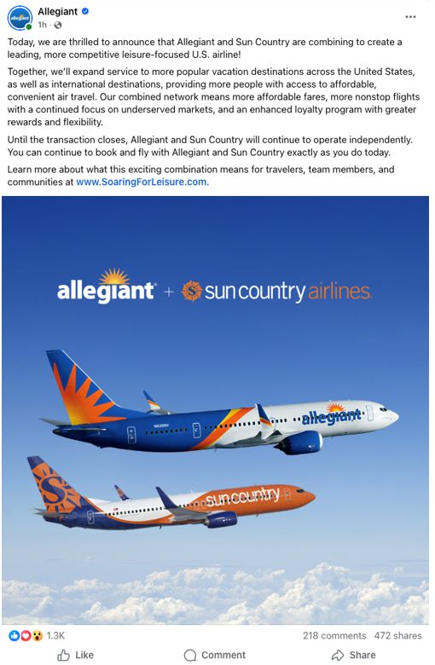

Instagram

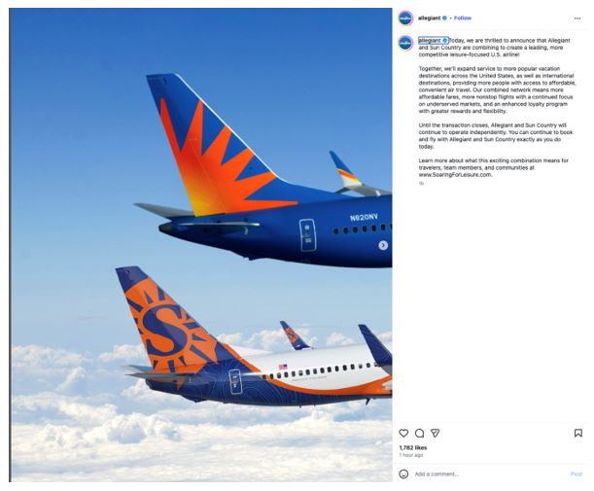

2

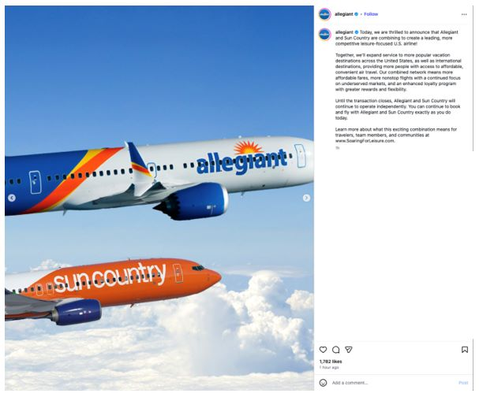

3

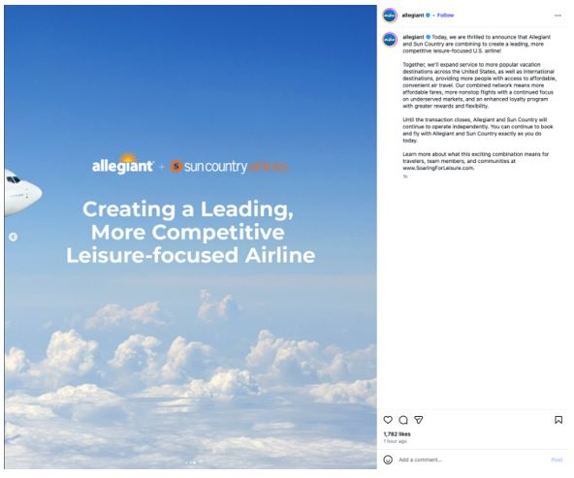

4

LinkedIn

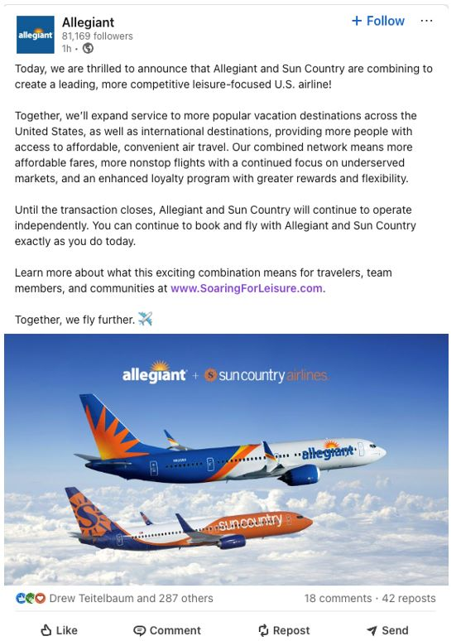

5

X
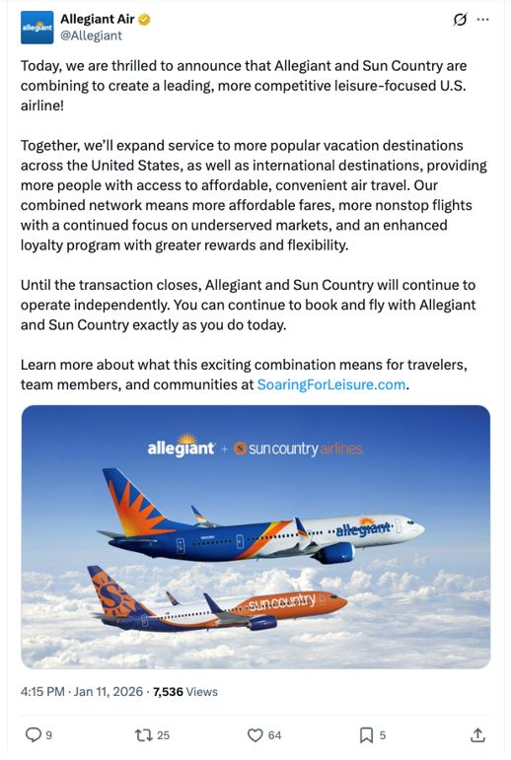

6

Cautionary Statement Regarding Forward-Looking Statements

This communication contains forward-looking statements under the safe harbor provisions of Section 21E of the Securities Exchange Act of 1934, Section 27A of the Securities Act of 1933 and the Private Securities Litigation Reform Act of 1995. Forward-looking statements include all statements that are not historical facts and often can be identified by the use of forward-looking terminology such as the words “believe,” “expect,” “guidance,” “anticipate,” “intend,” “plan,” “estimate”, “project”, “hope” or similar expressions. Forward-looking statements in this communication are based on Allegiant’s and Sun Country’s current expectations, estimates and projections about the expected date of closing of the proposed transaction and the potential benefits thereof, their respective businesses and industries, management’s beliefs and certain assumptions made by Allegiant and Sun Country, all of which are subject to change. Forward-looking statements in this communication may relate to, without limitation, the benefits of the proposed transaction, including future financial and operating results; the parties’ respective plans, objectives, expectations and intentions; the expected timing and likelihood of completion of the proposed transaction; expected synergies of the proposed transaction; the timing and result of various regulatory proceedings related to the proposed transaction; the ability to execute and finance current and long-term business, operational, capital expenditures and growth plans and strategies; the impact of increased or increasing transaction and financing costs associated with the proposed transaction or otherwise, as well as inflation and interest rates; and the ability to access debt and equity capital markets.

Forward-looking statements involve risks, uncertainties and assumptions that could cause actual results to differ materially from those expressed in any forward-looking statements. Accordingly, there are or will be important factors that could cause actual results to differ materially from those indicated in such statements and, therefore, you should not place undue reliance on any such statements and caution must be exercised in relying on forward-looking statements. Important risk factors that may cause such a difference include, but are not limited to, the following: the occurrence of any event, change or other circumstance that could give rise to the right of one or both of the parties to terminate the definitive merger agreement for the proposed transaction; the risk that potential legal proceedings may be instituted against Allegiant or Sun Country and result in significant costs of defense, indemnification or liability; the possibility that the proposed transaction does not close when expected or at all because required stockholder approvals, required regulatory approvals or other conditions to closing are not received or satisfied on a timely basis or at all (and the risk that such regulatory approvals may result in the imposition of conditions that could adversely affect the combined company or the expected benefits of the proposed transaction); the risk that the combined company will not realize expected benefits, cost savings, accretion, synergies and/or growth from the proposed transaction or that any of the foregoing may take longer to realize or be more costly to achieve than expected; disruption to the parties’ businesses as a result of the announcement and pendency of the proposed transaction; the costs associated with the anticipated length of time of the pendency of the proposed transaction, including the restrictions contained in the definitive merger agreement on the ability of each of Sun Country and Allegiant to operate their respective businesses outside the ordinary course consistent with past practice during the pendency of the proposed transaction; the diversion of Allegiant’s and Sun Country’s respective management teams’ attention and time from ongoing business operations and opportunities on acquisition-related matters; the risk that the integration of Sun Country’s operations will be materially delayed or will be more costly or difficult than expected or that Allegiant is otherwise unable to successfully integrate Sun Country’s businesses into its businesses; the possibility that the proposed transaction may be more expensive to complete than anticipated, including as a result of unexpected factors or events; reputational risk and potential adverse reactions of Allegiant’s or Sun Country’s customers, suppliers, employees, labor unions or other business partners, including those resulting from the announcement or completion of the proposed transaction; the dilution caused by Allegiant’s issuance of additional shares of its common stock in connection with the consummation of the proposed transaction; a material adverse change in the business, condition or results of operations of Allegiant or Sun Country; changes in domestic or international economic, political or business conditions, including those impacting the airline industry (including customers, employees and supply chains); Allegiant’s and Sun Country’s ability to successfully implement their respective operational, productivity and strategic initiatives; the outcome of claims, litigation, governmental proceedings and investigations involving Allegiant or Sun Country; and a cybersecurity incident or other disruption to Sun Country’s or Allegiant’s technology infrastructure.

Forward-looking statements in this communication are qualified by and should be read together with, the risk factors set forth above and the risk factors included in Allegiant’s and Sun Country’s respective annual and quarterly reports as filed with the Securities and Exchange Commission (the “SEC”), and readers should refer to such risks, uncertainties and risk factors in evaluating such forward-looking statements. In addition, the risk factors discussed above are not exhaustive and they, along with other risk factors, will be more fully discussed in the registration statement and joint proxy statement/prospectus to be filed with the SEC in connection with the proposed transaction.

7

The forward-looking statements in this communication are made only as of the date they were first issued, and unless otherwise required by applicable securities laws, Allegiant and Sun Country disclaim any intention or obligation to update or revise any forward-looking statements, whether as a result of new information, future events, or otherwise.

Important Additional Information and Where to Find It

In connection with the proposed transaction, Allegiant intends to file with the SEC a registration statement on Form S-4 (the “Registration Statement”), which will include a prospectus with respect to the shares of Allegiant’s common stock to be issued in the proposed transaction and a joint proxy statement for Allegiant’s and Sun Country’s respective stockholders (the “Joint Proxy Statement/Prospectus”). The definitive joint proxy statement (if and when available) will be mailed to stockholders of Allegiant and Sun Country. Each of Allegiant and Sun Country may also file with or furnish to the SEC other relevant documents regarding the proposed transaction. This communication is not a substitute for the Registration Statement, the Joint Proxy Statement/Prospectus or any other document that Allegiant or Sun Country may file with the SEC or send to their respective stockholders in connection with the proposed transaction. INVESTORS AND SECURITY HOLDERS OF ALLEGIANT AND SUN COUNTRY ARE URGED TO READ THE REGISTRATION STATEMENT AND THE JOINT PROXY STATEMENT/PROSPECTUS INCLUDED WITHIN THE REGISTRATION WHEN THEY BECOME AVAILABLE, AS WELL AS ANY OTHER RELEVANT DOCUMENTS FILED WITH THE SEC IN CONNECTION WITH THE PROPOSED TRANSACTION OR INCORPORATED BY REFERENCE INTO THE REGISTRATION STATEMENT AND THE JOINT PROXY STATEMENT/PROSPECTUS (INCLUDING ANY AMENDMENTS OR SUPPLEMENTS THERETO), BECAUSE THEY WILL CONTAIN IMPORTANT INFORMATION REGARDING ALLEGIANT, SUN COUNTRY, THE PROPOSED TRANSACTION AND RELATED MATTERS. Investors and security holders of Allegiant and Sun Country may obtain free copies of these documents and other documents filed with the SEC by Allegiant or Sun Country through the website maintained by the SEC at http://www.sec.gov or from Allegiant at its website, https://ir.allegiantair.com/financials/sec-filings/default.aspx, or from Sun Country at its website, https://ir.suncountry.com/financials/sec-filings. Documents filed with the SEC by Allegiant will be available free of charge by accessing Allegiant’s website at https://ir.allegiantair.com/financials/sec-filings/default.aspx, or alternatively by directing a request by mail to Allegiant’s Investor Relations department, 1201 North Town Center Drive, Las Vegas, NV 89144, and documents filed with the SEC by Sun Country will be available free of charge by accessing Sun Country’s website at https://ir.suncountry.com/financials/sec-filings, or alternatively by directing a request by mail to Sun Country’s Investor Relations department, 2005 Cargo Road, Minneapolis, MN 55450.

Participants In The Solicitation

Allegiant, Sun Country and certain of their respective directors and executive officers may be deemed to be participants in the solicitation of proxies from the stockholders of Allegiant and Sun Country in connection with the proposed transaction under the rules of the SEC.

Information about the interests of the directors and executive officers of Allegiant and Sun Country and other persons who may be deemed to be participants in the solicitation of stockholders of Allegiant and Sun Country in connection with the proposed transaction and a description of their direct and indirect interests, by security holdings or otherwise, will be included in the Joint Proxy Statement/Prospectus, which will be filed with the SEC.

Information about the directors and executive officers of Allegiant, their ownership of Allegiant common stock and Allegiant’s transactions with related persons can also be found in the Allegiant Annual Report and Allegiant’s definitive proxy statement in connection with its 2025 annual meeting of stockholders, as filed with the SEC on Schedule 14A on April 30, 2025 (the “Allegiant 2025 Proxy Statement”), and other documents subsequently filed by Allegiant with the SEC, which are available on its website, https://ir.allegiantair.com/financials/sec-filings/default.aspx. Such information is set forth in the sections entitled “Proposal No. 1 – Election of Directors”, “Proposal No. 2 – Advisory (non-binding) Vote on Executive Compensation”, “Proposal No. 3 – Approval of Amendment to Allegiant 2022 Long-Term Incentive Plan to Increase Number of Shares Available”, “Executive Compensation” and “Related Party Transactions” of the Allegiant 2025 Proxy Statement. To the extent holdings of Allegiant common stock by the directors and executive officers of Allegiant have changed from the amounts of Allegiant common stock held by such persons as reflected therein, such changes have been or will be reflected on Statements of Change in Ownership on Form 4 filed with the SEC, which are available at https://www.sec.gov/edgar/browse/?CIK=1362468&owner=exclude under the tab “Ownership Disclosures”.

8

Information about the directors and executive officers of Sun Country, their ownership of Sun Country common stock and Sun Country’s transactions with related persons can also be found in the definitive proxy statement for Sun Country’s 2025 annual meeting of stockholders, as filed with the SEC on Schedule 14A on April 25, 2025 (which is available at https://ir.suncountry.com/financials/sec-filings), and other documents subsequently filed by Sun Country with the SEC. Such information is set forth in the sections entitled “Proposal 1– Reelection of Directors”, “Proposal 2 – Non-binding (Advisory) Vote to Approve the Compensation of Our Named Executive Officers”, “Executive Compensation”, “Certain Relationships and Related Person Transactions” and “Security Ownership of Certain Beneficial Owners and Management” of such definitive proxy statement. Please also refer to Sun Country’s subsequent Current Reports, as filed with the SEC on Form 8-K on September 22, 2025 (which is available at https://ir.suncountry.com/financials/sec-filings) and on October 30, 2025, regarding subsequent changes to Sun Country’s Board of Directors and executive management following the filing of such definitive proxy statement. To the extent holdings of Sun Country common stock by the directors and executive officers of Sun Country have changed from the amounts of Sun Country common stock held by such persons as reflected in the definitive proxy statement, such changes have been or will be reflected on Statements of Change in Ownership on Form 4 filed with the SEC, which are available at https://www.sec.gov/edgar/browse/?CIK=1743907&owner=exclude under the tab “Ownership Disclosures”.

Free copies of these documents may be obtained as described above.

No Offer or Solicitation

This communication is for informational purposes only and does not constitute, or form a part of, an offer to sell, an offer to buy, or the solicitation of an offer to sell or the solicitation of an offer to buy any securities, and there shall be no sale of securities, in any jurisdiction in which such offer, solicitation or sale would be unlawful prior to registration or qualification under the securities laws of any such jurisdiction. No offer of securities shall be made except by means of a prospectus meeting the requirements of Section 10 of the Securities Act of 1933, as amended, and otherwise in accordance with applicable law.

9

Exhibit 99.3

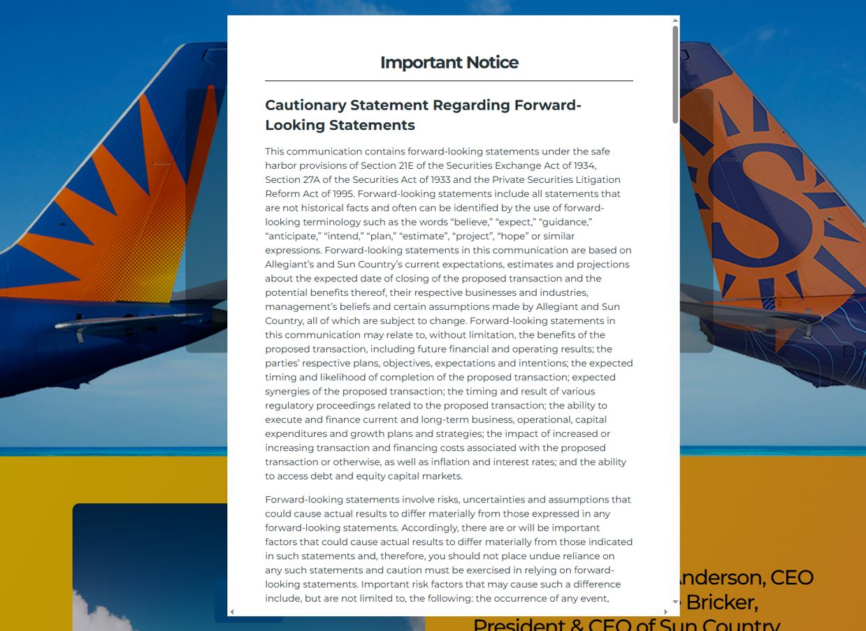

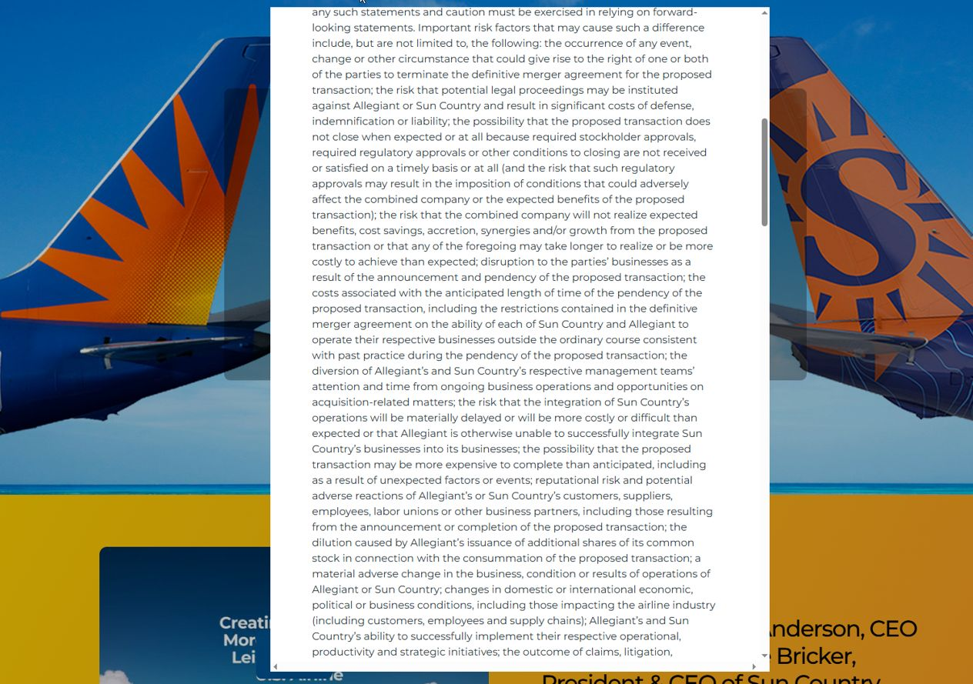

1

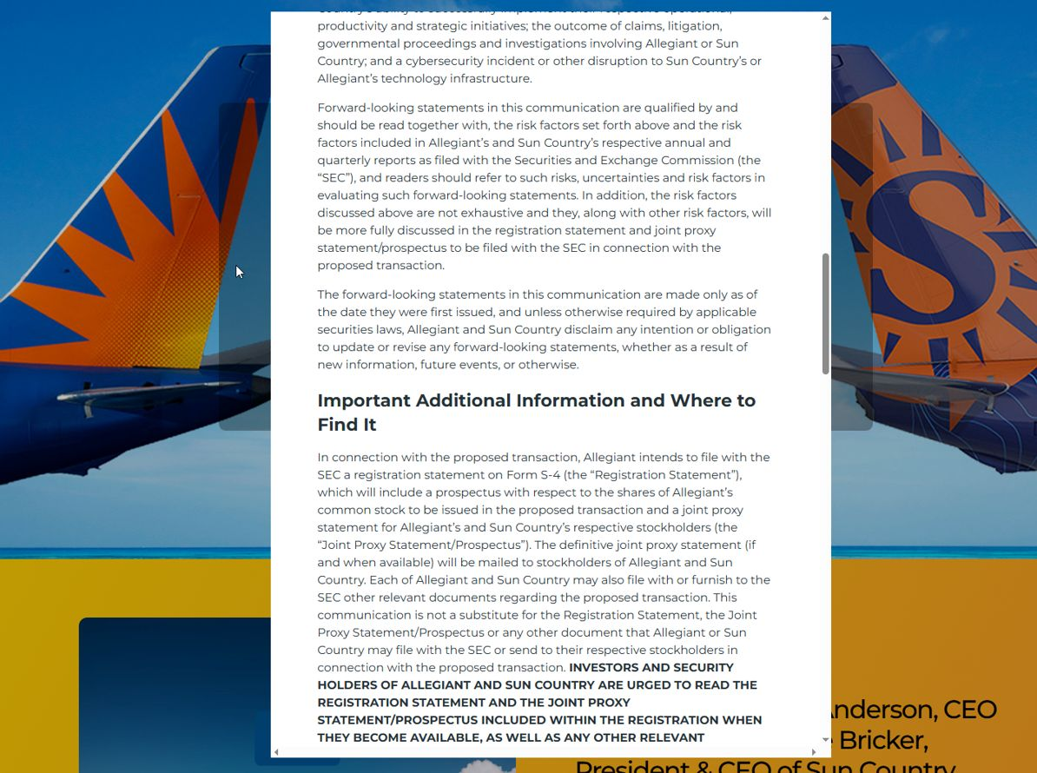

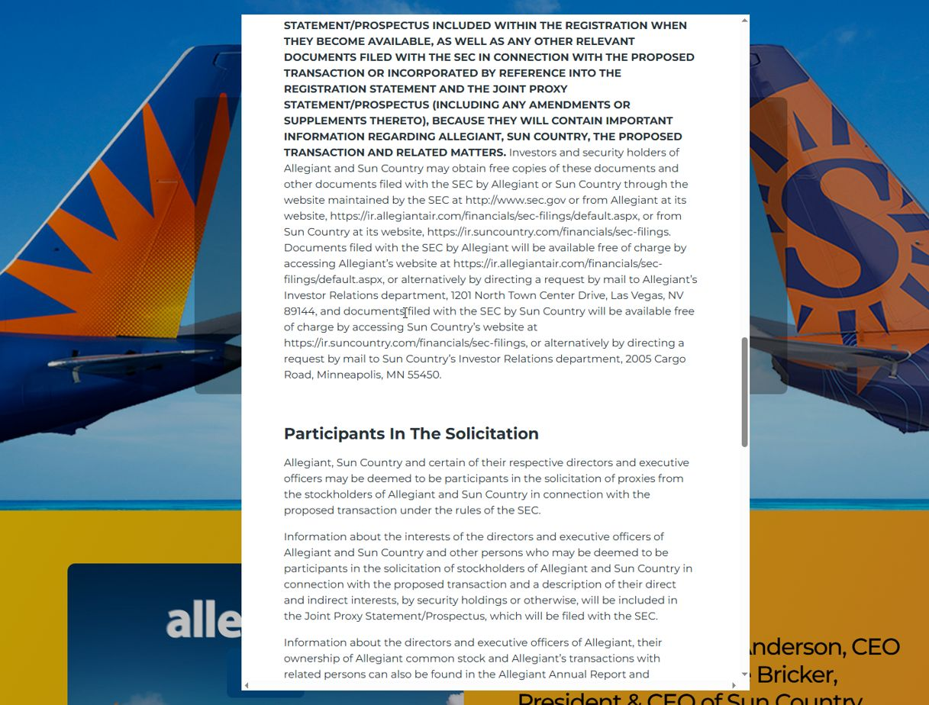

2

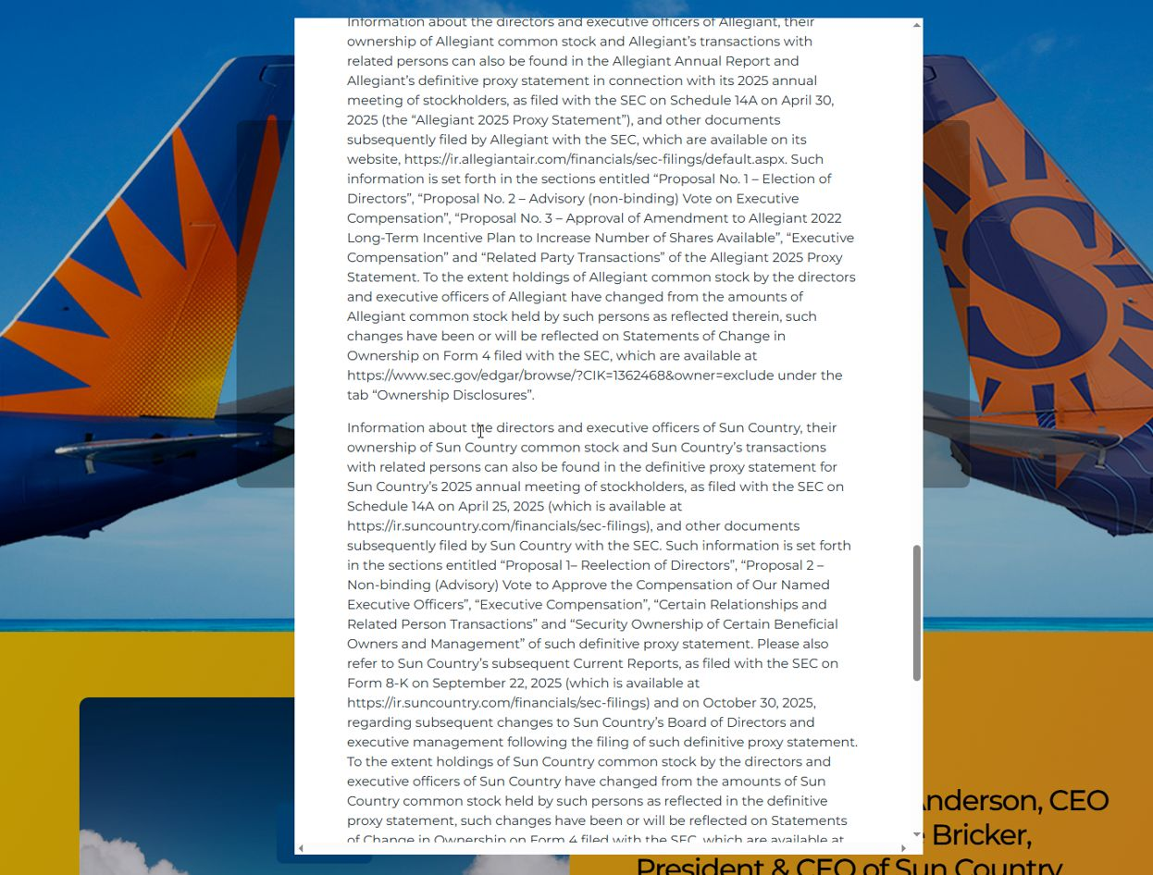

3

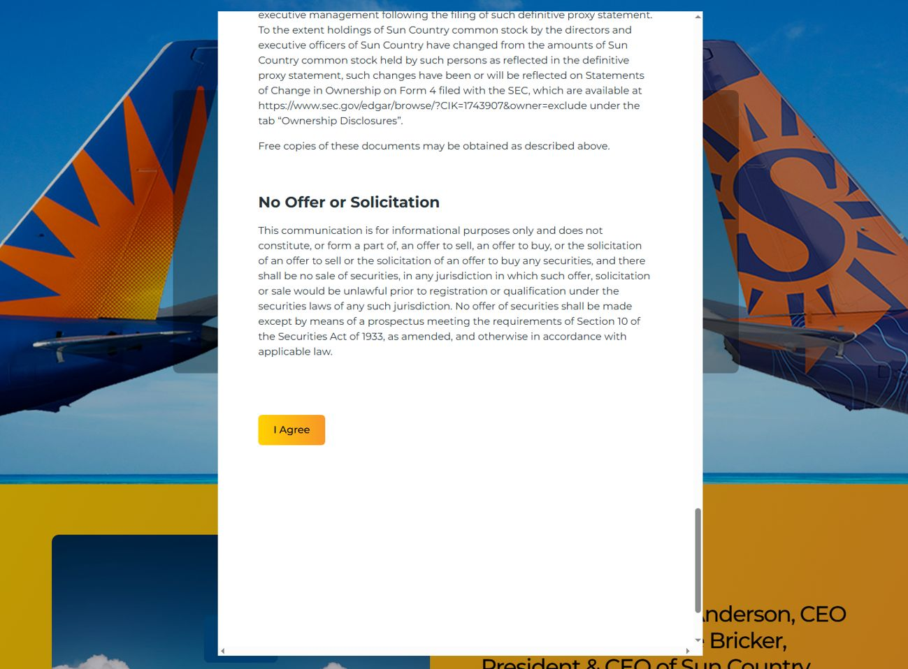

4

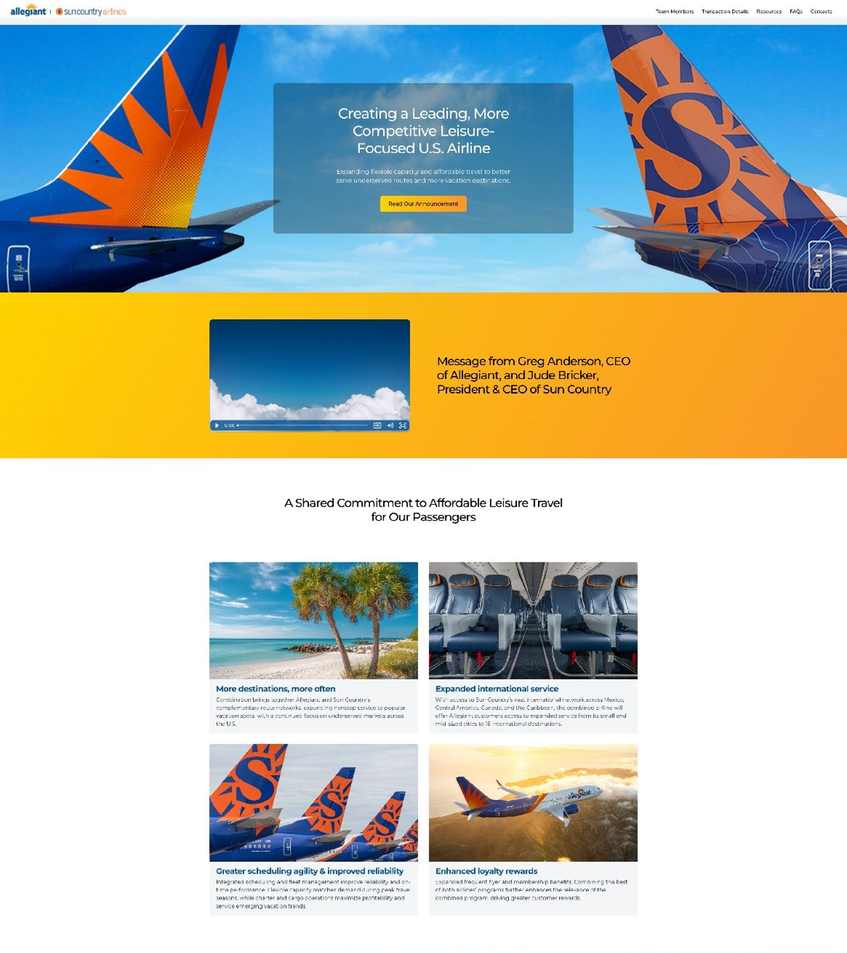

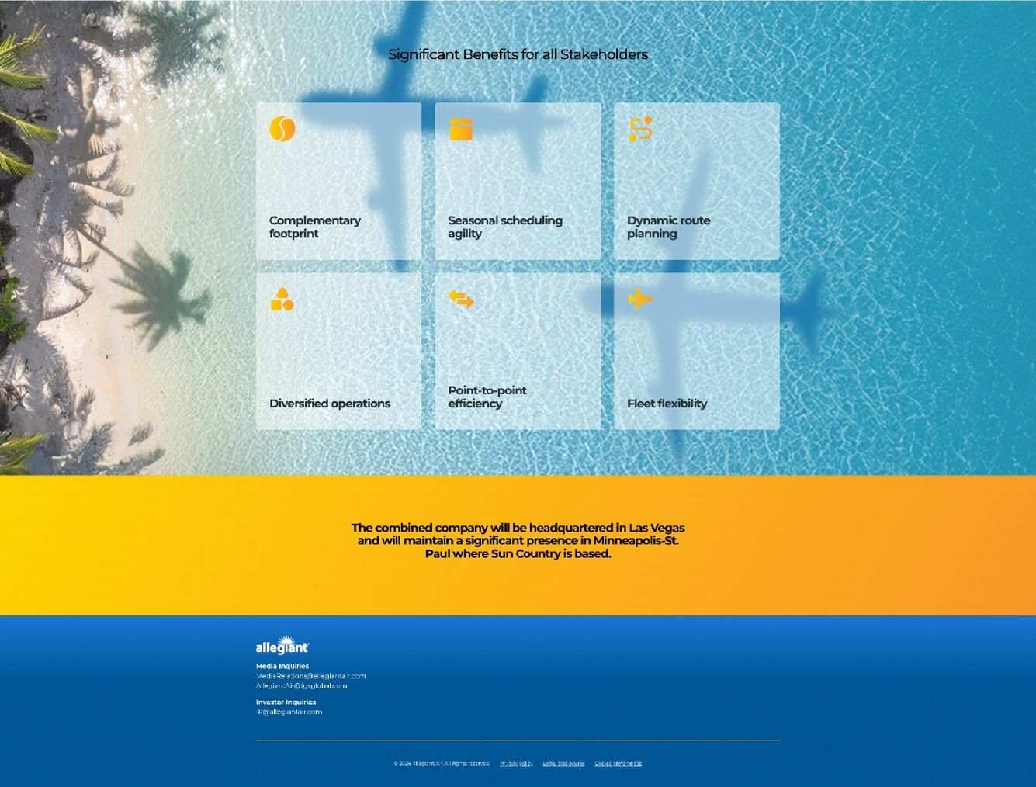

5



6



7

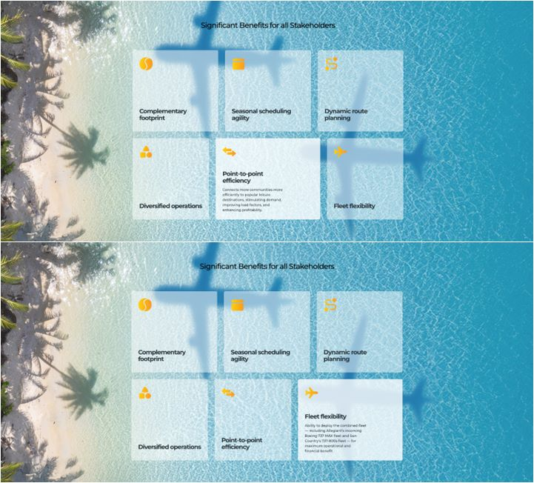

8

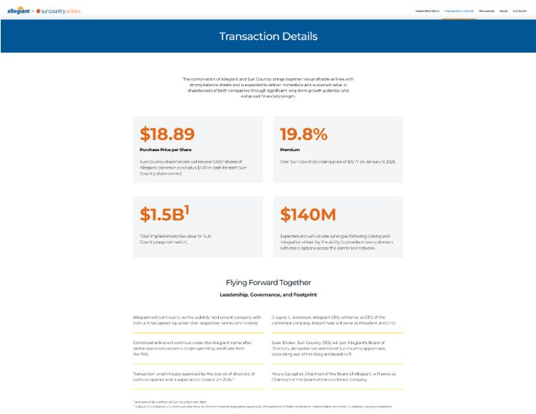


9

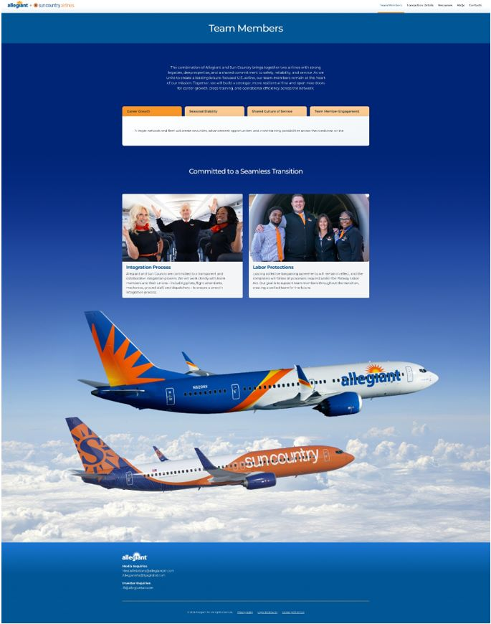

10

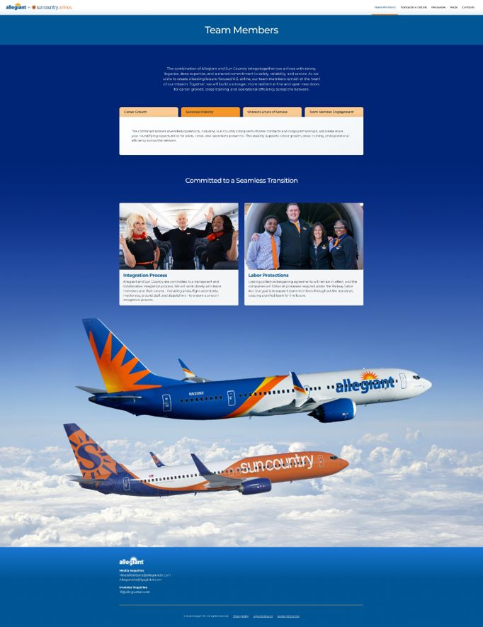

11

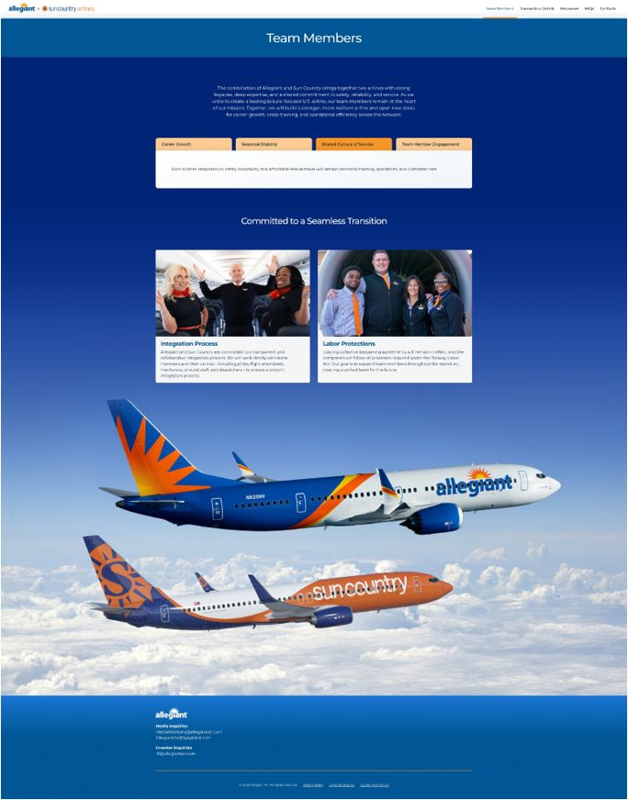

12

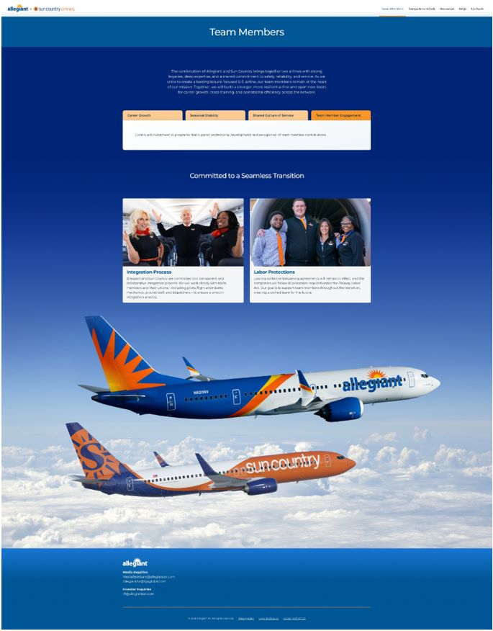

13

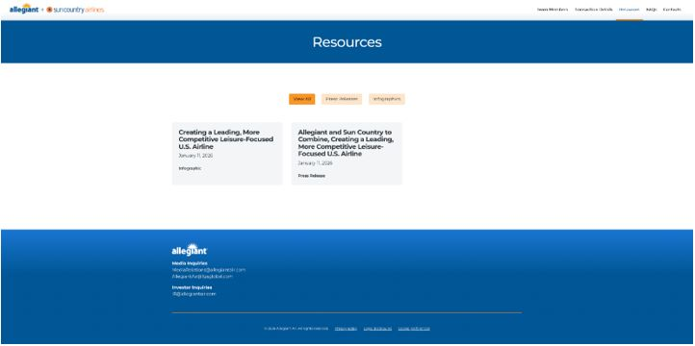

14

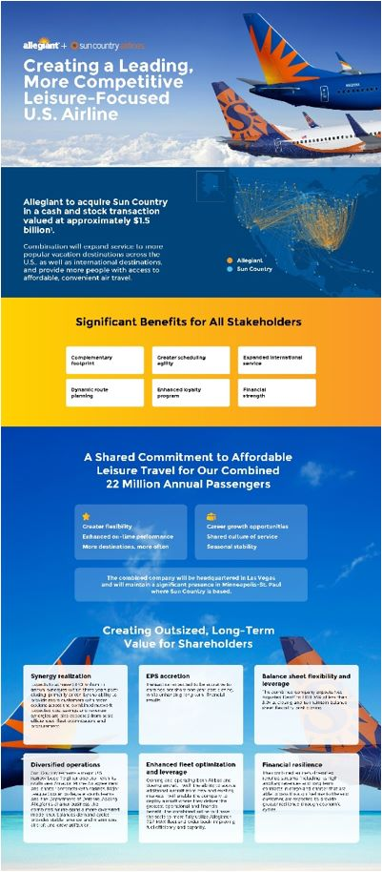

15

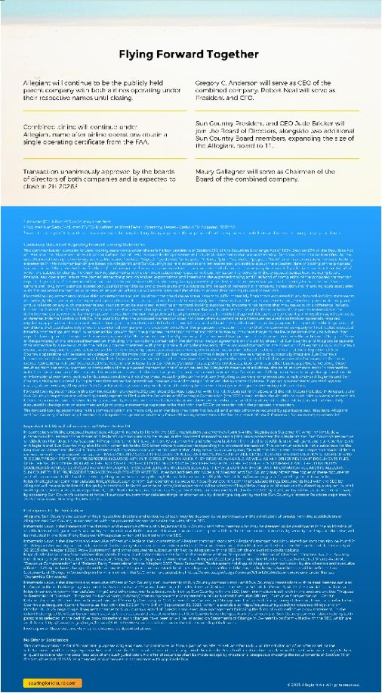

16

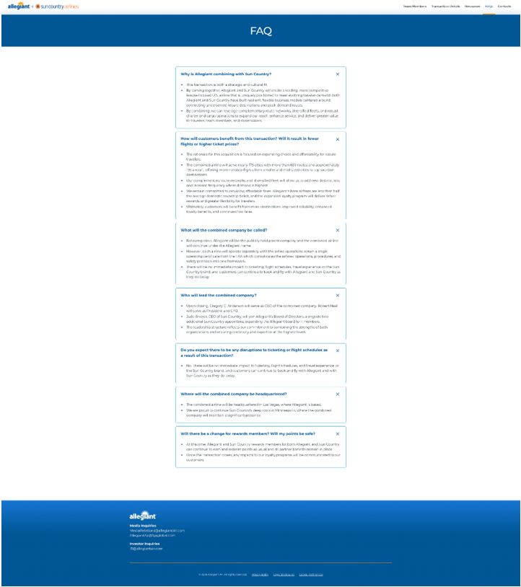

17

Exhibit 99.4

CEO Video Script

[Text on screen]

Creating a Leading, More Competitive Leisure-Focused U.S. Airline

ALLEGIANT CEO

 | • | Hello, everyone, and thank you for joining us today.

 | • | My name is Greg Anderson, and I am the CEO of Allegiant.

[Text on screen]

Greg Anderson
CEO of Allegiant Travel Company

ALLEGIANT CEO

 | • | I’m excited to share some important news about the future of our airlines.

 | • | We’ve announced that Allegiant will acquire Sun Country – bringing together two carriers with similar flexible capacity models, complementary networks, and a shared commitment to connecting travelers to the places they love.

 | • | Jude and I have known each other for a long time and have great mutual respect for one another and the team members at both companies. We – and these airlines – are cut from the same cloth in many ways, which is one reason we think this combination makes a lot of sense.

 | • | Let me begin by saying both Allegiant and Sun Country team members should take great pride in what we have built as independent companies. An airline is the ultimate team sport, and we have both established ourselves as leaders in affordable leisure travel with our flexible capacity models.

 | • | Our businesses are strategically aligned. Together, we will have more resources and greater flexibility to further strengthen our important role in North America’s leisure travel market, delivering value to travelers, partners, team members, shareholders, and the communities we serve.

 | • | First, our complementary route networks and diversified fleets will expand choice and improve service for customers. Together, we’ll offer more frequent service to more popular vacation spots across the U.S., as well as select international destinations, providing more people with access to affordable, convenient air travel.

 | • | Second, the combination of Allegiant’s scheduled service and charter operations with Sun Country’s long-term charter and cargo partnerships and their deep roots in Minneapolis creates a more diversified and adaptable airline. These operations balance demand cycles, provide stable revenue streams, and increase aircraft and crew utilization throughout the year.

 | • | Third, we are both doing this from a position of strength and together forming an even more resilient airline. By combining our two carriers – each known for outstanding operational performance, loyal customer bases, consistent profitability, and strong balance sheets – we will achieve greater scale and resources. This will enable us to further reinvest in the business and our team members, expand our network, and be the clear leader in affordable travel.

[Text on screen]

Jude Bricker
President & CEO of Sun Country Airlines

SUN COUNTRY CEO

 | • | I am thrilled to be here with Greg to announce this incredible milestone.

 | • | For over 40 years, Sun Country has been one of the country’s leading low-cost airlines, flying our guests to their favorite people and places.

 | • | We are founded in Minneapolis and have been an integral part of life in Minnesota ever since. By coming together with Allegiant, we’ll be better-positioned to deliver for our team, guests, and communities – now and long into the future.

 | • | I’ve had the privilege of working with both airlines and I can say with confidence that this combination is an exceptional fit in every way – for our customers, our employees, and our communities.

 | • | In fact, Sun Country’s first ever flight landed in Las Vegas, Allegiant’s headquarters.

 | • | For our guests, we will bring you even more nonstop flight options to new destinations for leisure travel without compromising on cost and service excellence across our two iconic airlines.

 | • | We will maintain our significant presence in Minneapolis and offer expanded loyalty rewards.

 | • | For our employees, we will be part of a larger, national airline with more flights, more investment in you, and more opportunities for career development and cross-training possibilities.

 | • | For our communities – in Minnesota and beyond – we’ll be an even stronger partner, with more flights in and out of Minneapolis-St. Paul and an unwavering dedication to making a positive impact here at home.

 | • | We are building a stronger airline together, greater than the sum of our parts, and I can’t wait for what’s to come.

ALLEGIANT CEO

 | • | That’s right, Jude. While our corporate headquarters will remain in Las Vegas, we are proud to continue Sun Country’s deep roots in Minneapolis, where the combined company will maintain a significant presence.

 | • | Just as Sun Country is vital to Minneapolis, Allegiant offers similarly important services to the 125 communities we serve. We greatly value the strong relationships that exist between an airline and its community.

 | • | Now, today’s announcement is just the first step in the process.

 | • | Until the transaction closes, which is expected in the second half of 2026, we’ll continue to operate as separate and independent companies, focused on delivering the reliable service and value that our customers expect.

 | • | As we move toward closing, we’ll solidify our integration plans. We look forward to working closely with our team members and their unions – including pilots, flight attendants, mechanics, ground staff, dispatchers, and our nonunion team members – to ensure a smooth and transparent integration. We’re committed to communicating updates throughout the process.

 | • | We encourage you to visit the website we’ve created www.SoaringForLeisure.com where we’ve posted additional information and will provide further updates as we work together toward completing the transaction.

 | • | This is an exciting chapter for our companies. Together, we look forward to creating one of the most adaptable and resilient airline models in the industry – better positioned to deliver even more benefits for travelers, team members, and the communities we serve.

 | • | Thank you.

Cautionary Statement Regarding Forward-Looking Statements

This communication contains forward-looking statements under the safe harbor provisions of Section 21E of the Securities Exchange Act of 1934, Section 27A of the Securities Act of 1933 and the Private Securities Litigation Reform Act of 1995. Forward-looking statements include all statements that are not historical facts and often can be identified by the use of forward-looking terminology such as the words “believe,” “expect,” “guidance,” “anticipate,” “intend,” “plan,” “estimate”, “project”, “hope” or similar expressions. Forward-looking statements in this communication are based on Allegiant’s and Sun Country’s current expectations, estimates and projections about the expected date of closing of the proposed transaction and the potential benefits thereof, their respective businesses and industries, management’s beliefs and certain assumptions made by Allegiant and Sun Country, all of which are subject to change. Forward-looking statements in this communication may relate to, without limitation, the benefits of the proposed transaction, including future financial and operating results; the parties’ respective plans, objectives, expectations and intentions; the expected timing and likelihood of completion of the proposed transaction; expected synergies of the proposed transaction; the timing and result of various regulatory proceedings related to the proposed transaction; the ability to execute and finance current and long-term business, operational, capital expenditures and growth plans and strategies; the impact of increased or increasing transaction and financing costs associated with the proposed transaction or otherwise, as well as inflation and interest rates; and the ability to access debt and equity capital markets.

Forward-looking statements involve risks, uncertainties and assumptions that could cause actual results to differ materially from those expressed in any forward-looking statements. Accordingly, there are or will be important factors that could cause actual results to differ materially from those indicated in such statements and, therefore, you should not place undue reliance on any such statements and caution must be exercised in relying on forward-looking statements. Important risk factors that may cause such a difference include, but are not limited to, the following: the occurrence of any event, change or other circumstance that could give rise to the right of one or both of the parties to terminate the definitive merger agreement for the proposed transaction; the risk that potential legal proceedings may be instituted against Allegiant or Sun Country and result in significant costs of defense, indemnification or liability; the possibility that the proposed transaction does not close when expected or at all because required stockholder approvals, required regulatory approvals or other conditions to closing are not received or satisfied on a timely basis or at all (and the risk that such regulatory approvals may result in the imposition of conditions that could adversely affect the combined company or the expected benefits of the proposed transaction); the risk that the combined company will not realize expected benefits, cost savings, accretion, synergies and/or growth from the proposed transaction or that any of the foregoing may take longer to realize or be more costly to achieve than expected; disruption to the parties’ businesses as a result of the announcement and pendency of the proposed transaction; the costs associated with the anticipated length of time of the pendency of the proposed transaction, including the restrictions contained in the definitive merger agreement on the ability of each of Sun Country and Allegiant to operate their respective businesses outside the ordinary course consistent with past practice during the pendency of the proposed transaction; the diversion of Allegiant’s and Sun Country’s respective management teams’ attention and time from ongoing business operations and opportunities on acquisition-related matters; the risk that the integration of Sun Country’s operations will be materially delayed or will be more costly or difficult than expected or that Allegiant is otherwise unable to successfully integrate Sun Country’s businesses into its businesses; the possibility that the proposed transaction may be more expensive to complete than anticipated, including as a result of unexpected factors or events; reputational risk and potential adverse reactions of Allegiant’s or Sun Country’s customers, suppliers, employees, labor unions or other business partners, including those resulting from the announcement or completion of the proposed transaction; the dilution caused by Allegiant’s issuance of additional shares of its common stock in connection with the consummation of the proposed transaction; a material adverse change in the business, condition or results of operations of Allegiant or Sun Country; changes in domestic or international economic, political or business conditions, including those impacting the airline industry (including customers, employees and supply chains); Allegiant’s and Sun Country’s ability to successfully implement their respective operational, productivity and strategic initiatives; the outcome of claims, litigation, governmental proceedings and investigations involving Allegiant or Sun Country; and a cybersecurity incident or other disruption to Sun Country’s or Allegiant’s technology infrastructure.

Forward-looking statements in this communication are qualified by and should be read together with, the risk factors set forth above and the risk factors included in Allegiant’s and Sun Country’s respective annual and quarterly reports as filed with the Securities and Exchange Commission (the “SEC”), and readers should refer to such risks, uncertainties and risk factors in evaluating such forward-looking statements. In addition, the risk factors discussed above are not exhaustive and they, along with other risk factors, will be more fully discussed in the registration statement and joint proxy statement/prospectus to be filed with the SEC in connection with the proposed transaction.

The forward-looking statements in this communication are made only as of the date they were first issued, and unless otherwise required by applicable securities laws, Allegiant and Sun Country disclaim any intention or obligation to update or revise any forward-looking statements, whether as a result of new information, future events, or otherwise.

Important Additional Information and Where to Find It

In connection with the proposed transaction, Allegiant intends to file with the SEC a registration statement on Form S-4 (the “Registration Statement”), which will include a prospectus with respect to the shares of Allegiant’s common stock to be issued in the proposed transaction and a joint proxy statement for Allegiant’s and Sun Country’s respective stockholders (the “Joint Proxy Statement/Prospectus”). The definitive joint proxy statement (if and when available) will be mailed to stockholders of Allegiant and Sun Country. Each of Allegiant and Sun Country may also file with or furnish to the SEC other relevant documents regarding the proposed transaction. This communication is not a substitute for the Registration Statement, the Joint Proxy Statement/Prospectus or any other document that Allegiant or Sun Country may file with the SEC or send to their respective stockholders in connection with the proposed transaction. INVESTORS AND SECURITY HOLDERS OF ALLEGIANT AND SUN COUNTRY ARE URGED TO READ THE REGISTRATION STATEMENT AND THE JOINT PROXY STATEMENT/PROSPECTUS INCLUDED WITHIN THE REGISTRATION WHEN THEY BECOME AVAILABLE, AS WELL AS ANY OTHER RELEVANT DOCUMENTS FILED WITH THE SEC IN CONNECTION WITH THE PROPOSED TRANSACTION OR INCORPORATED BY REFERENCE INTO THE REGISTRATION STATEMENT AND THE JOINT PROXY STATEMENT/PROSPECTUS (INCLUDING ANY AMENDMENTS OR SUPPLEMENTS THERETO), BECAUSE THEY WILL CONTAIN IMPORTANT INFORMATION REGARDING ALLEGIANT, SUN COUNTRY, THE PROPOSED TRANSACTION AND RELATED MATTERS. Investors and security holders of Allegiant and Sun Country may obtain free copies of these documents and other documents filed with the SEC by Allegiant or Sun Country through the website maintained by the SEC at http://www.sec.gov or from Allegiant at its website, https://ir.allegiantair.com/financials/sec-filings/default.aspx, or from Sun Country at its website, https://ir.suncountry.com/financials/sec-filings. Documents filed with the SEC by Allegiant will be available free of charge by accessing Allegiant’s website at https://ir.allegiantair.com/financials/sec-filings/default.aspx, or alternatively by directing a request by mail to Allegiant’s Investor Relations department, 1201 North Town Center Drive, Las Vegas, NV 89144, and documents filed with the SEC by Sun Country will be available free of charge by accessing Sun Country’s website at https://ir.suncountry.com/financials/sec-filings, or alternatively by directing a request by mail to Sun Country’s Investor Relations department, 2005 Cargo Road, Minneapolis, MN 55450.

Participants In The Solicitation

Allegiant, Sun Country and certain of their respective directors and executive officers may be deemed to be participants in the solicitation of proxies from the stockholders of Allegiant and Sun Country in connection with the proposed transaction under the rules of the SEC.

Information about the interests of the directors and executive officers of Allegiant and Sun Country and other persons who may be deemed to be participants in the solicitation of stockholders of Allegiant and Sun Country in connection with the proposed transaction and a description of their direct and indirect interests, by security holdings or otherwise, will be included in the Joint Proxy Statement/Prospectus, which will be filed with the SEC.

Information about the directors and executive officers of Allegiant, their ownership of Allegiant common stock and Allegiant’s transactions with related persons can also be found in the Allegiant Annual Report and Allegiant’s definitive proxy statement in connection with its 2025 annual meeting of stockholders, as filed with the SEC on Schedule 14A on April 30, 2025 (the “Allegiant 2025 Proxy Statement”), and other documents subsequently filed by Allegiant with the SEC, which are available on its website, https://ir.allegiantair.com/financials/sec-filings/default.aspx. Such information is set forth in the sections entitled “Proposal No. 1 – Election of Directors”, “Proposal No. 2 – Advisory (non-binding) Vote on Executive Compensation”, “Proposal No. 3 – Approval of Amendment to Allegiant 2022 Long-Term Incentive Plan to Increase Number of Shares Available”, “Executive Compensation” and “Related Party Transactions” of the Allegiant 2025 Proxy Statement. To the extent holdings of Allegiant common stock by the directors and executive officers of Allegiant have changed from the amounts of Allegiant common stock held by such persons as reflected therein, such changes have been or will be reflected on Statements of Change in Ownership on Form 4 filed with the SEC, which are available at https://www.sec.gov/edgar/browse/?CIK=1362468&owner=exclude under the tab “Ownership Disclosures”.

Information about the directors and executive officers of Sun Country, their ownership of Sun Country common stock and Sun Country’s transactions with related persons can also be found in the definitive proxy statement for Sun Country’s 2025 annual meeting of stockholders, as filed with the SEC on Schedule 14A on April 25, 2025 (which is available at https://ir.suncountry.com/financials/sec-filings), and other documents subsequently filed by Sun Country with the SEC. Such information is set forth in the sections entitled “Proposal 1– Reelection of Directors”, “Proposal 2 – Non-binding (Advisory) Vote to Approve the Compensation of Our Named Executive Officers”, “Executive Compensation”, “Certain Relationships and Related Person Transactions” and “Security Ownership of Certain Beneficial Owners and Management” of such definitive proxy statement. Please also refer to Sun Country’s subsequent Current Reports, as filed with the SEC on Form 8-K on September 22, 2025 (which is available at https://ir.suncountry.com/financials/sec-filings) and on October 30, 2025, regarding subsequent changes to Sun Country’s Board of Directors and executive management following the filing of such definitive proxy statement. To the extent holdings of Sun Country common stock by the directors and executive officers of Sun Country have changed from the amounts of Sun Country common stock held by such persons as reflected in the definitive proxy statement, such changes have been or will be reflected on Statements of Change in Ownership on Form 4 filed with the SEC, which are available at https://www.sec.gov/edgar/browse/?CIK=1743907&owner=exclude under the tab “Ownership Disclosures”.

Free copies of these documents may be obtained as described above.

No Offer or Solicitation

This communication is for informational purposes only and does not constitute, or form a part of, an offer to sell, an offer to buy, or the solicitation of an offer to sell or the solicitation of an offer to buy any securities, and there shall be no sale of securities, in any jurisdiction in which such offer, solicitation or sale would be unlawful prior to registration or qualification under the securities laws of any such jurisdiction. No offer of securities shall be made except by means of a prospectus meeting the requirements of Section 10 of the Securities Act of 1933, as amended, and otherwise in accordance with applicable law.

Exhibit 99.5

Allegiant All-Employee Note

Subject: Exciting News: Allegiant to Acquire Sun Country
FROM: Gregory C. Anderson, Allegiant CEO

Team Allegiant,

I’m reaching out to share exciting news – moments ago, we announced that Allegiant has reached an agreement to acquire Sun Country.

I want to take this opportunity to share directly with you why I am so excited for our path forward and what this means for our team at Allegiant.

A hallmark of our success is reflected in the special airline we have built over the years, as a team. By pioneering the low utilization, flexible capacity model, we have established ourselves as a leader in affordable leisure travel throughout the U.S.

Last year, as part of our broader strategy, we took some steps to reinforce our airline’s foundation. On the organizational side, we streamlined our corporate structure by divesting Sunseeker and returning our focus solely to the airline business. Commercially, we updated our technology and enhanced our product lineup with initiatives like Allegiant Extra. Financially, we made significant improvements to our balance sheet and delivered strong returns. Operationally, we restored peak day flying, introduced our new MAX fleet, and achieved our best operational performance in our company’s history. Your exceptional efforts truly solidified our leadership position in our segment of the industry and created this opportunity for us to grow.

So why acquire another carrier at this time? In our industry, size, scale, and relevancy have their advantages. Currently, five airlines control approximately 85 percent of the domestic market,

The remaining domestic market is served by seven airlines, with a primary focus on offering affordable fares for leisure travelers. Since the onset of the pandemic, most of these carriers have faced significant financial difficulties and losses – except for Sun Country and our company, both of which have consistently reported positive earnings. Our decision to acquire Sun Country is both logical and strategic, as it will enhance our overall performance, boost our ability to grow, and firmly establish us as the clear leader in our sector in the industry. The combination will bring together two airlines with complementary route networks, strong operations, and shared values. By joining forces, we’ll be able to offer customers more destinations and more frequent service, strengthen our year-round flying through expanded charter and cargo operations, and create new opportunities for our people as part of a larger, more diversified airline.

Another positive feature, there is no overlap between our bases. This independence will minimize the traditional friction that has occurred in past other airline combinations. Allegiant will be the brand of the combined airline following the issuance of a single operating certificate from the FAA which consolidates the airlines' operations, procedures, and safety protocols into one framework. For all these reasons, we are confident that adding Sun Country will substantially enhance our stature and strength against other competitors.

This is an exciting moment in Allegiant’s history, but it’s important to note that nothing changes right now. Until the transaction closes and all necessary approvals are received – which we expect to occur in the second half of 2026 – Allegiant and Sun Country will continue to operate as separate companies. It is business as usual. Our priorities remain the same: to continue to operate a great airline and to take care of our customers and one another.

As the acquiring airline, it’s important we handle this process with professionalism, humility, and respect toward our future colleagues. Sun Country runs a solid operation with talented people. In many ways, we are cut from the same cloth. Given the close connections between our two companies, I am confident that together, we will build an even stronger airline.

Once the transaction closes – which we expect in the second half of 2026 – I will continue to lead the combined company as CEO, BJ will remain President & CFO, together with our Allegiant senior leadership team. The company’s headquarters will remain in Las Vegas and we will maintain a significant presence in Minneapolis-St. Paul, honoring Sun Country’s deep roots there.

Integration planning will take place over time through our Integration Management Office (IMO), which will be led by Michael Broderick, Chief Integration Officer. Michael will begin building a dedicated integration team with representatives from both organizations in the coming weeks.

As this work progresses, we won’t have every answer immediately – and that’s expected. We will take a thoughtful, deliberate approach to all parts of the integration and communicate clearly and transparently. You will continue to hear directly from me and the leadership team as plans develop and milestones are reached.

I know announcements like this naturally create questions and uncertainty. That’s normal. Our commitment is to be open, honest, and consistent with you. To learn more about this exciting milestone, please join me and members of the senior leadership team for an Allegiant Town Hall on Monday, details to come.

You can find the press release with today’s announcement on our dedicated joint microsite, which we will continue to keep updated with information on the transaction. Today’s announcement will also likely generate significant interest from all of our key stakeholders.

If you receive any inquiries about this from the media, please direct them to Sonya Padgett at Sonya.Padgett@allegiantair.com. Investor inquiries should be directed to Sherry Wilson at Sherry.Wilson@allegiantair.com, and any government affairs inquiries should go to Drew Teitelbaum at Andrew.Teitelbaum@allegiantair.com.

Thank you for your professionalism and commitment and for all you do every day. I’m proud of this team, and I’m confident in what we can build together.

Together We Fly, Gregory C. Anderson
CEO of Allegiant

Cautionary Statement Regarding Forward-Looking Statements

This communication contains forward-looking statements under the safe harbor provisions of Section 21E of the Securities Exchange Act of 1934, Section 27A of the Securities Act of 1933 and the Private Securities Litigation Reform Act of 1995. Forward-looking statements include all statements that are not historical facts and often can be identified by the use of forward-looking terminology such as the words “believe,” “expect,” “guidance,” “anticipate,” “intend,” “plan,” “estimate”, “project”, “hope” or similar expressions. Forward-looking statements in this communication are based on Allegiant’s and Sun Country’s current expectations, estimates and projections about the expected date of closing of the proposed transaction and the potential benefits thereof, their respective businesses and industries, management’s beliefs and certain assumptions made by Allegiant and Sun Country, all of which are subject to change. Forward-looking statements in this communication may relate to, without limitation, the benefits of the proposed transaction, including future financial and operating results; the parties’ respective plans, objectives, expectations and intentions; the expected timing and likelihood of completion of the proposed transaction; expected synergies of the proposed transaction; the timing and result of various regulatory proceedings related to the proposed transaction; the ability to execute and finance current and long-term business, operational, capital expenditures and growth plans and strategies; the impact of increased or increasing transaction and financing costs associated with the proposed transaction or otherwise, as well as inflation and interest rates; and the ability to access debt and equity capital markets.

Forward-looking statements involve risks, uncertainties and assumptions that could cause actual results to differ materially from those expressed in any forward-looking statements. Accordingly, there are or will be important factors that could cause actual results to differ materially from those indicated in such statements and, therefore, you should not place undue reliance on any such statements and caution must be exercised in relying on forward-looking statements. Important risk factors that may cause such a difference include, but are not limited to, the following: the occurrence of any event, change or other circumstance that could give rise to the right of one or both of the parties to terminate the definitive merger agreement for the proposed transaction; the risk that potential legal proceedings may be instituted against Allegiant or Sun Country and result in significant costs of defense, indemnification or liability; the possibility that the proposed transaction does not close when expected or at all because required stockholder approvals, required regulatory approvals or other conditions to closing are not received or satisfied on a timely basis or at all (and the risk that such regulatory approvals may result in the imposition of conditions that could adversely affect the combined company or the expected benefits of the proposed transaction); the risk that the combined company will not realize expected benefits, cost savings, accretion, synergies and/or growth from the proposed transaction or that any of the foregoing may take longer to realize or be more costly to achieve than expected; disruption to the parties’ businesses as a result of the announcement and pendency of the proposed transaction; the costs associated with the anticipated length of time of the pendency of the proposed transaction, including the restrictions contained in the definitive merger agreement on the ability of each of Sun Country and Allegiant to operate their respective businesses outside the ordinary course consistent with past practice during the pendency of the proposed transaction; the diversion of Allegiant’s and Sun Country’s respective management teams’ attention and time from ongoing business operations and opportunities on acquisition-related matters; the risk that the integration of Sun Country’s operations will be materially delayed or will be more costly or difficult than expected or that Allegiant is otherwise unable to successfully integrate Sun Country’s businesses into its businesses; the possibility that the proposed transaction may be more expensive to complete than anticipated, including as a result of unexpected factors or events; reputational risk and potential adverse reactions of Allegiant’s or Sun Country’s customers, suppliers, employees, labor unions or other business partners, including those resulting from the announcement or completion of the proposed transaction; the dilution caused by Allegiant’s issuance of additional shares of its common stock in connection with the consummation of the proposed transaction; a material adverse change in the business, condition or results of operations of Allegiant or Sun Country; changes in domestic or international economic, political or business conditions, including those impacting the airline industry (including customers, employees and supply chains); Allegiant’s and Sun Country’s ability to successfully implement their respective operational, productivity and strategic initiatives; the outcome of claims, litigation, governmental proceedings and investigations involving Allegiant or Sun Country; and a cybersecurity incident or other disruption to Sun Country’s or Allegiant’s technology infrastructure.

Forward-looking statements in this communication are qualified by and should be read together with, the risk factors set forth above and the risk factors included in Allegiant’s and Sun Country’s respective annual and quarterly reports as filed with the Securities and Exchange Commission (the “SEC”), and readers should refer to such risks, uncertainties and risk factors in evaluating such forward-looking statements. In addition, the risk factors discussed above are not exhaustive and they, along with other risk factors, will be more fully discussed in the registration statement and joint proxy statement/prospectus to be filed with the SEC in connection with the proposed transaction.

The forward-looking statements in this communication are made only as of the date they were first issued, and unless otherwise required by applicable securities laws, Allegiant and Sun Country disclaim any intention or obligation to update or revise any forward-looking statements, whether as a result of new information, future events, or otherwise.

Important Additional Information and Where to Find It

In connection with the proposed transaction, Allegiant intends to file with the SEC a registration statement on Form S-4 (the “Registration Statement”), which will include a prospectus with respect to the shares of Allegiant’s common stock to be issued in the proposed transaction and a joint proxy statement for Allegiant’s and Sun Country’s respective stockholders (the “Joint Proxy Statement/Prospectus”). The definitive joint proxy statement (if and when available) will be mailed to stockholders of Allegiant and Sun Country. Each of Allegiant and Sun Country may also file with or furnish to the SEC other relevant documents regarding the proposed transaction. This communication is not a substitute for the Registration Statement, the Joint Proxy Statement/Prospectus or any other document that Allegiant or Sun Country may file with the SEC or send to their respective stockholders in connection with the proposed transaction. INVESTORS AND SECURITY HOLDERS OF ALLEGIANT AND SUN COUNTRY ARE URGED TO READ THE REGISTRATION STATEMENT AND THE JOINT PROXY STATEMENT/PROSPECTUS INCLUDED WITHIN THE REGISTRATION WHEN THEY BECOME AVAILABLE, AS WELL AS ANY OTHER RELEVANT DOCUMENTS FILED WITH THE SEC IN CONNECTION WITH THE PROPOSED TRANSACTION OR INCORPORATED BY REFERENCE INTO THE REGISTRATION STATEMENT AND THE JOINT PROXY STATEMENT/PROSPECTUS (INCLUDING ANY AMENDMENTS OR SUPPLEMENTS THERETO), BECAUSE THEY WILL CONTAIN IMPORTANT INFORMATION REGARDING ALLEGIANT, SUN COUNTRY, THE PROPOSED TRANSACTION AND RELATED MATTERS. Investors and security holders of Allegiant and Sun Country may obtain free copies of these documents and other documents filed with the SEC by Allegiant or Sun Country through the website maintained by the SEC at http://www.sec.gov or from Allegiant at its website, https://ir.allegiantair.com/financials/sec-filings/default.aspx, or from Sun Country at its website, https://ir.suncountry.com/financials/sec-filings. Documents filed with the SEC by Allegiant will be available free of charge by accessing Allegiant’s website at https://ir.allegiantair.com/financials/sec-filings/default.aspx, or alternatively by directing a request by mail to Allegiant’s Investor Relations department, 1201 North Town Center Drive, Las Vegas, NV 89144, and documents filed with the SEC by Sun Country will be available free of charge by accessing Sun Country’s website at https://ir.suncountry.com/financials/sec-filings, or alternatively by directing a request by mail to Sun Country’s Investor Relations department, 2005 Cargo Road, Minneapolis, MN 55450.

Participants In The Solicitation

Allegiant, Sun Country and certain of their respective directors and executive officers may be deemed to be participants in the solicitation of proxies from the stockholders of Allegiant and Sun Country in connection with the proposed transaction under the rules of the SEC.

Information about the interests of the directors and executive officers of Allegiant and Sun Country and other persons who may be deemed to be participants in the solicitation of stockholders of Allegiant and Sun Country in connection with the proposed transaction and a description of their direct and indirect interests, by security holdings or otherwise, will be included in the Joint Proxy Statement/Prospectus, which will be filed with the SEC.

Information about the directors and executive officers of Allegiant, their ownership of Allegiant common stock and Allegiant’s transactions with related persons can also be found in the Allegiant Annual Report and Allegiant’s definitive proxy statement in connection with its 2025 annual meeting of stockholders, as filed with the SEC on Schedule 14A on April 30, 2025 (the “Allegiant 2025 Proxy Statement”), and other documents subsequently filed by Allegiant with the SEC, which are available on its website, https://ir.allegiantair.com/financials/sec-filings/default.aspx. Such information is set forth in the sections entitled “Proposal No. 1 – Election of Directors”, “Proposal No. 2 – Advisory (non-binding) Vote on Executive Compensation”, “Proposal No. 3 – Approval of Amendment to Allegiant 2022 Long-Term Incentive Plan to Increase Number of Shares Available”, “Executive Compensation” and “Related Party Transactions” of the Allegiant 2025 Proxy Statement. To the extent holdings of Allegiant common stock by the directors and executive officers of Allegiant have changed from the amounts of Allegiant common stock held by such persons as reflected therein, such changes have been or will be reflected on Statements of Change in Ownership on Form 4 filed with the SEC, which are available at https://www.sec.gov/edgar/browse/?CIK=1362468&owner=exclude under the tab “Ownership Disclosures”.

Information about the directors and executive officers of Sun Country, their ownership of Sun Country common stock and Sun Country’s transactions with related persons can also be found in the definitive proxy statement for Sun Country’s 2025 annual meeting of stockholders, as filed with the SEC on Schedule 14A on April 25, 2025 (which is available at https://ir.suncountry.com/financials/sec-filings), and other documents subsequently filed by Sun Country with the SEC. Such information is set forth in the sections entitled “Proposal 1– Reelection of Directors”, “Proposal 2 – Non-binding (Advisory) Vote to Approve the Compensation of Our Named Executive Officers”, “Executive Compensation”, “Certain Relationships and Related Person Transactions” and “Security Ownership of Certain Beneficial Owners and Management” of such definitive proxy statement. Please also refer to Sun Country’s subsequent Current Reports, as filed with the SEC on Form 8-K on September 22, 2025 (which is available at https://ir.suncountry.com/financials/sec-filings) and on October 30, 2025, regarding subsequent changes to Sun Country’s Board of Directors and executive management following the filing of such definitive proxy statement. To the extent holdings of Sun Country common stock by the directors and executive officers of Sun Country have changed from the amounts of Sun Country common stock held by such persons as reflected in the definitive proxy statement, such changes have been or will be reflected on Statements of Change in Ownership on Form 4 filed with the SEC, which are available at https://www.sec.gov/edgar/browse/?CIK=1743907&owner=exclude under the tab “Ownership Disclosures”.

Free copies of these documents may be obtained as described above.

No Offer or Solicitation

This communication is for informational purposes only and does not constitute, or form a part of, an offer to sell, an offer to buy, or the solicitation of an offer to sell or the solicitation of an offer to buy any securities, and there shall be no sale of securities, in any jurisdiction in which such offer, solicitation or sale would be unlawful prior to registration or qualification under the securities laws of any such jurisdiction. No offer of securities shall be made except by means of a prospectus meeting the requirements of Section 10 of the Securities Act of 1933, as amended, and otherwise in accordance with applicable law.

Exhibit 99.6

Sun Country All-Employee Note from Allegiant CEO

Subject: Bringing together Allegiant and Sun Country
From: Gregory C. Anderson, Allegiant CEO
Date: Wednesday

Dear Sun Country team,

On behalf of everyone at Allegiant, it’s an honor to share directly why we are so excited about our agreement to join forces with your great company, Sun Country, and the bright opportunities we see ahead.

The combination we announced whereby Allegiant has agreed to acquire Sun Country brings together two airlines with strong legacies, deep expertise, and shared commitments to safety, reliability, and service. Together, we believe we can create a stronger airline, one that is better positioned to serve our customers, communities, and employees over the long term.

Jude began his career at Allegiant, and that foundation has clearly shaped the thoughtful, people-first leader he is today. We hold him and your team in the highest regard, not only for operational excellence, but for the integrity and care you bring to work every day.

As our leadership teams have spent time together, it has become clear that our two companies share a remarkably similar culture, grounded in mutual respect and a deep commitment to our customers and employees. That shared foundation will be critical to building a strong, unified airline and will position the combined company for long-term success.

Any future decisions will be communicated transparently and with respect for our employees and applicable agreements. Over the coming weeks and months, we will engage openly with employees, union representatives, and regulators, sharing information as decisions are made. We are committed to listening, communicating clearly, and treating everyone fairly and respectfully as we move forward.

We will be in touch again soon, and I look forward to meeting many of you in person. Looking ahead, I will join Jude in-person for a town hall to share more about the combination and what it means for employees and the future.

We look forward to working with Jude and the Sun Country executive team to complete the transaction and to welcoming you to Allegiant.

Sincerely,
Gregory C. Anderson
CEO of Allegiant

Cautionary Statement Regarding Forward-Looking Statements

This communication contains forward-looking statements under the safe harbor provisions of Section 21E of the Securities Exchange Act of 1934, Section 27A of the Securities Act of 1933 and the Private Securities Litigation Reform Act of 1995. Forward-looking statements include all statements that are not historical facts and often can be identified by the use of forward-looking terminology such as the words “believe,” “expect,” “guidance,” “anticipate,” “intend,” “plan,” “estimate”, “project”, “hope” or similar expressions. Forward-looking statements in this communication are based on Allegiant’s and Sun Country’s current expectations, estimates and projections about the expected date of closing of the proposed transaction and the potential benefits thereof, their respective businesses and industries, management’s beliefs and certain assumptions made by Allegiant and Sun Country, all of which are subject to change. Forward-looking statements in this communication may relate to, without limitation, the benefits of the proposed transaction, including future financial and operating results; the parties’ respective plans, objectives, expectations and intentions; the expected timing and likelihood of completion of the proposed transaction; expected synergies of the proposed transaction; the timing and result of various regulatory proceedings related to the proposed transaction; the ability to execute and finance current and long-term business, operational, capital expenditures and growth plans and strategies; the impact of increased or increasing transaction and financing costs associated with the proposed transaction or otherwise, as well as inflation and interest rates; and the ability to access debt and equity capital markets.

Forward-looking statements involve risks, uncertainties and assumptions that could cause actual results to differ materially from those expressed in any forward-looking statements. Accordingly, there are or will be important factors that could cause actual results to differ materially from those indicated in such statements and, therefore, you should not place undue reliance on any such statements and caution must be exercised in relying on forward-looking statements. Important risk factors that may cause such a difference include, but are not limited to, the following: the occurrence of any event, change or other circumstance that could give rise to the right of one or both of the parties to terminate the definitive merger agreement for the proposed transaction; the risk that potential legal proceedings may be instituted against Allegiant or Sun Country and result in significant costs of defense, indemnification or liability; the possibility that the proposed transaction does not close when expected or at all because required stockholder approvals, required regulatory approvals or other conditions to closing are not received or satisfied on a timely basis or at all (and the risk that such regulatory approvals may result in the imposition of conditions that could adversely affect the combined company or the expected benefits of the proposed transaction); the risk that the combined company will not realize expected benefits, cost savings, accretion, synergies and/or growth from the proposed transaction or that any of the foregoing may take longer to realize or be more costly to achieve than expected; disruption to the parties’ businesses as a result of the announcement and pendency of the proposed transaction; the costs associated with the anticipated length of time of the pendency of the proposed transaction, including the restrictions contained in the definitive merger agreement on the ability of each of Sun Country and Allegiant to operate their respective businesses outside the ordinary course consistent with past practice during the pendency of the proposed transaction; the diversion of Allegiant’s and Sun Country’s respective management teams’ attention and time from ongoing business operations and opportunities on acquisition-related matters; the risk that the integration of Sun Country’s operations will be materially delayed or will be more costly or difficult than expected or that Allegiant is otherwise unable to successfully integrate Sun Country’s businesses into its businesses; the possibility that the proposed transaction may be more expensive to complete than anticipated, including as a result of unexpected factors or events; reputational risk and potential adverse reactions of Allegiant’s or Sun Country’s customers, suppliers, employees, labor unions or other business partners, including those resulting from the announcement or completion of the proposed transaction; the dilution caused by Allegiant’s issuance of additional shares of its common stock in connection with the consummation of the proposed transaction; a material adverse change in the business, condition or results of operations of Allegiant or Sun Country; changes in domestic or international economic, political or business conditions, including those impacting the airline industry (including customers, employees and supply chains); Allegiant’s and Sun Country’s ability to successfully implement their respective operational, productivity and strategic initiatives; the outcome of claims, litigation, governmental proceedings and investigations involving Allegiant or Sun Country; and a cybersecurity incident or other disruption to Sun Country’s or Allegiant’s technology infrastructure.

Forward-looking statements in this communication are qualified by and should be read together with, the risk factors set forth above and the risk factors included in Allegiant’s and Sun Country’s respective annual and quarterly reports as filed with the Securities and Exchange Commission (the “SEC”), and readers should refer to such risks, uncertainties and risk factors in evaluating such forward-looking statements. In addition, the risk factors discussed above are not exhaustive and they, along with other risk factors, will be more fully discussed in the registration statement and joint proxy statement/prospectus to be filed with the SEC in connection with the proposed transaction.

The forward-looking statements in this communication are made only as of the date they were first issued, and unless otherwise required by applicable securities laws, Allegiant and Sun Country disclaim any intention or obligation to update or revise any forward-looking statements, whether as a result of new information, future events, or otherwise.

Important Additional Information and Where to Find It

In connection with the proposed transaction, Allegiant intends to file with the SEC a registration statement on Form S-4 (the “Registration Statement”), which will include a prospectus with respect to the shares of Allegiant’s common stock to be issued in the proposed transaction and a joint proxy statement for Allegiant’s and Sun Country’s respective stockholders (the “Joint Proxy Statement/Prospectus”). The definitive joint proxy statement (if and when available) will be mailed to stockholders of Allegiant and Sun Country. Each of Allegiant and Sun Country may also file with or furnish to the SEC other relevant documents regarding the proposed transaction. This communication is not a substitute for the Registration Statement, the Joint Proxy Statement/Prospectus or any other document that Allegiant or Sun Country may file with the SEC or send to their respective stockholders in connection with the proposed transaction. INVESTORS AND SECURITY HOLDERS OF ALLEGIANT AND SUN COUNTRY ARE URGED TO READ THE REGISTRATION STATEMENT AND THE JOINT PROXY STATEMENT/PROSPECTUS INCLUDED WITHIN THE REGISTRATION WHEN THEY BECOME AVAILABLE, AS WELL AS ANY OTHER RELEVANT DOCUMENTS FILED WITH THE SEC IN CONNECTION WITH THE PROPOSED TRANSACTION OR INCORPORATED BY REFERENCE INTO THE REGISTRATION STATEMENT AND THE JOINT PROXY STATEMENT/PROSPECTUS (INCLUDING ANY AMENDMENTS OR SUPPLEMENTS THERETO), BECAUSE THEY WILL CONTAIN IMPORTANT INFORMATION REGARDING ALLEGIANT, SUN COUNTRY, THE PROPOSED TRANSACTION AND RELATED MATTERS. Investors and security holders of Allegiant and Sun Country may obtain free copies of these documents and other documents filed with the SEC by Allegiant or Sun Country through the website maintained by the SEC at http://www.sec.gov or from Allegiant at its website, https://ir.allegiantair.com/financials/sec-filings/default.aspx, or from Sun Country at its website, https://ir.suncountry.com/financials/sec-filings. Documents filed with the SEC by Allegiant will be available free of charge by accessing Allegiant’s website at https://ir.allegiantair.com/financials/sec-filings/default.aspx, or alternatively by directing a request by mail to Allegiant’s Investor Relations department, 1201 North Town Center Drive, Las Vegas, NV 89144, and documents filed with the SEC by Sun Country will be available free of charge by accessing Sun Country’s website at https://ir.suncountry.com/financials/sec-filings, or alternatively by directing a request by mail to Sun Country’s Investor Relations department, 2005 Cargo Road, Minneapolis, MN 55450.

Participants In The Solicitation

Allegiant, Sun Country and certain of their respective directors and executive officers may be deemed to be participants in the solicitation of proxies from the stockholders of Allegiant and Sun Country in connection with the proposed transaction under the rules of the SEC.

Information about the interests of the directors and executive officers of Allegiant and Sun Country and other persons who may be deemed to be participants in the solicitation of stockholders of Allegiant and Sun Country in connection with the proposed transaction and a description of their direct and indirect interests, by security holdings or otherwise, will be included in the Joint Proxy Statement/Prospectus, which will be filed with the SEC.

Information about the directors and executive officers of Allegiant, their ownership of Allegiant common stock and Allegiant’s transactions with related persons can also be found in the Allegiant Annual Report and Allegiant’s definitive proxy statement in connection with its 2025 annual meeting of stockholders, as filed with the SEC on Schedule 14A on April 30, 2025 (the “Allegiant 2025 Proxy Statement”), and other documents subsequently filed by Allegiant with the SEC, which are available on its website, https://ir.allegiantair.com/financials/sec-filings/default.aspx. Such information is set forth in the sections entitled “Proposal No. 1 – Election of Directors”, “Proposal No. 2 – Advisory (non-binding) Vote on Executive Compensation”, “Proposal No. 3 – Approval of Amendment to Allegiant 2022 Long-Term Incentive Plan to Increase Number of Shares Available”, “Executive Compensation” and “Related Party Transactions” of the Allegiant 2025 Proxy Statement. To the extent holdings of Allegiant common stock by the directors and executive officers of Allegiant have changed from the amounts of Allegiant common stock held by such persons as reflected therein, such changes have been or will be reflected on Statements of Change in Ownership on Form 4 filed with the SEC, which are available at https://www.sec.gov/edgar/browse/?CIK=1362468&owner=exclude under the tab “Ownership Disclosures”.

Information about the directors and executive officers of Sun Country, their ownership of Sun Country common stock and Sun Country’s transactions with related persons can also be found in the definitive proxy statement for Sun Country’s 2025 annual meeting of stockholders, as filed with the SEC on Schedule 14A on April 25, 2025 (which is available at https://ir.suncountry.com/financials/sec-filings), and other documents subsequently filed by Sun Country with the SEC. Such information is set forth in the sections entitled “Proposal 1– Reelection of Directors”, “Proposal 2 – Non-binding (Advisory) Vote to Approve the Compensation of Our Named Executive Officers”, “Executive Compensation”, “Certain Relationships and Related Person Transactions” and “Security Ownership of Certain Beneficial Owners and Management” of such definitive proxy statement. Please also refer to Sun Country’s subsequent Current Reports, as filed with the SEC on Form 8-K on September 22, 2025 (which is available at https://ir.suncountry.com/financials/sec-filings) and on October 30, 2025, regarding subsequent changes to Sun Country’s Board of Directors and executive management following the filing of such definitive proxy statement. To the extent holdings of Sun Country common stock by the directors and executive officers of Sun Country have changed from the amounts of Sun Country common stock held by such persons as reflected in the definitive proxy statement, such changes have been or will be reflected on Statements of Change in Ownership on Form 4 filed with the SEC, which are available at https://www.sec.gov/edgar/browse/?CIK=1743907&owner=exclude under the tab “Ownership Disclosures”.

Free copies of these documents may be obtained as described above.

No Offer or Solicitation

This communication is for informational purposes only and does not constitute, or form a part of, an offer to sell, an offer to buy, or the solicitation of an offer to sell or the solicitation of an offer to buy any securities, and there shall be no sale of securities, in any jurisdiction in which such offer, solicitation or sale would be unlawful prior to registration or qualification under the securities laws of any such jurisdiction. No offer of securities shall be made except by means of a prospectus meeting the requirements of Section 10 of the Securities Act of 1933, as amended, and otherwise in accordance with applicable law.

Exhibit 99.7

Unions

1. | Why is Allegiant acquiring Sun Country?
 | • | Bringing the two airlines together results in a stronger combined entity, creates meaningful value for both customers and employees and makes good business sense.
 | • | Both airlines have unique business models and are positioned to create one of the most adaptable and resilient airlines in the industry, with the ability to respond quickly to changing market conditions, traveler demand and cargo customer needs. The two airlines have highly complementary route networks with no significant overlap which means expanded choices for customers. The complementary route networks between the two airlines also means less disruption in the lives of our pilots and flight attendants.
 | • | Both airlines match capacity to peak leisure travel periods, the year-round cargo operations, and the considerable charter service of both airlines will enable us to maintain utilization and profitability during off-peak passenger seasons.
 | • | In addition to continuing to fly our existing fleet of A320 aircraft, combining Allegiant’s Boeing 737 MAX fleet with Sun Country’s 737-800s fleet will provide operational and financial benefits (having owned aircraft rather than leased aircraft), both in passenger and cargo service. The fleet commonality for the Boeing 737 aircraft plus our existing A320 aircraft gives the combined airline a great of flexibility in matching fleet types with specific markets.

2. | What will be the name of the combined airline?
 | • | Following close, Allegiant will be the publicly held parent company and the combined airline will continue under the Allegiant name. However, each airline will operate separately until the airline operations obtain a single operating certificate from the FAA which consolidates the airlines' operations, procedures, and safety protocols into one framework. There will be no immediate impact to ticketing, flight schedules, travel experience, or the Sun Country brand, and customers can continue to book and fly with Allegiant and with Sun Country as they do today.

3. | Who will run the merged airline?
 | • | The existing Allegiant leadership team will run the merged airline.

4. | Will everyone have a job after the transaction and where will headquarters be located?
 | • | Headquarters of the merged airline will be in Las Vegas, where Allegiant is currently headquartered. We will maintain a significant presence in Minneapolis-St. Paul.
 | • | We won’t have a definitive answer regarding job retention until later in the process. Since the transaction is designed to increase the size of the airline, we do not expect any reductions to front-line positions. There may be some redundant positions on the corporate side, while other positions may be relocated to Las Vegas. We value all of those individuals who helped build these airlines and who will continue to help with the integration. For employees who will not remain with the airline long-term or who cannot relocate to Las Vegas, we are developing retention and severance plans to support them through the transition.

5. | Where will the SOC be located?
 | • | The SOC will be in Las Vegas. We will also be developing retention and moving expenses policies for affected employees. We will determine what the impact will be on Sun Country dispatchers and negotiate moving expenses and other related relocation issues with the TWU as appropriate.

6. | Will you commit that no employees will be furloughed?
 | • | We have no plans to furlough any front-line employees as part of the acquisition, as this process is designed to grow the airline. However, any determination regarding "no furlough" commitments will be made as the agreement approaches finalization. The airline industry as a whole, but especially the value market, is volatile and subject to unpredictable external events that directly affect whether airlines must resort to furloughs. While it is always our goal to avoid furloughs whenever possible, any “no furlough” commitments must take into account those realities and will be made with the knowledge of how past crises have impacted the industry.

7. | Will you keep aircraft and employees separated until there is an operational merger?
 | • | Allegiant and Sun Country will remain separate entities and operate business as usual. Post-close, decisions on where aircraft are operated will be based on where we are flying, where the aircraft can be best utilized, our order and option book with Boeing, which bases are best matched for the aircraft being flown, and the terms of the applicable contracts.

8. | Will the company be adding or closing any domiciles?
 | • | The good news is the acquisition plan does not anticipate any overlap of domiciles. Decisions regarding the opening of new domiciles and closing any existing domiciles will be made based on where we think the best opportunities exist to serve our customers and communities, generate revenue, make sure our domiciles are the appropriate size and scale, and be profitable.

9. | How will each airline’s various systems be merged (e.g., HRIS, crew pay, time and attendance, etc.)?
 | • | All decisions regarding the integration of the airline’s systems will be made after closing and we have properly assessed the systems we want to use at the combined airline.

10. | Will you commit to reimbursing expenses for union groups generated because of the transaction, such as for outside labor counsel, union leadership meetings with the company, E-Board/MEC meetings, and outside counsel for seniority integration?
 | • | We will consider any reasonable request made to us by the unions. Until we have a chance to sit down with the unions and understand their interests, any answer to that question is premature.

11. | Will you provide counsel and funds to non-union groups to protect their seniority and other interests?
 | • | Yes. We are not going to leave any front-line non-union employee group without the same protection as the unionized groups. As with the unionized employee groups, we will consider any reasonable request in this regard.

12. | Will you increase pay or at least move all employees to the higher pay rates that exist at each airline?
 | • | No decisions have been made about pay. We must negotiate any proposed changes with the bargaining representatives at both carriers.

13. | Will the company continue negotiating with the unions with amendable contracts?
 | • | For negotiations that are in mediation with the National Mediation Board (NMB), we will consult with the NMB at the appropriate time. The schedule of mediation is set by the NMB and the appointed mediator. We are committed to that process and will follow the NMB’s direction. For employee groups in direct negotiations that are not presently in mediation, we will meet with union leadership to decide what is best for the company and employees.

14. | When will the company begin negotiating joint collective bargaining agreements?
 | • | Negotiations for joint collective bargaining agreements typically begin after the NMB makes a “single carrier” determination and resolves any potential representation disputes. Once that occurs, we will continue to talk with the NMB (for any negotiations currently in mediation) and union leadership about the process that makes the most sense for both our employees and the company.

15. | When will the retention bonus be paid out to Allegiant pilots?
 | • | Currently, the agreement between Allegiant and IBT regarding the pilot retention bonus provides that the bonus will be paid once a new CBA is ratified. Any modification to that agreement requires negotiation with the union to change those terms.

16. | When will pass travel be addressed by Allegiant so employees of both airlines can fly on the other’s flights?
 | • | All policies will be reviewed to create one set of policies, including the important issue of pass travel.

Cautionary Statement Regarding Forward-Looking Statements

This communication contains forward-looking statements under the safe harbor provisions of Section 21E of the Securities Exchange Act of 1934, Section 27A of the Securities Act of 1933 and the Private Securities Litigation Reform Act of 1995. Forward-looking statements include all statements that are not historical facts and often can be identified by the use of forward-looking terminology such as the words “believe,” “expect,” “guidance,” “anticipate,” “intend,” “plan,” “estimate”, “project”, “hope” or similar expressions. Forward-looking statements in this communication are based on Allegiant’s and Sun Country’s current expectations, estimates and projections about the expected date of closing of the proposed transaction and the potential benefits thereof, their respective businesses and industries, management’s beliefs and certain assumptions made by Allegiant and Sun Country, all of which are subject to change. Forward-looking statements in this communication may relate to, without limitation, the benefits of the proposed transaction, including future financial and operating results; the parties’ respective plans, objectives, expectations and intentions; the expected timing and likelihood of completion of the proposed transaction; expected synergies of the proposed transaction; the timing and result of various regulatory proceedings related to the proposed transaction; the ability to execute and finance current and long-term business, operational, capital expenditures and growth plans and strategies; the impact of increased or increasing transaction and financing costs associated with the proposed transaction or otherwise, as well as inflation and interest rates; and the ability to access debt and equity capital markets.

Forward-looking statements involve risks, uncertainties and assumptions that could cause actual results to differ materially from those expressed in any forward-looking statements. Accordingly, there are or will be important factors that could cause actual results to differ materially from those indicated in such statements and, therefore, you should not place undue reliance on any such statements and caution must be exercised in relying on forward-looking statements. Important risk factors that may cause such a difference include, but are not limited to, the following: the occurrence of any event, change or other circumstance that could give rise to the right of one or both of the parties to terminate the definitive merger agreement for the proposed transaction; the risk that potential legal proceedings may be instituted against Allegiant or Sun Country and result in significant costs of defense, indemnification or liability; the possibility that the proposed transaction does not close when expected or at all because required stockholder approvals, required regulatory approvals or other conditions to closing are not received or satisfied on a timely basis or at all (and the risk that such regulatory approvals may result in the imposition of conditions that could adversely affect the combined company or the expected benefits of the proposed transaction); the risk that the combined company will not realize expected benefits, cost savings, accretion, synergies and/or growth from the proposed transaction or that any of the foregoing may take longer to realize or be more costly to achieve than expected; disruption to the parties’ businesses as a result of the announcement and pendency of the proposed transaction; the costs associated with the anticipated length of time of the pendency of the proposed transaction, including the restrictions contained in the definitive merger agreement on the ability of each of Sun Country and Allegiant to operate their respective businesses outside the ordinary course consistent with past practice during the pendency of the proposed transaction; the diversion of Allegiant’s and Sun Country’s respective management teams’ attention and time from ongoing business operations and opportunities on acquisition-related matters; the risk that the integration of Sun Country’s operations will be materially delayed or will be more costly or difficult than expected or that Allegiant is otherwise unable to successfully integrate Sun Country’s businesses into its businesses; the possibility that the proposed transaction may be more expensive to complete than anticipated, including as a result of unexpected factors or events; reputational risk and potential adverse reactions of Allegiant’s or Sun Country’s customers, suppliers, employees, labor unions or other business partners, including those resulting from the announcement or completion of the proposed transaction; the dilution caused by Allegiant’s issuance of additional shares of its common stock in connection with the consummation of the proposed transaction; a material adverse change in the business, condition or results of operations of Allegiant or Sun Country; changes in domestic or international economic, political or business conditions, including those impacting the airline industry (including customers, employees and supply chains); Allegiant’s and Sun Country’s ability to successfully implement their respective operational, productivity and strategic initiatives; the outcome of claims, litigation, governmental proceedings and investigations involving Allegiant or Sun Country; and a cybersecurity incident or other disruption to Sun Country’s or Allegiant’s technology infrastructure.

Forward-looking statements in this communication are qualified by and should be read together with, the risk factors set forth above and the risk factors included in Allegiant’s and Sun Country’s respective annual and quarterly reports as filed with the Securities and Exchange Commission (the “SEC”), and readers should refer to such risks, uncertainties and risk factors in evaluating such forward-looking statements. In addition, the risk factors discussed above are not exhaustive and they, along with other risk factors, will be more fully discussed in the registration statement and joint proxy statement/prospectus to be filed with the SEC in connection with the proposed transaction.

The forward-looking statements in this communication are made only as of the date they were first issued, and unless otherwise required by applicable securities laws, Allegiant and Sun Country disclaim any intention or obligation to update or revise any forward-looking statements, whether as a result of new information, future events, or otherwise.

Important Additional Information and Where to Find It

In connection with the proposed transaction, Allegiant intends to file with the SEC a registration statement on Form S-4 (the “Registration Statement”), which will include a prospectus with respect to the shares of Allegiant’s common stock to be issued in the proposed transaction and a joint proxy statement for Allegiant’s and Sun Country’s respective stockholders (the “Joint Proxy Statement/Prospectus”). The definitive joint proxy statement (if and when available) will be mailed to stockholders of Allegiant and Sun Country. Each of Allegiant and Sun Country may also file with or furnish to the SEC other relevant documents regarding the proposed transaction. This communication is not a substitute for the Registration Statement, the Joint Proxy Statement/Prospectus or any other document that Allegiant or Sun Country may file with the SEC or send to their respective stockholders in connection with the proposed transaction. INVESTORS AND SECURITY HOLDERS OF ALLEGIANT AND SUN COUNTRY ARE URGED TO READ THE REGISTRATION STATEMENT AND THE JOINT PROXY STATEMENT/PROSPECTUS INCLUDED WITHIN THE REGISTRATION WHEN THEY BECOME AVAILABLE, AS WELL AS ANY OTHER RELEVANT DOCUMENTS FILED WITH THE SEC IN CONNECTION WITH THE PROPOSED TRANSACTION OR INCORPORATED BY REFERENCE INTO THE REGISTRATION STATEMENT AND THE JOINT PROXY STATEMENT/PROSPECTUS (INCLUDING ANY AMENDMENTS OR SUPPLEMENTS THERETO), BECAUSE THEY WILL CONTAIN IMPORTANT INFORMATION REGARDING ALLEGIANT, SUN COUNTRY, THE PROPOSED TRANSACTION AND RELATED MATTERS. Investors and security holders of Allegiant and Sun Country may obtain free copies of these documents and other documents filed with the SEC by Allegiant or Sun Country through the website maintained by the SEC at http://www.sec.gov or from Allegiant at its website, https://ir.allegiantair.com/financials/sec-filings/default.aspx, or from Sun Country at its website, https://ir.suncountry.com/financials/sec-filings. Documents filed with the SEC by Allegiant will be available free of charge by accessing Allegiant’s website at https://ir.allegiantair.com/financials/sec-filings/default.aspx, or alternatively by directing a request by mail to Allegiant’s Investor Relations department, 1201 North Town Center Drive, Las Vegas, NV 89144, and documents filed with the SEC by Sun Country will be available free of charge by accessing Sun Country’s website at https://ir.suncountry.com/financials/sec-filings, or alternatively by directing a request by mail to Sun Country’s Investor Relations department, 2005 Cargo Road, Minneapolis, MN 55450.

Participants In The Solicitation

Allegiant, Sun Country and certain of their respective directors and executive officers may be deemed to be participants in the solicitation of proxies from the stockholders of Allegiant and Sun Country in connection with the proposed transaction under the rules of the SEC.

Information about the interests of the directors and executive officers of Allegiant and Sun Country and other persons who may be deemed to be participants in the solicitation of stockholders of Allegiant and Sun Country in connection with the proposed transaction and a description of their direct and indirect interests, by security holdings or otherwise, will be included in the Joint Proxy Statement/Prospectus, which will be filed with the SEC.

Information about the directors and executive officers of Allegiant, their ownership of Allegiant common stock and Allegiant’s transactions with related persons can also be found in the Allegiant Annual Report and Allegiant’s definitive proxy statement in connection with its 2025 annual meeting of stockholders, as filed with the SEC on Schedule 14A on April 30, 2025 (the “Allegiant 2025 Proxy Statement”), and other documents subsequently filed by Allegiant with the SEC, which are available on its website, https://ir.allegiantair.com/financials/sec-filings/default.aspx. Such information is set forth in the sections entitled “Proposal No. 1 – Election of Directors”, “Proposal No. 2 – Advisory (non-binding) Vote on Executive Compensation”, “Proposal No. 3 – Approval of Amendment to Allegiant 2022 Long-Term Incentive Plan to Increase Number of Shares Available”, “Executive Compensation” and “Related Party Transactions” of the Allegiant 2025 Proxy Statement. To the extent holdings of Allegiant common stock by the directors and executive officers of Allegiant have changed from the amounts of Allegiant common stock held by such persons as reflected therein, such changes have been or will be reflected on Statements of Change in Ownership on Form 4 filed with the SEC, which are available at https://www.sec.gov/edgar/browse/?CIK=1362468&owner=exclude under the tab “Ownership Disclosures”.

Information about the directors and executive officers of Sun Country, their ownership of Sun Country common stock and Sun Country’s transactions with related persons can also be found in the definitive proxy statement for Sun Country’s 2025 annual meeting of stockholders, as filed with the SEC on Schedule 14A on April 25, 2025 (which is available at https://ir.suncountry.com/financials/sec-filings), and other documents subsequently filed by Sun Country with the SEC. Such information is set forth in the sections entitled “Proposal 1– Reelection of Directors”, “Proposal 2 – Non-binding (Advisory) Vote to Approve the Compensation of Our Named Executive Officers”, “Executive Compensation”, “Certain Relationships and Related Person Transactions” and “Security Ownership of Certain Beneficial Owners and Management” of such definitive proxy statement. Please also refer to Sun Country’s subsequent Current Reports, as filed with the SEC on Form 8-K on September 22, 2025 (which is available at https://ir.suncountry.com/financials/sec-filings) and on October 30, 2025, regarding subsequent changes to Sun Country’s Board of Directors and executive management following the filing of such definitive proxy statement. To the extent holdings of Sun Country common stock by the directors and executive officers of Sun Country have changed from the amounts of Sun Country common stock held by such persons as reflected in the definitive proxy statement, such changes have been or will be reflected on Statements of Change in Ownership on Form 4 filed with the SEC, which are available at https://www.sec.gov/edgar/browse/?CIK=1743907&owner=exclude under the tab “Ownership Disclosures”.

Free copies of these documents may be obtained as described above.

No Offer or Solicitation

This communication is for informational purposes only and does not constitute, or form a part of, an offer to sell, an offer to buy, or the solicitation of an offer to sell or the solicitation of an offer to buy any securities, and there shall be no sale of securities, in any jurisdiction in which such offer, solicitation or sale would be unlawful prior to registration or qualification under the securities laws of any such jurisdiction. No offer of securities shall be made except by means of a prospectus meeting the requirements of Section 10 of the Securities Act of 1933, as amended, and otherwise in accordance with applicable law.

Exhibit 99.8

Allegiant Customer Email

From: Allegiant
Subject: A Message from Allegiant CEO, Gregory C. Anderson

Dear [NAME],

Today, I’m excited to share some important news about the future of Allegiant. We have reached an agreement to acquire Sun Country, bringing together two carriers who have built their businesses around connecting travelers to the places they love, with a focus on value, convenience, and customer choice.

This combination is about creating more opportunities for customers to travel where, when, and how you want – more destinations, more affordable fares, and even better service, while maintaining the values and reliability you expect from Allegiant. The combined airline is expected to bring you:

 | • | An expanded network serving nearly 175 destinations across the U.S. and international locations.
 | • | More frequent flights to popular vacation spots and leisure destinations from origin cities that have been underserved.
 | • | Continued affordable fares with even greater choice and flexibility.
 | • | A stronger loyalty program with more ways to earn and redeem rewards across a larger network.
 | • | Enhanced reliability and service through better scheduling, fleet coordination, and operational efficiencies.

Today’s announcement is the first step in a process that will take time. Until the transaction closes, Allegiant and Sun Country will continue to operate as separate and independent airlines. There will be no immediate impact to ticketing, flight schedules, travel experience, or the Sun Country brand, and you can continue to book and fly with Allegiant and with Sun Country as they do today.

If you are an Allegiant Rewards member, you will continue to earn and redeem rewards as usual, and all your current benefits remain in place. Over time, we look forward to combining the best of both loyalty programs to bring you even more value.

You can read more about today’s announcement, and we’ll share further details in the months ahead as things progress.

Thank you for your loyalty to Allegiant. We’re excited to begin this next chapter and look forward to welcoming you onboard – to more destinations than ever before.

Sincerely,
Gregory C. Anderson
CEO of Allegiant

Cautionary Statement Regarding Forward-Looking Statements

This communication contains forward-looking statements under the safe harbor provisions of Section 21E of the Securities Exchange Act of 1934, Section 27A of the Securities Act of 1933 and the Private Securities Litigation Reform Act of 1995. Forward-looking statements include all statements that are not historical facts and often can be identified by the use of forward-looking terminology such as the words “believe,” “expect,” “guidance,” “anticipate,” “intend,” “plan,” “estimate”, “project”, “hope” or similar expressions. Forward-looking statements in this communication are based on Allegiant’s and Sun Country’s current expectations, estimates and projections about the expected date of closing of the proposed transaction and the potential benefits thereof, their respective businesses and industries, management’s beliefs and certain assumptions made by Allegiant and Sun Country, all of which are subject to change. Forward-looking statements in this communication may relate to, without limitation, the benefits of the proposed transaction, including future financial and operating results; the parties’ respective plans, objectives, expectations and intentions; the expected timing and likelihood of completion of the proposed transaction; expected synergies of the proposed transaction; the timing and result of various regulatory proceedings related to the proposed transaction; the ability to execute and finance current and long-term business, operational, capital expenditures and growth plans and strategies; the impact of increased or increasing transaction and financing costs associated with the proposed transaction or otherwise, as well as inflation and interest rates; and the ability to access debt and equity capital markets.

Forward-looking statements involve risks, uncertainties and assumptions that could cause actual results to differ materially from those expressed in any forward-looking statements. Accordingly, there are or will be important factors that could cause actual results to differ materially from those indicated in such statements and, therefore, you should not place undue reliance on any such statements and caution must be exercised in relying on forward-looking statements. Important risk factors that may cause such a difference include, but are not limited to, the following: the occurrence of any event, change or other circumstance that could give rise to the right of one or both of the parties to terminate the definitive merger agreement for the proposed transaction; the risk that potential legal proceedings may be instituted against Allegiant or Sun Country and result in significant costs of defense, indemnification or liability; the possibility that the proposed transaction does not close when expected or at all because required stockholder approvals, required regulatory approvals or other conditions to closing are not received or satisfied on a timely basis or at all (and the risk that such regulatory approvals may result in the imposition of conditions that could adversely affect the combined company or the expected benefits of the proposed transaction); the risk that the combined company will not realize expected benefits, cost savings, accretion, synergies and/or growth from the proposed transaction or that any of the foregoing may take longer to realize or be more costly to achieve than expected; disruption to the parties’ businesses as a result of the announcement and pendency of the proposed transaction; the costs associated with the anticipated length of time of the pendency of the proposed transaction, including the restrictions contained in the definitive merger agreement on the ability of each of Sun Country and Allegiant to operate their respective businesses outside the ordinary course consistent with past practice during the pendency of the proposed transaction; the diversion of Allegiant’s and Sun Country’s respective management teams’ attention and time from ongoing business operations and opportunities on acquisition-related matters; the risk that the integration of Sun Country’s operations will be materially delayed or will be more costly or difficult than expected or that Allegiant is otherwise unable to successfully integrate Sun Country’s businesses into its businesses; the possibility that the proposed transaction may be more expensive to complete than anticipated, including as a result of unexpected factors or events; reputational risk and potential adverse reactions of Allegiant’s or Sun Country’s customers, suppliers, employees, labor unions or other business partners, including those resulting from the announcement or completion of the proposed transaction; the dilution caused by Allegiant’s issuance of additional shares of its common stock in connection with the consummation of the proposed transaction; a material adverse change in the business, condition or results of operations of Allegiant or Sun Country; changes in domestic or international economic, political or business conditions, including those impacting the airline industry (including customers, employees and supply chains); Allegiant’s and Sun Country’s ability to successfully implement their respective operational, productivity and strategic initiatives; the outcome of claims, litigation, governmental proceedings and investigations involving Allegiant or Sun Country; and a cybersecurity incident or other disruption to Sun Country’s or Allegiant’s technology infrastructure.

Forward-looking statements in this communication are qualified by and should be read together with, the risk factors set forth above and the risk factors included in Allegiant’s and Sun Country’s respective annual and quarterly reports as filed with the Securities and Exchange Commission (the “SEC”), and readers should refer to such risks, uncertainties and risk factors in evaluating such forward-looking statements. In addition, the risk factors discussed above are not exhaustive and they, along with other risk factors, will be more fully discussed in the registration statement and joint proxy statement/prospectus to be filed with the SEC in connection with the proposed transaction.

The forward-looking statements in this communication are made only as of the date they were first issued, and unless otherwise required by applicable securities laws, Allegiant and Sun Country disclaim any intention or obligation to update or revise any forward-looking statements, whether as a result of new information, future events, or otherwise.

Important Additional Information and Where to Find It

In connection with the proposed transaction, Allegiant intends to file with the SEC a registration statement on Form S-4 (the “Registration Statement”), which will include a prospectus with respect to the shares of Allegiant’s common stock to be issued in the proposed transaction and a joint proxy statement for Allegiant’s and Sun Country’s respective stockholders (the “Joint Proxy Statement/Prospectus”). The definitive joint proxy statement (if and when available) will be mailed to stockholders of Allegiant and Sun Country. Each of Allegiant and Sun Country may also file with or furnish to the SEC other relevant documents regarding the proposed transaction. This communication is not a substitute for the Registration Statement, the Joint Proxy Statement/Prospectus or any other document that Allegiant or Sun Country may file with the SEC or send to their respective stockholders in connection with the proposed transaction. INVESTORS AND SECURITY HOLDERS OF ALLEGIANT AND SUN COUNTRY ARE URGED TO READ THE REGISTRATION STATEMENT AND THE JOINT PROXY STATEMENT/PROSPECTUS INCLUDED WITHIN THE REGISTRATION WHEN THEY BECOME AVAILABLE, AS WELL AS ANY OTHER RELEVANT DOCUMENTS FILED WITH THE SEC IN CONNECTION WITH THE PROPOSED TRANSACTION OR INCORPORATED BY REFERENCE INTO THE REGISTRATION STATEMENT AND THE JOINT PROXY STATEMENT/PROSPECTUS (INCLUDING ANY AMENDMENTS OR SUPPLEMENTS THERETO), BECAUSE THEY WILL CONTAIN IMPORTANT INFORMATION REGARDING ALLEGIANT, SUN COUNTRY, THE PROPOSED TRANSACTION AND RELATED MATTERS. Investors and security holders of Allegiant and Sun Country may obtain free copies of these documents and other documents filed with the SEC by Allegiant or Sun Country through the website maintained by the SEC at http://www.sec.gov or from Allegiant at its website, https://ir.allegiantair.com/financials/sec-filings/default.aspx, or from Sun Country at its website, https://ir.suncountry.com/financials/sec-filings. Documents filed with the SEC by Allegiant will be available free of charge by accessing Allegiant’s website at https://ir.allegiantair.com/financials/sec-filings/default.aspx, or alternatively by directing a request by mail to Allegiant’s Investor Relations department, 1201 North Town Center Drive, Las Vegas, NV 89144, and documents filed with the SEC by Sun Country will be available free of charge by accessing Sun Country’s website at https://ir.suncountry.com/financials/sec-filings, or alternatively by directing a request by mail to Sun Country’s Investor Relations department, 2005 Cargo Road, Minneapolis, MN 55450.

Participants In The Solicitation

Allegiant, Sun Country and certain of their respective directors and executive officers may be deemed to be participants in the solicitation of proxies from the stockholders of Allegiant and Sun Country in connection with the proposed transaction under the rules of the SEC.

Information about the interests of the directors and executive officers of Allegiant and Sun Country and other persons who may be deemed to be participants in the solicitation of stockholders of Allegiant and Sun Country in connection with the proposed transaction and a description of their direct and indirect interests, by security holdings or otherwise, will be included in the Joint Proxy Statement/Prospectus, which will be filed with the SEC.

Information about the directors and executive officers of Allegiant, their ownership of Allegiant common stock and Allegiant’s transactions with related persons can also be found in the Allegiant Annual Report and Allegiant’s definitive proxy statement in connection with its 2025 annual meeting of stockholders, as filed with the SEC on Schedule 14A on April 30, 2025 (the “Allegiant 2025 Proxy Statement”), and other documents subsequently filed by Allegiant with the SEC, which are available on its website, https://ir.allegiantair.com/financials/sec-filings/default.aspx. Such information is set forth in the sections entitled “Proposal No. 1 – Election of Directors”, “Proposal No. 2 – Advisory (non-binding) Vote on Executive Compensation”, “Proposal No. 3 – Approval of Amendment to Allegiant 2022 Long-Term Incentive Plan to Increase Number of Shares Available”, “Executive Compensation” and “Related Party Transactions” of the Allegiant 2025 Proxy Statement. To the extent holdings of Allegiant common stock by the directors and executive officers of Allegiant have changed from the amounts of Allegiant common stock held by such persons as reflected therein, such changes have been or will be reflected on Statements of Change in Ownership on Form 4 filed with the SEC, which are available at https://www.sec.gov/edgar/browse/?CIK=1362468&owner=exclude under the tab “Ownership Disclosures”.

Information about the directors and executive officers of Sun Country, their ownership of Sun Country common stock and Sun Country’s transactions with related persons can also be found in the definitive proxy statement for Sun Country’s 2025 annual meeting of stockholders, as filed with the SEC on Schedule 14A on April 25, 2025 (which is available at https://ir.suncountry.com/financials/sec-filings), and other documents subsequently filed by Sun Country with the SEC. Such information is set forth in the sections entitled “Proposal 1– Reelection of Directors”, “Proposal 2 – Non-binding (Advisory) Vote to Approve the Compensation of Our Named Executive Officers”, “Executive Compensation”, “Certain Relationships and Related Person Transactions” and “Security Ownership of Certain Beneficial Owners and Management” of such definitive proxy statement. Please also refer to Sun Country’s subsequent Current Reports, as filed with the SEC on Form 8-K on September 22, 2025 (which is available at https://ir.suncountry.com/financials/sec-filings) and on October 30, 2025, regarding subsequent changes to Sun Country’s Board of Directors and executive management following the filing of such definitive proxy statement. To the extent holdings of Sun Country common stock by the directors and executive officers of Sun Country have changed from the amounts of Sun Country common stock held by such persons as reflected in the definitive proxy statement, such changes have been or will be reflected on Statements of Change in Ownership on Form 4 filed with the SEC, which are available at https://www.sec.gov/edgar/browse/?CIK=1743907&owner=exclude under the tab “Ownership Disclosures”.

Free copies of these documents may be obtained as described above.

No Offer or Solicitation

This communication is for informational purposes only and does not constitute, or form a part of, an offer to sell, an offer to buy, or the solicitation of an offer to sell or the solicitation of an offer to buy any securities, and there shall be no sale of securities, in any jurisdiction in which such offer, solicitation or sale would be unlawful prior to registration or qualification under the securities laws of any such jurisdiction. No offer of securities shall be made except by means of a prospectus meeting the requirements of Section 10 of the Securities Act of 1933, as amended, and otherwise in accordance with applicable law.

Exhibit 99.9

Talking Points for Agents and Customer Care

READ FIRST! HOW TO USE THIS DOCUMENT:

Context: Allegiant has announced that it has reached an agreement to acquire Sun Country.

Your Role: As you regularly engage directly with our customers, you may be asked questions about this transaction and what it means for them. Below are talking points to help guide your discussions, though the one key message that it’s critical to make clear: “It’s business as usual at Allegiant.”

Communication Protocol: This document is intended for your use only and should not be distributed or forwarded. It is critical that we speak with one voice. If you are asked a question that you do not know the answer to, do not speculate or make up an answer. Instead, take note of the question and respond with the following:

“I don’t want to speculate. I am happy to pass your question along and get back to you.”

Refer any questions that you are unable to answer to your usual senior contact at Allegiant.

 | • | Thank you for reaching out.

 | • | As you may have heard, Allegiant has agreed to acquire Sun Country, bringing together two carriers who have built their businesses around connecting travelers to the places they love, with a focus on value, convenience, and customer choice.

 | • | This combination is about creating more opportunities for customers, who can expect:

 | o | An expanded network serving nearly 175 destinations across the U.S. and international locations.

 | o | More frequent flights to popular vacation spots and leisure destinations from origin cities that have been underserved.

 | o | Continued affordable fares with even greater choice and flexibility.

 | o | A stronger loyalty program with more ways to earn and redeem rewards across a larger network.

 | o | Enhanced reliability and service through better scheduling, fleet coordination, and operational efficiencies.

 | • | We are excited about this opportunity, and we hope you are too – it’s a significant moment for our team and our customers.

 | • | Importantly, it is business as usual for us. Until the transaction closes, which we expect in the second half of 2026, Allegiant and Sun Country will continue to operate as separate and independent airlines.

 | • | There will be no immediate impact to ticketing, flight schedules, travel experience, or the Sun Country brand, and you can continue to book and fly with Allegiant and with Sun Country as they do today.

 | • | We will keep you updated as appropriate and will let you know well in advance of any changes that may affect you. There is also more information on this announcement on the dedicated website we created at www.SoaringForLeisure.com.

 | • | If you have any questions, please feel free to reach out. We’re here to help.

Cautionary Statement Regarding Forward-Looking Statements

This communication contains forward-looking statements under the safe harbor provisions of Section 21E of the Securities Exchange Act of 1934, Section 27A of the Securities Act of 1933 and the Private Securities Litigation Reform Act of 1995. Forward-looking statements include all statements that are not historical facts and often can be identified by the use of forward-looking terminology such as the words “believe,” “expect,” “guidance,” “anticipate,” “intend,” “plan,” “estimate”, “project”, “hope” or similar expressions. Forward-looking statements in this communication are based on Allegiant’s and Sun Country’s current expectations, estimates and projections about the expected date of closing of the proposed transaction and the potential benefits thereof, their respective businesses and industries, management’s beliefs and certain assumptions made by Allegiant and Sun Country, all of which are subject to change. Forward-looking statements in this communication may relate to, without limitation, the benefits of the proposed transaction, including future financial and operating results; the parties’ respective plans, objectives, expectations and intentions; the expected timing and likelihood of completion of the proposed transaction; expected synergies of the proposed transaction; the timing and result of various regulatory proceedings related to the proposed transaction; the ability to execute and finance current and long-term business, operational, capital expenditures and growth plans and strategies; the impact of increased or increasing transaction and financing costs associated with the proposed transaction or otherwise, as well as inflation and interest rates; and the ability to access debt and equity capital markets.

Forward-looking statements involve risks, uncertainties and assumptions that could cause actual results to differ materially from those expressed in any forward-looking statements. Accordingly, there are or will be important factors that could cause actual results to differ materially from those indicated in such statements and, therefore, you should not place undue reliance on any such statements and caution must be exercised in relying on forward-looking statements. Important risk factors that may cause such a difference include, but are not limited to, the following: the occurrence of any event, change or other circumstance that could give rise to the right of one or both of the parties to terminate the definitive merger agreement for the proposed transaction; the risk that potential legal proceedings may be instituted against Allegiant or Sun Country and result in significant costs of defense, indemnification or liability; the possibility that the proposed transaction does not close when expected or at all because required stockholder approvals, required regulatory approvals or other conditions to closing are not received or satisfied on a timely basis or at all (and the risk that such regulatory approvals may result in the imposition of conditions that could adversely affect the combined company or the expected benefits of the proposed transaction); the risk that the combined company will not realize expected benefits, cost savings, accretion, synergies and/or growth from the proposed transaction or that any of the foregoing may take longer to realize or be more costly to achieve than expected; disruption to the parties’ businesses as a result of the announcement and pendency of the proposed transaction; the costs associated with the anticipated length of time of the pendency of the proposed transaction, including the restrictions contained in the definitive merger agreement on the ability of each of Sun Country and Allegiant to operate their respective businesses outside the ordinary course consistent with past practice during the pendency of the proposed transaction; the diversion of Allegiant’s and Sun Country’s respective management teams’ attention and time from ongoing business operations and opportunities on acquisition-related matters; the risk that the integration of Sun Country’s operations will be materially delayed or will be more costly or difficult than expected or that Allegiant is otherwise unable to successfully integrate Sun Country’s businesses into its businesses; the possibility that the proposed transaction may be more expensive to complete than anticipated, including as a result of unexpected factors or events; reputational risk and potential adverse reactions of Allegiant’s or Sun Country’s customers, suppliers, employees, labor unions or other business partners, including those resulting from the announcement or completion of the proposed transaction; the dilution caused by Allegiant’s issuance of additional shares of its common stock in connection with the consummation of the proposed transaction; a material adverse change in the business, condition or results of operations of Allegiant or Sun Country; changes in domestic or international economic, political or business conditions, including those impacting the airline industry (including customers, employees and supply chains); Allegiant’s and Sun Country’s ability to successfully implement their respective operational, productivity and strategic initiatives; the outcome of claims, litigation, governmental proceedings and investigations involving Allegiant or Sun Country; and a cybersecurity incident or other disruption to Sun Country’s or Allegiant’s technology infrastructure.

Forward-looking statements in this communication are qualified by and should be read together with, the risk factors set forth above and the risk factors included in Allegiant’s and Sun Country’s respective annual and quarterly reports as filed with the Securities and Exchange Commission (the “SEC”), and readers should refer to such risks, uncertainties and risk factors in evaluating such forward-looking statements. In addition, the risk factors discussed above are not exhaustive and they, along with other risk factors, will be more fully discussed in the registration statement and joint proxy statement/prospectus to be filed with the SEC in connection with the proposed transaction.

The forward-looking statements in this communication are made only as of the date they were first issued, and unless otherwise required by applicable securities laws, Allegiant and Sun Country disclaim any intention or obligation to update or revise any forward-looking statements, whether as a result of new information, future events, or otherwise.

Important Additional Information and Where to Find It

In connection with the proposed transaction, Allegiant intends to file with the SEC a registration statement on Form S-4 (the “Registration Statement”), which will include a prospectus with respect to the shares of Allegiant’s common stock to be issued in the proposed transaction and a joint proxy statement for Allegiant’s and Sun Country’s respective stockholders (the “Joint Proxy Statement/Prospectus”). The definitive joint proxy statement (if and when available) will be mailed to stockholders of Allegiant and Sun Country. Each of Allegiant and Sun Country may also file with or furnish to the SEC other relevant documents regarding the proposed transaction. This communication is not a substitute for the Registration Statement, the Joint Proxy Statement/Prospectus or any other document that Allegiant or Sun Country may file with the SEC or send to their respective stockholders in connection with the proposed transaction. INVESTORS AND SECURITY HOLDERS OF ALLEGIANT AND SUN COUNTRY ARE URGED TO READ THE REGISTRATION STATEMENT AND THE JOINT PROXY STATEMENT/PROSPECTUS INCLUDED WITHIN THE REGISTRATION WHEN THEY BECOME AVAILABLE, AS WELL AS ANY OTHER RELEVANT DOCUMENTS FILED WITH THE SEC IN CONNECTION WITH THE PROPOSED TRANSACTION OR INCORPORATED BY REFERENCE INTO THE REGISTRATION STATEMENT AND THE JOINT PROXY STATEMENT/PROSPECTUS (INCLUDING ANY AMENDMENTS OR SUPPLEMENTS THERETO), BECAUSE THEY WILL CONTAIN IMPORTANT INFORMATION REGARDING ALLEGIANT, SUN COUNTRY, THE PROPOSED TRANSACTION AND RELATED MATTERS. Investors and security holders of Allegiant and Sun Country may obtain free copies of these documents and other documents filed with the SEC by Allegiant or Sun Country through the website maintained by the SEC at http://www.sec.gov or from Allegiant at its website, https://ir.allegiantair.com/financials/sec-filings/default.aspx, or from Sun Country at its website, https://ir.suncountry.com/financials/sec-filings. Documents filed with the SEC by Allegiant will be available free of charge by accessing Allegiant’s website at https://ir.allegiantair.com/financials/sec-filings/default.aspx, or alternatively by directing a request by mail to Allegiant’s Investor Relations department, 1201 North Town Center Drive, Las Vegas, NV 89144, and documents filed with the SEC by Sun Country will be available free of charge by accessing Sun Country’s website at https://ir.suncountry.com/financials/sec-filings, or alternatively by directing a request by mail to Sun Country’s Investor Relations department, 2005 Cargo Road, Minneapolis, MN 55450.

Participants In The Solicitation

Allegiant, Sun Country and certain of their respective directors and executive officers may be deemed to be participants in the solicitation of proxies from the stockholders of Allegiant and Sun Country in connection with the proposed transaction under the rules of the SEC.

Information about the interests of the directors and executive officers of Allegiant and Sun Country and other persons who may be deemed to be participants in the solicitation of stockholders of Allegiant and Sun Country in connection with the proposed transaction and a description of their direct and indirect interests, by security holdings or otherwise, will be included in the Joint Proxy Statement/Prospectus, which will be filed with the SEC.

Information about the directors and executive officers of Allegiant, their ownership of Allegiant common stock and Allegiant’s transactions with related persons can also be found in the Allegiant Annual Report and Allegiant’s definitive proxy statement in connection with its 2025 annual meeting of stockholders, as filed with the SEC on Schedule 14A on April 30, 2025 (the “Allegiant 2025 Proxy Statement”), and other documents subsequently filed by Allegiant with the SEC, which are available on its website, https://ir.allegiantair.com/financials/sec-filings/default.aspx. Such information is set forth in the sections entitled “Proposal No. 1 – Election of Directors”, “Proposal No. 2 – Advisory (non-binding) Vote on Executive Compensation”, “Proposal No. 3 – Approval of Amendment to Allegiant 2022 Long-Term Incentive Plan to Increase Number of Shares Available”, “Executive Compensation” and “Related Party Transactions” of the Allegiant 2025 Proxy Statement. To the extent holdings of Allegiant common stock by the directors and executive officers of Allegiant have changed from the amounts of Allegiant common stock held by such persons as reflected therein, such changes have been or will be reflected on Statements of Change in Ownership on Form 4 filed with the SEC, which are available at https://www.sec.gov/edgar/browse/?CIK=1362468&owner=exclude under the tab “Ownership Disclosures”.

Information about the directors and executive officers of Sun Country, their ownership of Sun Country common stock and Sun Country’s transactions with related persons can also be found in the definitive proxy statement for Sun Country’s 2025 annual meeting of stockholders, as filed with the SEC on Schedule 14A on April 25, 2025 (which is available at https://ir.suncountry.com/financials/sec-filings), and other documents subsequently filed by Sun Country with the SEC. Such information is set forth in the sections entitled “Proposal 1– Reelection of Directors”, “Proposal 2 – Non-binding (Advisory) Vote to Approve the Compensation of Our Named Executive Officers”, “Executive Compensation”, “Certain Relationships and Related Person Transactions” and “Security Ownership of Certain Beneficial Owners and Management” of such definitive proxy statement. Please also refer to Sun Country’s subsequent Current Reports, as filed with the SEC on Form 8-K on September 22, 2025 (which is available at https://ir.suncountry.com/financials/sec-filings) and on October 30, 2025, regarding subsequent changes to Sun Country’s Board of Directors and executive management following the filing of such definitive proxy statement. To the extent holdings of Sun Country common stock by the directors and executive officers of Sun Country have changed from the amounts of Sun Country common stock held by such persons as reflected in the definitive proxy statement, such changes have been or will be reflected on Statements of Change in Ownership on Form 4 filed with the SEC, which are available at https://www.sec.gov/edgar/browse/?CIK=1743907&owner=exclude under the tab “Ownership Disclosures”.

Free copies of these documents may be obtained as described above.

No Offer or Solicitation

This communication is for informational purposes only and does not constitute, or form a part of, an offer to sell, an offer to buy, or the solicitation of an offer to sell or the solicitation of an offer to buy any securities, and there shall be no sale of securities, in any jurisdiction in which such offer, solicitation or sale would be unlawful prior to registration or qualification under the securities laws of any such jurisdiction. No offer of securities shall be made except by means of a prospectus meeting the requirements of Section 10 of the Securities Act of 1933, as amended, and otherwise in accordance with applicable law.

Exhibit 99.10

Allegiant Supplier/Partner Email

From: Allegiant
Subject: An Important Message from Allegiant

Dear [NAME],

Today, I’m excited to share some important news about the future of Allegiant. We have reached an agreement to acquire Sun Country, bringing together two carriers who have built their businesses around connecting travelers to the places they love, with a focus on value, convenience, and customer choice.

This combination is about creating more opportunities for customers to travel where, when, and how you want – more destinations, more affordable fares, and even better service, while maintaining the values and reliability you expect from Allegiant. The combined airline is expected to bring you:

 | • | An expanded network serving nearly 175 destinations across the U.S. and international locations.
 | • | More frequent flights to popular vacation spots and leisure destinations from origin cities that have been underserved.
 | • | Continued affordable fares with even greater choice and flexibility.
 | • | A stronger loyalty program with more ways to earn and redeem rewards across a larger network.
 | • | Enhanced reliability and service through better scheduling, fleet coordination, and operational efficiencies.

Today’s announcement is the first step in a process that will take time. Until the transaction closes, Allegiant and Sun Country will continue to operate as separate and independent airlines. There will be no immediate changes to our relationship with you.

We’re committed to keeping you informed and will share more details in the months ahead as things progress. In the meantime, your regular point of contact will be reaching out to address any questions, and you can find more information here.

Thank you for your partnership. We’re excited to begin this next chapter.

Sincerely,
Gregory C. Anderson
CEO of Allegiant

Cautionary Statement Regarding Forward-Looking Statements

This communication contains forward-looking statements under the safe harbor provisions of Section 21E of the Securities Exchange Act of 1934, Section 27A of the Securities Act of 1933 and the Private Securities Litigation Reform Act of 1995. Forward-looking statements include all statements that are not historical facts and often can be identified by the use of forward-looking terminology such as the words “believe,” “expect,” “guidance,” “anticipate,” “intend,” “plan,” “estimate”, “project”, “hope” or similar expressions. Forward-looking statements in this communication are based on Allegiant’s and Sun Country’s current expectations, estimates and projections about the expected date of closing of the proposed transaction and the potential benefits thereof, their respective businesses and industries, management’s beliefs and certain assumptions made by Allegiant and Sun Country, all of which are subject to change. Forward-looking statements in this communication may relate to, without limitation, the benefits of the proposed transaction, including future financial and operating results; the parties’ respective plans, objectives, expectations and intentions; the expected timing and likelihood of completion of the proposed transaction; expected synergies of the proposed transaction; the timing and result of various regulatory proceedings related to the proposed transaction; the ability to execute and finance current and long-term business, operational, capital expenditures and growth plans and strategies; the impact of increased or increasing transaction and financing costs associated with the proposed transaction or otherwise, as well as inflation and interest rates; and the ability to access debt and equity capital markets.

Forward-looking statements involve risks, uncertainties and assumptions that could cause actual results to differ materially from those expressed in any forward-looking statements. Accordingly, there are or will be important factors that could cause actual results to differ materially from those indicated in such statements and, therefore, you should not place undue reliance on any such statements and caution must be exercised in relying on forward-looking statements. Important risk factors that may cause such a difference include, but are not limited to, the following: the occurrence of any event, change or other circumstance that could give rise to the right of one or both of the parties to terminate the definitive merger agreement for the proposed transaction; the risk that potential legal proceedings may be instituted against Allegiant or Sun Country and result in significant costs of defense, indemnification or liability; the possibility that the proposed transaction does not close when expected or at all because required stockholder approvals, required regulatory approvals or other conditions to closing are not received or satisfied on a timely basis or at all (and the risk that such regulatory approvals may result in the imposition of conditions that could adversely affect the combined company or the expected benefits of the proposed transaction); the risk that the combined company will not realize expected benefits, cost savings, accretion, synergies and/or growth from the proposed transaction or that any of the foregoing may take longer to realize or be more costly to achieve than expected; disruption to the parties’ businesses as a result of the announcement and pendency of the proposed transaction; the costs associated with the anticipated length of time of the pendency of the proposed transaction, including the restrictions contained in the definitive merger agreement on the ability of each of Sun Country and Allegiant to operate their respective businesses outside the ordinary course consistent with past practice during the pendency of the proposed transaction; the diversion of Allegiant’s and Sun Country’s respective management teams’ attention and time from ongoing business operations and opportunities on acquisition-related matters; the risk that the integration of Sun Country’s operations will be materially delayed or will be more costly or difficult than expected or that Allegiant is otherwise unable to successfully integrate Sun Country’s businesses into its businesses; the possibility that the proposed transaction may be more expensive to complete than anticipated, including as a result of unexpected factors or events; reputational risk and potential adverse reactions of Allegiant’s or Sun Country’s customers, suppliers, employees, labor unions or other business partners, including those resulting from the announcement or completion of the proposed transaction; the dilution caused by Allegiant’s issuance of additional shares of its common stock in connection with the consummation of the proposed transaction; a material adverse change in the business, condition or results of operations of Allegiant or Sun Country; changes in domestic or international economic, political or business conditions, including those impacting the airline industry (including customers, employees and supply chains); Allegiant’s and Sun Country’s ability to successfully implement their respective operational, productivity and strategic initiatives; the outcome of claims, litigation, governmental proceedings and investigations involving Allegiant or Sun Country; and a cybersecurity incident or other disruption to Sun Country’s or Allegiant’s technology infrastructure.

Forward-looking statements in this communication are qualified by and should be read together with, the risk factors set forth above and the risk factors included in Allegiant’s and Sun Country’s respective annual and quarterly reports as filed with the Securities and Exchange Commission (the “SEC”), and readers should refer to such risks, uncertainties and risk factors in evaluating such forward-looking statements. In addition, the risk factors discussed above are not exhaustive and they, along with other risk factors, will be more fully discussed in the registration statement and joint proxy statement/prospectus to be filed with the SEC in connection with the proposed transaction.

The forward-looking statements in this communication are made only as of the date they were first issued, and unless otherwise required by applicable securities laws, Allegiant and Sun Country disclaim any intention or obligation to update or revise any forward-looking statements, whether as a result of new information, future events, or otherwise.

Important Additional Information and Where to Find It

In connection with the proposed transaction, Allegiant intends to file with the SEC a registration statement on Form S-4 (the “Registration Statement”), which will include a prospectus with respect to the shares of Allegiant’s common stock to be issued in the proposed transaction and a joint proxy statement for Allegiant’s and Sun Country’s respective stockholders (the “Joint Proxy Statement/Prospectus”). The definitive joint proxy statement (if and when available) will be mailed to stockholders of Allegiant and Sun Country. Each of Allegiant and Sun Country may also file with or furnish to the SEC other relevant documents regarding the proposed transaction. This communication is not a substitute for the Registration Statement, the Joint Proxy Statement/Prospectus or any other document that Allegiant or Sun Country may file with the SEC or send to their respective stockholders in connection with the proposed transaction. INVESTORS AND SECURITY HOLDERS OF ALLEGIANT AND SUN COUNTRY ARE URGED TO READ THE REGISTRATION STATEMENT AND THE JOINT PROXY STATEMENT/PROSPECTUS INCLUDED WITHIN THE REGISTRATION WHEN THEY BECOME AVAILABLE, AS WELL AS ANY OTHER RELEVANT DOCUMENTS FILED WITH THE SEC IN CONNECTION WITH THE PROPOSED TRANSACTION OR INCORPORATED BY REFERENCE INTO THE REGISTRATION STATEMENT AND THE JOINT PROXY STATEMENT/PROSPECTUS (INCLUDING ANY AMENDMENTS OR SUPPLEMENTS THERETO), BECAUSE THEY WILL CONTAIN IMPORTANT INFORMATION REGARDING ALLEGIANT, SUN COUNTRY, THE PROPOSED TRANSACTION AND RELATED MATTERS. Investors and security holders of Allegiant and Sun Country may obtain free copies of these documents and other documents filed with the SEC by Allegiant or Sun Country through the website maintained by the SEC at http://www.sec.gov or from Allegiant at its website, https://ir.allegiantair.com/financials/sec-filings/default.aspx, or from Sun Country at its website, https://ir.suncountry.com/financials/sec-filings. Documents filed with the SEC by Allegiant will be available free of charge by accessing Allegiant’s website at https://ir.allegiantair.com/financials/sec-filings/default.aspx, or alternatively by directing a request by mail to Allegiant’s Investor Relations department, 1201 North Town Center Drive, Las Vegas, NV 89144, and documents filed with the SEC by Sun Country will be available free of charge by accessing Sun Country’s website at https://ir.suncountry.com/financials/sec-filings, or alternatively by directing a request by mail to Sun Country’s Investor Relations department, 2005 Cargo Road, Minneapolis, MN 55450.

Participants In The Solicitation

Allegiant, Sun Country and certain of their respective directors and executive officers may be deemed to be participants in the solicitation of proxies from the stockholders of Allegiant and Sun Country in connection with the proposed transaction under the rules of the SEC.

Information about the interests of the directors and executive officers of Allegiant and Sun Country and other persons who may be deemed to be participants in the solicitation of stockholders of Allegiant and Sun Country in connection with the proposed transaction and a description of their direct and indirect interests, by security holdings or otherwise, will be included in the Joint Proxy Statement/Prospectus, which will be filed with the SEC.

Information about the directors and executive officers of Allegiant, their ownership of Allegiant common stock and Allegiant’s transactions with related persons can also be found in the Allegiant Annual Report and Allegiant’s definitive proxy statement in connection with its 2025 annual meeting of stockholders, as filed with the SEC on Schedule 14A on April 30, 2025 (the “Allegiant 2025 Proxy Statement”), and other documents subsequently filed by Allegiant with the SEC, which are available on its website, https://ir.allegiantair.com/financials/sec-filings/default.aspx. Such information is set forth in the sections entitled “Proposal No. 1 – Election of Directors”, “Proposal No. 2 – Advisory (non-binding) Vote on Executive Compensation”, “Proposal No. 3 – Approval of Amendment to Allegiant 2022 Long-Term Incentive Plan to Increase Number of Shares Available”, “Executive Compensation” and “Related Party Transactions” of the Allegiant 2025 Proxy Statement. To the extent holdings of Allegiant common stock by the directors and executive officers of Allegiant have changed from the amounts of Allegiant common stock held by such persons as reflected therein, such changes have been or will be reflected on Statements of Change in Ownership on Form 4 filed with the SEC, which are available at https://www.sec.gov/edgar/browse/?CIK=1362468&owner=exclude under the tab “Ownership Disclosures”.

Information about the directors and executive officers of Sun Country, their ownership of Sun Country common stock and Sun Country’s transactions with related persons can also be found in the definitive proxy statement for Sun Country’s 2025 annual meeting of stockholders, as filed with the SEC on Schedule 14A on April 25, 2025 (which is available at https://ir.suncountry.com/financials/sec-filings), and other documents subsequently filed by Sun Country with the SEC. Such information is set forth in the sections entitled “Proposal 1– Reelection of Directors”, “Proposal 2 – Non-binding (Advisory) Vote to Approve the Compensation of Our Named Executive Officers”, “Executive Compensation”, “Certain Relationships and Related Person Transactions” and “Security Ownership of Certain Beneficial Owners and Management” of such definitive proxy statement. Please also refer to Sun Country’s subsequent Current Reports, as filed with the SEC on Form 8-K on September 22, 2025 (which is available at https://ir.suncountry.com/financials/sec-filings) and on October 30, 2025, regarding subsequent changes to Sun Country’s Board of Directors and executive management following the filing of such definitive proxy statement. To the extent holdings of Sun Country common stock by the directors and executive officers of Sun Country have changed from the amounts of Sun Country common stock held by such persons as reflected in the definitive proxy statement, such changes have been or will be reflected on Statements of Change in Ownership on Form 4 filed with the SEC, which are available at https://www.sec.gov/edgar/browse/?CIK=1743907&owner=exclude under the tab “Ownership Disclosures”.

Free copies of these documents may be obtained as described above.

No Offer or Solicitation

This communication is for informational purposes only and does not constitute, or form a part of, an offer to sell, an offer to buy, or the solicitation of an offer to sell or the solicitation of an offer to buy any securities, and there shall be no sale of securities, in any jurisdiction in which such offer, solicitation or sale would be unlawful prior to registration or qualification under the securities laws of any such jurisdiction. No offer of securities shall be made except by means of a prospectus meeting the requirements of Section 10 of the Securities Act of 1933, as amended, and otherwise in accordance with applicable law.

Exhibit 99.11

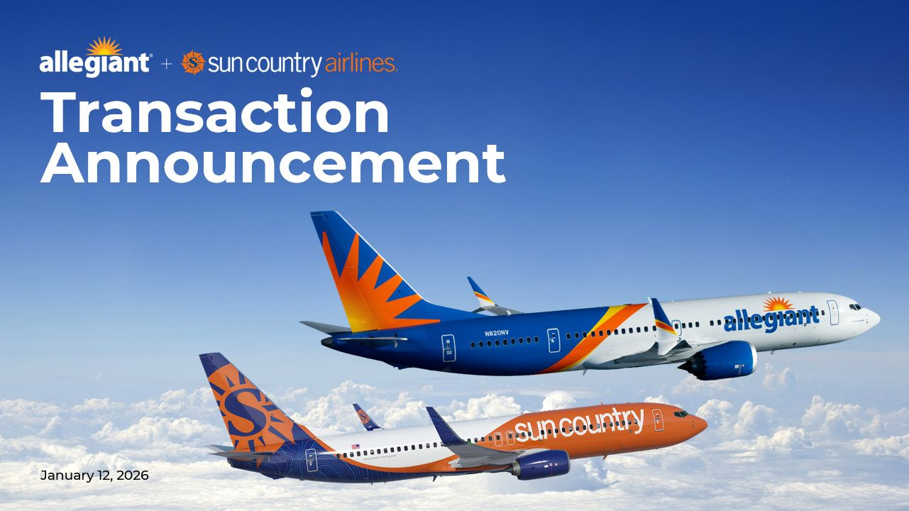
TransactionAnnouncement January 12, 2026

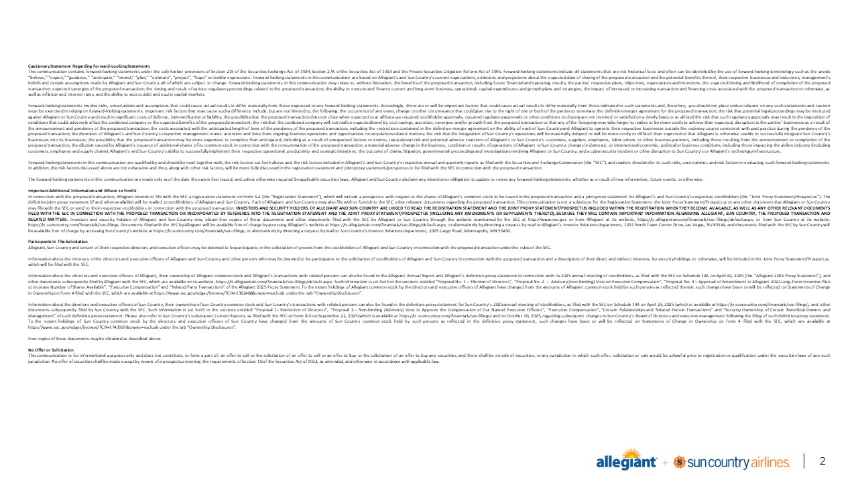
Forward-Looking Statements Sub-Header: Enter your optional sub-heading here Source: Footnotes. Cautionary Statement Regarding Forward-Looking Statements This communication contains forward-looking statements under the safe harbor provisions of Section 21E of the Securities Exchange Act of 1934, Section 27A of the Securities Act of 1933 and the Private Securities Litigation Reform Act of 1995. Forward-looking statements include all statements that are not historical facts and often can be identified by the use of forward-looking terminology such as the words “believe,” “expect,” “guidance,” “anticipate,” “intend,” “plan,” “estimate”, “project”, “hope” or similar expressions. Forward-looking statements in this communication are based on Allegiant’s and Sun Country’s current expectations, estimates and projections about the expected date of closing of the proposed transaction and the potential benefits thereof, their respective businesses and industries, management’s beliefs and certain assumptions made by Allegiant and Sun Country, all of which are subject to change. Forward-looking statements in this communication may relate to, without limitation, the benefits of the proposed transaction, including future financial and operating results; the parties’ respective plans, objectives, expectations and intentions; the expected timing and likelihood of completion of the proposed transaction; expected synergies of the proposed transaction; the timing and result of various regulatory proceedings related to the proposed transaction; the ability to execute and finance current and long-term business, operational, capital expenditures and growth plans and strategies; the impact of increased or increasing transaction and financing costs associated with the proposed transaction or otherwise, as well as inflation and interest rates; and the ability to access debt and equity capital markets. Forward-looking statements involve risks, uncertainties and assumptions that could cause actual results to differ materially from those expressed in any forward-looking statements. Accordingly, there are or will be important factors that could cause actual results to differ materially from those indicated in such statements and, therefore, you should not place undue reliance on any such statements and caution must be exercised in relying on forward-looking statements. Important risk factors that may cause such a difference include, but are not limited to, the following: the occurrence of any event, change or other circumstance that could give rise to the right of one or both of the parties to terminate the definitive merger agreement for the proposed transaction; the risk that potential legal proceedings may be instituted against Allegiant or Sun Country and result in significant costs of defense, indemnification or liability; the possibility that the proposed transaction does not close when expected or at all because required stockholder approvals, required regulatory approvals or other conditions to closing are not received or satisfied on a timely basis or at all (and the risk that such regulatory approvals may result in the imposition of conditions that could adversely affect the combined company or the expected benefits of the proposed transaction); the risk that the combined company will not realize expected benefits, cost savings, accretion, synergies and/or growth from the proposed transaction or that any of the foregoing may take longer to realize or be more costly to achieve than expected; disruption to the parties’ businesses as a result of the announcement and pendency of the proposed transaction; the costs associated with the anticipated length of time of the pendency of the proposed transaction, including the restrictions contained in the definitive merger agreement on the ability of each of Sun Country and Allegiant to operate their respective businesses outside the ordinary course consistent with past practice during the pendency of the proposed transaction; the diversion of Allegiant’s and Sun Country’s respective management teams’ attention and time from ongoing business operations and opportunities on acquisition-related matters; the risk that the integration of Sun Country’s operations will be materially delayed or will be more costly or difficult than expected or that Allegiant is otherwise unable to successfully integrate Sun Country’s businesses into its businesses; the possibility that the proposed transaction may be more expensive to complete than anticipated, including as a result of unexpected factors or events; reputational risk and potential adverse reactions of Allegiant’s or Sun Country’s customers, suppliers, employees, labor unions or other business partners, including those resulting from the announcement or completion of the proposed transaction; the dilution caused by Allegiant’s issuance of additional shares of its common stock in connection with the consummation of the proposed transaction; a material adverse change in the business, condition or results of operations of Allegiant or Sun Country; changes in domestic or international economic, political or business conditions, including those impacting the airline industry (including customers, employees and supply chains); Allegiant’s and Sun Country’s ability to successfully implement their respective operational, productivity and strategic initiatives; the outcome of claims, litigation, governmental proceedings and investigations involving Allegiant or Sun Country; and a cybersecurity incident or other disruption to Sun Country’s or Allegiant’s technology infrastructure. Forward-looking statements in this communication are qualified by and should be read together with, the risk factors set forth above and the risk factors included in Allegiant’s and Sun Country’s respective annual and quarterly reports as filed with the Securities and Exchange Commission (the “SEC”), and readers should refer to such risks, uncertainties and risk factors in evaluating such forward-looking statements. In addition, the risk factors discussed above are not exhaustive and they, along with other risk factors, will be more fully discussed in the registration statement and joint proxy statement/prospectus to be filed with the SEC in connection with the proposed transaction. The forward-looking statements in this communication are made only as of the date they were first issued, and unless otherwise required by applicable securities laws, Allegiant and Sun Country disclaim any intention or obligation to update or revise any forward-looking statements, whether as a result of new information, future events, or otherwise. Important Additional Information and Where to Find It In connection with the proposed transaction, Allegiant intends to file with the SEC a registration statement on Form S-4 (the “Registration Statement”), which will include a prospectus with respect to the shares of Allegiant’s common stock to be issued in the proposed transaction and a joint proxy statement for Allegiant’s and Sun Country’s respective stockholders (the “Joint Proxy Statement/Prospectus”). The definitive joint proxy statement (if and when available) will be mailed to stockholders of Allegiant and Sun Country. Each of Allegiant and Sun Country may also file with or furnish to the SEC other relevant documents regarding the proposed transaction. This communication is not a substitute for the Registration Statement, the Joint Proxy Statement/Prospectus or any other document that Allegiant or Sun Country may file with the SEC or send to their respective stockholders in connection with the proposed transaction. INVESTORS AND SECURITY HOLDERS OF ALLEGIANT AND SUN COUNTRY ARE URGED TO READ THE REGISTRATION STATEMENT AND THE JOINT PROXY STATEMENT/PROSPECTUS INCLUDED WITHIN THE REGISTRATION WHEN THEY BECOME AVAILABLE, AS WELL AS ANY OTHER RELEVANT DOCUMENTS FILED WITH THE SEC IN CONNECTION WITH THE PROPOSED TRANSACTION OR INCORPORATED BY REFERENCE INTO THE REGISTRATION STATEMENT AND THE JOINT PROXY STATEMENT/PROSPECTUS (INCLUDING ANY AMENDMENTS OR SUPPLEMENTS THERETO), BECAUSE THEY WILL CONTAIN IMPORTANT INFORMATION REGARDING ALLEGIANT, SUN COUNTRY, THE PROPOSED TRANSACTION AND RELATED MATTERS. Investors and security holders of Allegiant and Sun Country may obtain free copies of these documents and other documents filed with the SEC by Allegiant or Sun Country through the website maintained by the SEC at http://www.sec.gov or from Allegiant at its website, https://ir.allegiantair.com/financials/sec-filings/default.aspx, or from Sun Country at its website, https://ir.suncountry.com/financials/sec-filings. Documents filed with the SEC by Allegiant will be available free of charge by accessing Allegiant’s website at https://ir.allegiantair.com/financials/sec-filings/default.aspx, or alternatively by directing a request by mail to Allegiant’s Investor Relations department, 1201 North Town Center Drive, Las Vegas, NV 89144, and documents filed with the SEC by Sun Country will be available free of charge by accessing Sun Country’s website at https://ir.suncountry.com/financials/sec-filings, or alternatively by directing a request by mail to Sun Country’s Investor Relations department, 2005 Cargo Road, Minneapolis, MN 55450. Participants In The Solicitation Allegiant, Sun Country and certain of their respective directors and executive officers may be deemed to be participants in the solicitation of proxies from the stockholders of Allegiant and Sun Country in connection with the proposed transaction under the rules of the SEC. Information about the interests of the directors and executive officers of Allegiant and Sun Country and other persons who may be deemed to be participants in the solicitation of stockholders of Allegiant and Sun Country in connection with the proposed transaction and a description of their direct and indirect interests, by security holdings or otherwise, will be included in the Joint Proxy Statement/Prospectus, which will be filed with the SEC. Information about the directors and executive officers of Allegiant, their ownership of Allegiant common stock and Allegiant’s transactions with related persons can also be found in the Allegiant Annual Report and Allegiant’s definitive proxy statement in connection with its 2025 annual meeting of stockholders, as filed with the SEC on Schedule 14A on April 30, 2025 (the “Allegiant 2025 Proxy Statement”), and other documents subsequently filed by Allegiant with the SEC, which are available on its website, https://ir.allegiantair.com/financials/sec-filings/default.aspx. Such information is set forth in the sections entitled “Proposal No. 1 – Election of Directors”, “Proposal No. 2 – Advisory (non-binding) Vote on Executive Compensation”, “Proposal No. 3 – Approval of Amendment to Allegiant 2022 Long-Term Incentive Plan to Increase Number of Shares Available”, “Executive Compensation” and “Related Party Transactions” of the Allegiant 2025 Proxy Statement. To the extent holdings of Allegiant common stock by the directors and executive officers of Allegiant have changed from the amounts of Allegiant common stock held by such persons as reflected therein, such changes have been or will be reflected on Statements of Change in Ownership on Form 4 filed with the SEC, which are available at https://www.sec.gov/edgar/browse/?CIK=1362468&owner=exclude under the tab “Ownership Disclosures”. Information about the directors and executive officers of Sun Country, their ownership of Sun Country common stock and Sun Country’s transactions with related persons can also be found in the definitive proxy statement for Sun Country’s 2025 annual meeting of stockholders, as filed with the SEC on Schedule 14A on April 25, 2025 (which is available at https://ir.suncountry.com/financials/sec-filings), and other documents subsequently filed by Sun Country with the SEC. Such information is set forth in the sections entitled “Proposal 1– Reelection of Directors”, “Proposal 2 – Non-binding (Advisory) Vote to Approve the Compensation of Our Named Executive Officers”, “Executive Compensation”, “Certain Relationships and Related Person Transactions” and “Security Ownership of Certain Beneficial Owners and Management” of such definitive proxy statement. Please also refer to Sun Country’s subsequent Current Reports, as filed with the SEC on Form 8-K on September 22, 2025 (which is available at https://ir.suncountry.com/financials/sec-filings) and on October 30, 2025, regarding subsequent changes to Sun Country’s Board of Directors and executive management following the filing of such definitive proxy statement. To the extent holdings of Sun Country common stock by the directors and executive officers of Sun Country have changed from the amounts of Sun Country common stock held by such persons as reflected in the definitive proxy statement, such changes have been or will be reflected on Statements of Change in Ownership on Form 4 filed with the SEC, which are available at https://www.sec.gov/edgar/browse/?CIK=1743907&owner=exclude under the tab “Ownership Disclosures”. Free copies of these documents may be obtained as described above. No Offer or Solicitation This communication is for informational purposes only and does not constitute, or form a part of, an offer to sell or the solicitation of an offer to sell or an offer to buy or the solicitation of an offer to buy any securities, and there shall be no sale of securities, in any jurisdiction in which such offer, solicitation or sale would be unlawful prior to registration or qualification under the securities laws of any such jurisdiction. No offer of securities shall be made except by means of a prospectus meeting the requirements of Section 10 of the Securities Act of 1933, as amended, and otherwise in accordance with applicable law.

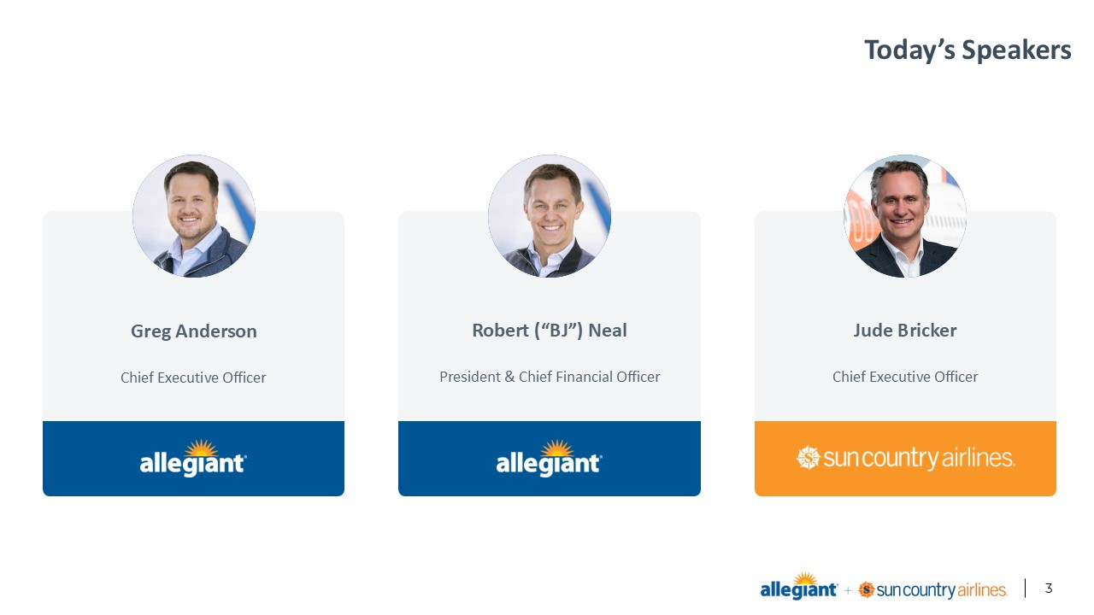
Today’s Speakers Greg Anderson Chief Executive Officer Robert (“BJ”) Neal President & Chief Financial Officer Jude Bricker Chief Executive Officer

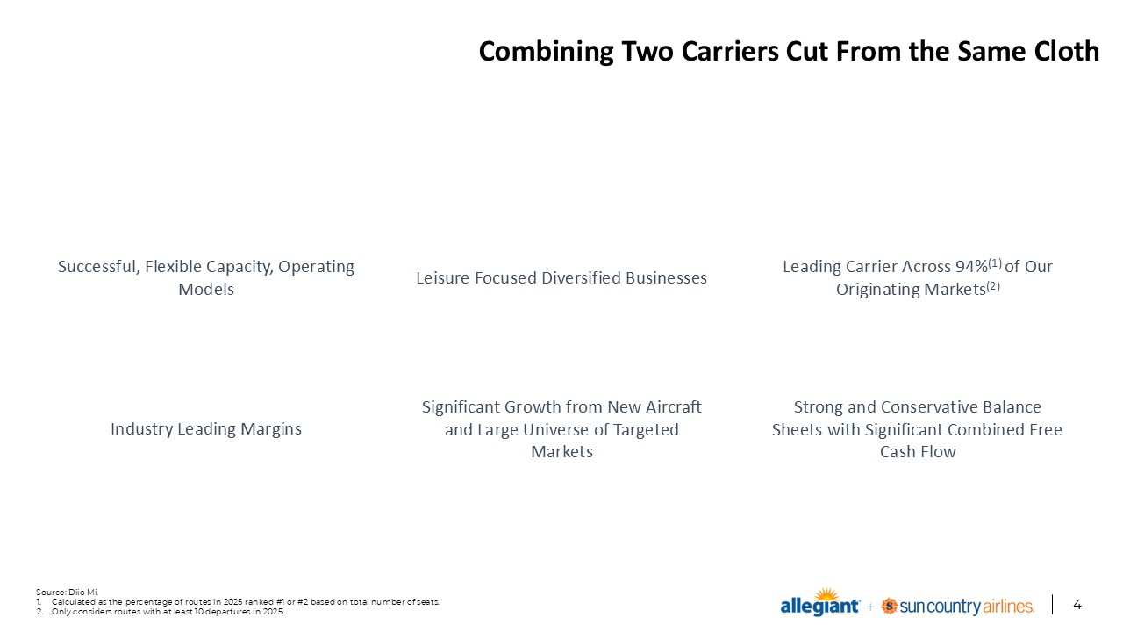
Combining Two Carriers Cut From the Same Cloth Source: Diio Mi. Calculated as the percentage of routes in 2025 ranked #1 or #2 based on total number of seats. Only considers routes with at least 10 departures in 2025. Successful, Flexible Capacity, Operating Models Leisure Focused Diversified Businesses Industry Leading Margins Leading Carrier Across 94%(1) of Our Originating Markets(2) Significant Growth from New Aircraft and Large Universe of Targeted Markets Strong and Conservative Balance Sheets with Significant Combined Free Cash Flow

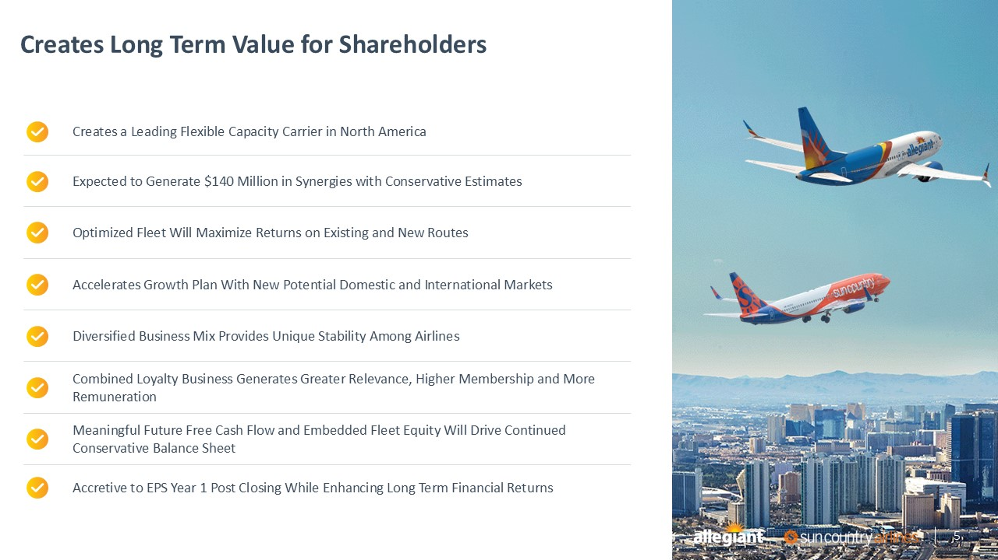
Creates Long Term Value for Shareholders Source: Footnotes. Sub-Header: Enter your optional sub-heading here Enter your text here Line 2 Line 3 Line 4 5 Creates a Leading Flexible Capacity Carrier in North America Expected to Generate $140 Million in Synergies with Conservative Estimates Optimized Fleet Will Maximize Returns on Existing and New Routes Accelerates Growth Plan With New Potential Domestic and International Markets Diversified Business Mix Provides Unique Stability Among Airlines Meaningful Future Free Cash Flow and Embedded Fleet Equity Will Drive Continued Conservative Balance Sheet Accretive to EPS Year 1 Post Closing While Enhancing Long Term Financial Returns Combined Loyalty Business Generates Greater Relevance, Higher Membership and More Remuneration 5

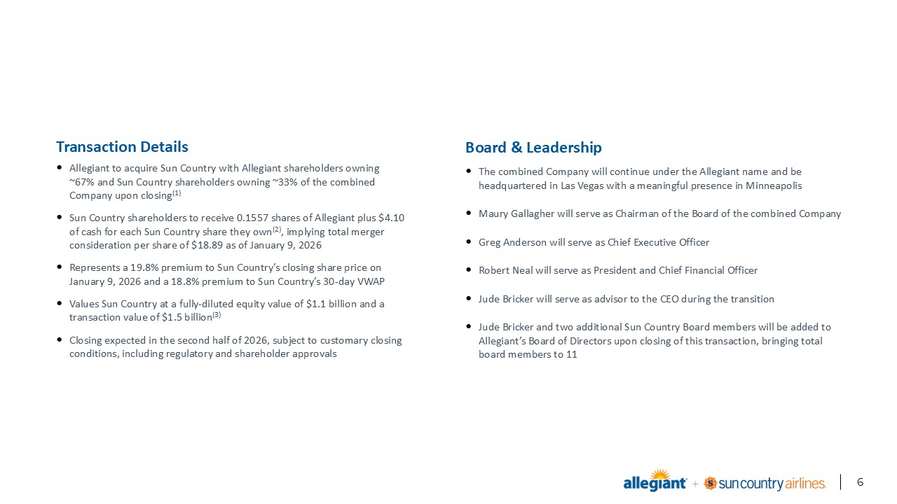
Transaction Overview On a fully-diluted basis. Based on Sun Country’s and Allegiant’s share price as of January 9, 2026. Includes $0.4bn of Sun Country’s adjusted net debt (including leases) as of 3Q25. Transaction Details Allegiant to acquire Sun Country with Allegiant shareholders owning ~67% and Sun Country shareholders owning ~33% of the combined Company upon closing(1) Sun Country shareholders to receive 0.1557 shares of Allegiant plus $4.10 of cash for each Sun Country share they own(2), implying total merger consideration per share of $18.89 as of January 9, 2026 Represents a 19.8% premium to Sun Country’s closing share price on January 9, 2026 and a 18.8% premium to Sun Country’s 30-day VWAP Values Sun Country at a fully-diluted equity value of $1.1 billion and a transaction value of $1.5 billion(3) Closing expected in the second half of 2026, subject to customary closing conditions, including regulatory and shareholder approvals Board & Leadership The combined Company will continue under the Allegiant name and be headquartered in Las Vegas with a meaningful presence in Minneapolis Maury Gallagher will serve as Chairman of the Board of the combined Company Greg Anderson will serve as Chief Executive Officer Robert Neal will serve as President and Chief Financial Officer Jude Bricker will serve as advisor to the CEO during the transition Jude Bricker and two additional Sun Country Board members will be added to Allegiant’s Board of Directors upon closing of this transaction, bringing total board members to 11

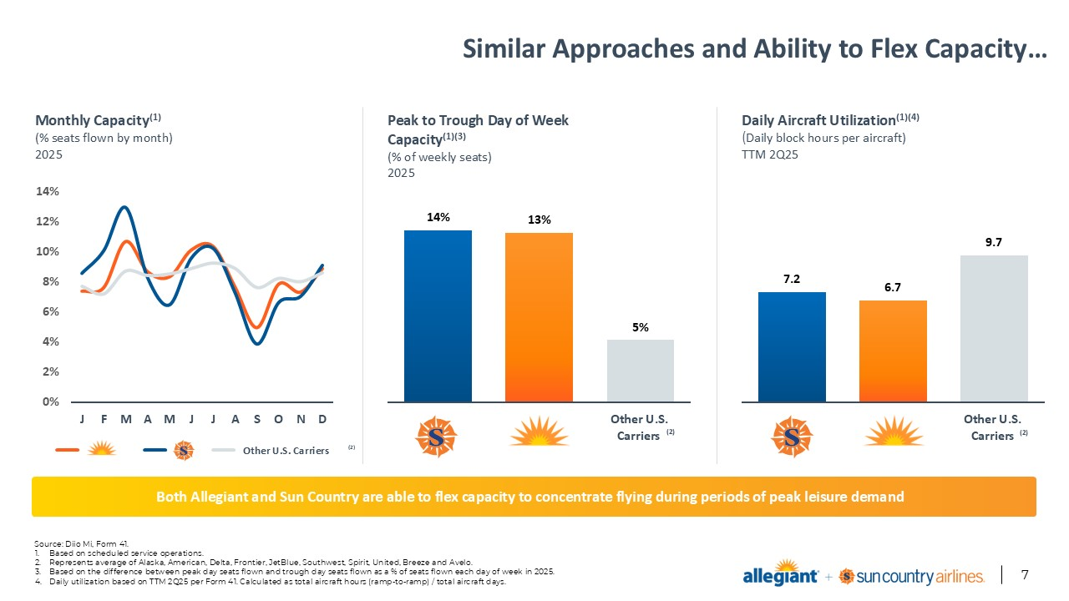
Other U.S. Carriers Similar Approaches and Ability to Flex Capacity… Source: Diio Mi, Form 41. Based on scheduled service operations. Represents average of Alaska, American, Delta, Frontier, JetBlue, Southwest, Spirit, United, Breeze and Avelo. Based on the difference between peak day seats flown and trough day seats flown as a % of seats flown each day of week in 2025. Daily utilization based on TTM 2Q25 per Form 41. Calculated as total aircraft hours (ramp-to-ramp) / total aircraft days. Monthly Capacity(1) (% seats flown by month) 2025 Peak to Trough Day of Week Capacity(1)(3) (% of weekly seats) 2025 (2) (2) Both Allegiant and Sun Country are able to flex capacity to concentrate flying during periods of peak leisure demand Daily Aircraft Utilization(1)(4) (Daily block hours per aircraft) TTM 2Q25 (2)

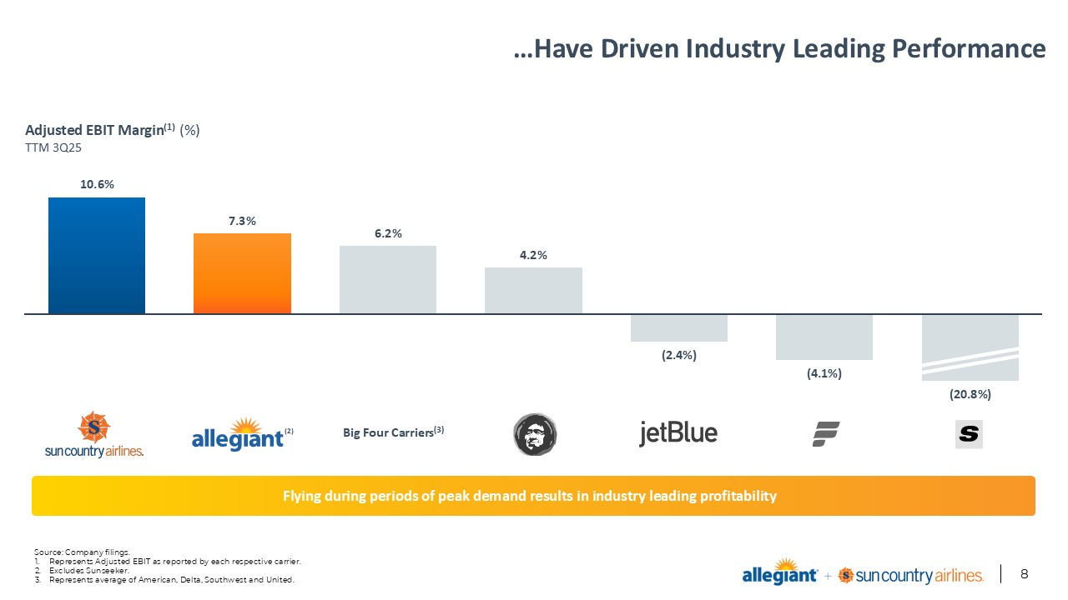
…Have Driven Industry Leading Performance Source: Company filings. Represents Adjusted EBIT as reported by each respective carrier. Excludes Sunseeker. Represents average of American, Delta, Southwest and United. Adjusted EBIT Margin(1) (%) TTM 3Q25 (2) Big Four Carriers(3) Flying during periods of peak demand results in industry leading profitability

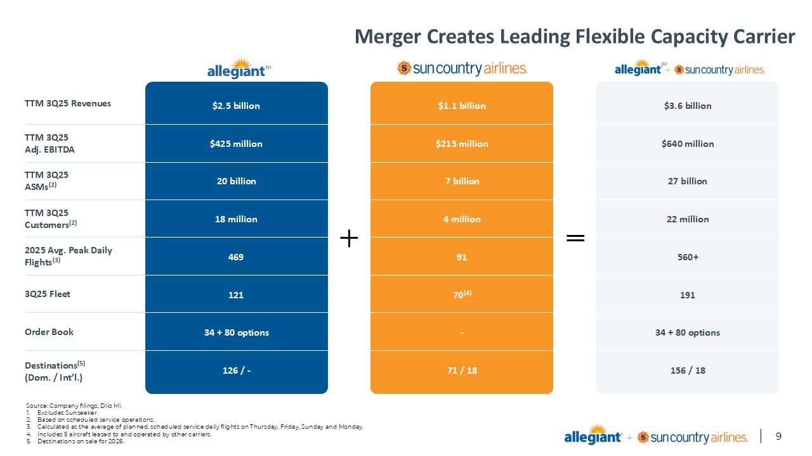
Merger Creates Leading Flexible Capacity Carrier Source: Company filings, Diio Mi. Excludes Sunseeker. Based on scheduled service operations. Calculated as the average of planned, scheduled service daily flights on Thursday, Friday, Sunday and Monday. Includes 5 aircraft leased to and operated by other carriers. Destinations on sale for 2026. TTM 3Q25 Revenues TTM 3Q25 Customers(2) 3Q25 Fleet Order Book 2025 Avg. Peak Daily Flights(3) Destinations(5) (Dom. / Int’l.) TTM 3Q25 ASMs(2) TTM 3Q25 Adj. EBITDA $2.5 billion $425 million 20 billion 18 million 469 121 34 + 80 options 126 / - $1.1 billion $215 million 7 billion 4 million 91 70(4) - 71 / 18 $3.6 billion $640 million 27 billion 22 million 560+ 191 34 + 80 options 156 / 18 (1) (1)

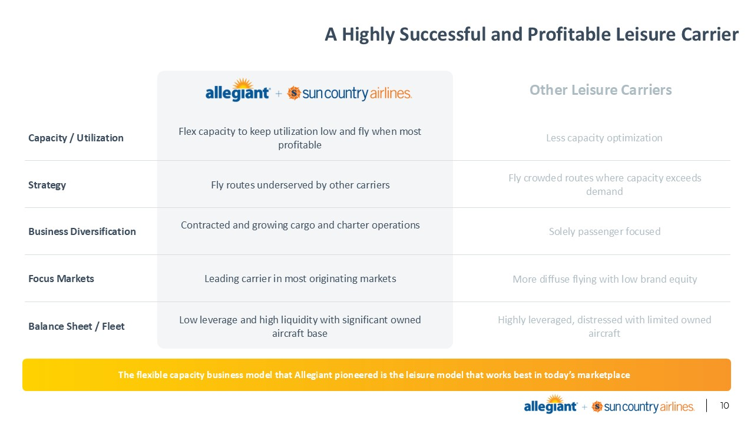
A Highly Successful and Profitable Leisure Carrier Source: Footnotes. Sub-Header: Enter your optional sub-heading here Enter your text here Line 2 Line 3 Line 4 Capacity / Utilization Focus Markets Strategy Business Diversification Other Leisure Carriers The flexible capacity business model that Allegiant pioneered is the leisure model that works best in today’s marketplace Flex capacity to keep utilization low and fly when most profitable Leading carrier in most originating markets Fly routes underserved by other carriers Balance Sheet / Fleet Contracted and growing cargo and charter operations Low leverage and high liquidity with significant owned aircraft base Less capacity optimization More diffuse flying with low brand equity Fly crowded routes where capacity exceeds demand Solely passenger focused Highly leveraged, distressed with limited owned aircraft

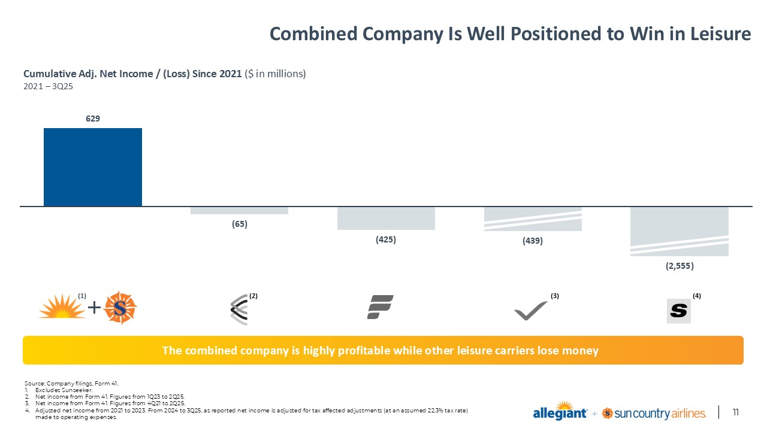
Combined Company Is Well Positioned to Win in Leisure Source: Company filings, Form 41. Excludes Sunseeker. Net income from Form 41. Figures from 1Q23 to 2Q25. Net income from Form 41. Figures from 4Q21 to 2Q25. Adjusted net income from 2021 to 2023. From 2024 to 3Q25, as reported net income is adjusted for tax affected adjustments (at an assumed 22.3% tax rate) made to operating expenses. Cumulative Adj. Net Income / (Loss) Since 2021 ($ in millions) 2021 – 3Q25 The combined company is highly profitable while other leisure carriers lose money (2) (3) (4) (1)

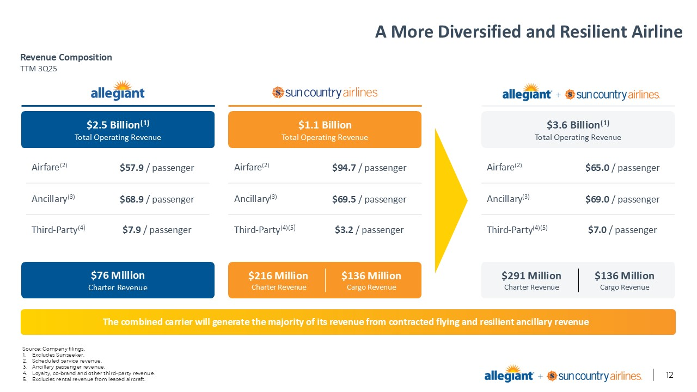
A More Diversified and Resilient Airline Source: Company filings. Excludes Sunseeker. Scheduled service revenue. Ancillary passenger revenue. Loyalty, co-brand and other third-party revenue. Excludes rental revenue from leased aircraft. Revenue Composition TTM 3Q25 The combined carrier will generate the majority of its revenue from contracted flying and resilient ancillary revenue $2.5 Billion(1) Total Operating Revenue $76 Million Charter Revenue $1.1 Billion Total Operating Revenue $216 Million Charter Revenue $136 Million Cargo Revenue $3.6 Billion(1) Total Operating Revenue Airfare(2) $57.9 / passenger Ancillary(3) $68.9 / passenger Third-Party(4) $7.9 / passenger Airfare(2) $94.7 / passenger Ancillary(3) $69.5 / passenger Third-Party(4)(5) $3.2 / passenger Airfare(2) $65.0 / passenger Ancillary(3) $69.0 / passenger Third-Party(4)(5) $7.0 / passenger $291 Million Charter Revenue $136 Million Cargo Revenue

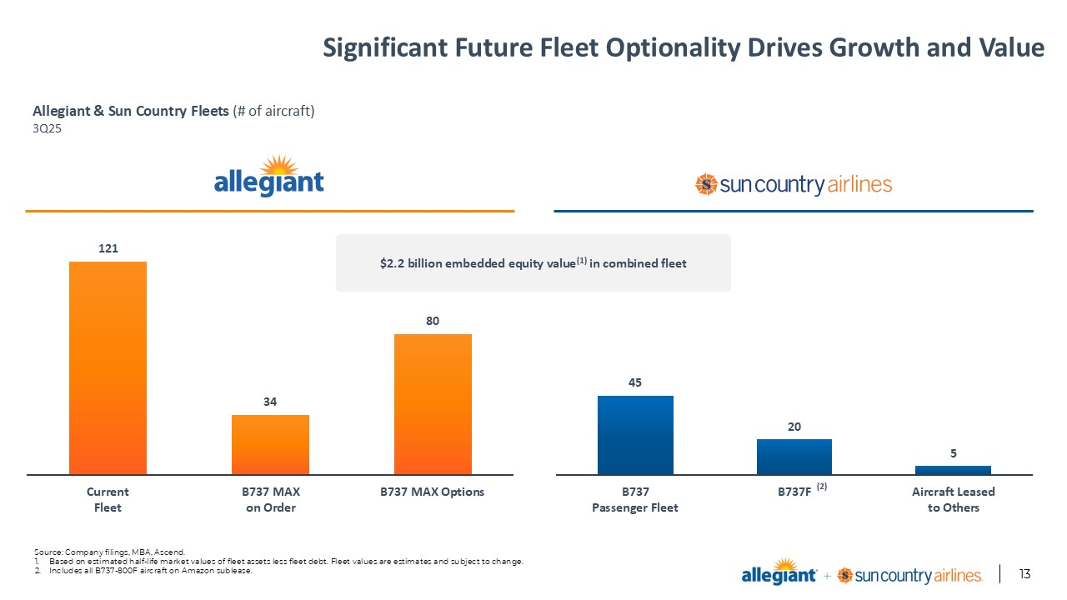
Significant Future Fleet Optionality Drives Growth and Value Source: Company filings, MBA, Ascend. Based on estimated half-life market values of fleet assets less fleet debt. Fleet values are estimates and subject to change. Includes all B737-800F aircraft on Amazon sublease. Allegiant & Sun Country Fleets (# of aircraft)3Q25 (2) $2.2 billion embedded equity value(1) in combined fleet

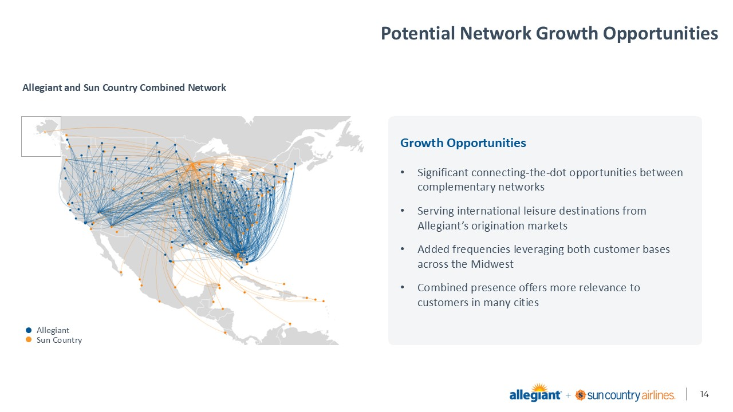
Potential Network Growth Opportunities Source: Footnotes. Allegiant and Sun Country Combined Network Growth Opportunities Significant connecting-the-dot opportunities between complementary networks Serving international leisure destinations from Allegiant’s origination markets Added frequencies leveraging both customer bases across the Midwest Combined presence offers more relevance to customers in many cities Allegiant Sun Country

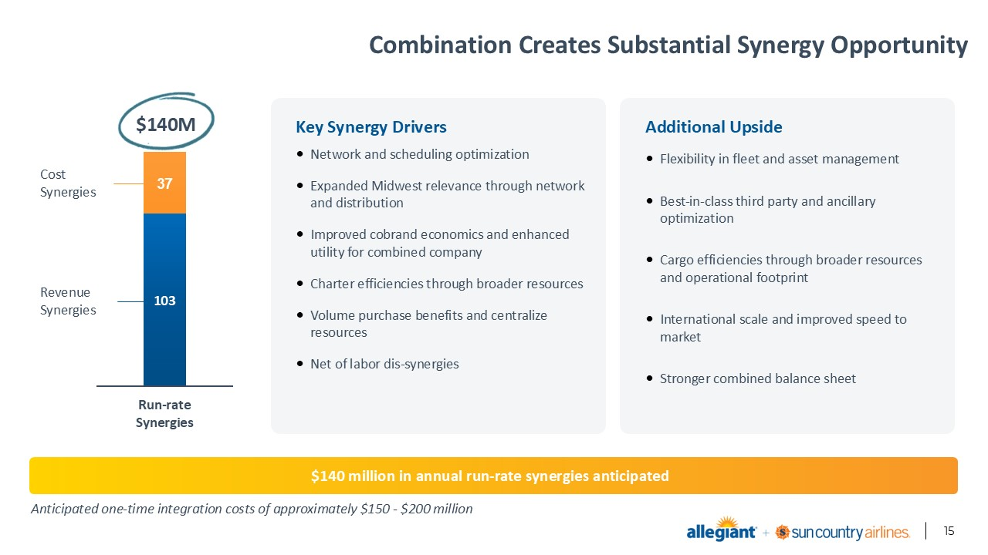
Combination Creates Substantial Synergy Opportunity Source: Footnotes. Sub-Header: Enter your optional sub-heading here Enter your text here Line 2 Line 3 Line 4 Anticipated one-time integration costs of approximately $150 - $200 million $140M CostSynergies RevenueSynergies $140 million in annual run-rate synergies anticipated Key Synergy Drivers Network and scheduling optimization Expanded Midwest relevance through network and distribution Improved cobrand economics and enhanced utility for combined company Charter efficiencies through broader resources Volume purchase benefits and centralize resources Net of labor dis-synergies Additional Upside Flexibility in fleet and asset management Best-in-class third party and ancillary optimization Cargo efficiencies through broader resources and operational footprint International scale and improved speed to market Stronger combined balance sheet

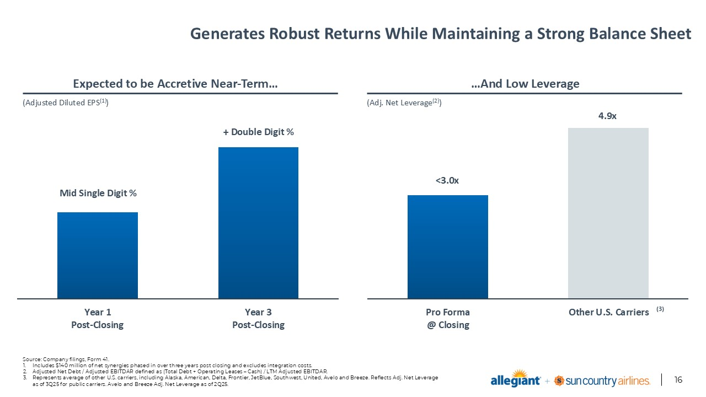
Generates Robust Returns While Maintaining a Strong Balance Sheet Source: Company filings, Form 41. Includes $140 million of net synergies phased in over three years post closing and excludes integration costs. Adjusted Net Debt / Adjusted EBITDAR defined as (Total Debt + Operating Leases – Cash) / LTM Adjusted EBITDAR. Represents average of other U.S. carriers, including Alaska, American, Delta, Frontier, JetBlue, Southwest, United, Avelo and Breeze. Reflects Adj. Net Leverage as of 3Q25 for public carriers. Avelo and Breeze Adj. Net Leverage as of 2Q25. (Adjusted Diluted EPS(1)) (Adj. Net Leverage(2)) Mid Single Digit % + Double Digit % <3.0x 4.9x (3) Expected to be Accretive Near-Term… …And Low Leverage

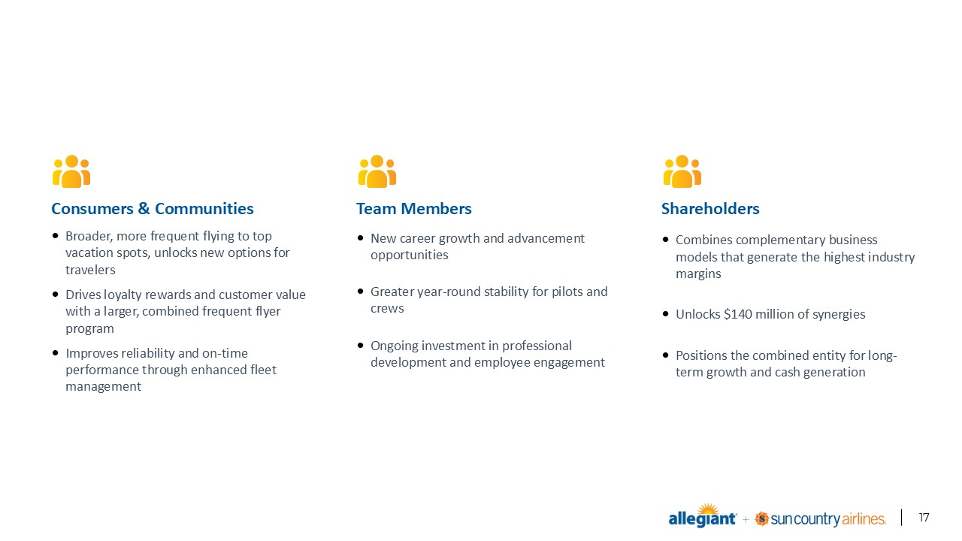
Creating Value for All Our Stakeholders Source: Footnotes. Sub-Header: Enter your optional sub-heading here Enter your text here Line 2 Line 3 Line 4 Consumers & Communities Broader, more frequent flying to top vacation spots, unlocks new options for travelers Drives loyalty rewards and customer value with a larger, combined frequent flyer program Improves reliability and on-time performance through enhanced fleet management Team Members New career growth and advancement opportunities Greater year-round stability for pilots and crews Ongoing investment in professional development and employee engagement Shareholders Combines complementary business models that generate the highest industry margins Unlocks $140 million of synergies Positions the combined entity for long-term growth and cash generation


Source: Footnotes.

